Beyond the Gradient: A Narrative Review of 4D Flow CMR in Aortic Stenosis
Chapter 1: Introduction
Aortic stenosis (AS) is a common valvular heart disease in high-income countries, and its prevalence increases markedly with age.^{1,2} Although it was previously considered mainly an age-related degenerative process, AS is now recognised as an active disease involving lipid accumulation, inflammation, fibrosis and progressive calcification of the aortic valve leaflets.² These changes stiffen the leaflets, restrict their opening and increase obstruction to blood flow from the left ventricle (LV).²
The obstruction creates sustained pressure overload on the LV. The initial response is concentric hypertrophy, which helps reduce wall stress and maintain cardiac function.² With persistent pressure overload, this adaptation can become maladaptive and is associated with myocardial fibrosis, impaired ventricular function and adverse clinical outcomes.² Accurate assessment of AS severity is therefore important when determining the timing of valve intervention. This is particularly challenging in patients with discordant or low-flow, low-gradient AS, in whom conventional haemodynamic measurements may not provide a straightforward assessment of stenosis severity.¹ Current guidelines integrate symptoms, LV function, haemodynamic severity and other clinical findings when considering surgical aortic valve replacement (SAVR) or transcatheter aortic valve implantation (TAVI).¹ Severe high-gradient AS is characterised by a peak transvalvular velocity (Vpeak) ≥4.0 m/s, a mean transvalvular pressure gradient ≥40 mmHg and an aortic valve area (AVA) ≤1.0 cm².¹ Transthoracic echocardiography (TTE) remains the main imaging modality for the assessment of AS because of its wide availability and high temporal resolution.¹
However, TTE has important technical limitations. Continuous-wave Doppler measurements depend on alignment between the ultrasound beam and the direction of blood flow. Eccentric stenotic jets can make this alignment difficult, and poor alignment can result in underestimation of Vpeak.^{3,4} Adriaans et al. demonstrated this in a prospective study of 20 patients with AS. The difference in Vpeak between 4D flow CMR and TTE was strongly associated with flow-jet eccentricity (r = 0.89, P < 0.001).³ The study also found higher Vpeak and mean pressure gradient measurements with 4D flow CMR than with TTE.³ These findings suggest that jet orientation can contribute to differences between the two methods.
AVA provides another potential source of measurement error. The continuity equation requires measurement of the left ventricular outflow tract (LVOT) diameter and assumes a circular LVOT geometry.^{3,4} However, three-dimensional imaging has shown that the LVOT is commonly elliptical. Measurement of a single diameter can therefore underestimate the LVOT cross-sectional area and affect the calculated AVA.³ In the study by Adriaans et al., 4D flow CMR produced a 19.9% larger AVA than TTE and improved concordance between Vpeak and AVA and between mean pressure gradient and AVA.³
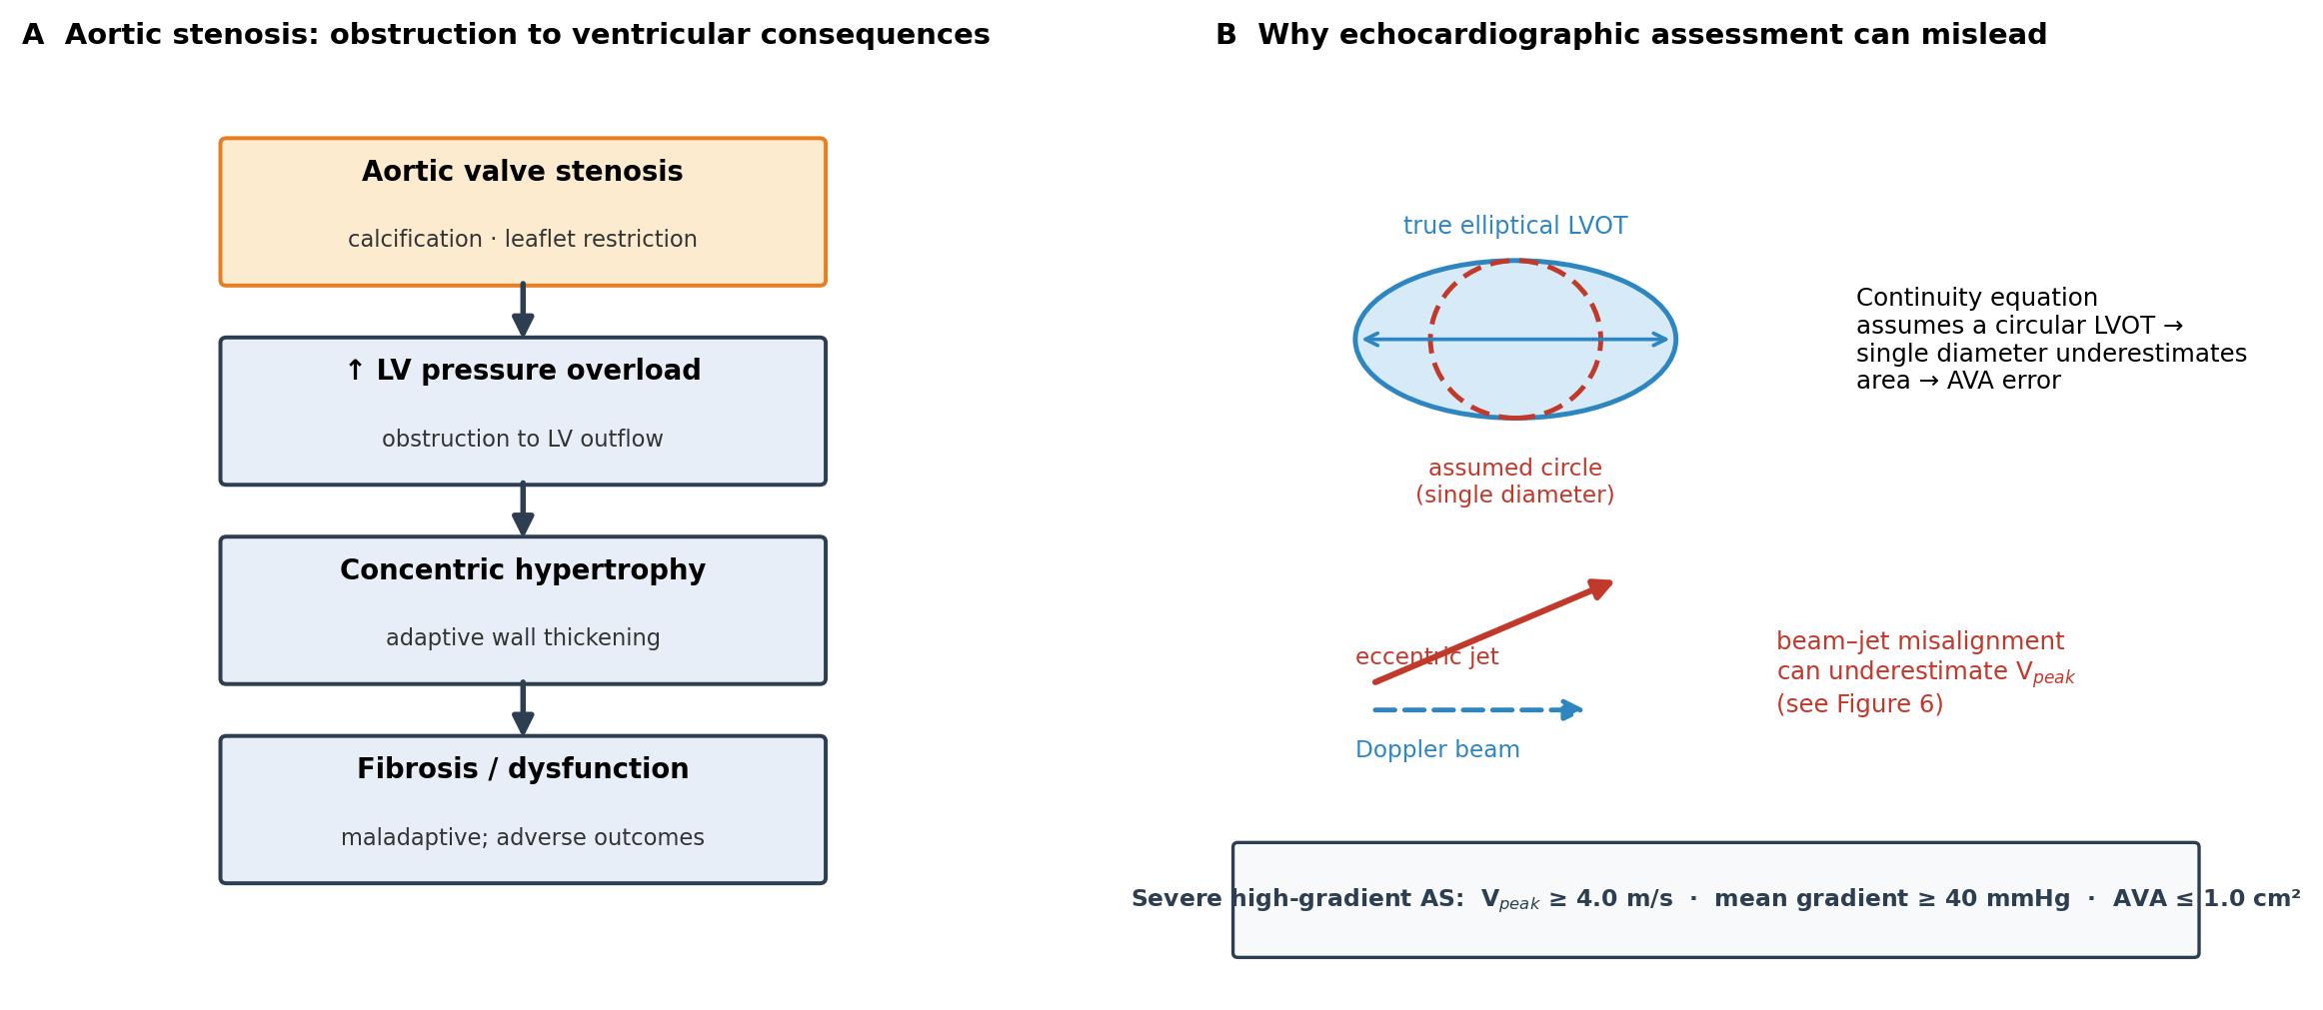
Figure 1. Aortic stenosis and its assessment. (A) Progression from valvular obstruction to left ventricular pressure overload, hypertrophy and fibrosis. (B) Sources of error in echocardiographic assessment, including the circular-LVOT assumption of the continuity equation and beam–jet misalignment. Original schematic.
AS, aortic stenosis; AVA, aortic valve area; LV, left ventricle; LVOT, left ventricular outflow tract; Vpeak, peak transvalvular velocity.
Four-dimensional flow cardiovascular magnetic resonance (4D flow CMR) provides a different approach to flow assessment. It measures blood velocity in three directions across the cardiac cycle within a three-dimensional volume.^{4,5} Because the velocity data cover a volume rather than a single predefined plane, measurement planes can be positioned retrospectively after acquisition.^{4,5} This may be useful in AS because the direction of an eccentric stenotic jet may not be known before imaging. In addition to conventional flow measures, 4D flow CMR can quantify haemodynamic parameters such as wall shear stress (WSS), turbulent kinetic energy (TKE) and viscous energy loss (VEL).⁴ These measures provide information about abnormal flow and energy dissipation that is not captured by conventional velocity and pressure-gradient measurements alone.⁴
This narrative review examines the current evidence for 4D flow CMR in AS. It considers the technical basis of the method, its assessment of conventional haemodynamic measures, validation against TTE and invasive catheterisation, and its application to advanced flow and energy measures. It also considers emerging associations between 4D-flow-derived measurements and functional or clinical outcomes, the place of 4D flow within the wider imaging assessment of AS, and the methodological limitations that currently restrict wider clinical application.
Chapter 2: Technical Principles of 4D Flow CMR
4D flow CMR is a phase-contrast magnetic resonance technique that measures blood velocity in three directions across the cardiac cycle within a three-dimensional volume.^{4,5} It builds on conventional two-dimensional phase-contrast imaging, where velocity is measured through a predefined imaging plane. In 4D flow CMR, velocity data are acquired throughout a volume, allowing measurement planes to be positioned retrospectively after acquisition.^{4,5} This is relevant to AS because the direction of a stenotic jet may be eccentric and difficult to predict before the scan.
Velocity is encoded through changes in the phase of the MR signal. Measurements are obtained along three spatial directions, allowing the three components of the velocity vector to be assessed.⁵ An important acquisition parameter is the velocity encoding value (VENC), which defines the velocity range that can be measured without phase aliasing. If the VENC is too low, high velocities can be aliased. If it is set unnecessarily high, velocity-to-noise performance can decrease.⁵ VENC selection therefore requires a balance between capturing the expected peak velocity and maintaining adequate sensitivity to slower flow. This is particularly relevant in AS, where high transvalvular velocities occur alongside lower velocities in the surrounding flow field.
The acquisition is synchronised with the cardiac cycle to produce time-resolved velocity data.⁵ Respiratory motion also needs to be controlled or compensated during the acquisition, and different approaches can be used depending on the protocol.⁵ Garcia et al. described 4D flow CMR as providing three-dimensional, time-resolved assessment of aortic flow, with acquisition protocols designed to provide sufficient spatial and temporal resolution for visualising complex flow patterns.⁴ The consensus statement on 4D flow CMR reports a typical spatial resolution of about 1.5–3.0 mm, a temporal resolution of roughly 30–40 ms and acquisition times of about 5 to 25 minutes.⁵ These values matter in AS because the stenotic jet is narrow and short-lived: if the spatial or temporal resolution is insufficient, the highest velocities within the jet may be averaged out and underestimated, a point returned to in Chapter 3. Higher spatial resolution can improve the representation of complex flow structures but may increase acquisition time and reduce signal-to-noise performance.⁵
Table 1. Key 4D flow CMR acquisition and analysis parameters and their relevance to aortic stenosis.
Parameter | Typical consideration | Relevance to aortic stenosis
Spatial resolution | ~1.5–3.0 mm | A narrow stenotic jet may be underestimated if insufficiently resolved; also affects energy-loss quantification
Temporal resolution | ~30–40 ms | Needed to capture rapidly changing systolic flow
VENC | Set to the expected peak velocity | Too low → aliasing of high jet velocities; too high → reduced velocity-to-noise sensitivity
Acquisition time | ~5–25 min (protocol dependent) | Longer than a routine echocardiographic study
ECG gating / respiratory control | Required for time-resolved reconstruction | Enables analysis across the cardiac cycle
Post-processing | Background-phase and concomitant-gradient correction, aliasing correction, segmentation | Introduces operator dependence and standardisation considerations
ECG, electrocardiogram; VENC, velocity encoding value. Typical values are drawn from the 4D flow CMR consensus statement.⁵
The reconstructed data require several processing steps before quantitative analysis. Background phase errors, including those related to eddy currents, need to be corrected, while concomitant gradient effects may require separate correction.⁵ Velocity aliasing can also be corrected during post-processing. The aorta and other structures of interest are then segmented, after which measurement planes can be positioned within the acquired volume to quantify flow and velocity.^{4,5} Each processing step can introduce residual error, so the final measurements depend not only on the acquisition but also on the analysis method.
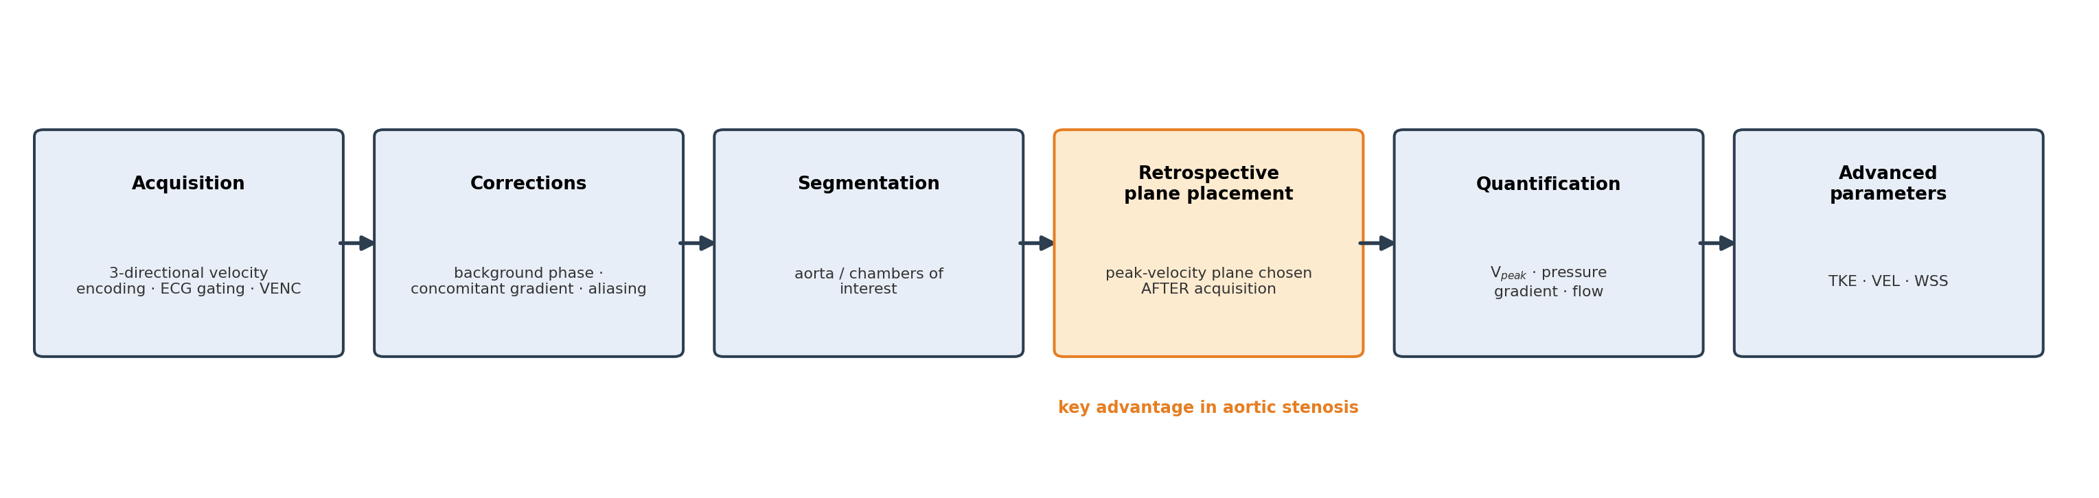
Figure 2. Overview of the 4D flow CMR acquisition and analysis pipeline, adapted for aortic stenosis. Retrospective plane placement (highlighted) allows the peak-velocity plane to be selected after acquisition. Adapted from the 4D flow CMR consensus statement.⁵
ECG, electrocardiogram; TKE, turbulent kinetic energy; VEL, viscous energy loss; VENC, velocity encoding value; WSS, wall shear stress; Vpeak, peak transvalvular velocity.
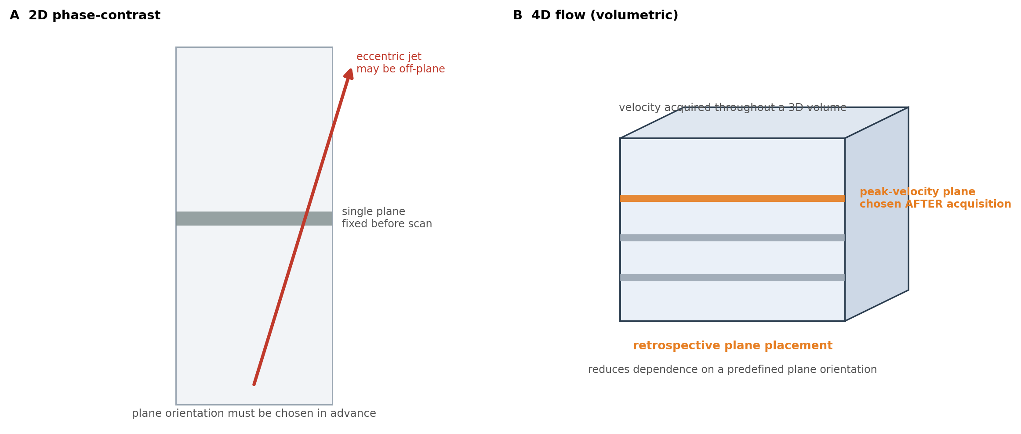
Figure 3. Retrospective measurement-plane placement. In 2D phase-contrast imaging (A) the plane is fixed before acquisition and an eccentric jet may lie off-plane; in 4D flow (B) velocity is acquired throughout a volume, allowing the peak-velocity plane to be positioned after acquisition. Original schematic.
2D, two-dimensional; 3D, three-dimensional.
Segmentation and analysis methods can also affect reproducibility. Manual analysis requires the operator to identify the relevant anatomy and measurement planes and can be time-consuming. Semi-automated methods have therefore been developed to reduce operator input. Grafton-Clarke et al. evaluated a semi-automated pipeline using CAAS MR Solutions for peak aortic valve pressure-gradient assessment.⁶ The study included 11 patients and compared the semi-automated method with invasive measurements and manual 4D flow analysis. The semi-automated method showed a mean bias of −0.3 mmHg compared with invasive measurements and required approximately 4 minutes per subject, compared with about 20 minutes for manual analysis.⁶ However, the study was small and used different software for the manual and semi-automated analyses. These factors limit how far the findings can be generalised.
The reliability of advanced 4D-flow measures also depends on the quality of the underlying velocity data. This is particularly relevant for WSS, which is derived from velocity gradients close to the vessel wall. Numerical simulations have shown that MRI-derived WSS is sensitive to factors including spatial resolution and the method used to estimate the velocity gradient.⁷ WSS measurements should therefore be interpreted with caution, particularly when comparing studies that use different acquisition and analysis methods.
Overall, 4D flow CMR provides a three-dimensional and time-resolved description of cardiovascular flow, but the measurements remain dependent on acquisition settings and post-processing. These technical factors are important when interpreting studies comparing 4D flow with echocardiography or invasive measurements and when considering the clinical relevance of more advanced haemodynamic parameters.
Chapter 3: Haemodynamic Assessment of Aortic Stenosis Using 4D Flow CMR
The potential value of 4D flow CMR in AS can be assessed by comparing its measurements of peak velocity, pressure gradient and valve area with established methods. The available evidence shows that 4D flow CMR can measure these parameters, but the differences from TTE are not consistent across studies. This section therefore considers both the potential advantages and the reasons for disagreement between techniques.
Table 2. Principal studies evaluating 4D flow CMR for the haemodynamic assessment of aortic stenosis.
Study | Population | n | Comparison | Main finding | Key limitation
Adriaans et al.³ | Mixed-severity AS | 20 | 4D flow vs TTE | Higher Vpeak (+16.4%) and mean gradient (+14.9%); Vpeak difference tracked jet eccentricity (r = 0.89) | Small; single-centre
Archer et al.¹¹ | Severe AS | 18 | 4D flow vs TTE vs invasive | 4D-flow peak gradient closer to invasive (54±26 vs 50±34 mmHg) than TTE (61±32); lower bias but weaker correlation | Small; single-centre
Grafton-Clarke et al.⁶ | Severe AS | 11 | Semi-automated 4D flow vs invasive / manual | Very low gradient bias (−0.3 mmHg); high reproducibility (ICC 0.98/0.99); ~4 vs ~20 min analysis | Very small; all severe; specific pipeline
Grafton-Clarke et al.⁸ | AS (PREFER-CMR) | 30 | 4D flow vs CWD; outcome = intervention | 4D-flow Vpeak associated with subsequent intervention (HR 2.51); exploratory 3.5 m/s cut-off | Outcome = decision, not hard endpoint; ~8-mo follow-up
Hälvä et al.⁹ | Severe AS | — | 4D flow & 2D-PC CMR vs TTE | 4D flow underestimated Vpeak vs echocardiography (bias −1.1 m/s) | Contrasts with refs 3, 8; different framework
AS, aortic stenosis; CWD, continuous-wave Doppler; HR, hazard ratio; ICC, intraclass correlation coefficient; TTE, transthoracic echocardiography; Vpeak, peak transvalvular velocity; 2D-PC, two-dimensional phase-contrast. Several cohorts originate from related research programmes with overlapping investigators; findings should not be interpreted as independent replication where cohorts overlap. References correspond to the master bibliography.
Peak Velocity
Peak transvalvular velocity (Vpeak) is an important component of AS grading but is sensitive to the alignment between the Doppler beam and the direction of the stenotic jet. Because 4D flow CMR measures velocity in three directions across a three-dimensional volume, measurement planes can be positioned retrospectively after acquisition. This reduces the dependence on selecting a suitable measurement plane before imaging, which may be useful when the stenotic jet is eccentric.^{3,4}
Adriaans et al. compared 4D flow CMR with TTE in 20 patients with different degrees of AS. 4D flow CMR measured a 16.4% higher Vpeak than TTE (P < 0.001), and the difference between the two methods was strongly associated with flow-jet eccentricity (r = 0.89, P < 0.001).³ The mean pressure gradient was also 14.9% higher with 4D flow CMR than with TTE (P = 0.013).³ These findings support a relationship between jet eccentricity and differences in velocity measurements between the two techniques.
Grafton-Clarke et al. reported a similar direction of difference in a later study of 30 patients with AS. The mean Vpeak was 4.2 m/s with 4D flow CMR compared with 3.4 m/s by continuous-wave Doppler among patients who underwent valve intervention. Across the cohort, Doppler Vpeak was lower than 4D flow, with a bias of −0.5 m/s (P = 0.01) and a moderate correlation between the methods (r = 0.55, P = 0.002).⁸ The study also found that 4D-flow Vpeak was associated with subsequent valve intervention. However, the study was small and observational, and these findings do not establish that 4D flow should replace Doppler assessment.
Importantly, the direction of the difference is not consistent across all studies. Hälvä et al. compared 4D flow CMR, two-dimensional phase-contrast CMR and TTE in patients with severe AS and found that 4D flow CMR underestimated peak velocity compared with echocardiography, with a bias of −1.1 m/s.⁹ This contrasts with the higher 4D-flow velocities reported by Adriaans et al. and Grafton-Clarke et al.^{3,8} These opposing directions may reflect competing sources of error. Poor beam alignment tends to lower the Doppler velocity, which makes 4D flow appear higher, whereas limited spatial and temporal resolution tends to lower the 4D flow velocity, which makes it appear lower. The net difference in any given study may therefore depend on which of these effects dominates, alongside variation in patient characteristics, jet morphology, VENC and post-processing, none of which were directly compared across the studies.
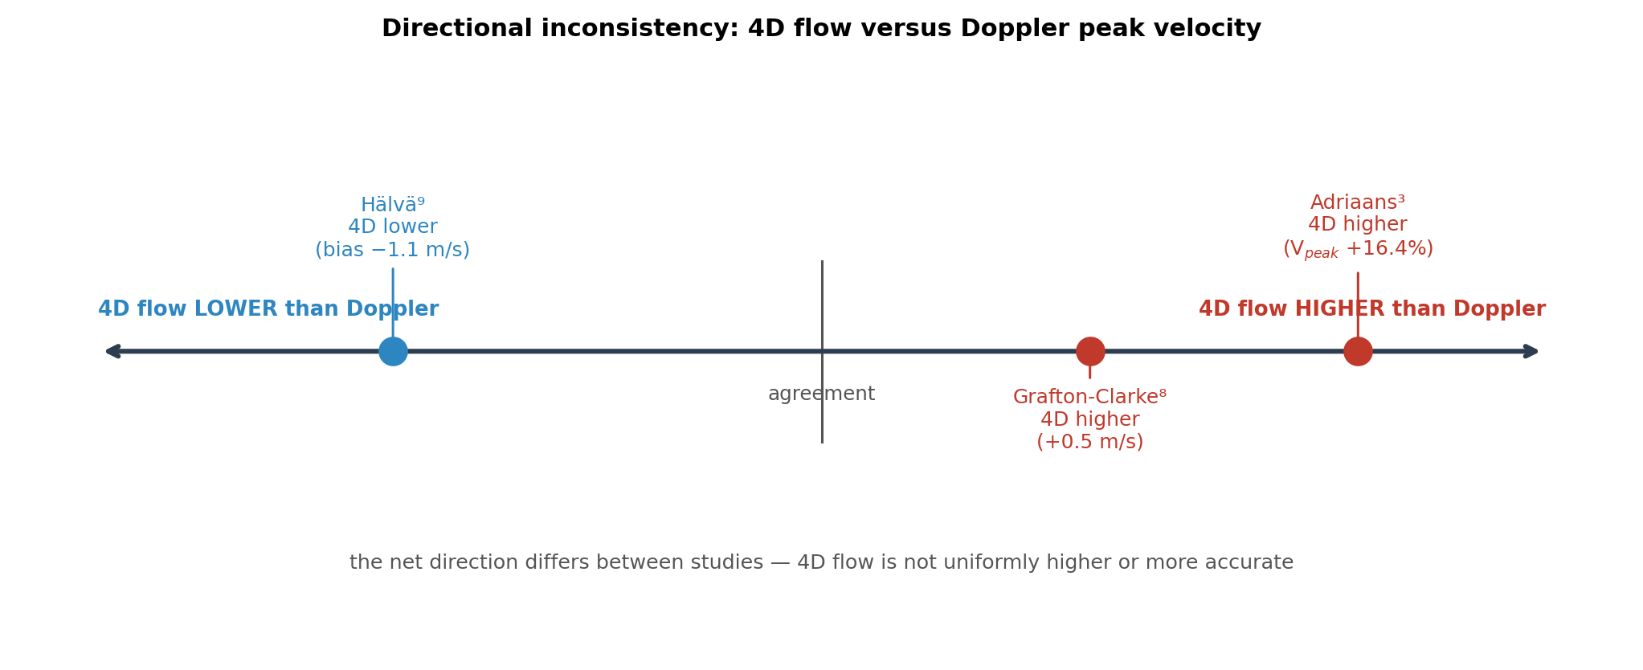
Figure 4. Directional inconsistency across studies comparing 4D flow and Doppler peak velocity: 4D flow read higher than Doppler in some cohorts and lower in others. Data from Adriaans et al.,³ Grafton-Clarke et al.⁸ and Hälvä et al.⁹
Vpeak, peak transvalvular velocity. Values are as reported in each study (percentage difference or mean bias); the figure indicates the direction of difference, not a pooled estimate.
The conflicting results indicate that 4D flow CMR should not be assumed to provide a consistently higher or more accurate Vpeak than TTE. Its potential advantage is the ability to assess the velocity field retrospectively within the acquired volume, reducing dependence on a predefined measurement-plane orientation. However, the measured peak remains dependent on acquisition quality and spatial and temporal resolution. The technical advantages of three-dimensional acquisition therefore reduce one source of measurement error but do not remove all sources of uncertainty.
Pressure Gradient and Comparison with Invasive Measurement
Pressure-gradient assessment provides a different way of comparing 4D flow CMR with established methods. Doppler estimates the maximal instantaneous pressure difference from blood velocity using the simplified Bernoulli equation. Invasive catheterisation commonly measures the peak-to-peak pressure difference between the left ventricle and aorta. These measurements therefore do not represent exactly the same physical quantity. Pressure recovery distal to the stenosis can also contribute to differences between Doppler-derived and catheter-derived gradients.¹⁰
Archer et al. compared 4D flow CMR, TTE and invasive measurements in 18 patients with severe AS.¹¹ In the patients who underwent invasive assessment, the peak gradient was 54 ± 26 mmHg with 4D flow CMR and 50 ± 34 mmHg with invasive measurement (P = 0.67). TTE produced a higher mean value of 61 ± 32 mmHg compared with the invasive measurement (P = 0.0002).¹¹ Bland–Altman analysis showed a bias of −18.6 mmHg for the TTE comparison with invasive measurement.¹¹ When a peak-gradient cut-off of 64 mmHg was used to classify severe AS, agreement with the invasive classification was slightly higher for 4D flow (weighted κ = 0.25) than for Doppler (weighted κ = 0.16), although agreement was modest for both approaches and the confidence intervals were wide.¹¹ These findings indicate that 4D flow showed less systematic difference from the invasive measurement than TTE in this cohort.
This result needs careful interpretation. The lower bias with 4D flow did not mean that it had better precision. In the same study, TTE showed a stronger correlation with invasive measurements than 4D flow (r = 0.95 versus r = 0.63).¹¹ Therefore, in this cohort, the principal difference favouring 4D flow was lower systematic bias rather than greater correlation or precision.
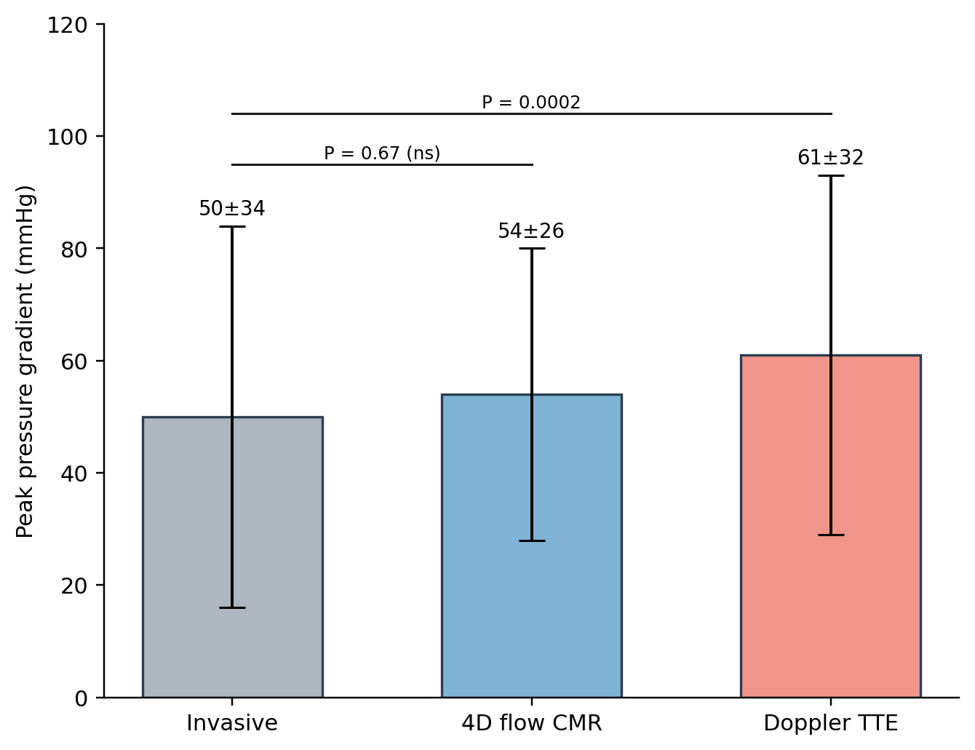
Figure 5. Peak transvalvular pressure gradient by modality in the Archer et al. cohort (mean ± SD). Data derived from Archer et al.¹¹
SD, standard deviation; TTE, transthoracic echocardiography. Values reflect the subgroup undergoing invasive assessment within a small single-centre cohort; the figure illustrates between-modality differences and should not be interpreted as evidence of superiority or of equivalent precision.
Similar findings were reported by Grafton-Clarke et al. in their semi-automated validation study. In 11 patients with severe AS, the invasive peak pressure gradient was 51.9 ± 35.2 mmHg compared with 52.2 ± 29.2 mmHg using the semi-automated 4D-flow method.⁶ The bias between the two methods was −0.3 mmHg (P = 0.974), with a correlation of r = 0.70 (P = 0.017).⁶ The semi-automated method also showed high reproducibility, with interobserver and intraobserver ICCs of 0.98 and 0.99, respectively.⁶ However, the study included only 11 patients, all with severe AS, and the findings were obtained using a specific acquisition and analysis pipeline. This limits their generalisability to broader AS populations and other software platforms.
The difference between Doppler and invasive pressure measurements should not be confused with the effect of Doppler beam alignment on Vpeak. Poor alignment can cause underestimation of Doppler velocity, particularly with eccentric jets. In contrast, differences between Doppler-derived and invasive pressure gradients partly reflect the different pressure measurements obtained by the two techniques and the effect of pressure recovery.¹⁰ A lower Doppler velocity in an individual patient therefore does not necessarily imply that the Doppler-derived pressure gradient will also be lower than the invasive gradient.
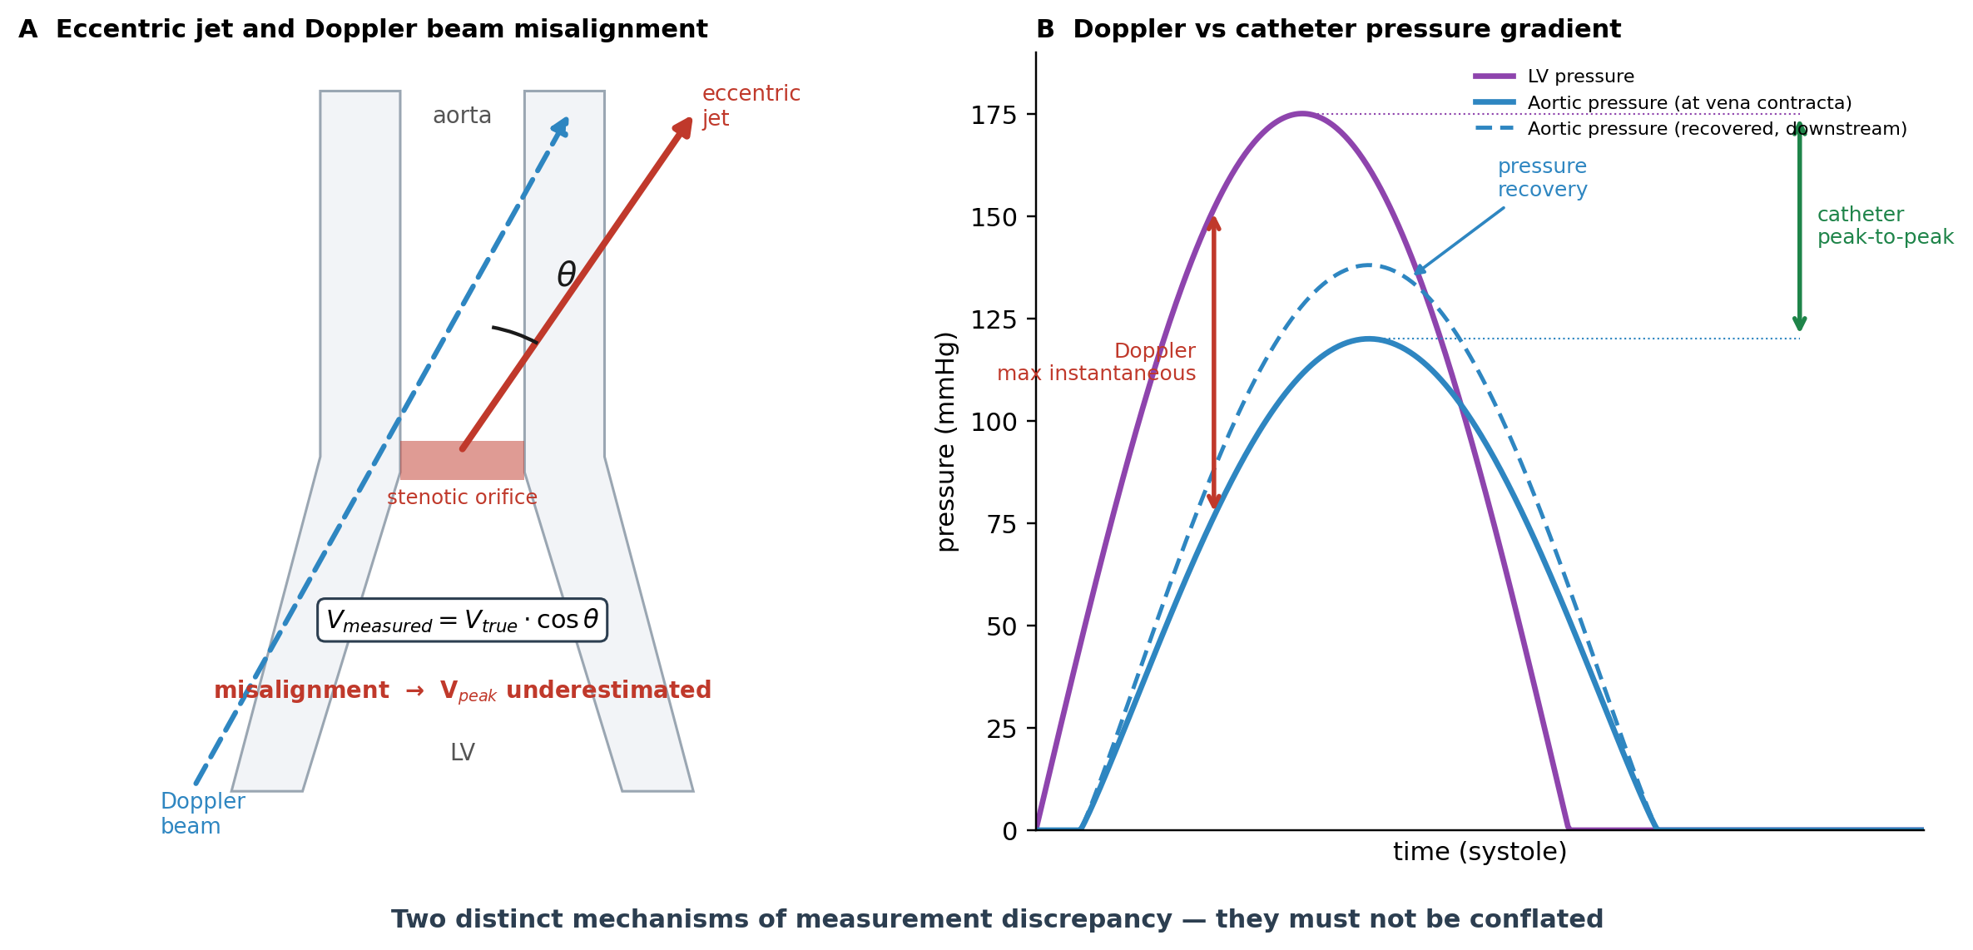
Figure 6. Two distinct and non-interchangeable sources of measurement discrepancy in aortic stenosis. (A) Eccentric jet and Doppler beam misalignment causing underestimation of peak velocity. (B) Doppler maximum instantaneous versus catheter peak-to-peak pressure gradient, with pressure recovery downstream. Original schematic; the eccentric-jet concept in panel A is informed by Adriaans et al.³
LV, left ventricle; Vpeak, peak transvalvular velocity. Panel B pressure tracings are schematic and not drawn to scale.
Overall, the invasive comparison studies provide evidence that 4D-flow-derived pressure gradients can show close agreement with catheter-based measurements.^{6,11} However, the available studies are small and were performed at single centres, and agreement with an invasive measurement does not by itself establish clinical superiority. Larger studies using standardised acquisition and analysis methods are needed to determine the reproducibility and clinical relevance of these measurements.
Valve Area and Discordant Grading
AVA provides another potential source of disagreement between imaging methods. TTE calculates AVA using the continuity equation, which requires measurement of LVOT diameter and assumes a circular geometry. Because the LVOT is commonly elliptical, a single diameter measurement can affect the calculated cross-sectional area and therefore the estimated AVA.³
Adriaans et al. found that 4D flow CMR produced a 19.9% larger AVA than TTE, with a mean difference of 19.9 ± 20.6% (P = 0.002).³ The use of 4D flow CMR also improved concordance between Vpeak and AVA from 0.68 to 0.87 and between mean pressure gradient and AVA from 0.68 to 0.86.³ This suggests that the severity parameters were more internally consistent when derived using 4D-flow data.
However, improved concordance does not establish which measurement is correct. Archer et al. found similar effective orifice areas between 4D flow CMR and TTE, with values of 1.1 ± 0.5 cm² and 1.2 ± 0.4 cm², respectively (P = 0.10).¹¹ The two studies also used different approaches to derive valve area. Therefore, differences in AVA between studies may reflect both the underlying imaging method and the method used for post-processing.
These findings are relevant to patients with discordant AS measurements. Differences between Vpeak, pressure gradient and AVA can arise from measurement limitations, flow conditions and differences in the physical quantities assessed. 4D flow CMR allows velocity and flow to be examined within the same three-dimensional dataset and may therefore provide additional information when conventional measurements are difficult to reconcile. However, improved concordance between parameters should not be interpreted as proof of improved clinical decision-making.
Overall Evidence
The current evidence supports a potential complementary role for 4D flow CMR in the haemodynamic assessment of AS. Its three-dimensional acquisition allows retrospective assessment of the velocity field and reduces dependence on a predefined measurement-plane orientation. Small validation studies have also shown close agreement between 4D-flow-derived pressure gradients and invasive measurements.^{6,11}
The evidence for peak velocity is less consistent. Adriaans et al. and Grafton-Clarke et al. reported higher 4D-flow velocities than TTE, whereas Hälvä et al. reported lower values.^{3,8,9} This variation indicates that the technical advantages of 4D flow do not remove all sources of measurement uncertainty. Acquisition parameters, spatial and temporal resolution, VENC, segmentation and analysis software can all affect the measurements.
The current evidence therefore supports 4D flow CMR as a complementary technique rather than a replacement for TTE. Its potential value appears greatest when echocardiographic measurements are discordant or technically difficult, particularly where an eccentric flow jet may affect Doppler alignment. However, the available studies are generally small and use different acquisition and analysis methods. Further prospective studies with standardised protocols and larger patient populations are needed before 4D-flow-derived thresholds can be incorporated into routine AS grading or intervention pathways.
Chapter 4: Advanced Haemodynamic Parameters
Beyond the standard measures used to grade AS, 4D flow CMR can provide information about how stenosis alters blood flow and interacts with the aortic wall. Turbulent kinetic energy (TKE) and viscous energy loss (VEL) describe different aspects of haemodynamic energy dissipation, whereas wall shear stress (WSS) describes the mechanical interaction between blood flow and the vessel wall.⁴ All three parameters are derived from the underlying velocity data and are therefore affected by the acquisition and processing factors discussed in Chapter 2.
Table 3. Advanced 4D flow CMR-derived haemodynamic parameters: definitions, supporting evidence and technical sensitivities.
Parameter | Quantifies | Derived from | Key evidence | Resolution sensitivity | Current status
TKE | Energy of turbulent velocity fluctuations | Variance of the velocity field | Related to irreversible pressure loss¹²; adds to echocardiography¹³ | Errors <15% at coarse voxel size¹⁵ | Research measure
VEL | Viscous energy dissipation | Velocity gradients between adjacent layers | Higher in BAV with stenosis; links to LV mass and strain¹⁴ | Up to 83% underestimation at 2.5 mm voxel¹⁵ | Research measure
WSS | Frictional force on the vessel wall | Near-wall velocity gradient | Regional WSS associated with aortic-wall histology in BAV¹⁶ | Underestimated versus reference; method-dependent⁷ | Research measure
BAV, bicuspid aortic valve; LV, left ventricle; TKE, turbulent kinetic energy; VEL, viscous energy loss; WSS, wall shear stress. References correspond to the master bibliography.
Turbulent Kinetic Energy
When the high-velocity jet passing through a stenotic valve interacts with the surrounding blood, the flow becomes disturbed and turbulent. TKE quantifies the energy associated with the random velocity fluctuations within this turbulent flow.⁴ Dyverfeldt et al. measured TKE in the ascending aorta in a small study of 18 subjects, including four healthy volunteers and 14 patients with AS. Peak TKE was related to irreversible pressure loss across the stenotic valve, suggesting that it may provide information about energy dissipation that is not captured by a single transvalvular pressure gradient.¹²
Binter et al. subsequently reported that TKE measured using multipoint 4D flow CMR provided additional information to conventional echocardiographic measures when assessing AS severity.¹³ These findings suggest that turbulent flow contains information about the haemodynamic consequences of stenosis beyond peak velocity or mean pressure gradient alone. However, TKE quantifies energy associated with turbulent velocity fluctuations within the blood flow and should not be interpreted as a direct measure of myocardial work or oxygen consumption.
The clinical relevance of TKE remains uncertain. Most available studies have been relatively small and have focused on associations with haemodynamic severity rather than prospective clinical outcomes. In addition, TKE measurements depend on the spatial and temporal resolution of the acquired velocity data. These limitations make direct comparison of absolute TKE values between studies difficult.⁴ TKE should therefore currently be considered an additional haemodynamic measure rather than an established clinical marker for determining the severity of AS or the timing of intervention.
Viscous Energy Loss
VEL describes energy dissipated through viscous forces within the blood. It is related to velocity gradients between adjacent layers of flowing blood and therefore differs from the turbulent energy represented by TKE.⁴ 4D flow CMR can map the distribution of VEL throughout the aorta and identify regions where greater energy dissipation occurs.
Garcia et al. illustrated the potential of VEL mapping using a single-case comparison between a healthy subject and a patient with bicuspid aortic valve (BAV) and mild AS. Net energy loss was 2.1 mW in the healthy subject compared with 7.7 mW in the patient.⁴ This example demonstrates how 4D flow CMR can identify differences in energy dissipation within the aorta. However, it represents an illustrative comparison between two individuals and should not be interpreted as a threshold for AS severity.
More recent group-level evidence has provided further information. Aliabadi et al. studied 71 participants, including healthy controls and three BAV groups, and found higher peak-systolic VEL in participants with BAV and stenosis than in healthy controls. VEL was also associated with measures of stenosis severity and, together with kinetic energy, showed relationships with left ventricular mass and strain.¹⁴ These findings suggest that abnormal aortic energy dissipation may be related to the ventricular consequences of altered flow. However, the study was cross-sectional, so it cannot establish whether increased VEL contributes to ventricular remodelling or simply reflects more advanced valve disease.
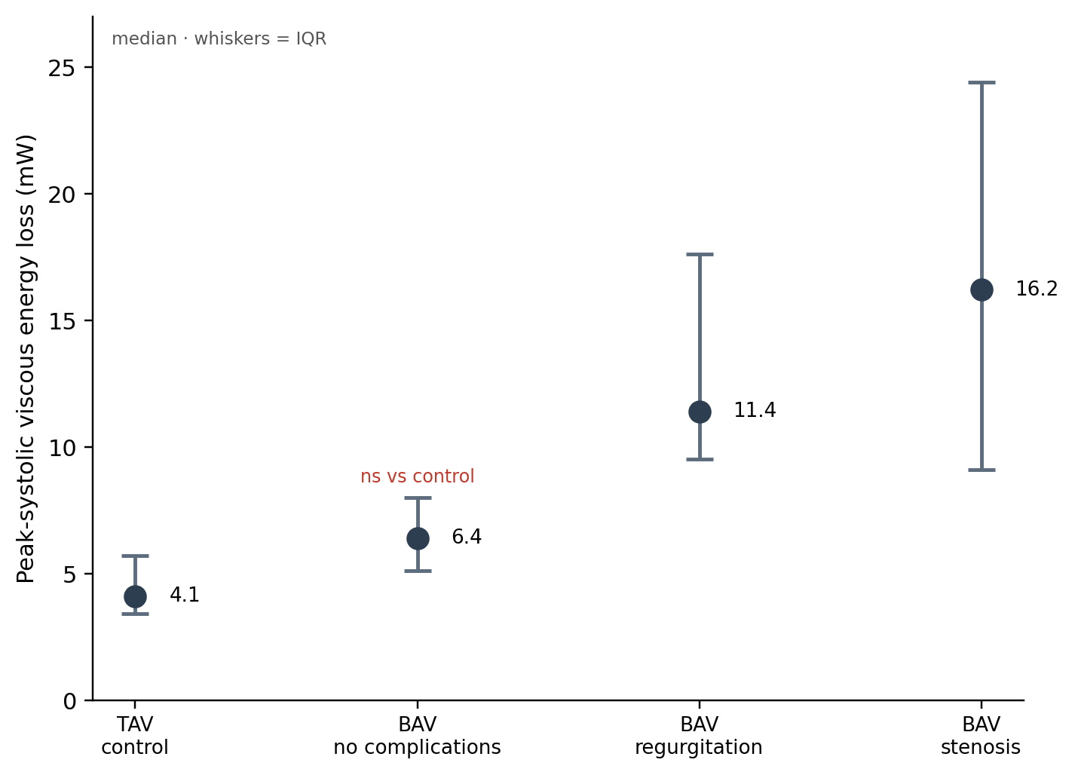
Figure 7. Peak-systolic viscous energy loss across control and bicuspid-aortic-valve groups (median; whiskers denote the interquartile range). Data derived from Aliabadi et al.¹⁴
BAV, bicuspid aortic valve; TAV, tricuspid aortic valve; VEL, viscous energy loss. Values are median [IQR]. The uncomplicated BAV group did not differ significantly from controls for peak-systolic VEL. The cohort was predominantly BAV and should not be interpreted as representative of degenerative tricuspid aortic stenosis.
The measurement of VEL is also particularly sensitive to spatial resolution. Binter et al. showed that increasing voxel size from 0.625 to 2.5 mm resulted in up to an 83% underestimation of viscous energy losses, whereas TKE showed errors below 15% under the conditions tested.¹⁵ This substantial resolution dependence is important when comparing studies using different acquisition protocols. Absolute VEL values should therefore be interpreted cautiously, and comparisons are more reliable when the same acquisition and analysis methods are used.
Wall Shear Stress
WSS describes the frictional force exerted by flowing blood on the vessel wall and is estimated from the velocity gradient close to the wall.⁴ In AS, particularly when associated with BAV, eccentric systolic jets can produce regional changes in flow direction and WSS within the ascending aorta. 4D flow CMR allows these spatial variations to be visualised and quantified.
Guzzardi et al. compared 4D-flow-derived WSS patterns with histological findings from aortic tissue obtained during surgery in patients with BAV. Regions exposed to higher WSS showed greater elastic-fibre degeneration and extracellular matrix changes.¹⁶ This provides an association between abnormal haemodynamics and structural changes in the aortic wall and is consistent with a possible role of flow-related mechanical forces in aortic remodelling. However, the cross-sectional nature of the study does not establish that increased WSS causes these changes or predicts subsequent aortic enlargement.
WSS measurements also have important technical limitations. The calculation depends on estimating velocity gradients close to the vessel wall, making the measurement sensitive to spatial resolution and the method used for gradient estimation. Numerical simulations have shown that MRI-derived WSS can be underestimated compared with reference values.⁷ The absolute values should therefore be interpreted with caution, particularly when comparing results obtained using different acquisition protocols or analysis methods.
These limitations are important when considering the potential clinical role of WSS. Although abnormal WSS patterns have been associated with aortic remodelling and histological changes in BAV, current evidence does not establish WSS as an independent predictor of aortic dilation, dissection or other clinical outcomes. Its current value is mainly in describing the relationship between abnormal flow and the mechanical environment of the aortic wall.
Interpretation and Limitations
TKE, VEL and WSS provide different information from the conventional AS measures discussed in Chapter 3. TKE describes turbulent velocity fluctuations and their associated energy, VEL describes viscous energy dissipation, and WSS describes the interaction between blood flow and the vessel wall.^{4,12–16} Together, these measures allow 4D flow CMR to describe aspects of the haemodynamic consequences of AS that are not represented by a single velocity, pressure gradient or valve area.
This additional information may be relevant because patients with similar conventional measures of AS can have different flow patterns and different effects on the aorta and LV. However, the evidence remains largely observational. Many studies have focused on BAV rather than the older patients with degenerative tricuspid AS who represent a substantial proportion of the clinical AS population.^{4,14,16} This limits the extent to which findings from BAV cohorts can be generalised to all patients with AS.
Methodological variation is another important limitation. TKE, VEL and WSS depend on spatial and temporal resolution, VENC, segmentation and post-processing.^{7,15} These factors can affect absolute measurements and make comparisons between studies difficult. Standardisation of acquisition and analysis methods is therefore necessary before reliable reference ranges or clinical thresholds can be established.
Overall, current evidence supports TKE, VEL and WSS as potentially useful research measures that provide additional information about the haemodynamic consequences of AS. Their clinical value remains uncertain. They have not yet been shown to improve clinical decision-making or patient outcomes, and they should not currently be used as replacements for established measures of AS severity. Further prospective studies in larger and more representative AS populations are needed to determine whether these parameters provide independent prognostic information and whether changes in them are associated with ventricular remodelling or outcomes after valve intervention.
Chapter 5: Ventricular and Myocardial Energetics
The haemodynamic effects of AS are ultimately imposed on the LV. Conventional measures such as peak velocity, pressure gradient and AVA primarily describe the severity of valvular obstruction and provide less direct information about the mechanical work required from the ventricle to maintain forward flow. This has led to interest in myocardial energetics and in the use of pressure–volume (PV) loops and 4D-flow-derived LV kinetic energy to characterise the ventricular response to AS. These approaches measure different aspects of ventricular physiology and should therefore be considered complementary.
Left Ventricular Blood-Flow Kinetic Energy
The kinetic energy of blood within the LV can be calculated from 4D flow CMR velocity data and normalised to LV end-diastolic volume (KEiEDV). Elhawaz et al. investigated LV blood-flow kinetic energy in 18 patients with severe AS before valve intervention, with 12 patients returning for CMR follow-up approximately three months after intervention.¹⁷ The study assessed total LV blood-flow kinetic energy as well as direct, delayed, retained and residual flow components.¹⁷
Several changes in flow energetics were observed after valve intervention. Direct-flow kinetic energy decreased from a median [IQR] of 4.9 [5.0] μJ to 1.86 [1.7] μJ (P = 0.01), while delayed-flow kinetic energy decreased from 2.46 [3.0] μJ to 1.38 [1.0] μJ (P = 0.03). The time delay for peak E-wave propagation from the base to the mid-ventricle also decreased after intervention (P = 0.04).¹⁷ These findings suggest that relieving the valvular obstruction changes the distribution and timing of intracavitary blood-flow energy.
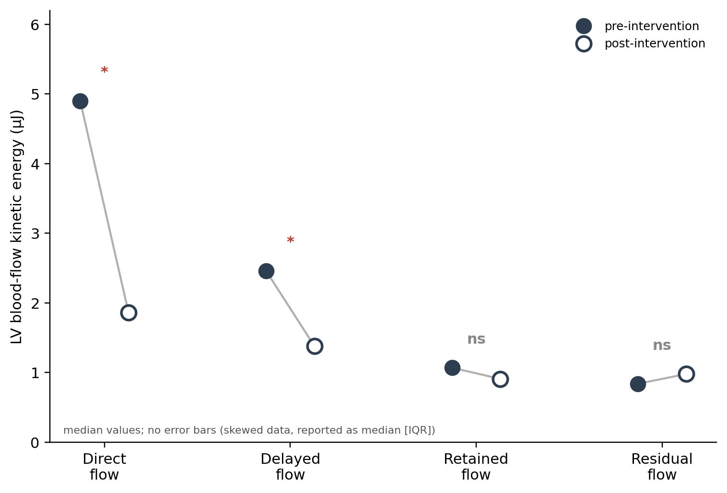
Figure 8. Left ventricular blood-flow kinetic-energy components before and after valve intervention (median values). Only the direct and delayed components changed significantly. Data derived from Elhawaz et al.¹⁷
LV, left ventricle; ns, not significant; μJ, microjoules. Values are medians; no error bars are shown because the data were reported as median [IQR]. *P < 0.05.
The study also found an association between LV kinetic energy and objective functional capacity. Average LV KEiEDV was inversely correlated with six-minute walk test (6MWT) distance (r = −0.53, P < 0.01). Diastolic KEiEDV showed the same correlation (r = −0.53, P < 0.01), while peak E-wave KEiEDV showed a weaker association (r = −0.38, P = 0.04).¹⁷ These findings suggest that altered intracavitary flow energetics are associated with exercise capacity in patients with severe AS.
LV kinetic energy was also associated with subsequent ventricular remodelling. Pre-operative average LV KEiEDV showed a correlation with LV mass regression after valve intervention (r = 0.67, P = 0.02).¹⁷ In contrast, mean echocardiographic pressure gradient and CMR-derived LVEF were not significantly correlated with subsequent LV mass regression in this study.¹⁷ This raises the possibility that flow-based measures may capture aspects of the ventricular response that are not reflected by conventional measures.
However, these findings require cautious interpretation. The study included only 18 patients, with follow-up available in 12, and there was no healthy control group. The analysis was also observational, so the correlations do not demonstrate that altered kinetic energy causes reduced exercise capacity or determines the extent of reverse remodelling. The authors described the findings as an initial assessment and called for further investigation.¹⁷ Therefore, LV KEiEDV should currently be regarded as an emerging research measure rather than an established prognostic measure.
Non-invasive Pressure–Volume Loops
PV loops describe the relationship between LV pressure and volume throughout the cardiac cycle. The area enclosed by the loop represents stroke work, while the pressure–volume area (PVA) incorporates stroke work and potential energy. These measures provide information about ventricular mechanical work and efficiency that cannot be obtained from LVEF alone.¹⁸
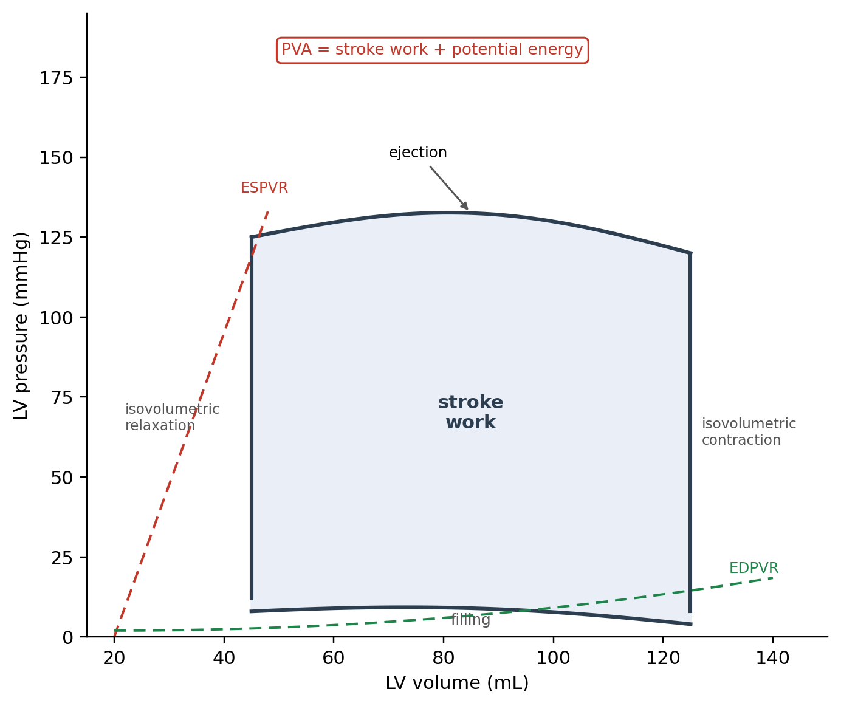
Figure 9. Schematic left ventricular pressure–volume loop. The enclosed area represents stroke work; the pressure–volume area (PVA) additionally incorporates potential energy. Original schematic.
EDPVR, end-diastolic pressure–volume relationship; ESPVR, end-systolic pressure–volume relationship; LV, left ventricle; PVA, pressure–volume area. Diagram is illustrative and not drawn to scale.
Traditional PV-loop assessment requires simultaneous measurement of ventricular pressure and volume, usually with an invasive catheter. This limits its use outside specialised research settings. Seemann et al. developed a non-invasive approach that combines LV volume curves obtained from CMR with brachial blood pressure and a time-varying elastance model to estimate LV pressure throughout the cardiac cycle.¹⁹
Seemann et al. developed and validated the method experimentally before applying it in healthy participants and patients with heart failure. Stroke work showed an intraclass correlation coefficient of 0.93 with a bias of −0.02 ± 0.03 J, while ventricular efficiency showed an intraclass correlation coefficient of 0.84 with a bias of 3.5 ± 2.1%.¹⁹ These findings supported the feasibility of estimating important PV-loop parameters without direct intracardiac pressure measurement.
The method was subsequently validated against invasive pressure measurements in humans by Arvidsson et al. Four patients with severe heart failure and LV dyssynchrony underwent CMR followed by LV catheterisation, with eight datasets obtained under different haemodynamic conditions.²⁰ Non-invasive PV-loop estimates showed high agreement with invasive measurements for stroke work (R² = 0.96, bias 4.6%), potential energy (R² = 0.83, bias 1.5%), and ventricular efficiency (R² = 0.98, bias 0.8%).²⁰ Other parameters, including arterial elastance and mean external power, also showed good agreement. These findings provide stronger evidence that PV-loop measures can be reconstructed non-invasively in humans.
However, this validation was performed in only four patients with advanced heart failure and LV dyssynchrony.²⁰ It therefore establishes agreement with invasive measurements in a selected population rather than demonstrating clinical validity in AS. The haemodynamic conditions of severe AS, including increased afterload and concentric LV hypertrophy, may differ from those in the populations used for validation. The accuracy and clinical usefulness of non-invasive PV loops in AS therefore require direct investigation.
Myocardial Energetics in Aortic Stenosis
PV-loop analysis provides a framework for assessing the mechanical energy required for ventricular contraction. In AS, increased resistance to LV outflow raises ventricular afterload and requires the LV to generate greater systolic pressure. This increases the mechanical demand placed on the ventricle and contributes to the development of hypertrophy and, in advanced disease, myocardial dysfunction.
The pressure–volume area (PVA) represents the sum of stroke work and potential energy and has been used as an index of the total mechanical energy generated by the ventricle.¹⁸ The relationship between PVA and myocardial oxygen consumption provides an established physiological framework for studying ventricular energetic efficiency.¹⁸ However, PVA obtained from a non-invasive PV loop should not be interpreted as a direct measurement of myocardial oxygen consumption in an individual patient. It is an indirect mechanical estimate based on the pressure–volume relationship.
This distinction is particularly relevant to AS. Increased transvalvular resistance is expected to increase ventricular pressure generation and mechanical work, but the extent to which this translates into increased PVA or reduced myocardial efficiency in individual patients with AS has not been established by the current 4D flow literature. Therefore, the concept is physiologically plausible but remains an area requiring direct clinical investigation.
Linking Flow Energetics and Myocardial Work
The flow-based measures discussed in Chapter 4 and the ventricular measures discussed here describe different parts of the same physiological pathway. TKE and VEL describe energy associated with disturbed flow and energy dissipation within the blood. LV blood-flow kinetic energy describes the movement of blood within the ventricular cavity. PV-loop-derived stroke work and PVA, in contrast, describe mechanical work and energy associated with ventricular contraction.
These measures should therefore not be treated as interchangeable. In particular, TKE or VEL should not be described as direct measures of myocardial work. Similarly, LV blood-flow kinetic energy does not directly quantify myocardial oxygen consumption. The measures are physiologically related, but they are not equivalent: the stenotic valve increases LV pressure loading, while abnormal flow and energy dissipation represent additional features of the haemodynamic environment. The ventricular response to these conditions can then be assessed through mechanical work and remodelling.
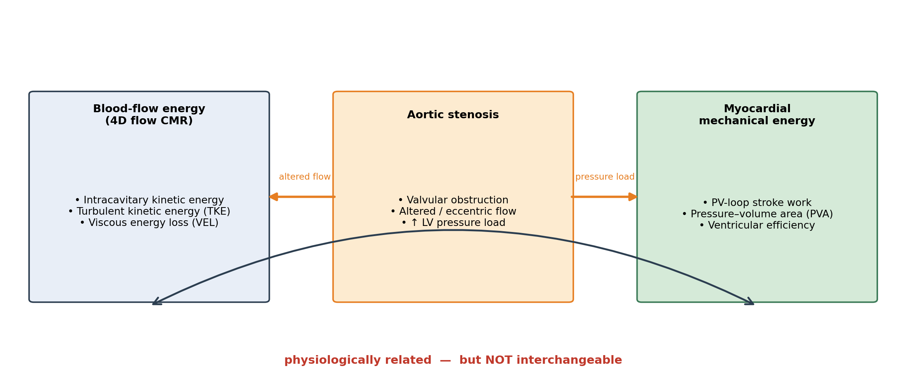
Figure 10. Relationship between blood-flow energy measures and myocardial mechanical energy in aortic stenosis. The two energy domains are physiologically related but not interchangeable. Original schematic.
LV, left ventricle; PV, pressure–volume; PVA, pressure–volume area; TKE, turbulent kinetic energy; VEL, viscous energy loss.
This distinction provides a useful framework for integrating 4D flow CMR with PV-loop analysis. 4D flow can describe the flow-related consequences of the stenosis, while PV-loop reconstruction can estimate the mechanical response of the ventricle. Studying both may therefore provide a more complete assessment of the energetic burden of AS than either approach alone. However, direct studies combining these measurements in AS are currently limited.
Relevance to Aortic Stenosis and Current Research Gap
The available evidence suggests that ventricular energetic assessment may provide information beyond conventional measures of AS severity and LVEF. Elhawaz et al. demonstrated associations between LV blood-flow kinetic energy, functional capacity and subsequent LV mass regression after valve intervention.¹⁷ Non-invasive PV-loop reconstruction has also shown good agreement with invasive measurements in experimental models and selected patients with heart failure.^{19,20}
The evidence is nevertheless insufficient to establish either approach as a clinical decision-making tool in AS. The LV kinetic-energy study was small and had limited follow-up, while PV-loop validation has mainly been performed outside AS populations. The assumptions used to estimate LV pressure from brachial pressure and a time-varying elastance model may also require further testing under the altered loading conditions of AS.
This represents an important research gap. A method that can estimate ventricular mechanical work non-invasively could potentially complement 4D-flow measures of valvular and intracavitary haemodynamics. However, prospective studies are required to determine whether these energetic measures provide information that is independent of established AS parameters and whether they are associated with clinically meaningful outcomes.
At present, LV kinetic energy and non-invasive PV-loop-derived measures should therefore be regarded as emerging research measures rather than established clinical biomarkers. Their potential value lies in characterising the ventricular consequences of AS and in providing a framework for studying why patients with similar conventional measures of stenosis may develop different degrees of functional impairment and ventricular remodelling.
Chapter 6: Clinical and Prognostic Relevance
The clinical value of a measurement depends on more than its technical accuracy. It is useful to consider whether a 4D flow measurement is associated with symptoms or functional status, whether it relates to subsequent clinical events, and whether its use improves patient management. Current evidence addresses the first two areas to some extent, but there is not yet evidence that using 4D flow CMR to guide management improves patient outcomes.
Association with Functional Capacity and Symptoms
Several studies have examined whether 4D flow measurements are related to functional limitation in patients with AS. Archer et al. found that 4D flow-derived peak pressure gradient and effective orifice area (EOA) were associated with six-minute walk test (6MWT) distance (r = −0.45, P = 0.01 and r = 0.54, P = 0.002, respectively).¹¹ The relationship with echocardiographic measurements was less consistent. Doppler-derived pressure gradient was not significantly associated with 6MWT distance, whereas Doppler-derived EOA was (r = 0.45, P = 0.01).¹¹ Both 4D flow and Doppler pressure gradients were also associated with New York Heart Association (NYHA) functional class.¹¹
These findings suggest that 4D flow-derived haemodynamic measurements reflect aspects of functional limitation in AS. However, they do not demonstrate that 4D flow is superior to echocardiography for assessing symptoms or exercise capacity. The cohort was small, and the relationships were cross-sectional. The observed correlations therefore indicate an association between haemodynamic measurements and functional status rather than establishing a predictive relationship.
LV blood-flow kinetic energy has also been related to functional capacity. As discussed in Chapter 5, Elhawaz et al. found an inverse association between average LV kinetic energy indexed to end-diastolic volume (KEiEDV) and 6MWT distance (r = −0.53, P < 0.01).¹⁷ It should be noted that Archer et al. and Elhawaz et al. originate from the same Sheffield/EurValve research programme, involve substantial author overlap and both report cohorts of 18 patients. Their findings should therefore not be interpreted as fully independent replication of the association.^{11,17} Both indicate that 4D-flow-derived measurements may reflect functional consequences of AS, but they require validation in larger and independent patient populations.
Association with Ventricular Remodelling
A second area of interest is whether 4D flow measurements are associated with the ventricular response following valve intervention. Archer et al. reported that the change in 4D flow-derived pressure gradient after intervention was associated with LV mass regression (r = 0.64, P = 0.04). The corresponding association for the change in Doppler-derived gradient did not reach statistical significance (r = 0.63, P = 0.06).¹¹ The similar correlation coefficients indicate that the difference between the two analyses should not be interpreted as evidence of a large difference in biological association.
Elhawaz et al. also found an association between pre-intervention LV KEiEDV and subsequent LV mass regression (r = 0.67, P = 0.02).¹⁷ Together, these findings raise the possibility that 4D-flow-derived measures may provide information about the ventricular response that is not fully captured by conventional measurements. However, both studies were small, observational and originated from the same research programme. The associations therefore do not establish that these measurements determine the extent of reverse remodelling or that they can be used to select patients who will benefit most from intervention.
Association with Valve Intervention
The most direct evidence for a potential prognostic role of 4D flow comes from the PREFER-CMR registry. Grafton-Clarke et al. studied 30 patients who underwent both TTE and 4D flow CMR, of whom 17 subsequently underwent aortic valve intervention during a mean follow-up of approximately eight months.⁸
Both Doppler and 4D flow peak velocity were higher in patients who subsequently underwent intervention. Mean CWD Vpeak was 3.4 m/s in patients undergoing intervention compared with 2.6 m/s in those who did not (P = 0.0025). The corresponding 4D flow values were 4.2 and 2.7 m/s (P < 0.0001).⁸ 4D flow Vpeak was also higher than CWD Vpeak, with a bias of −0.5 m/s (P = 0.01) and a correlation of R = 0.55 (P = 0.002).⁸
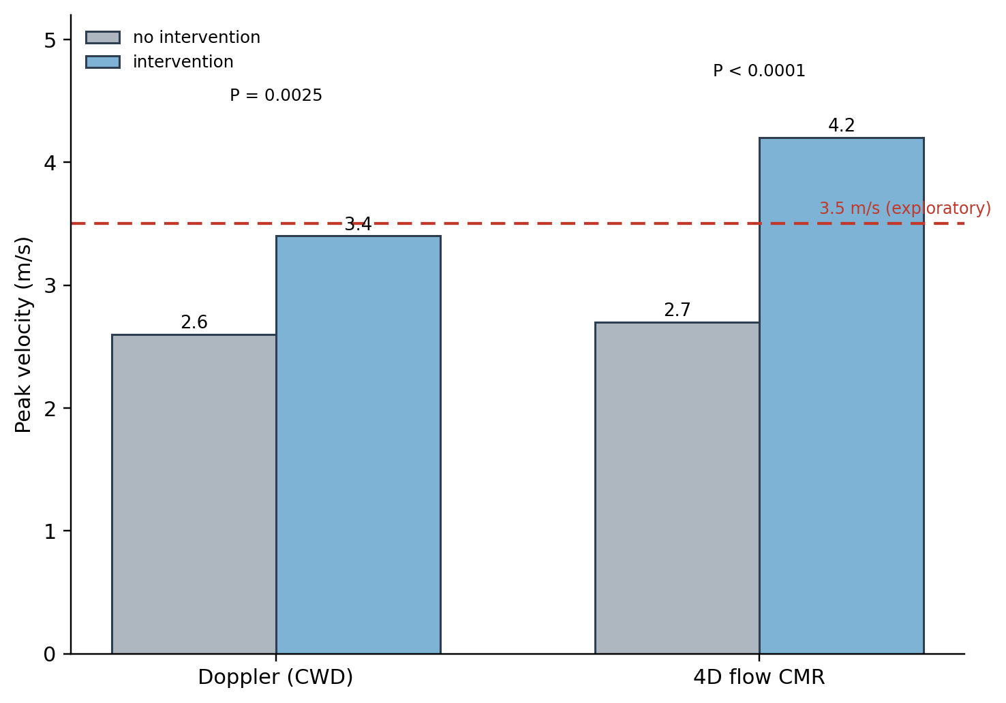
Figure 11. Peak velocity by subsequent-intervention status, measured by continuous-wave Doppler and 4D flow CMR. Data derived from Grafton-Clarke et al.⁸
CWD, continuous-wave Doppler. The outcome was the decision to undertake valve intervention rather than a hard patient-centred endpoint; the 3.5 m/s value is an exploratory threshold derived from a small cohort, not an established clinical criterion.
In Cox regression analysis, 4D flow Vpeak was associated with subsequent valve intervention (hazard ratio 2.51, P < 0.01), whereas CWD Vpeak was not statistically significant in the same analysis (hazard ratio 0.54, P = 0.76).⁸ A 4D flow Vpeak above 3.5 m/s was associated with subsequent intervention, with approximately 80% sensitivity and specificity in this cohort.⁸
These findings are of interest because they suggest that 4D flow Vpeak may contain information associated with the clinical decision to intervene. However, the outcome was valve intervention rather than a hard clinical outcome such as mortality or heart-failure hospitalisation. The follow-up period was also too short to assess longer-term outcomes.⁸ In addition, the decision to intervene was made by a multidisciplinary team that had access to the available clinical and imaging information. The outcome was therefore not independent of the information available to the clinical decision-making team.
There were also baseline differences between the intervention and non-intervention groups, including age, ejection fraction and renal function.⁸ These factors may have influenced the decision to intervene and could contribute to the observed association. The proposed Vpeak threshold of 3.5 m/s should therefore be considered an exploratory finding that requires validation in larger and independent cohorts rather than as a replacement for established severity thresholds.
4D Flow CMR in the Context of Other Imaging
The potential role of 4D flow CMR should be considered alongside the imaging that is already used when echocardiographic assessment is uncertain. For patients with discordant or low-flow, low-gradient AS, current guidelines recommend additional investigations, including computed tomography aortic-valve calcium scoring to support the grading of severity and, in low-flow, low-gradient AS with reduced ejection fraction, dobutamine stress echocardiography to help distinguish true-severe from pseudo-severe disease.¹ Any clinical role for 4D flow CMR would therefore need to be defined in relation to these established options rather than to echocardiography alone.
CMR also contributes to AS assessment beyond flow measurement. It provides accurate assessment of ventricular volumes and mass, while tissue characterisation, including late gadolinium enhancement and T1 mapping, can provide information about myocardial fibrosis and the ventricular response to AS.²¹ In this context, 4D flow is best viewed as one component of a multiparametric CMR examination rather than as a stand-alone test. It is also relevant that much of the AS-specific 4D flow evidence discussed above comes from a small number of cohorts, with several studies originating from the same research programmes and substantial author overlap. This further limits how far the current findings can be generalised.
From Association to Clinical Utility
The distinction between association, prediction and clinical utility is important when interpreting the current evidence. A measurement can agree with a reference method, correlate with functional status, or be associated with a subsequent clinical decision without demonstrating that its use improves patient care.
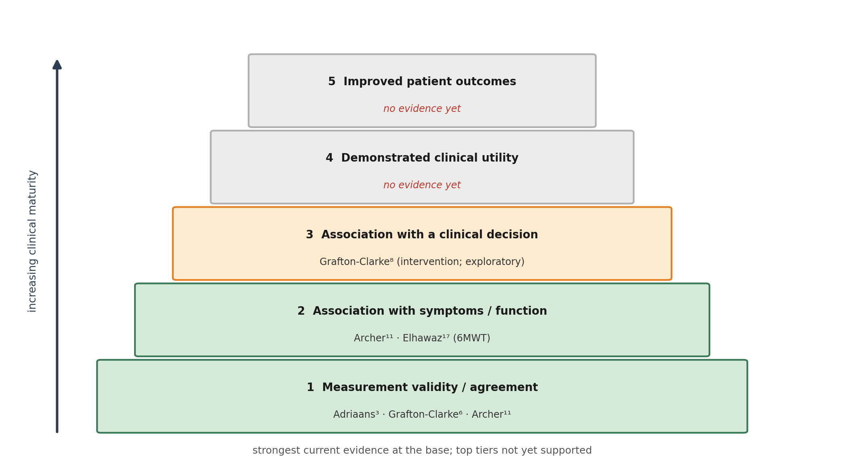
Figure 12. Evidence hierarchy for 4D flow CMR in aortic stenosis, from measurement validity to demonstrated improvement in patient outcomes, with current studies mapped to each level. Original schematic.
6MWT, six-minute walk test. Studies are placed at the highest evidence level they currently support; the upper two tiers are not yet supported by the reviewed literature. References correspond to the master bibliography.
For 4D flow CMR in AS, the strongest evidence currently concerns its technical and haemodynamic capabilities. Studies have shown that it can provide complementary measurements of velocity, pressure gradient and valve area, with particularly useful information when Doppler measurements are affected by eccentric flow or when conventional parameters are discordant.^{3,6,11}
The evidence for functional and prognostic applications is less mature. Associations with 6MWT, LV mass regression and valve intervention have been reported, but these findings are based mainly on small observational cohorts.^{8,11,17} The studies reviewed here have not demonstrated that incorporating 4D flow CMR into clinical decision-making improves survival, symptoms, ventricular recovery or other patient-centred outcomes.^{8,11,17}
Current guideline-based AS assessment therefore remains centred on clinical assessment and echocardiography, with additional imaging used when conventional findings are inconclusive.¹ 4D flow CMR is best considered a complementary technique, particularly for patients in whom Doppler measurements are technically difficult or discordant with other clinical or imaging findings.
Future studies should determine whether 4D flow measurements provide independent prognostic information and whether their incorporation into clinical management improves patient outcomes. Larger multicentre cohorts, standardised acquisition and analysis protocols, external validation of proposed thresholds and prospective outcome studies will be needed before these measurements can be incorporated into routine AS management.
Chapter 7: Discussion and Conclusion
Discussion
This review examined the role of 4D flow CMR in AS, from the technical basis of the method to its haemodynamic measurements, advanced flow and energy parameters, ventricular energetics and emerging clinical applications. Overall, the evidence shows that 4D flow CMR can measure the parameters used to assess AS and can provide information about flow that is not readily available from conventional echocardiography. However, its current role is complementary to echocardiography rather than a replacement for it.
The most consistent evidence in the current literature concerns the assessment of transvalvular haemodynamics. Because 4D flow acquires velocity throughout a volume, the measurement plane can be selected after image acquisition. This reduces the dependence on a predefined imaging plane that affects continuous-wave Doppler when the stenotic jet is eccentric.^{4,5} Studies comparing 4D flow with invasive catheterisation have also shown close agreement for transvalvular pressure gradients, including a semi-automated analysis approach with low measurement bias.^{6,11} Adriaans et al. further reported improved concordance between peak velocity, mean pressure gradient and AVA when 4D flow measurements were used.³ These findings provide the strongest current evidence for a complementary role for 4D flow when conventional measurements are technically difficult or discordant. However, the available validation studies remain relatively small and have mainly been performed in single-centre settings.
The evidence is less consistent for peak velocity itself. Adriaans et al. and Grafton-Clarke et al. reported higher peak velocities with 4D flow than with Doppler and found associations between the difference and flow-jet characteristics.^{3,8} In contrast, Hälvä et al. reported that 4D flow underestimated peak velocity in patients with severe AS.⁹ This difference between studies is important. It suggests that 4D flow should not be described simply as producing a higher or more accurate peak velocity than echocardiography. The opposing directions may reflect competing sources of error: beam misalignment tends to lower the Doppler velocity, whereas limited spatial and temporal resolution tends to lower the 4D flow velocity, so the net difference may depend on which effect dominates in a given cohort. Differences in patient characteristics, jet morphology, acquisition parameters and post-processing may all contribute.
The review also identified two separate sources of discrepancy in conventional assessment that should not be conflated. Doppler-derived velocity can be underestimated when the ultrasound beam is not sufficiently aligned with an eccentric stenotic jet.^{3,4} This is different from the discrepancy between Doppler-derived and invasively measured pressure gradients. Doppler estimates the maximum instantaneous pressure difference from blood velocity, whereas catheterisation commonly measures the peak-to-peak pressure difference between the left ventricle and aorta. Pressure recovery can contribute to the difference between these measurements.¹⁰ Therefore, the limitations of Doppler velocity measurement and the differences between Doppler and invasive pressure gradients have different physical explanations.
The advanced parameters available from 4D flow provide another perspective on AS. TKE, VEL and WSS describe different aspects of the haemodynamic environment. TKE has been related to irreversible pressure loss across the stenotic valve,¹² while VEL has been associated with abnormal flow and ventricular workload in studies of bicuspid aortic valve disease.¹⁴ WSS has also been associated with regional changes in the aortic wall.¹⁶ These measurements may therefore provide information that is not captured by peak velocity, pressure gradient or AVA alone.
However, their clinical significance remains uncertain. Much of the evidence for WSS and VEL comes from bicuspid aortic valve populations rather than older patients with degenerative tricuspid AS.^{14,16} Several studies are also small and cross-sectional. The observed relationships therefore demonstrate associations rather than causal effects. In addition, technical factors influence the measurements. VEL is particularly sensitive to spatial resolution, with lower resolution resulting in substantial underestimation of viscous energy loss.¹⁵ These factors currently limit the use of advanced energy measures for defining clinical thresholds or guiding intervention.
A similar distinction is needed when considering ventricular energetics. The kinetic energy of intracavitary blood flow, TKE and VEL describe properties of blood flow, whereas PV-loop-derived stroke work and pressure-volume area describe mechanical energy generated by the myocardium. These measures are physiologically related but are not interchangeable.^{17–20} LV blood-flow kinetic energy has been associated with functional capacity and subsequent LV mass regression after valve intervention.¹⁷ Non-invasive PV-loop methods provide another approach to estimating myocardial mechanical work and have been compared with invasive pressure measurements in other cardiovascular settings.^{19,20} However, their specific application to AS remains insufficiently studied. The assumptions used to estimate LV pressure and mechanical work therefore require further assessment in patients with the pressure overload and ventricular remodelling associated with AS.
The clinical and prognostic evidence is less developed than the technical validation evidence. Associations have been reported between 4D flow measurements, six-minute walk distance and LV mass regression.^{11,17} The PREFER-CMR study also found an association between 4D flow peak velocity and subsequent valve intervention.⁸ However, the study included only 30 patients and the outcome was the decision to perform valve intervention rather than an independent clinical endpoint such as mortality or heart-failure hospitalisation. The follow-up period was also relatively short. In addition, the clinical decision was made using the available clinical and imaging information, meaning that the outcome was not independent of the information being evaluated.⁸ The proposed 3.5 m/s threshold should therefore be regarded as an exploratory finding requiring validation in larger independent cohorts rather than as an alternative to established severity criteria.
These findings illustrate the difference between measurement validity, prognostic association and clinical utility. A measurement may agree with a reference method, correlate with symptoms or functional capacity, and be associated with a subsequent clinical decision without demonstrating that its use improves patient care. For 4D flow CMR, the evidence is currently strongest for its technical and haemodynamic capabilities. Evidence for functional and prognostic applications is promising but remains based mainly on small observational studies. Much of the AS-specific evidence comes from a small number of cohorts, with several studies originating from the same research programmes and substantial author overlap, while independent studies do not fully agree, particularly on peak velocity.^{3,8,9,11,17}
The main limitation of the current evidence is therefore not a lack of potentially informative measurements, but the absence of sufficiently large, independent and outcome-linked studies demonstrating added value beyond established AS assessment.
Within the literature reviewed here, no study has demonstrated that incorporating 4D flow CMR into AS management improves survival, symptoms, ventricular recovery or other patient-centred outcomes.^{8,11,17}
Practical considerations also affect the potential clinical adoption of 4D flow CMR. The technique requires access to CMR, longer acquisition than a routine echocardiographic assessment and specialised image processing. Semi-automated analysis can reduce processing time and operator dependence,⁶ but acquisition and post-processing remain insufficiently standardised.⁵ In addition, 4D flow is only one part of a CMR examination that can also assess ventricular volumes, mass and myocardial fibrosis,²¹ and its role would need to be defined alongside established investigations for discordant AS, including CT calcium scoring and stress echocardiography.¹ These factors, together with the small sample sizes and single-centre design of many studies, limit the generalisability of the current evidence.
Taken together, the literature supports 4D flow CMR as a complementary method for selected patients rather than as a replacement for TTE. Its most immediate value may be in patients with eccentric flow, technically difficult Doppler measurements or discordant severity parameters. Whether the additional haemodynamic and energetic information can improve risk stratification or influence the timing of intervention remains an important unanswered question.
Conclusion
4D flow CMR provides a three-dimensional assessment of blood flow that can address some of the technical limitations of conventional Doppler echocardiography. Its ability to assess flow retrospectively from different planes is particularly relevant to eccentric stenotic jets. Small validation studies support close agreement between 4D flow-derived and invasive pressure-gradient measurements.^{6,11}
The technique provides additional measures of turbulent and viscous energy loss, wall shear stress and ventricular blood-flow kinetic energy. These measurements offer greater insight into the haemodynamic and ventricular consequences of AS, but their clinical significance has not yet been established.^{12–17} The available evidence linking 4D flow measurements with functional capacity, ventricular remodelling and valve intervention is encouraging, but remains limited by small cohorts, overlapping study populations, observational designs and limited follow-up.
On current evidence, 4D flow CMR is best regarded as a complementary technique within a multiparametric assessment of AS, particularly when conventional measurements are technically difficult or discordant. It should not yet be considered a replacement for established echocardiographic assessment or used alone to determine the timing of valve intervention. Larger multicentre studies with standardised acquisition and analysis, external validation of proposed thresholds and prospective patient-centred outcomes are required to establish whether 4D flow CMR can provide clinically meaningful benefits. The combination of 4D flow assessment with non-invasive measures of myocardial energetics also provides a potential framework for further research into why patients with similar anatomical or haemodynamic severity can develop different degrees of ventricular dysfunction.
References
1. Vahanian A, Beyersdorf F, Praz F, Milojevic M, Baldus S, Bauersachs J, et al. 2021 ESC/EACTS Guidelines for the management of valvular heart disease. Eur Heart J. 2022;43(7):561–632.
2. Garg P, Markl M, Sathananthan J, Sellers SL, Meduri C, Cavalcante J. Restoration of flow in the aorta: a novel therapeutic target in aortic valve intervention. Nat Rev Cardiol. 2024;21(4):264–273.
3. Adriaans BP, Westenberg JJM, van Cauteren YJM, Gerretsen S, Elbaz MSM, Bekkers SCAM, et al. Clinical assessment of aortic valve stenosis: comparison between 4D flow MRI and transthoracic echocardiography. J Magn Reson Imaging. 2020;51(2):472–480.
4. Garcia J, Barker AJ, Markl M. The role of imaging of flow patterns by 4D flow MRI in aortic stenosis. JACC Cardiovasc Imaging. 2019;12(2):252–266.
5. Dyverfeldt P, Bissell M, Barker AJ, Bolger AF, Carlhäll CJ, Ebbers T, et al. 4D flow cardiovascular magnetic resonance consensus statement. J Cardiovasc Magn Reson. 2015;17:72.
6. Grafton-Clarke C, Njoku P, Aben JP, Ledoux L, Zhong L, Westenberg J, et al. Validation of aortic valve pressure gradient quantification using semi-automated 4D flow CMR pipeline. BMC Res Notes. 2022;15(1):151.
7. Petersson S, Dyverfeldt P, Ebbers T. Assessment of the accuracy of MRI wall shear stress estimation using numerical simulations. J Magn Reson Imaging. 2012;36(1):128–138.
8. Grafton-Clarke C, Assadi H, Li R, Mehmood Z, Hall R, Matthews G, et al. Four-dimensional flow provides incremental diagnostic value over echocardiography in aortic stenosis. Open Heart. 2025;12(1):e003081.
9. Hälvä R, Vaara SM, Peltonen JI, Kaasalainen TT, Holmström M, Lommi J, et al. Peak flow measurements in patients with severe aortic stenosis: a prospective comparative study between cardiovascular magnetic resonance 2D and 4D flow and transthoracic echocardiography. J Cardiovasc Magn Reson. 2021;23(1):132.
10. Parameswaran AC, Reisner D, Amanullah A. Discrepancy between gradients derived by cardiac catheterization and by Doppler echocardiography in aortic stenosis: how often does pressure recovery play a role? Echocardiography. 2009;26(9):1000–1005.
11. Archer GT, Elhawaz A, Barker N, Fidock B, Rothman A, van der Geest RJ, et al. Validation of four-dimensional flow cardiovascular magnetic resonance for aortic stenosis assessment. Sci Rep. 2020;10(1):10569.
12. Dyverfeldt P, Hope MD, Tseng EE, Saloner D. Magnetic resonance measurement of turbulent kinetic energy for the estimation of irreversible pressure loss in aortic stenosis. JACC Cardiovasc Imaging. 2013;6(1):64–71.
13. Binter C, Gotschy A, Sündermann SH, Frank M, Tanner FC, Lüscher TF, et al. Turbulent kinetic energy assessed by multipoint 4-dimensional flow magnetic resonance imaging provides additional information relative to echocardiography for the determination of aortic stenosis severity. Circ Cardiovasc Imaging. 2017;10(6):e005486.
14. Aliabadi S, Labib D, Rivest S, White JA, Garcia J. Post-valvular energy exchange in bicuspid aortic valve with regurgitation and stenosis and its association with left ventricular workload: a 4D flow magnetic resonance imaging cross-sectional study. BMC Med Imaging. 2025;25(1):492.
15. Binter C, Gülan U, Holzner M, Kozerke S. On the accuracy of viscous and turbulent loss quantification in stenotic aortic flow using phase-contrast MRI. Magn Reson Med. 2016;76(1):191–196.
16. Guzzardi DG, Barker AJ, van Ooij P, Malaisrie SC, Puthumana JJ, Belke DD, et al. Valve-related hemodynamics mediate human bicuspid aortopathy: insights from wall shear stress mapping. J Am Coll Cardiol. 2015;66(8):892–900.
17. Elhawaz A, Archer GT, Zafar H, Fidock B, Barker N, Jones R, et al. Left ventricular blood flow kinetic energy is associated with the six-minute walk test and left ventricular remodelling post valvular intervention in aortic stenosis. Quant Imaging Med Surg. 2021;11(4):1470–1482.
18. Knaapen P, Germans T, Knuuti J, Paulus WJ, Dijkmans PA, Allaart CP, et al. Myocardial energetics and efficiency: current status of the noninvasive approach. Circulation. 2007;115(7):918–927.
19. Seemann F, Arvidsson P, Nordlund D, Kopic S, Carlsson M, Arheden H, et al. Noninvasive quantification of pressure-volume loops from brachial pressure and cardiovascular magnetic resonance. Circ Cardiovasc Imaging. 2019;12(1):e008493.
20. Arvidsson PM, Green PG, Watson WD, Shanmuganathan M, Heiberg E, De Maria GL, et al. Non-invasive left ventricular pressure-volume loops from cardiovascular magnetic resonance imaging and brachial blood pressure: validation using pressure catheter measurements. Eur Heart J Imaging Methods Pract. 2023;1(2):qyad035.
21. Bing R, Cavalcante JL, Everett RJ, Clavel MA, Newby DE, Dweck MR. Imaging and impact of myocardial fibrosis in aortic stenosis. JACC Cardiovasc Imaging. 2019;12(2):283–296.

