Beyond the Gradient: A Narrative Review of 4D Flow CMR in Aortic Stenosis

Abstract

Aortic stenosis (AS) is a common valvular heart disease for which management depends on accurate assessment of disease severity. Transthoracic echocardiography (TTE) is the primary imaging modality but has recognised limitations: continuous-wave Doppler is sensitive to alignment between the ultrasound beam and an eccentric stenotic jet, while the continuity-equation estimate of aortic valve area assumes a circular left ventricular outflow tract. Four-dimensional flow cardiovascular magnetic resonance (4D flow CMR) measures three-directional, time-resolved blood velocity throughout a volume, allowing measurement planes to be positioned retrospectively and enabling quantification of advanced haemodynamic measures such as turbulent kinetic energy, viscous energy loss and wall shear stress.
This narrative review examines the current evidence for 4D flow CMR in AS, covering its technical basis; assessment of peak velocity, pressure gradient and valve area in comparison with TTE and invasive catheterisation; advanced flow-energy parameters; ventricular and myocardial energetics, including left ventricular blood-flow kinetic energy and non-invasive pressure–volume loop concepts; and emerging associations with functional capacity, ventricular remodelling and valve intervention.
Small validation studies show that 4D-flow-derived pressure gradients can agree closely with invasive measurements, and the technique may be particularly useful when Doppler assessment is technically difficult or when conventional severity parameters are discordant. However, evidence for peak velocity is inconsistent, with some studies reporting higher and others lower values than Doppler, reflecting competing sources of measurement error. Advanced flow-energy measures and ventricular energetic indices remain primarily research tools, and flow energy should not be equated with myocardial mechanical work. Although 4D flow measurements have been associated with symptoms, ventricular remodelling and the decision to intervene, no study has demonstrated that 4D-flow-guided management improves patient-centred outcomes. On current evidence, 4D flow CMR is best regarded as a complementary technique within a multiparametric assessment of AS. Larger multicentre studies with standardised acquisition and analysis, external validation and prospective outcome-linked designs are required to establish its clinical utility.
Keywords: aortic stenosis; 4D flow cardiovascular magnetic resonance; haemodynamic assessment; wall shear stress; pressure–volume loop; myocardial energetics.

Abbreviations

4D flow CMR Four-dimensional flow cardiovascular magnetic resonance
6MWT Six-minute walk test
AS Aortic stenosis
AVA Aortic valve area
BAV Bicuspid aortic valve
CMR Cardiovascular magnetic resonance
CWD Continuous-wave Doppler
EACTS European Association for Cardio-Thoracic Surgery
ECG Electrocardiogram
EOA Effective orifice area
ESPVR End-systolic pressure–volume relationship
ESC European Society of Cardiology
KEiEDV Kinetic energy indexed to end-diastolic volume
LV Left ventricle / left ventricular
LVOT Left ventricular outflow tract
NYHA New York Heart Association
PE Potential energy

PV Pressure–volume
PVA Pressure–volume area
SAVR Surgical aortic valve replacement
SW Stroke work
TAVI Transcatheter aortic valve implantation
TKE Turbulent kinetic energy
TTE Transthoracic echocardiography
VEL Viscous energy loss
VENC Velocity encoding
Vpeak Peak transvalvular velocity
WSS Wall shear stress

Chapter 1: Introduction

Aortic stenosis (AS) is a common valvular heart disease in hih-income countries, and its prevalence increases markedly with age.^{1,2}Although it was previously considered mainly an age-related degenerative process, AS is now recognised as an active disease involving lipid accumulation, inflammation, fibrosis and progressive calcification of the aortic valve leaflets.² These changes stiffen the leaflets, restrict their opening and increase obstruction to blood flow from the left ventricle (LV).²
However, TTE has important technical limitations (Figure 1). Continuous-wave Doppler measurements depend on alignment between the ultrasound beam and the direction of blood flow. Eccentric stenotic jets can make this alignment difficult, and poor alignment can result in underestimation of Vpeak.^{3,4} Adriaans et al. demonstrated this in a prospective study of 20 patients with AS. The difference in Vpeak between 4D flow CMR and TTE was strongly associated with flow-jet eccentricity (r = 0.89, P < 0.001).³ The study also found higher Vpeak and mean pressure gradient measurements with 4D flow CMR than with TTE.³ These findings suggest that jet orientation can contribute to differences between the two methods.
AVA provides another potential source of measurement error. The continuity equation requires measurement of the left ventricular outflow tract (LVOT) diameter and assumes a circular LVOT geometry.^{3,4} However, three-dimensional imaging has shown that the LVOT is commonly elliptical. Measurement of a single diameter can therefore underestimate the LVOT cross-sectional area and affect the calculated AVA.³ In the study by Adriaans et al., 4D flow CMR produced a 19.9% larger AVA than TTE and improved concordance between Vpeak and AVA and between mean pressure gradient and AVA.³
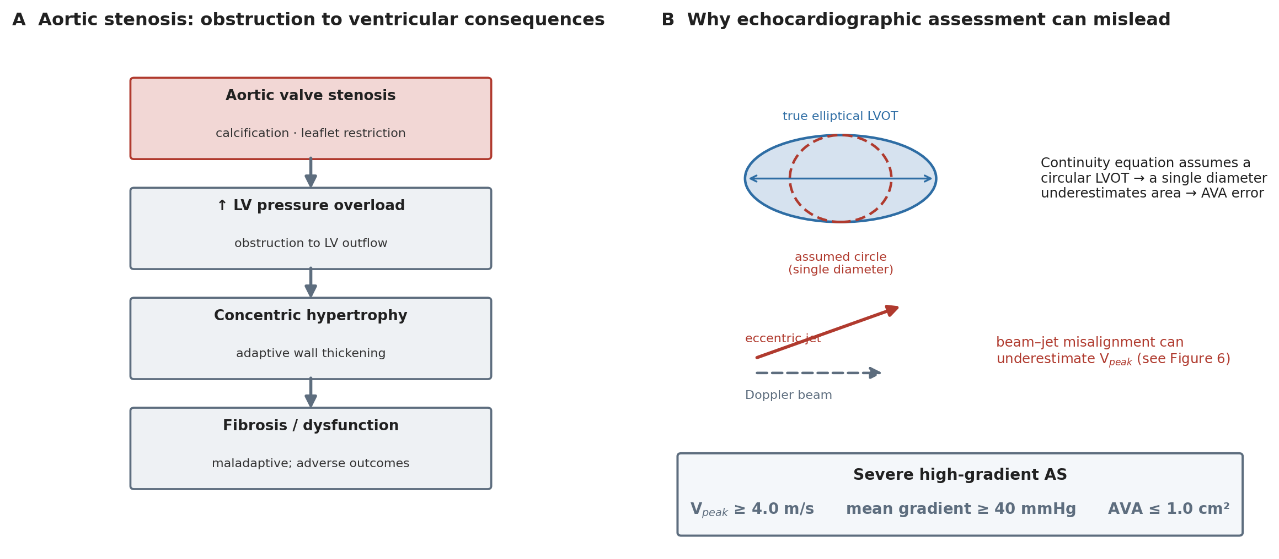
Figure 1. Aortic stenosis and its assessment. (A) Progression from valvular obstruction to left ventricular pressure overload, hypertrophy and fibrosis. (B) Sources of error in echocardiographic assessment, including the circular-LVOT assumption of the continuity equation and beam–jet misalignment. Original schematic.
AS = aortic stenosis; AVA = aortic valve area; LV = left ventricle; LVOT = left ventricular outflow tract; Vpeak = peak transvalvular velocity.

Four-dimensional flow cardiovascular magnetic resonance (4D flow CMR) provides a different approach to flow assessment. It measures blood velocity in three directions across the cardiac cycle within a three-dimensional volume.^{4,5} Because the velocity data cover a volume rather than a single predefined plane, measurement planes can be positioned retrospectively after acquisition.^{4,5} This may be useful in AS because the direction of an eccentric stenotic jet may not be known before imaging. In addition to conventional flow measures, 4D flow CMR can quantify haemodynamic parameters such as wall shear stress (WSS), turbulent kinetic energy (TKE) and viscous energy loss (VEL).⁴ These measures provide information about abnormal flow and energy dissipation that is not captured by conventional velocity and pressure-gradient measurements alone.⁴

Chapter 2: Technical Principles of 4D Flow CMR

4D flow CMR is a phase-contrast magnetic resonance technique that measures blood velocity in three directions across the cardiac cycle within a three-dimensional volume.^{4,5} It builds on conventional two-dimensional phase-contrast imaging, where velocity is measured through a predefined imaging plane. In 4D flow CMR, velocity data are acquired throughout a volume, allowing measurement planes to be positioned retrospectively after acquisition.^{4,5} This is relevant to AS because the direction of a stenotic jet may be eccentric and difficult to predict before the scan (Figure 3).
The acquisition is synchronised with the cardiac cycle to produce time-resolved velocity data.⁵ Respiratory motion also needs to be controlled or compensated during the acquisition, and different approaches can be used depending on the protocol.⁵ Garcia et al. described 4D flow CMR as providing three-dimensional, time-resolved assessment of aortic flow, with acquisition protocols designed to provide sufficient spatial and temporal resolution for visualising complex flow patterns.⁴ The consensus statement on 4D flow CMR reports a typical spatial resolution of about 1.5–3.0 mm, a temporal resolution of roughly 30–40 ms and acquisition times of about 5 to 25 minutes (Table 1).⁵ These values matter in AS because the stenotic jet is narrow and short-lived: if the spatial or temporal resolution is insufficient, the highest velocities within the jet may be averaged out and underestimated, a point returned to in Chapter 3. Higher spatial resolution can improve the representation of complex flow structures but may increase acquisition time and reduce signal-to-noise performance.⁵

Table 1. Key 4D flow CMR acquisition and analysis parameters and their relevance to aortic stenosis.
Parameter | Typical consideration | Relevance to aortic stenosis
Spatial resolution | ~1.5–3.0 mm | A narrow stenotic jet may be underestimated if insufficiently resolved; also affects energy-loss quantification
Temporal resolution | ~30–40 ms | Needed to capture rapidly changing systolic flow
VENC | Set to the expected peak velocity | Too low → aliasing of high jet velocities; too high → reduced velocity-to-noise sensitivity
Acquisition time | ~5–25 min (protocol dependent) | Longer than a routine echocardiographic study
ECG gating / respiratory control | Required for time-resolved reconstruction | Enables analysis across the cardiac cycle
Post-processing | Background-phase and concomitant-gradient correction, aliasing correction, segmentation | Introduces operator dependence and standardisation considerations
ECG = electrocardiogram; VENC = velocity encoding value. Typical values are drawn from the 4D flow CMR consensus statement.⁵

The reconstructed data require several processing steps before quantitative analysis (Figure 2). The distinction between fixed and retrospective measurement-plane placement is illustrated in Figure 3. Background phase errors, including those related to eddy currents, need to be corrected, while concomitant gradient effects may require separate correction.5 Velocity aliasing can also be corrected during post-processing. The aorta and other structures of interest are then segmented, after which measurement planes can be positioned within the acquired volume to quantify flow and velocity.4,5 Each processing step can introduce residual error, so the final measurements depend not only on the acquisition but also on the analysis method.
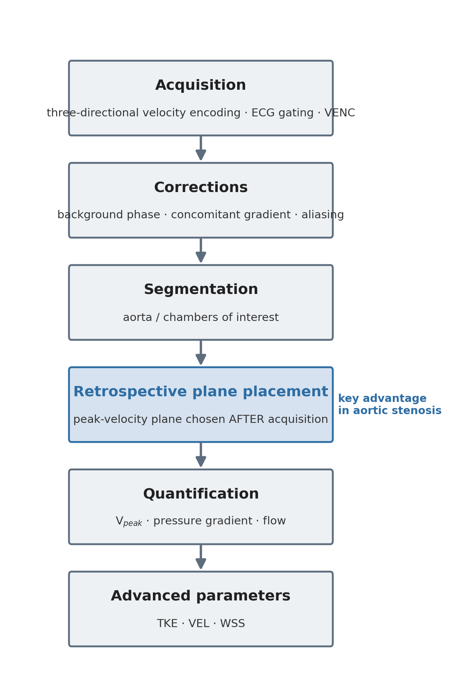
Figure 2. Overview of the 4D flow CMR acquisition and analysis pipeline, adapted for aortic stenosis. Retrospective plane placement (highlighted) allows the peak-velocity plane to be selected after acquisition. Adapted from the 4D flow CMR consensus statement.⁵
ECG = electrocardiogram; TKE = turbulent kinetic energy; VEL = viscous energy loss; VENC =velocity encoding value; WSS = wall shear stress; Vpeak, = peak transvalvular velocity.
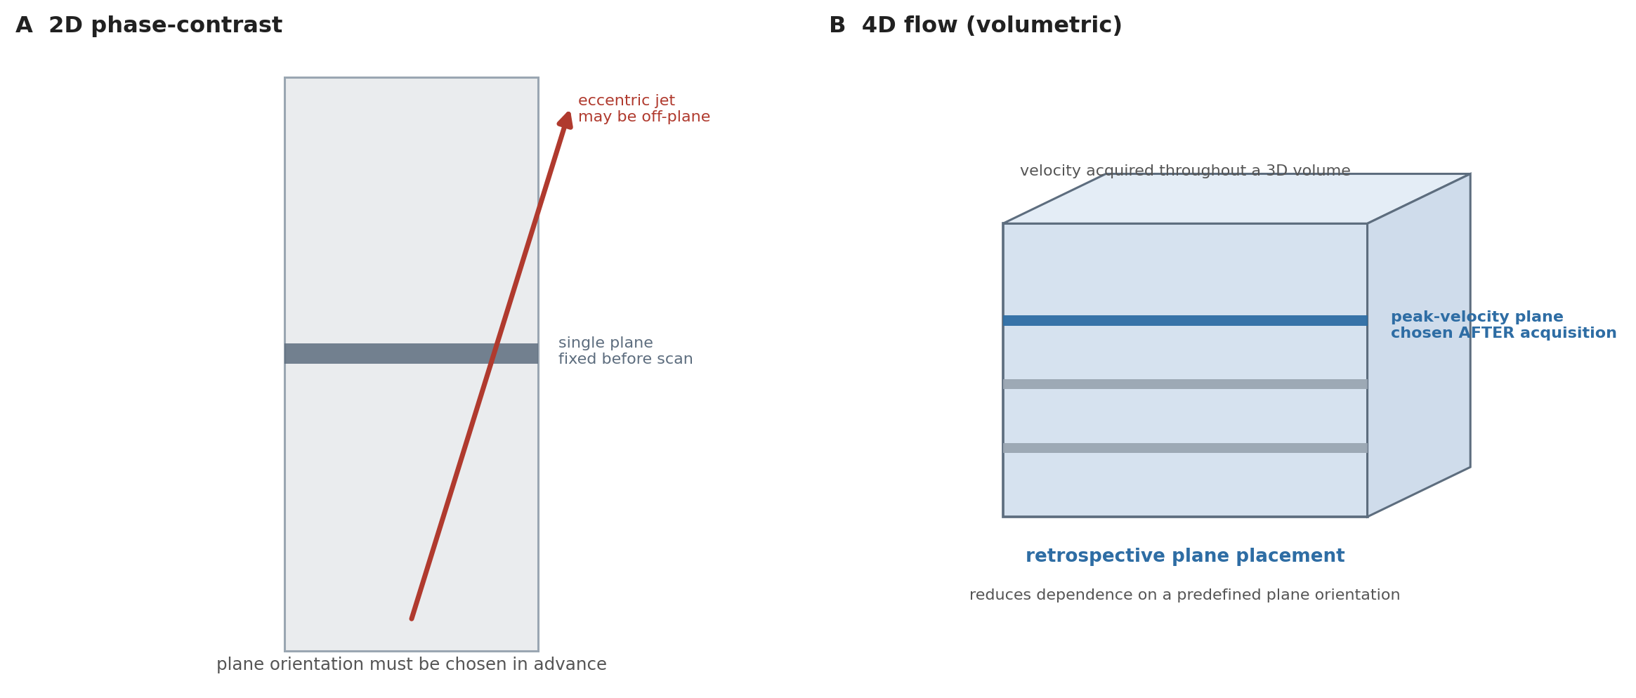
Figure 3. Retrospective measurement-plane placement. In 2D phase-contrast imaging (A) the plane is fixed before acquisition and an eccentric jet may lie off-plane; in 4D flow (B) velocity is acquired throughout a volume, allowing the peak-velocity plane to be positioned after acquisition. (schematic).
2D = two-dimensional; 3D = three-dimensional.

Segmentation and analysis methods can also affect reproducibility. Manual analysis requires the operator to identify the relevant anatomy and measurement planes and can be time-consuming. Semi-automated methods have therefore been developed to reduce operator input. Grafton-Clarke et al. evaluated a semi-automated pipeline using CAAS MR Solutions for peak aortic valve pressure-gradient assessment.⁶ The study included 11 patients and compared the semi-automated method with invasive measurements and manual 4D flow analysis. The semi-automated method showed a mean bias of −0.3 mmHg compared with invasive measurements and required approximately 4 minutes per subject, compared with about 20 minutes for manual analysis.⁶ However, the study was small and used different software for the manual and semi-automated analyses. These factors limit how far the findings can be generalised.
Overall, 4D flow CMR provides a three-dimensional and time-resolved description of cardiovascular flow, but the measurements remain dependent on acquisition settings and post-processing. These technical factors are important when interpreting studies comparing 4D flow with echocardiography or invasive measurements and when considering the clinical relevance of more advanced haemodynamic parameters.

Chapter 3: Haemodynamic Assessment of Aortic Stenosis Using 4D Flow CMR
The principal comparative studies are summarised in Table 2.
Table 2. Principal studies evaluating 4D flow CMR for the haemodynamic assessment of aortic stenosis.
Study | Population | n | Comparison | Main finding | Key limitation
Adriaans et al.³ | Mixed-severity AS | 20 | 4D flow vs TTE | Higher Vpeak (+16.4%) and mean gradient (+14.9%); Vpeak difference tracked jet eccentricity (r = 0.89) | Small; single-centre
Archer et al.⁸ | Severe AS | 18 | 4D flow vs TTE vs invasive | 4D-flow peak gradient closer to invasive (54±26 vs 50±34 mmHg) than TTE (61±32); lower bias but weaker correlation | Small; single-centre
Grafton-Clarke et al.⁶ | Severe AS | 11 | Semi-automated 4D flow vs invasive / manual | Very low gradient bias (−0.3 mmHg); high reproducibility (ICC 0.98/0.99); ~4 vs ~20 min analysis | Very small; all severe; specific pipeline
Grafton-Clarke et al.⁹ | AS (PREFER-CMR) | 30 | 4D flow vs CWD; outcome = intervention | 4D-flow Vpeak associated with subsequent intervention (HR 2.51); exploratory 3.5 m/s cut-off | Outcome = decision, not hard endpoint; ~8-mo follow-up
Hälvä et al.¹⁰ | Severe AS | 90 | 4D flow & 2D-PC CMR vs TTE | 4D flow underestimated Vpeak vs echocardiography (bias −1.1 m/s) | Contrasts with refs 3, 8; different framework
AS = aortic stenosis; CWD = continuous-wave Doppler; HR = hazard ratio; ICC = intraclass correlation coefficient; TTE = transthoracic echocardiography; Vpeak = peak transvalvular velocity; 2D-PC = two-dimensional phase-contrast. Several cohorts originate from related research programmes with overlapping investigators; findings should not be interpreted as independent replication where cohorts overlap. References correspond to the master bibliography.

Peak Velocity

Peak transvalvular velocity (Vpeak) is an important component of AS grading but is sensitive to the alignment between the Doppler beam and the direction of the stenotic jet. Because 4D flow CMR measures velocity in three directions across a three-dimensional volume, measurement planes can be positioned retrospectively after acquisition. This reduces the dependence on selecting a suitable measurement plane before imaging, which may be useful when the stenotic jet is eccentric.^{3,4}
Adriaans et al. compared 4D flow CMR with TTE in 20 patients with different degrees of AS. 4D flow CMR measured a 16.4% higher Vpeak than TTE (P < 0.001), and the difference between the two methods was strongly associated with flow-jet eccentricity (r = 0.89, P < 0.001).³ The mean pressure gradient was also 14.9% higher with 4D flow CMR than with TTE (P = 0.013).³ These findings support a relationship between jet eccentricity and differences in velocity measurements between the two techniques.
Grafton-Clarke et al. reported a similar direction of difference in a later study of 30 patients with AS. The mean Vpeak was 4.2 m/s with 4D flow CMR compared with 3.4 m/s by continuous-wave Doppler among patients who underwent valve intervention. Across the cohort, Doppler Vpeak was lower than 4D flow, with a bias of −0.5 m/s (P = 0.01) and a moderate correlation between the methods (r = 0.55, P = 0.002).⁹ The study also found that 4D-flow Vpeak was associated with subsequent valve intervention. However, the study was small and observational, and these findings do not establish that 4D flow should replace Doppler assessment.
Importantly, the direction of the difference is not consistent across all studies. Hälvä et al. compared 4D flow CMR, two-dimensional phase-contrast CMR and TTE in patients with severe AS and found that 4D flow CMR underestimated peak velocity compared with echocardiography (Figure 4), with a bias of −1.1 m/s.¹⁰ This contrasts with the higher 4D-flow velocities reported by Adriaans et al. and Grafton-Clarke et al.^{3,9} These opposing directions may reflect competing sources of error. Poor beam alignment tends to lower the Doppler velocity, which makes 4D flow appear higher, whereas limited spatial and temporal resolution tends to lower the 4D flow velocity, which makes it appear lower. The net difference in any given study may therefore depend on which of these effects dominates, alongside variation in patient characteristics, jet morphology, VENC and post-processing, none of which were directly compared across the studies.
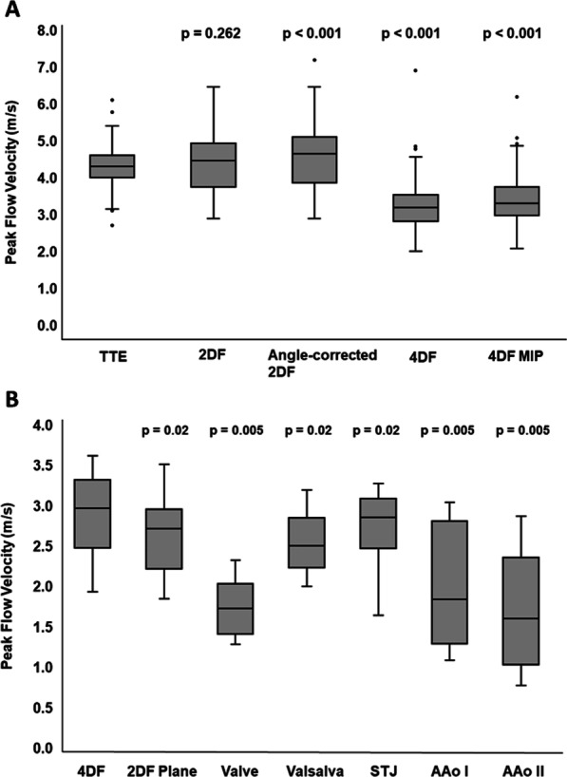
Figure 4. Comparison of peak systolic velocity measured by transthoracic echocardiography, 2D phase-contrast CMR, angle-corrected 2D phase-contrast CMR and 4D flow CMR in patients with severe aortic stenosis (panel A), and by 4D flow across anatomical positions (panel B). Reproduced from Hälvä et al.¹⁰ under the Creative Commons Attribution 4.0 International licence.
2DF = 2D phase-contrast flow; 4DF = 4D flow; AAo = ascending aorta; MIP = maximum-intensity projection; STJ = sinotubular junction; TTE = transthoracic echocardiography.

Pressure Gradient and Comparison with Invasive Measurement

Pressure-gradient assessment provides a different way of comparing 4D flow CMR with established methods. Doppler estimates the maximal instantaneous pressure difference from blood velocity using the simplified Bernoulli equation. Invasive catheterisation commonly measures the peak-to-peak pressure difference between the left ventricle and aorta. These measurements therefore do not represent exactly the same physical quantity. Pressure recovery distal to the stenosis can also contribute to differences between Doppler-derived and catheter-derived gradients.¹¹
Archer et al. compared 4D flow CMR, TTE and invasive measurements (Figure 5) in 18 patients with severe AS.⁸ In the patients who underwent invasive assessment, the peak gradient was 54 ± 26 mmHg with 4D flow CMR and 50 ± 34 mmHg with invasive measurement (P = 0.67). TTE produced a higher mean value of 61 ± 32 mmHg compared with the invasive measurement (P = 0.0002).⁸ Bland–Altman analysis showed a bias of −18.6 mmHg for the TTE comparison with invasive measurement.⁸ When a peak-gradient cut-off of 64 mmHg was used to classify severe AS, agreement with the invasive classification was slightly higher for 4D flow (weighted κ = 0.25) than for Doppler (weighted κ = 0.16), although agreement was modest for both approaches and the confidence intervals were wide.⁸ These findings indicate that 4D flow showed less systematic difference from the invasive measurement than TTE in this cohort.
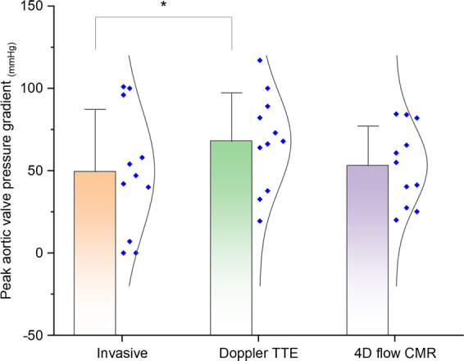
Figure 5. Comparison of peak transvalvular pressure gradient measured by invasive catheterisation, Doppler transthoracic echocardiography and 4D flow CMR in the Archer et al. cohort. Reproduced from Archer et al.⁸ under the Creative Commons Attribution 4.0 International licence.
TTE = transthoracic echocardiography. * statistically significant difference.
Similar findings were reported by Grafton-Clarke et al. in their semi-automated validation study. In 11 patients with severe AS, the invasive peak pressure gradient was 51.9 ± 35.2 mmHg compared with 52.2 ± 29.2 mmHg using the semi-automated 4D-flow method.⁶ The bias between the two methods was −0.3 mmHg (P = 0.974), with a correlation of r = 0.70 (P = 0.017).⁶ The semi-automated method also showed high reproducibility, with interobserver and intraobserver ICCs of 0.98 and 0.99, respectively.⁶ The two non-interchangeable sources of measurement discrepancy are illustrated in Figure 6.

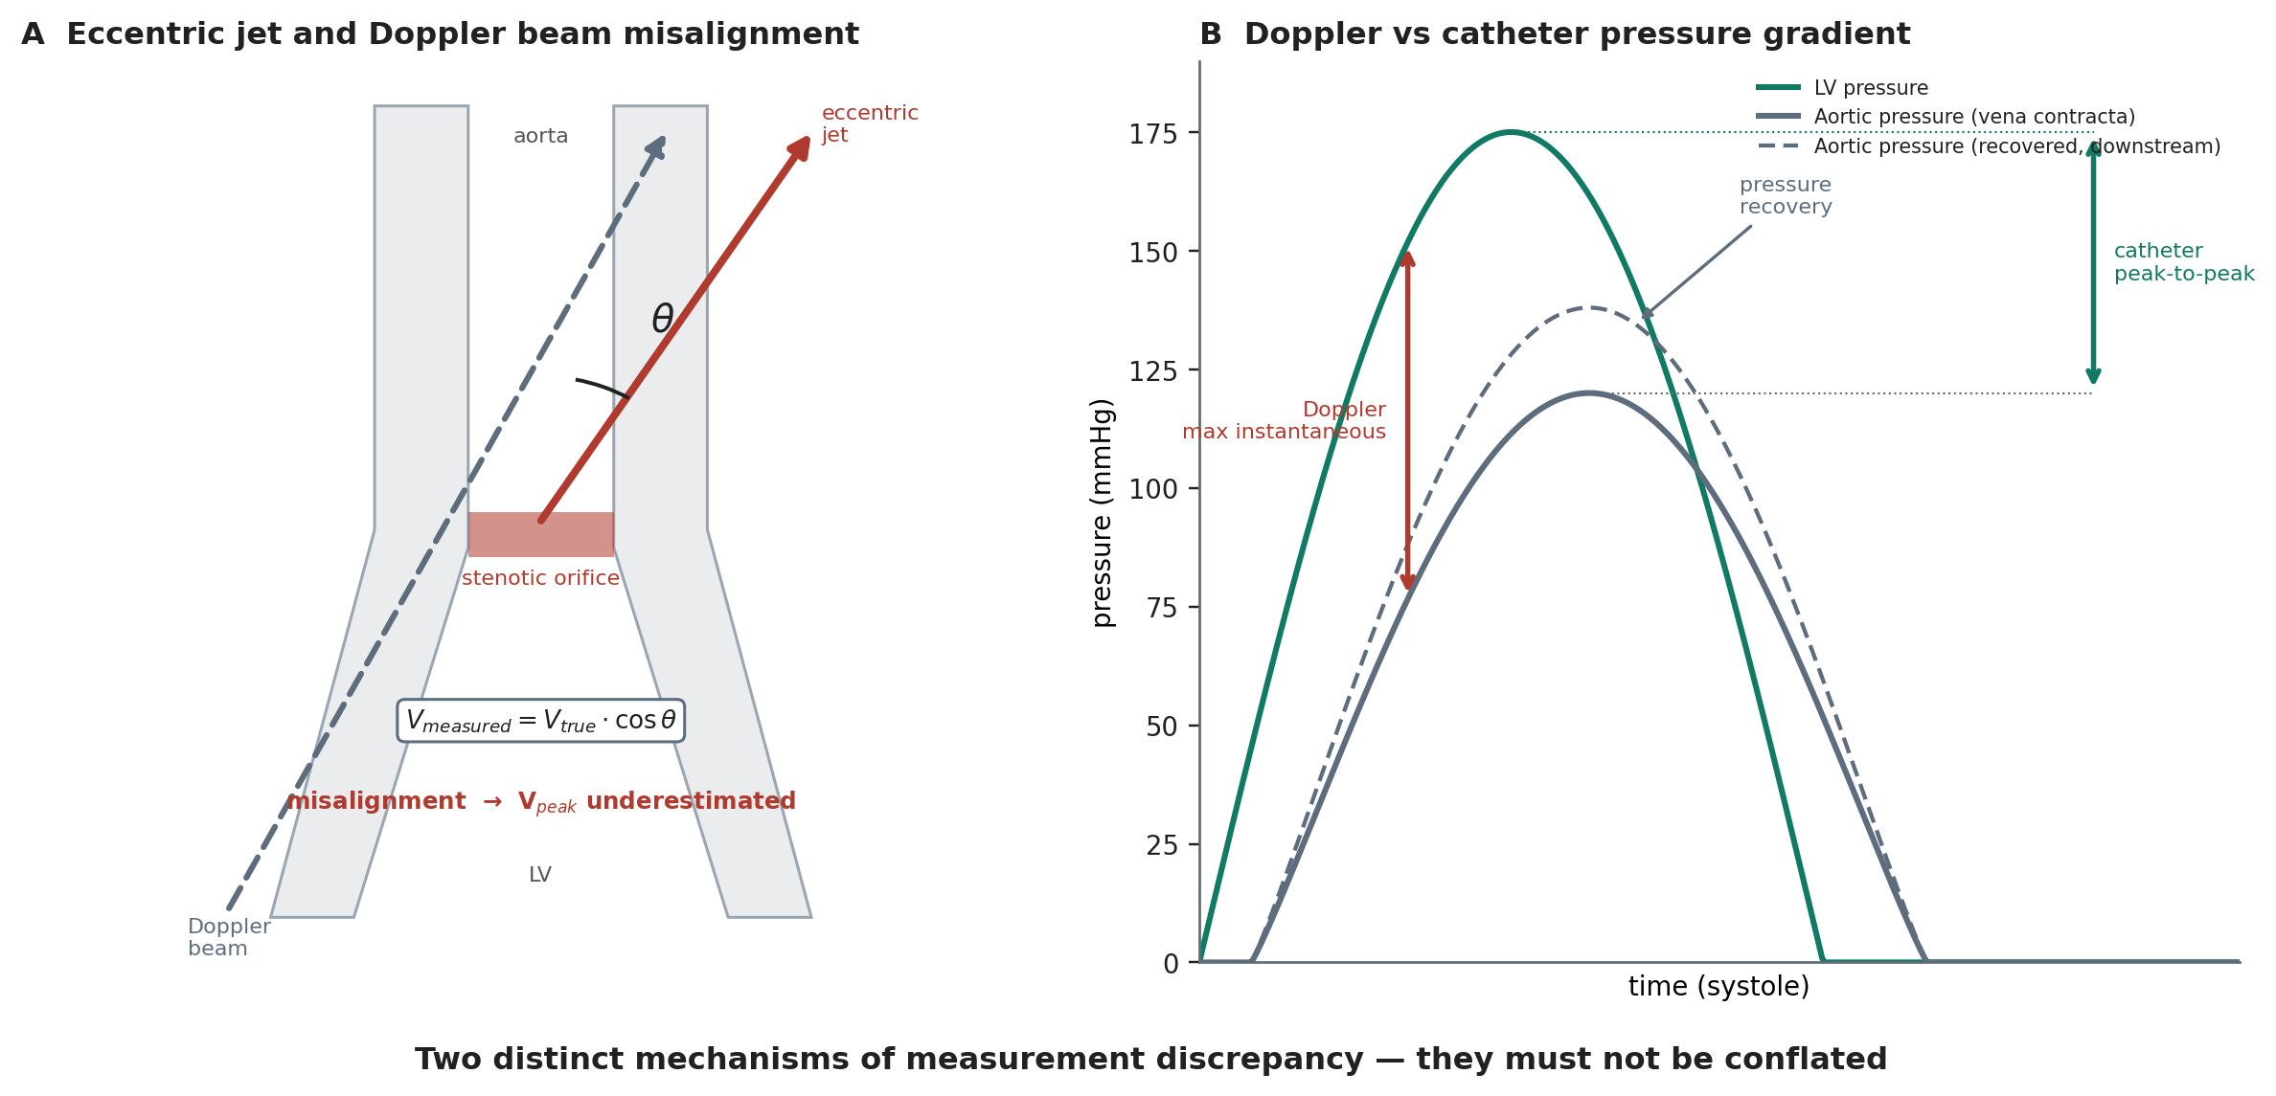
Figure 6. Two distinct and non-interchangeable sources of measurement discrepancy in aortic stenosis. (A) Eccentric jet and Doppler beam misalignment causing underestimation of peak velocity. (B) Doppler maximum instantaneous versus catheter peak-to-peak pressure gradient, with pressure recovery downstream. Original schematic; the eccentric-jet concept in panel A is informed by Adriaans et al.³
LV = left ventricle; Vpeak = peak transvalvular velocity. Panel B pressure tracings are schematic and not drawn to scale.

Valve Area and Discordant Grading

AVA provides another potential source of disagreement between imaging methods. TTE calculates AVA using the continuity equation, which requires measurement of LVOT diameter and assumes a circular geometry. Because the LVOT is commonly elliptical, a single diameter measurement can affect the calculated cross-sectional area and therefore the estimated AVA.³
Adriaans et al. found that 4D flow CMR produced a 19.9% larger AVA than TTE, with a mean difference of 19.9 ± 20.6% (P = 0.002).³ The use of 4D flow CMR also improved concordance between Vpeak and AVA from 0.68 to 0.87 and between mean pressure gradient and AVA from 0.68 to 0.86.³ This suggests that the severity parameters were more internally consistent when derived using 4D-flow data.
However, improved concordance does not establish which measurement is correct. Archer et al. found similar effective orifice areas between 4D flow CMR and TTE, with values of 1.1 ± 0.5 cm² and 1.2 ± 0.4 cm², respectively (P = 0.10).⁸ The two studies also used different approaches to derive valve area. Therefore, differences in AVA between studies may reflect both the underlying imaging method and the method used for post-processing.

Overall Evidence

The current evidence therefore supports 4D flow CMR as a complementary technique rather than a replacement for TTE. Its potential value appears greatest when echocardiographic measurements are discordant or technically difficult, particularly where an eccentric flow jet may affect Doppler alignment. However, the available studies are generally small and use different acquisition and analysis methods. Further prospective studies with standardised protocols and larger patient populations are needed before 4D-flow-derived thresholds can be incorporated into routine AS grading or intervention pathways.

Chapter 4: Advanced Haemodynamic Parameters

Beyond the standard measures used to grade AS, 4D flow CMR can provide information about how stenosis alters blood flow and interacts with the aortic wall. Turbulent kinetic energy (TKE) and viscous energy loss (VEL) describe different aspects of haemodynamic energy dissipation, whereas wall shear stress (WSS) describes the mechanical interaction between blood flow and the vessel wall (Table 3).⁴ All three parameters are derived from the underlying velocity data and are therefore affected by the acquisition and processing factors discussed in Chapter 2.
Table 3. Advanced 4D flow CMR-derived haemodynamic parameters: definitions, supporting evidence and technical sensitivities.
Parameter | Quantifies | Derived from | Key evidence | Resolution sensitivity | Current status
TKE | Energy of turbulent velocity fluctuations | Variance of the velocity field | Related to irreversible pressure loss¹²; adds to echocardiography¹³ | Errors <15% at coarse voxel size¹⁵ | Research measure
VEL | Viscous energy dissipation | Velocity gradients between adjacent layers | Higher in BAV with stenosis; links to LV mass and strain¹⁴ | Up to 83% underestimation at 2.5 mm voxel¹⁵ | Research measure
WSS | Frictional force on the vessel wall | Near-wall velocity gradient | Regional WSS associated with aortic-wall histology in BAV¹⁶ | Underestimated versus reference; method-dependent⁷ | Research measure
BAV = bicuspid aortic valve; LV = left ventricle; TKE = turbulent kinetic energy; VEL = viscous energy loss; WSS = wall shear stress. References correspond to the master bibliography.

Turbulent Kinetic Energy

When the high-velocity jet passing through a stenotic valve interacts with the surrounding blood, the flow becomes disturbed and turbulent. TKE quantifies the energy associated with the random velocity fluctuations within this turbulent flow.⁴ Dyverfeldt et al. measured TKE in the ascending aorta in a small study of 18 subjects, including four healthy volunteers and 14 patients with AS. Peak TKE was related to irreversible pressure loss across the stenotic valve, suggesting that it may provide information about energy dissipation that is not captured by a single transvalvular pressure gradient.¹²
Binter et al. subsequently reported that TKE measured using multipoint 4D flow CMR provided additional information to conventional echocardiographic measures when assessing AS severity.¹³ These findings suggest that turbulent flow contains information about the haemodynamic consequences of stenosis beyond peak velocity or mean pressure gradient alone. However, TKE quantifies energy associated with turbulent velocity fluctuations within the blood flow and should not be interpreted as a direct measure of myocardial work or oxygen consumption.
The clinical relevance of TKE remains uncertain. Most available studies have been relatively small and have focused on associations with haemodynamic severity rather than prospective clinical outcomes. In addition, TKE measurements depend on the spatial and temporal resolution of the acquired velocity data. These limitations make direct comparison of absolute TKE values between studies difficult.⁴ TKE should therefore currently be considered an additional haemodynamic measure rather than an established clinical marker for determining the severity of AS or the timing of intervention.

Viscous Energy Loss

VEL describes energy dissipated through viscous forces within the blood. It is related to velocity gradients between adjacent layers of flowing blood and therefore differs from the turbulent energy represented by TKE.⁴ 4D flow CMR can map the distribution of VEL throughout the aorta and identify regions where greater energy dissipation occurs.
The measurement of VEL is also particularly sensitive to spatial resolution. Binter et al. showed that increasing voxel size from 0.625 to 2.5 mm resulted in up to an 83% underestimation of viscous energy losses, whereas TKE showed errors below 15% under the conditions tested.¹⁵ This substantial resolution dependence is important when comparing studies using different acquisition protocols. Absolute VEL values should therefore be interpreted cautiously, and comparisons are more reliable when the same acquisition and analysis methods are used.

Wall Shear Stress

WSS describes the frictional force exerted by flowing blood on the vessel wall and is estimated from the velocity gradient close to the wall.⁴ In AS, particularly when associated with BAV, eccentric systolic jets can produce regional changes in flow direction and WSS within the ascending aorta. 4D flow CMR allows these spatial variations to be visualised and quantified.
Guzzardi et al. compared 4D-flow-derived WSS patterns with histological findings from aortic tissue obtained during surgery in patients with BAV. Regions exposed to higher WSS showed greater elastic-fibre degeneration and extracellular matrix changes.¹⁶ This provides an association between abnormal haemodynamics and structural changes in the aortic wall and is consistent with a possible role of flow-related mechanical forces in aortic remodelling. However, the cross-sectional nature of the study does not establish that increased WSS causes these changes or predicts subsequent aortic enlargement.
WSS measurements also have important technical limitations. The calculation depends on estimating velocity gradients close to the vessel wall, making the measurement sensitive to spatial resolution and the method used for gradient estimation. Numerical simulations have shown that MRI-derived WSS can be underestimated compared with reference values.⁷ The absolute values should therefore be interpreted with caution, particularly when comparing results obtained using different acquisition protocols or analysis methods.

Interpretation and Limitations

Chapter 5: Ventricular and Myocardial Energetics

Left Ventricular Blood-Flow Kinetic Energy

The kinetic energy of blood within the LV can be calculated from 4D flow CMR velocity data and normalised to LV end-diastolic volume (KEiEDV). Elhawaz et al. investigated LV blood-flow kinetic energy in 18 patients with severe AS before valve intervention, with 12 patients returning for CMR follow-up approximately three months after intervention.¹⁷ The study assessed total LV blood-flow kinetic energy as well as direct, delayed, retained and residual flow components.¹⁷
Several changes in flow energetics were observed after valve intervention. Direct-flow kinetic energy decreased from a median [IQR] of 4.9 [5.0] μJ to 1.86 [1.7] μJ (P = 0.01), while delayed-flow kinetic energy decreased from 2.46 [3.0] μJ to 1.38 [1.0] μJ (P = 0.03). The time delay for peak E-wave propagation from the base to the mid-ventricle also decreased after intervention (P = 0.04).¹⁷ These findings suggest that relieving the valvular obstruction changes the distribution and timing of intracavitary blood-flow energy.
The study also found an association between LV kinetic energy and objective functional capacity. Average LV KEiEDV was inversely correlated with six-minute walk test (6MWT) distance (r = −0.53, P < 0.01). Diastolic KEiEDV showed the same correlation (r = −0.53, P < 0.01), while peak E-wave KEiEDV showed a weaker association (r = −0.38, P = 0.04).¹⁷ These findings suggest that altered intracavitary flow energetics are associated with exercise capacity in patients with severe AS.
LV kinetic energy was also associated with subsequent ventricular remodelling. Pre-operative average LV KEiEDV showed a correlation with LV mass regression after valve intervention (r = 0.67, P = 0.02).¹⁷ In contrast, mean echocardiographic pressure gradient and CMR-derived LVEF were not significantly correlated with subsequent LV mass regression in this study.¹⁷ This raises the possibility that flow-based measures may capture aspects of the ventricular response that are not reflected by conventional measures.
However, these findings require cautious interpretation. The study included only 18 patients, with follow-up available in 12, and there was no healthy control group. The analysis was also observational, so the correlations do not demonstrate that altered kinetic energy causes reduced exercise capacity or determines the extent of reverse remodelling. The authors described the findings as an initial assessment and called for further investigation.¹⁷ Therefore, LV KEiEDV should currently be regarded as an emerging research measure rather than an established prognostic measure.

Non-invasive Pressure–Volume Loops
PV loops describe the relationship between LV pressure and volume throughout the cardiac cycle (Figure 7). The area enclosed by the loop represents stroke work, while the pressure–volume area (PVA) incorporates stroke work and potential energy. These measures provide information about ventricular mechanical work and efficiency that cannot be obtained from LVEF alone.¹⁸
Ea = arterial elastance; EDV = end-diastolic volume; Emax = maximal elastance; ESPVR = end-systolic pressure–volume relationship; ESV = end-systolic volume; LV = left ventricle; PE = potential energy; PVA = pressure–volume area; SW = stroke work; V0 = volume-axis intercept. MEP = mean external power, VE = ventricular efficiency and EPEV are further energetic parameters derived from the loop, as defined in the source.
Seemann et al. developed and validated the method experimentally before applying it in healthy participants and patients with heart failure. Stroke work showed an intraclass correlation coefficient of 0.93 with a bias of −0.02 ± 0.03 J, while ventricular efficiency showed an intraclass correlation coefficient of 0.84 with a bias of 3.5 ± 2.1%.19 These findings supported the feasibility of estimating important PV-loop parameters without direct intracardiac pressure measurement.
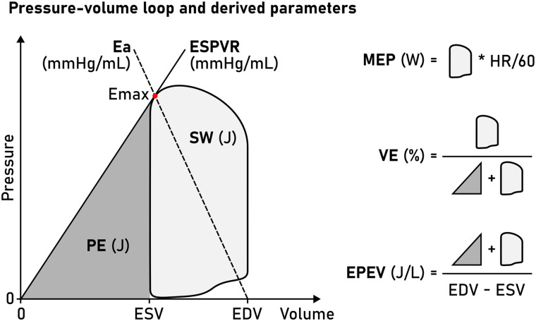
Figure 7. Left ventricular pressure–volume loop. The area enclosed by the loop represents stroke work (SW), while the area between the end-systolic pressure–volume relationship (ESPVR) and the end-systolic volume represents potential energy (PE); together, these constitute the pressure–volume area (PVA). Reproduced from Arvidsson et al.20 under the Creative Commons Attribution 4.0 International licence.
The method was subsequently validated against invasive pressure measurements in humans by Arvidsson et al. Four patients with severe heart failure and LV dyssynchrony underwent CMR followed by LV catheterisation, with eight datasets obtained under different haemodynamic conditions.20 Non-invasive PV-loop estimates showed high agreement with invasive measurements for stroke work (R2 = 0.96, bias 4.6%), potential energy (R2 = 0.83, bias 1.5%), and ventricular efficiency (R2 = 0.98, bias 0.8%).20 Other parameters, including arterial elastance and mean external power, also showed good agreement. These findings provide stronger evidence that PV-loop measures can be reconstructed non-invasively in humans.

Myocardial Energetics in Aortic Stenosis

The pressure–volume area (PVA) represents the sum of stroke work and potential energy and has been used as an index of the total mechanical energy generated by the ventricle.¹⁸ The relationship between PVA and myocardial oxygen consumption provides an established physiological framework for studying ventricular energetic efficiency.¹⁸ However, PVA obtained from a non-invasive PV loop should not be interpreted as a direct measurement of myocardial oxygen consumption in an individual patient. It is an indirect mechanical estimate based on the pressure–volume relationship.

Linking Flow Energetics and Myocardial Work

The flow-based measures discussed in Chapter 4 and the ventricular measures discussed here describe different parts of the same physiological pathway (Figure 8). TKE and VEL describe energy associated with disturbed flow and energy dissipation within the blood. LV blood-flow kinetic energy describes the movement of blood within the ventricular cavity. PV-loop-derived stroke work and PVA, in contrast, describe mechanical work and energy associated with ventricular contraction.
These measures should therefore not be treated as interchangeable. In particular, TKE or VEL should not be described as direct measures of myocardial work. Similarly, LV blood-flow kinetic energy does not directly quantify myocardial oxygen consumption. The measures are physiologically related, but they are not equivalent: the stenotic valve increases LV pressure loading, while abnormal flow and energy dissipation represent additional features of the haemodynamic environment. The ventricular response to these conditions can then be assessed through mechanical work and remodelling.
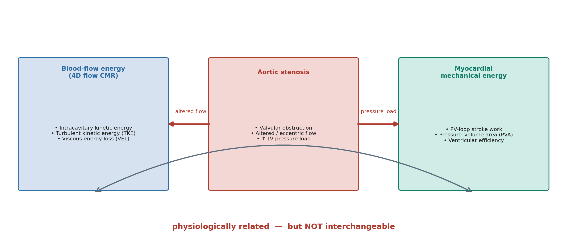
Figure 8. Relationship between blood-flow energy measures and myocardial mechanical energy in aortic stenosis. The two energy domains are physiologically related but not interchangeable. (schematic) Original schematic.
LV = left ventricle; PV = pressure–volume; PVA = pressure–volume area; TKE = turbulent kinetic energy; VEL = viscous energy loss.

Relevance to Aortic Stenosis and Current Research Gap

This represents an important research gap. A method that can estimate ventricular mechanical work non-invasively could potentially complement 4D-flow measures of valvular and intracavitary haemodynamics. However, prospective studies are required to determine whether these energetic measures provide information that is independent of established AS parameters and whether they are associated with clinically meaningful outcomes.

Chapter 6: Clinical and Prognostic Relevance

The clinical value of a measurement depends on more than its technical accuracy. It is useful to consider whether a 4D flow measurement is associated with symptoms or functional status, whether it relates to subsequent clinical events, and whether its use improves patient management. Current evidence addresses the first two areas to some extent, but there is not yet evidence that using 4D flow CMR to guide management improves patient outcomes.

Association with Functional Capacity and Symptoms

Association with Ventricular Remodelling

A second area of interest is whether 4D flow measurements are associated with the ventricular response following valve intervention. Archer et al. reported that the change in 4D-flow-derived pressure gradient after intervention was associated with LV mass regression (r = 0.64, P = 0.04). The corresponding association for the change in Doppler-derived gradient did not reach statistical significance (r = 0.63, P = 0.06).⁸ The similar correlation coefficients indicate that the difference between the two analyses should not be interpreted as evidence of a large difference in biological association.
Elhawaz et al. also found an association between pre-intervention LV KEiEDV and subsequent LV mass regression (r = 0.67, P = 0.02).¹⁷ Together, these findings raise the possibility that 4D-flow-derived measures may provide information about the ventricular response that is not fully captured by conventional measurements. However, both studies were small, observational and originated from the same research programme. The associations therefore do not establish that these measurements determine the extent of reverse remodelling or that they can be used to select patients who will benefit most from intervention.

Association with Valve Intervention

The most direct evidence for a potential prognostic role of 4D flow comes from the PREFER-CMR registry. Grafton-Clarke et al. studied 30 patients who underwent both TTE and 4D flow CMR, of whom 17 subsequently underwent aortic valve intervention during a mean follow-up of approximately eight months.⁹
Among patients who subsequently underwent intervention, mean CWD Vpeak was 2.6 m/s in those who did not undergo intervention (P = 0.0025), while the corresponding 4D-flow Vpeak was 2.7 m/s (P < 0.0001).9
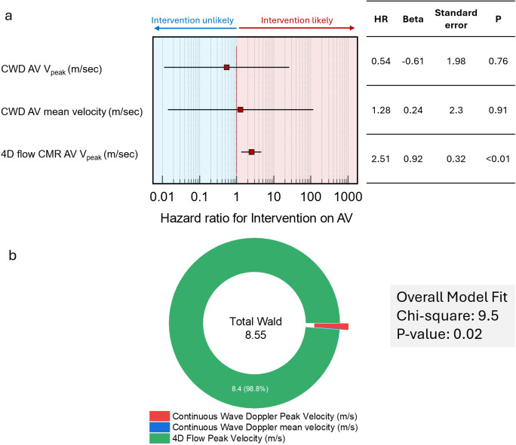
Figure 9. Cox regression analysis for aortic-valve intervention. 4D flow CMR peak velocity was associated with subsequent intervention (hazard ratio 2.51), whereas continuous-wave Doppler peak and mean velocities were not. Reproduced from Grafton-Clarke et al.9 under the Creative Commons Attribution 4.0 International licence..
AV = aortic valve; CWD = continuous-wave Doppler; HR = hazard ratio; Vpeak = peak velocity.
In Cox regression analysis (Figure 9), 4D flow Vpeak was associated with subsequent valve intervention (hazard ratio 2.51, P < 0.01), whereas CWD Vpeak was not statistically significant in the same analysis (hazard ratio 0.54, P = 0.76).⁹ A 4D flow Vpeak above 3.5 m/s was associated with subsequent intervention, with approximately 80% sensitivity and specificity in this cohort.⁹
These findings are of interest because they suggest that 4D flow Vpeak may contain information associated with the clinical decision to intervene. However, the outcome was valve intervention rather than a hard clinical outcome such as mortality or heart-failure hospitalisation. The follow-up period was also too short to assess longer-term outcomes.⁹ In addition, the decision to intervene was made by a multidisciplinary team that had access to the available clinical and imaging information. The outcome was therefore not independent of the information available to the clinical decision-making team.

4D Flow CMR in the Context of Other Imaging

From Association to Clinical Utility

The distinction between association, prediction and clinical utility is important when interpreting the current evidence (Figure 10). A measurement can agree with a reference method, correlate with functional status, or be associated with a subsequent clinical decision without demonstrating that its use improves patient care.
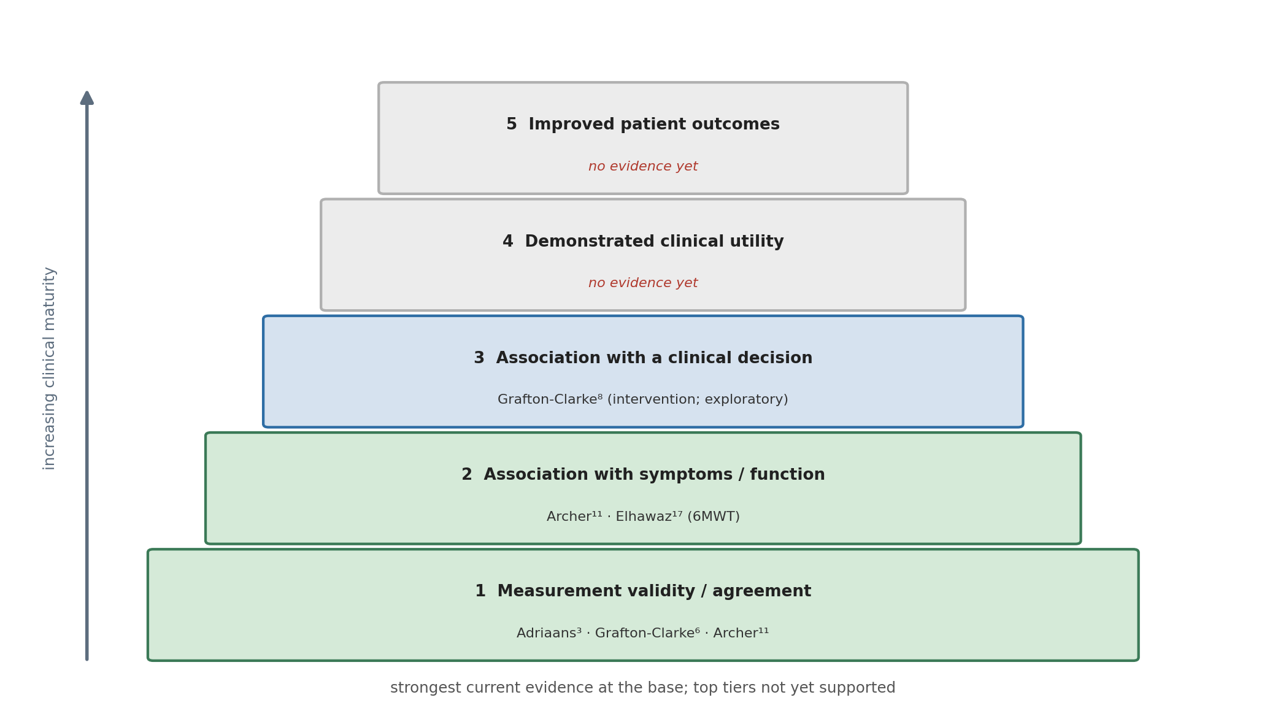
Figure 10. Evidence hierarchy for 4D flow CMR in aortic stenosis, from measurement validity to demonstrated improvement in patient outcomes, with current studies mapped to each level. Original schematic.
6MWT = six-minute walk test. Studies are placed at the highest evidence level they currently support; the upper two tiers are not yet supported by the reviewed literature. References correspond to the master bibliography.
For 4D flow CMR in AS, the strongest evidence currently concerns its technical and haemodynamic capabilities. Studies have shown that it can provide complementary measurements of velocity, pressure gradient and valve area, with particularly useful information when Doppler measurements are affected by eccentric flow or when conventional parameters are discordant.^{3,6,8}

Chapter 7: Discussion and Conclusion

Discussion

This review examined the role of 4D flow CMR in AS, from the technical basis of the method to its haemodynamic measurements, advanced flow and energy parameters, ventricular energetics and emerging clinical applications. Overall, the evidence shows that 4D flow CMR can measure the parameters used to assess AS and can provide information about flow that is not readily available from conventional echocardiography. However, its current role is complementary to echocardiography rather than a replacement for it.
The most consistent evidence in the current literature concerns the assessment of transvalvular haemodynamics. Because 4D flow acquires velocity throughout a volume, the measurement plane can be selected after image acquisition. This reduces the dependence on a predefined imaging plane that affects continuous-wave Doppler when the stenotic jet is eccentric.^{4,5} Studies comparing 4D flow with invasive catheterisation have also shown close agreement for transvalvular pressure gradients, including a semi-automated analysis approach with low measurement bias.^{6,8} Adriaans et al. further reported improved concordance between peak velocity, mean pressure gradient and AVA when 4D flow measurements were used.³ These findings provide the strongest current evidence for a complementary role for 4D flow when conventional measurements are technically difficult or discordant. However, the available validation studies remain relatively small and have mainly been performed in single-centre settings.
The review also identified two separate sources of discrepancy in conventional assessment that should not be conflated (Figure 6). Doppler-derived velocity can be underestimated when the ultrasound beam is not sufficiently aligned with an eccentric stenotic jet.^{3,4} This is different from the discrepancy between Doppler-derived and invasively measured pressure gradients. Doppler estimates the maximum instantaneous pressure difference from blood velocity, whereas catheterisation commonly measures the peak-to-peak pressure difference between the left ventricle and aorta. Pressure recovery can contribute to the difference between these measurements.¹¹ Therefore, the limitations of Doppler velocity measurement and the differences between Doppler and invasive pressure gradients have different physical explanations.
The distinction between blood-flow and myocardial mechanical energetics established in Chapter 5 should be retained when interpreting their clinical associations. LV blood-flow kinetic energy has been associated with functional capacity and subsequent LV mass regression after valve intervention.17 Non-invasive PV-loop methods have been compared with invasive pressure measurements in other cardiovascular settings.19,20 Their specific application to AS remains insufficiently studied.
The clinical and prognostic evidence is less developed than the technical validation evidence. Associations have been reported between 4D flow measurements, six-minute walk distance and LV mass regression.^{8,17} The PREFER-CMR study also found an association between 4D flow peak velocity and subsequent valve intervention.⁹ However, the study included only 30 patients and the outcome was the decision to perform valve intervention rather than an independent clinical endpoint such as mortality or heart-failure hospitalisation. The follow-up period was also relatively short. In addition, the clinical decision was made using the available clinical and imaging information, meaning that the outcome was not independent of the information being evaluated.⁹ The proposed 3.5 m/s threshold should therefore be regarded as an exploratory finding requiring validation in larger independent cohorts rather than as an alternative to established severity criteria.
These findings illustrate the difference between measurement validity, prognostic association and clinical utility (Figure 10). A measurement may agree with a reference method, correlate with symptoms or functional capacity, and be associated with a subsequent clinical decision without demonstrating that its use improves patient care. For 4D flow CMR, the evidence is currently strongest for its technical and haemodynamic capabilities. Evidence for functional and prognostic applications is promising but remains based mainly on small observational studies. Much of the AS-specific evidence comes from a small number of cohorts, with several studies originating from the same research programmes and substantial author overlap, while independent studies do not fully agree, particularly on peak velocity.^{3,8–10,17}
The main limitation of the current evidence is therefore not a lack of potentially informative measurements, but the absence of sufficiently large, independent and outcome-linked studies demonstrating added value beyond established AS assessment.
Within the literature reviewed here, no study has demonstrated that incorporating 4D flow CMR into AS management improves survival, symptoms, ventricular recovery or other patient-centred outcomes.^{8,9,17}

Conclusion

4D flow CMR provides a three-dimensional assessment of blood flow that can address some of the technical limitations of conventional Doppler echocardiography. Its ability to assess flow retrospectively from different planes is particularly relevant to eccentric stenotic jets. Small validation studies support close agreement between 4D-flow-derived and invasive pressure-gradient measurements.^{6,8}
The technique provides additional measures of turbulent and viscous energy loss, wall shear stress and ventricular blood-flow kinetic energy. These measurements offer greater insight into the haemodynamic and ventricular consequences of AS, but their clinical significance has not yet been established.^{12–17} The available evidence linking 4D flow measurements with functional capacity, ventricular remodelling and valve intervention is encouraging, but remains limited by small cohorts, overlapping study populations, observational designs and limited follow-up.

References

1. Vahanian A, Beyersdorf F, Praz F, Milojevic M, Baldus S, Bauersachs J. 2021 ESC/EACTS Guidelines for the management of valvular heart disease. Eur Heart J. 2022;43(7):561-632. doi:10.1093/eurheartj/ehab395
2. Garg P, Markl M, Sathananthan J, Sellers S, Meduri C, Cavalcante J. Restoration of flow in the aorta: a novel therapeutic target in aortic valve intervention. Nat Rev Cardiol. 2024;21(4):264-273. doi:10.1038/s41569-023-00943-6
3. Adriaans B, Westenberg J, van CY, Gerretsen S, Elbaz M, Bekkers S. Clinical assessment of aortic valve stenosis: Comparison between 4D flow MRI and transthoracic echocardiography. J Magn Reson Imaging. 2020;51(2):472-480. doi:10.1002/jmri.26847
4. Garcia J, Barker A, Markl M. The Role of Imaging of Flow Patterns by 4D Flow MRI in Aortic Stenosis. JACC Cardiovasc Imaging. 2019;12(2):252-266. doi:10.1016/j.jcmg.2018.10.034
5. Dyverfeldt P, Bissell M, Barker A, Bolger A, Carlhall C, Ebbers T. 4D flow cardiovascular magnetic resonance consensus statement. J Cardiovasc Magn Reson. 2015;17(1):72. doi:10.1186/s12968-015-0174-5
6. Grafton-Clarke C, Njoku P, Aben J, Ledoux L, Zhong L, Westenberg J. Validation of aortic valve pressure gradient quantification using semi-automated 4D flow CMR pipeline. BMC Res Notes. 2022;15(1):151. doi:10.1186/s13104-022-06033-z
7. Petersson S, Dyverfeldt P, Ebbers T. Assessment of the accuracy of MRI wall shear stress estimation using numerical simulations. J Magn Reson Imaging. 2012;36(1):128-138. doi:10.1002/jmri.23610
8. Archer GT, Elhawaz A, Barker N, Fidock B, Rothman A, van der Geest RJ. Validation of four-dimensional flow cardiovascular magnetic resonance for aortic stenosis assessment. Sci Rep. 2020;10(1):10569. doi:10.1038/s41598-020-66659-6
9. Grafton-Clarke C, Assadi H, Li R, Mehmood Z, Hall R, Matthews G. Four-dimensional flow provides incremental diagnostic value over echocardiography in aortic stenosis. Open Heart. 2025;12(1). doi:10.1136/openhrt-2024-003081
10. Halva R, Vaara S, Peltonen J, Kaasalainen T, Holmstrom M, Lommi J. Peak flow measurements in patients with severe aortic stenosis: a prospective comparative study between cardiovascular magnetic resonance 2D and 4D flow and transthoracic echocardiography. J Cardiovasc Magn Reson. 2021;23(1):132. doi:10.1186/s12968-021-00825-1
11. Parameswaran A, Reisner D, Amanullah A. Discrepancy between gradients derived by cardiac catheterization and by Doppler echocardiography in aortic stenosis: how often does pressure recovery play a role? Echocardiography. 2009;26(9):1000-1005; quiz 999. doi:10.1111/j.1540-8175.2009.00909.x
12. Dyverfeldt P, Hope M, Tseng E, Saloner D. Magnetic resonance measurement of turbulent kinetic energy for the estimation of irreversible pressure loss in aortic stenosis. JACC Cardiovasc Imaging. 2013;6(1):64-71. doi:10.1016/j.jcmg.2012.07.017
13. Binter C, Gotschy A, Sundermann S, Frank M, Tanner F, Luscher T. Turbulent Kinetic Energy Assessed by Multipoint 4-Dimensional Flow Magnetic Resonance Imaging Provides Additional Information Relative to Echocardiography for the Determination of Aortic Stenosis Severity. Circ Cardiovasc Imaging. 2017;10(6). doi:10.1161/CIRCIMAGING.116.005486
14. Aliabadi S, Labib D, Rivest S, White J, Garcia J. Post-valvular energy exchange in bicuspid aortic valve with regurgitation and stenosis and its association with left ventricular workload: a 4D flow magnetic resonance imaging cross-sectional study. BMC Med Imaging. 2025;25(1):492. doi:10.1186/s12880-025-02026-z
15. Binter C, Gulan U, Holzner M, Kozerke S. On the accuracy of viscous and turbulent loss quantification in stenotic aortic flow using phase-contrast MRI. Magn Reson Med. 2016;76(1):191-196. doi:10.1002/mrm.25862
16. Guzzardi D, Barker A, van OP, Malaisrie S, Puthumana J, Belke D. Valve-Related Hemodynamics Mediate Human Bicuspid Aortopathy: Insights From Wall Shear Stress Mapping. J Am Coll Cardiol. 2015;66(8):892-900. doi:10.1016/j.jacc.2015.06.1310
17. Elhawaz A, Archer G, Zafar H, Fidock B, Barker N, Jones R. Left ventricular blood flow kinetic energy is associated with the six-minute walk test and left ventricular remodelling post valvular intervention in aortic stenosis. Quant Imaging Med Surg. 2021;11(4):1470-1482. doi:10.21037/qims-20-586
18. Knaapen P, Germans T, Knuuti J, Paulus W, Dijkmans P, Allaart C. Myocardial energetics and efficiency: current status of the noninvasive approach. Circulation. 2007;115(7):918-927. doi:10.1161/CIRCULATIONAHA.106.660639
19. Seemann F, Arvidsson P, Nordlund D, Kopic S, Carlsson M, Arheden H. Noninvasive Quantification of Pressure-Volume Loops From Brachial Pressure and Cardiovascular Magnetic Resonance. Circ Cardiovasc Imaging. 2019;12(1):e008493. doi:10.1161/CIRCIMAGING.118.008493
20. Arvidsson P, Green P, Watson W, Shanmuganathan M, Heiberg E, De MG. Non-invasive left ventricular pressure-volume loops from cardiovascular magnetic resonance imaging and brachial blood pressure: validation using pressure catheter measurements. Eur Heart J Imaging Methods Pract. 2023;1(2):qyad035. doi:10.1093/ehjimp/qyad035
21. Bing R, Cavalcante J, Everett R, Clavel M, Newby D, Dweck M. Imaging and Impact of Myocardial Fibrosis in Aortic Stenosis. JACC Cardiovasc Imaging. 2019;12(2):283-296. doi:10.1016/j.jcmg.2018.11.026
22. Ribic D, Remme EW, Smiseth OA, Massey RJ, Eek CH, Kvitting JPE, et al. Non-invasive pressure-volume analysis: a novel method for evaluating ventricular function in patients with aortic stenosis. Front Cardiovasc Med. 2025;12:1740710. doi:10.3389/fcvm.2025.1740710

