3. Results
3.1 Participant characteristics
The final analysis comprised five participants with aortic stenosis (AS) and five control participants. Baseline demographic, clinical and CMR-derived characteristics of the analysed participants are presented in Table 1.
The mean age was 73.6 ± 9.6 years (range 60–83 years) in the AS group and 57.6 ± 17.0 years (range 39–77 years) in the control group. Two AS participants were female and three were male, compared with four female and one male control participant. Atrial fibrillation was present in one AS participant (20%) and two controls (40%). Hypertension was present in four AS participants (80%) and none of the controls, while ischaemic heart disease was present in two AS participants (40%) and none of the controls. Oedema was present in one AS participant (20%) and two controls (40%). Diabetes mellitus and COPD were absent in both groups. Smoking was recorded in one AS participant (20%); among controls, one participant was a current smoker, one was an ex-smoker and three had never smoked.
Table 1. Baseline demographic, clinical and MASS-derived CMR characteristics of the analysed participants
Characteristic | AS (n=5) | Controls (n=5)
Age, years | 73.6 ± 9.6 (60–83) | 57.6 ± 17.0 (39–77)
Height, cm | 171.4 ± 9.8 | 172.6 ± 7.5
Weight, kg | 80.8 ± 14.3 | 85.8 ± 12.9
BMI, kg/m² | 27.6 ± 3.7 | 28.8 ± 3.4
Female, n (%) | 2 (40%) | 4 (80%)
Male, n (%) | 3 (60%) | 1 (20%)
NYHA class I, n (%) | 2 (40%) | 3 (60%)
NYHA class II, n (%) | 0 (0%) | 2 (40%)
NYHA class III, n (%) | 2 (40%) | 0 (0%)
NYHA class IV, n (%) | 1 (20%) | 0 (0%)
Atrial fibrillation, n (%) | 1 (20%) | 2 (40%)
Oedema, n (%) | 1 (20%) | 2 (40%)
Hypertension, n (%) | 4 (80%) | 0 (0%)
Diabetes mellitus, n (%) | 0 (0%) | 0 (0%)
Ischaemic heart disease, n (%) | 2 (40%) | 0 (0%)
COPD, n (%) | 0 (0%) | 0 (0%)
Smoking, n (%) | 1 (20%) | 1 (20%)*
LV EDV, mL | 230.8 ± 170.2 | 160.8 ± 39.3
LV ESV, mL | 152.6 ± 180.6 | 72.3 ± 17.1
LV stroke volume, mL | 78.2 ± 17.0 | 88.5 ± 24.3
LVEF, % | 46.0 ± 23.3 | 54.9 ± 4.7
Table footnote: Continuous variables are presented as mean ± standard deviation (SD), and categorical variables as n (%). *Smoking status in controls comprised one current smoker, one ex-smoker and three never-smokers; the value shown represents current smoking. LV EDV, ESV, stroke volume and LVEF were derived from the MASS CMR analysis for both groups. AS, aortic stenosis; BMI, body mass index; COPD, chronic obstructive pulmonary disease; EDV, end-diastolic volume; ESV, end-systolic volume; LV, left ventricular; LVEF, left ventricular ejection fraction; NYHA, New York Heart Association; SD, standard deviation.
The MASS-derived mean LV end-diastolic volume (EDV) was 230.8 ± 170.2 mL in the AS group and 160.8 ± 39.3 mL in controls. Mean LV end-systolic volume (ESV) was 152.6 ± 180.6 mL and 72.3 ± 17.1 mL, respectively. Mean stroke volume was 78.2 ± 17.0 mL in AS and 88.5 ± 24.3 mL in controls, while mean left ventricular ejection fraction (LVEF) was 46.0 ± 23.3% and 54.9 ± 4.7%, respectively.
Available AS valve-related measurements were reported descriptively. CMR-derived peak aortic velocity was 3.66 ± 0.71 m/s (range 2.80–4.30 m/s; n=5), while echocardiographic peak aortic velocity was 3.34 ± 0.73 m/s (range 2.50–4.30 m/s; n=5). The mean echocardiographic transvalvular gradient was 27.40 ± 11.91 mmHg (range 14–41 mmHg; n=5). Aortic valve area, based on the AVA_VTI field in the source dataset, was available for four participants and was 1.00 ± 0.24 cm² (range 0.70–1.20 cm²).
The valve-related measurements showed discordance between CMR and echocardiographic measurements in two participants. Aortic regurgitation was recorded as nil in two AS participants and mild in three. No mild-to-moderate AR was recorded in the analysed AS cohort. AR status was not available for the control cohort.

3.2 EDV-normalised LV kinetic energy
Between-group comparisons for the three flow-energetic parameters across the five predefined cardiac intervals are presented in Table 2. EDV-normalised LV kinetic energy was assessed first.
Table 2. Comparison of 4D-flow CMR-derived LV flow-energetic parameters between AS and control groups
Domain | Cardiac interval | Controls (n=5) | AS (n=5) | Statistical test | Test statistic | Mean difference, control − AS (95% CI) | p-value | Hedges' g
EDV-normalised kinetic energy (µJ/mL) | FullRR | 9.82 ± 3.27 | 14.15 ± 3.54 | Student's t-test | t(8) = −2.013 | −4.34 (−9.30 to 0.63) | 0.079 | −1.149
 | Systole | 9.09 ± 2.94 | 13.47 ± 4.96 | Student's t-test | t(8) = −1.698 | −4.37 (−10.31 to 1.57) | 0.128 | −0.969
 | Diastole | 8.23 (7.24) | 16.11 (6.58) | Mann–Whitney U | U = 5.00 | — | 0.151 | —
 | E-wave | 9.61 ± 3.22 | 14.60 ± 4.96 | Student's t-test | t(8) = −1.889 | −4.99 (−11.08 to 1.10) | 0.096 | −1.078
 | A-wave | 9.27 (15.92) | 17.78 (6.16) | Mann–Whitney U | U = 5.00 | — | 0.151 | —
LV vorticity (s⁻¹) | FullRR | 239.22 ± 27.01 | 315.10 ± 59.91 | Student's t-test | t(8) = −2.581 | −75.87 (−143.65 to −8.10) | 0.033 | −1.474
 | Systole | 237.33 ± 34.49 | 308.67 ± 44.46 | Student's t-test | t(8) = −2.835 | −71.34 (−129.37 to −13.31) | 0.022 | −1.619
 | Diastole | 245.56 ± 43.53 | 318.38 ± 75.88 | Student's t-test | t(8) = −1.861 | −72.82 (−163.03 to 17.39) | 0.100 | −1.063
 | E-wave | 243.20 ± 17.91 | 317.53 ± 80.54 | Student's t-test | t(8) = −2.014 | −74.33 (−159.42 to 10.76) | 0.079 | −1.150
 | A-wave | 249.14 ± 105.64 | 319.80 ± 73.30 | Student's t-test | t(8) = −1.229 | −70.65 (−203.26 to 61.95) | 0.254 | −0.701
Energy loss (µW) | FullRR | 579.85 ± 267.13 | 1245.26 ± 729.98 | Student's t-test | t(8) = −1.914 | −665.41 (−1467.05 to 136.22) | 0.092 | −1.093
 | Systole | 599.16 ± 388.59 | 1203.90 ± 699.58 | Student's t-test | t(8) = −1.690 | −604.75 (−1430.04 to 220.54) | 0.130 | −0.965
 | Diastole | 593.60 ± 265.45 | 1260.32 ± 744.61 | Student's t-test | t(8) = −1.886 | −666.72 (−1481.96 to 148.52) | 0.096 | −1.077
 | E-wave | 501.42 ± 92.53 | 1192.73 ± 796.44 | Student's t-test | t(8) = −1.928 | −691.31 (−1518.18 to 135.56) | 0.090 | −1.101
 | A-wave | 769.47 ± 634.23 | 1388.06 ± 676.47 | Student's t-test | t(8) = −1.492 | −618.59 (−1574.88 to 337.70) | 0.174 | −0.852
Table footnote: Values are presented as mean ± SD for variables analysed using independent-samples t-tests and median (IQR) for variables analysed using the Mann–Whitney U test. Diastolic and A-wave kinetic energy were analysed using the Mann–Whitney U test because of borderline distributional findings and graphical assessment. Mean differences are calculated as control minus AS; negative values therefore indicate numerically higher values in the AS group. Ninety-five per cent confidence intervals are reported for parametric comparisons. All p-values are two-tailed. Exact two-tailed p = 0.151 was obtained for both Mann–Whitney U comparisons. Hedges' g is reported for independent-samples t-test comparisons; no effect size is reported for the non-parametric comparisons. FullRR, full cardiac cycle; AS, aortic stenosis; CMR, cardiovascular magnetic resonance; EDV, end-diastolic volume; IQR, interquartile range; LV, left ventricular; SD, standard deviation.
None of the five kinetic-energy comparisons reached the nominal significance threshold of p < 0.05. Kinetic energy was numerically higher in the AS group across all five intervals. FullRR kinetic energy was 14.15 ± 3.54 µJ/mL in AS compared with 9.82 ± 3.27 µJ/mL in controls (p = 0.079). Systolic and E-wave kinetic energy were also higher in AS, with p-values of 0.128 and 0.096, respectively. The diastolic and A-wave comparisons were analysed using the Mann–Whitney U test and both yielded U = 5.00 and exact p = 0.151.
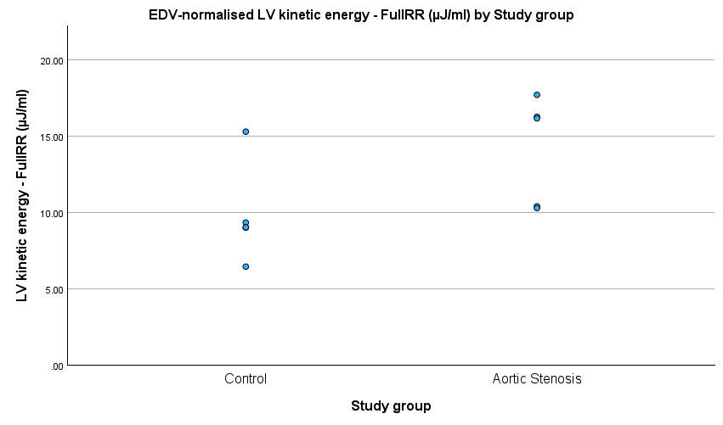
Figure 1 shows the distribution of EDV-normalised LV kinetic energy during the FullRR interval.
Figure 1. EDV-normalised LV kinetic energy during the FullRR interval in AS and control participants. Points represent individual observations. The between-group comparison was not statistically significant (p = 0.079).
3.3 LV vorticity
LV vorticity was assessed across the predefined cardiac intervals.
Mean FullRR LV vorticity was higher in the AS group than in controls (315.10 ± 59.91 vs 239.22 ± 27.01 s⁻¹). The mean difference was −75.87 s⁻¹ (95% CI −143.65 to −8.10; p = 0.033; Hedges' g = −1.474).
Systolic LV vorticity was also higher in AS than in controls (308.67 ± 44.46 vs 237.33 ± 34.49 s⁻¹), with a mean difference of −71.34 s⁻¹ (95% CI −129.37 to −13.31; p = 0.022; Hedges' g = −1.619).
The remaining vorticity comparisons were not statistically significant. Diastolic vorticity was 318.38 ± 75.88 s⁻¹ in AS and 245.56 ± 43.53 s⁻¹ in controls (p = 0.100). E-wave vorticity was 317.53 ± 80.54 s⁻¹ and 243.20 ± 17.91 s⁻¹, respectively (p = 0.079), while A-wave vorticity was 319.80 ± 73.30 s⁻¹ and 249.14 ± 105.64 s⁻¹ (p = 0.254). The corresponding 95% CIs were −163.03 to 17.39, −159.42 to 10.76 and −203.26 to 61.95, respectively.
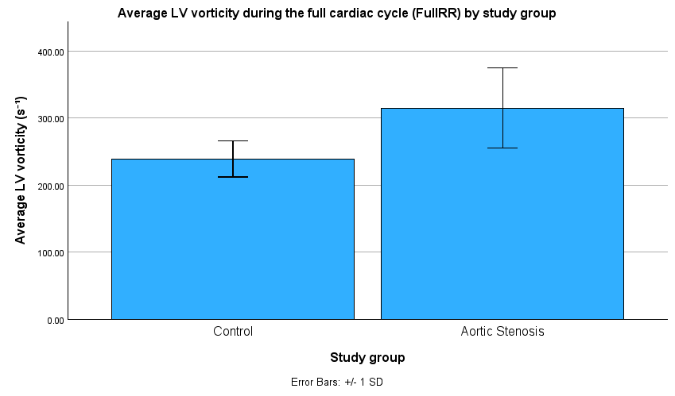
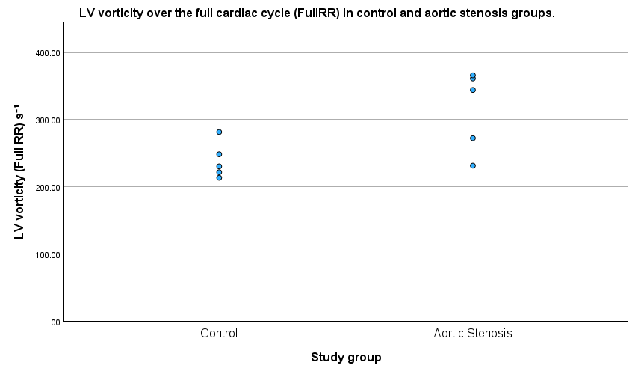
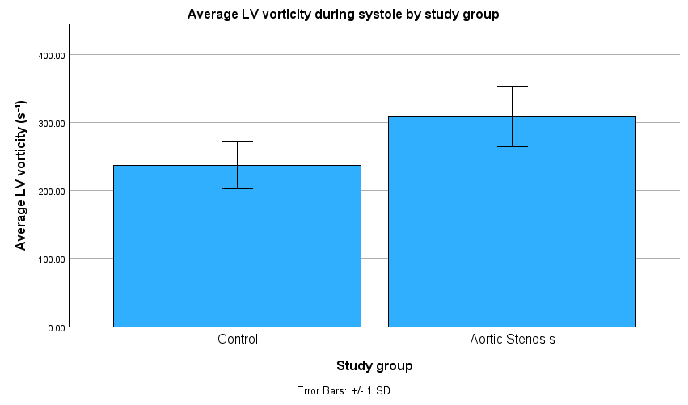
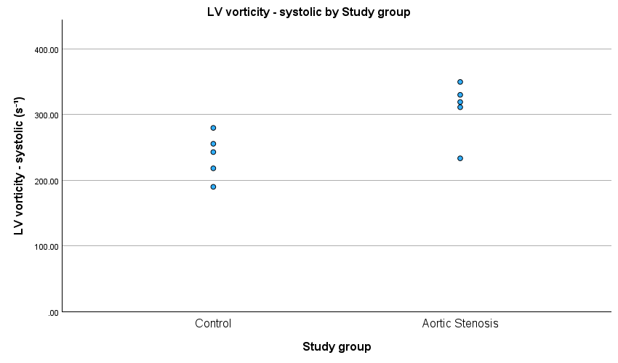
Figure 2 presents the FullRR and systolic LV vorticity comparisons and individual observations.
A
B
C
D
Figure 2. LV vorticity in AS and control participants. (A) Mean FullRR LV vorticity and (B) mean systolic LV vorticity, with error bars representing ±1 SD. (C) Individual FullRR observations and (D) individual systolic observations. Between-group differences were statistically significant for FullRR (p = 0.033) and systolic (p = 0.022).
3.4 LV energy loss
LV energy loss was assessed across the predefined cardiac intervals. None of the five comparisons reached the nominal significance threshold of p < 0.05.
Mean FullRR energy loss was 1245.26 ± 729.98 µW in the AS group and 579.85 ± 267.13 µW in controls (p = 0.092). Systolic energy loss was 1203.90 ± 699.58 µW and 599.16 ± 388.59 µW, respectively (p = 0.130).
Diastolic energy loss was 1260.32 ± 744.61 µW in AS and 593.60 ± 265.45 µW in controls (p = 0.096). E-wave energy loss was 1192.73 ± 796.44 µW and 501.42 ± 92.53 µW, respectively (p = 0.090), while A-wave energy loss was 1388.06 ± 676.47 µW and 769.47 ± 634.23 µW (p = 0.174).
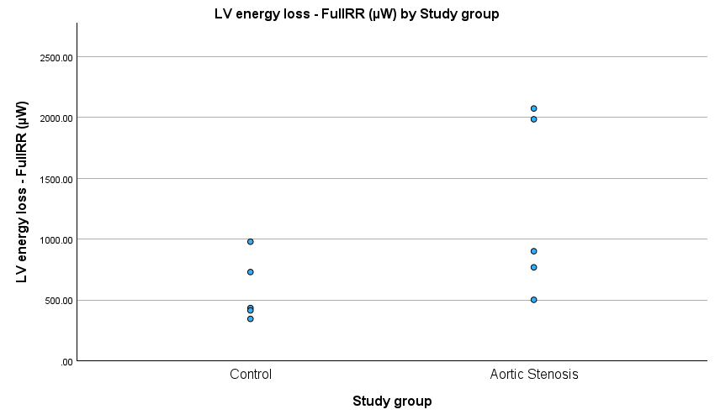
Figure 3 shows the distribution of LV energy loss during the FullRR interval.
Figure 3. LV energy loss during the FullRR interval in AS and control participants. Points represent individual observations. The between-group comparison was not statistically significant (p = 0.092).

3.5 Overall flow-energetic findings
Across the three 4D-flow CMR-derived parameters, statistically significant between-group differences were observed only for LV vorticity during FullRR and systole. Mean vorticity was higher in the AS group for both intervals, with p = 0.033 and p = 0.022, respectively.
None of the five EDV-normalised kinetic-energy comparisons or the five energy-loss comparisons reached the nominal significance threshold of p < 0.05.
The Welch unequal-variance sensitivity analysis produced the same significance classification as the primary analysis. FullRR vorticity remained statistically significant with p = 0.045, while systolic vorticity remained statistically significant with p = 0.023. No other comparison changed its statistical significance classification. The primary analysis remains the equal-variance Student's t-test results reported in Table 2.

