PACER

Peripheral Activity Completion Estimation and Recognition

Dr. Daniel Ross Moore

Center for Efficient, Scalable and Reliable Computing

Dept. of Electrical and Computer Engineering

North Carolina State University, Raleigh, USA

drmoore2@ncsu.edu

Dr. Alexander G. Dean

Center for Efficient, Scalable and Reliable Computing

Dept. of Electrical and Computer Engineering

North Carolina State University, Raleigh, USA

agdean@ncsu.edu

*Abstract*—Embedded peripheral devices such as memories, sensors and communications interfaces are used to perform a function external to a host microcontroller. The device manufacturer typically specifies worst-case current consumption and latency estimates for each of these peripheral actions. Peripheral Activity Completion, Estimation and Recognition (PACER) is introduced as a variety of algorithms that can be applied to detect completed peripheral operations in real-time. By detecting activity completion, PACER enables the host to exploit slack between the worst-case estimate and the actual response time. These methods were tested independently and in conjunction with IODVS on multiple common peripheral devices. For the peripheral devices under test, the test fixture confirmed decreases in energy expenditures of up to 62% and latency reductions of up to 67%.

Keywords-Embedded Systems; Dynamic Voltage Scaling (DVS); Dynamic Power Management (DPM); low-power; low-energy; wireless sensor node (WSN); timing and performance analysis; energy-aware design; power aware embedded computing; adaptive embedded systems.

# Introduction

Embedded systems are often constrained by timing and energy budgets because both factors affect the resultant cost and size of the system. Peripheral devices external to the microcontroller (MCU) such as those shown in Figure 1 can play a significant role in system-wide energy consumption. There are many methods available for decreasing the static power usage of peripherals [1] [2] [3]. PACER decreases dynamic power consumption and latency by exploiting the slack between actual versus worst-case operation time.

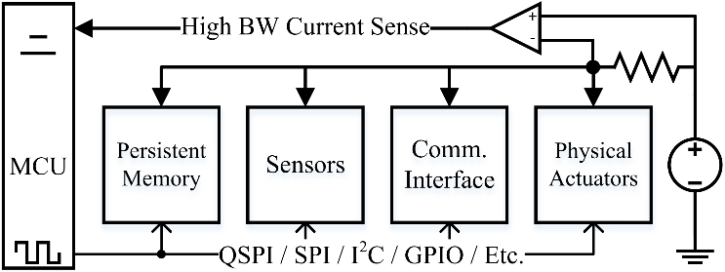Device manufacturers derive and specify the worst-case operation duration by summing exacerbating factors including age, temperature and voltage. Using the worst-case operation time as a naïve guideline, the energy consumption of a given operation is characterized by (1).

Figure : System Diagram

|  |  |
| --- | --- |
| $$E_{op}=\int_{0}^{t_{op}}{P_{op}(t)dt}+\int_{t_{op}}^{t_{slack}}{P_{slack}(t)dt}$$ | (1) |

Where $t_{op}$ and $P_{op}$ are the time and power comprising the actual operation while $t_{slack}$ and $P_{slack}$ are the time and power comprising the period between operation completion and the worst-case execution time.

Most peripheral devices provide a mechanism for signaling that operations completed earlier than the maximum. However, using these mechanisms results in sub-optimal power performance. For example, a common method of detecting write completion on external non-volatile memory relies on polling a status register. Performing this method has the following power and energy consequences:

|  |  |
| --- | --- |
|  | () |
|  | (3) |

* : MCU must be active while polling
* $P_{MCD}$: MCU communications driver must be active
* $P_{Comm}$: Communications incurs $P=cf{V_{dd}}^{2}$ penalty
* $P_{Match}$: MCU and device voltages must be matched.
  + Neither can use dynamic voltage scaling
* $P_{Dev}$: Device communications driver must be active

Of course, the optimal energy expenditure on an operation is simply As the energy cost of computation continues to decrease in modern microcontrollers, it becomes more rewarding to use onboard intelligence to minimize system-level energy consumption. PACER develops adaptive timing, current usage and charge consumption heuristics for estimating early completion of peripheral operations, thus reducing total latency and energy consumption.

The estimate is verified in real-time and the heuristic is updated with the results. In this fashion, the algorithms are resistant to variations in behavior that may occur across the lifecycle of the device. PACER is evaluated against a variety of embedded peripherals and is shown to significantly decrease both energy consumption and latency of peripherals with minimal computational overhead.

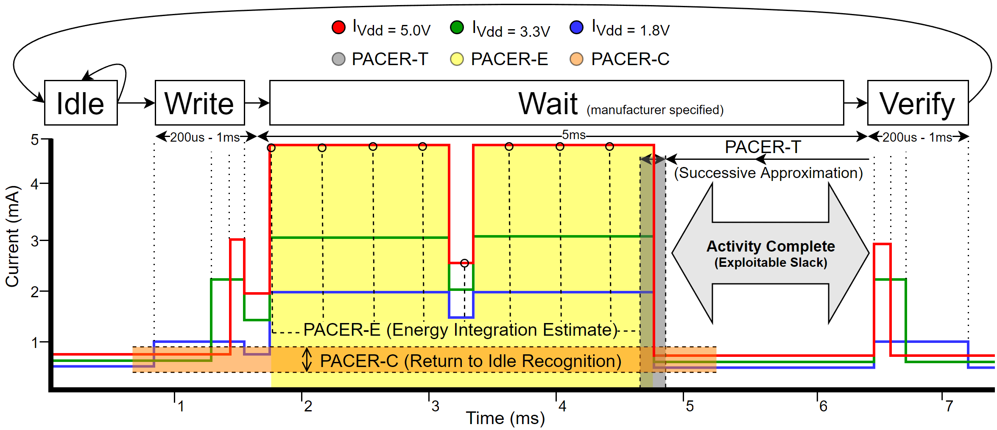For example, when writing a page of EEPROM a voltage-independent wait state is encountered that is specified to a maximum duration of 5ms. However, that specification is for the worst case and is more suitable for a timeout value. The current consumption profile of an EEPROM write operation at varying voltages is shown in **Error! Reference source not found.**. As the device transitions through the Idle 🡪 Write 🡪 Wait 🡪 Verify states, it can be inferred from the current profile that the operation completed by the 5ms mark and that it was not necessary to delay until approximately 6.5ms per the specification.

Figure : A Typical External Memory Transaction with IODVS and PACER

In the case of EEPROM and most peripheral devices, a register is provided which indicates when the write has completed. Polling this register requires the MCU to communicate with the peripheral and thus results in transitioning to a voltage-dependent state. Thus, accurate estimations can decrease latency and energy consumption, but inaccurate estimates can result in an early transition to a voltage-dependent state and thus increase energy consumption.

There are a wide variety of peripheral devices with a correspondingly wide variety of completion determinism and current profiles. Devices with highly deterministic timing respond best to the timing heuristic while those with variable timing respond best to current or charge heuristics.

PACER seeks to estimate and detect early completion of operations in peripheral devices by applying timing and current usage heuristics. Through early completion detection, ACR is able to decrease both latency and system-wide energy consumption. PACER is particularly advantageous to systems implementing IODVS by decreasing the effective duration of voltage-independent states.

Related Work

Intra-Operation Dynamic Voltage Scaling [1] (IODVS) has been shown to significantly reduce the energy consumption of embedded peripherals (Flash, EEPROM, sensors, etc.) during their voltage-independent states. These states typically occur during mandatory delay periods as the device completes a specified operation. Peripheral Activity Completion Estimation and Recognition (PACER) seeks to further reduce system-wide energy consumption and decrease peripheral latency by recognizing the completion of the voltage-independent state and thus completing the overall operation early.

We propose three considerably different methods to decrease peripheral latency by detecting activity-complete.

## Timing Heuristic

Peripheral operations can vary in their latency or completion times due to a number of factors. Temperature can significantly affect the completion time for peripherals with deterministic timing requirements such as DRAM [2]. Device aging can also affect timing due to a number of issues resulting from fundamental semiconductor physics [3]. Furthermore, some devices simply have non-deterministic completion times due to features such as MMUs and caches that are implemented in various data storage devices like Micro-SD cards, or age and wear as they effect FLASH storage timing.

Because the latency can vary significantly between operations, it is necessary to develop a timing heuristic that can adapt to slowly changing effects like age and temperature as well as rapidly changing factors like cache hits and misses. Adaptive delay estimation is not a new problem [4] and research continues to compensate for non-deterministic delay with different approaches for wireless communications, control systems and mass storage latency [5].

## Energy Heuristic

For devices with highly variable timing and dynamic current consumption characteristics, integrating the current consumption of the device throughout an operation can allow for better detection of completion. Some operations can be characterized by the amount of charge necessary to complete them. This technique is referred to as “coulomb counting” and is a common technique used to determine the state of charge in rechargeable batteries [6].

## Current Heuristic

The completion of some peripheral operations are easily detectable by their current consumption profile. These devices have a distinct and deterministic current profile that can be characterized and used to estimate the moment when an operation completes.

Simple and differential power analysis (SPA and DPA) attacks are performed by monitoring device current consumption with very fine grained detail. These attacks seek to undermine encryption techniques by monitoring the current consumption of the processor and detecting the moment at which the processor executes a branch operation [7]. The attacks have been performed on an ARM Cortex MCU using AES and required an extensive measurement setup to accomplish [8]. PACER is inspired by this previous work using fine-grained in-circuit current measurement and fortunately benefits from much more lenient sampling requirements.

# Methods

## Timing Heuristic PACER-T

The PACER-T algorithm uses a successive binary approximation algorithm to determine the optimal delay latency for an operation. The algorithm begins by executing an operation with the amount of delay specified in the device datasheet. After each iteration, if the operation was successful, then the amount of delay is halved. Otherwise, the operation resulted in an error and the next delay is increased by half the distance to the last previously successful operation.

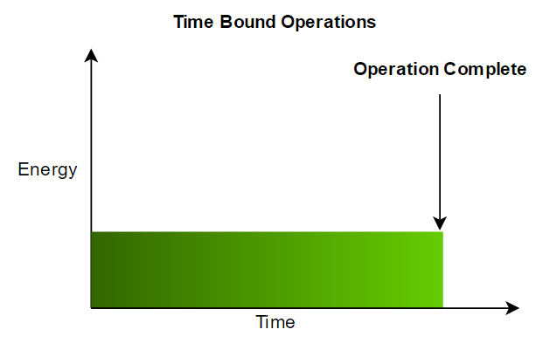

Figure

The algorithm is executed online and provides the tightest possible timing. In fact, the timing is so precise that it should be considered marginally stable. To account for extremely small variations in timing, for instance due to clock jitter or internal peripheral asynchronous operation, the minimum delay found by PACERT-T is increased by 5% in the following tests. This value was not optimized and may even be much smaller. It would likely be beneficial for a system using this algorithm to re-characterize the peripheral device periodically in order to account for temperature variations.

## Energy Heuristic PACER-E

The energy based heuristic was performed in much the same way as the timing heuristic. The system aggregates all output current samples from the power supply consumed by the peripheral device. When the digital integration has reached the test value, the operation is ‘complete’ and checked for correctness.

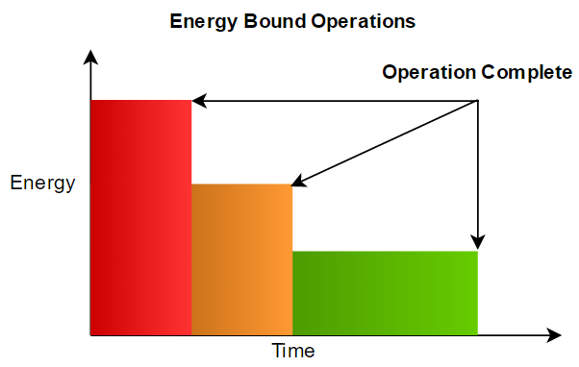

This algorithm is intended for use in devices that consume a constant amount of energy per operation. It compensates for devices that are energy bounded rather than time-bounded.

The algorithm uses a successive binary approximation in the same fashion as PACER-T in order to determine the exact amount of energy required to perform an operation. PACER-E is somewhat less precise than the timing based algorithm due to the time required to both sample and perform the digital integration necessary for threshold checking.

The energy consumed throughout a test is calculated using the fundamental relationship shown in (4). The results were calculated offline via (5) and (6), where S is the state of the device, and Ts is the sampling period.

|  |  |
| --- | --- |
|  | () |
|  | () |
|  | () |

## Current Heuristic PACER-C

The charge algorithm is also performed online and makes use of the current profile in order to determine if an operation has completed. The algorithm begins by taking a sample of the power supply output current. Next, the operation is executed and is not considered complete until the output current returns to some percentage of its previous state.

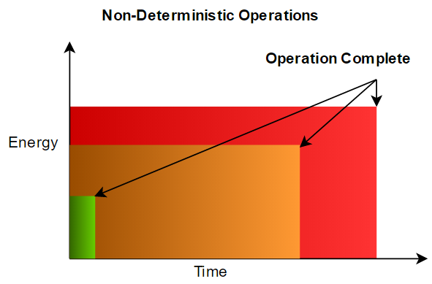

For instance, if the output current were measured to be 1mA before the operation began, and assuming that the operation will result in some increase in current, it is logical to wait until the current is once again at 1mA before polling the peripheral device for operation completion.

PACER-C is the most basic method to determine in real time if an operation has completed and may also be prone to false positives in some cases. There are many more advanced algorithms that can suit the purpose such as a multi-layer perceptron that is used in neural networks. It is notable however, that reducing the complexity of the detector is very important so that the algorithm can ensure that it is maintaining pace with incoming samples. Naturally, more complex algorithms could be accommodated by a more powerful host microcontroller.

# Materials

PACER and IODVS are hosted on a STM32F429 MCU implemented on the STMicroelectronics DISCO board and hosted by the PRIME assembly. The board provides 64MB of SDRAM which allows for simultaneous sampling throughout the test suite at very high speed. All experiments were sampled at 1MSPS and the SDRAM allowed any individual experiment to last up to 1 full second. All of the analog conversions as well as the device state sampling were performed via DMA. Therefore, the test fixture is expected to have had no impact on the operation under test.

The PRIME (Precise Real-Time In-Circuit Micro-EMS) hosts a variety of peripherals commonly implemented in embedded designs. The board provides access to Bluetooth, Wi-Fi and a Si1143 proximity detector. PACER was evaluated on NAND and NOR FLASH memories, as well as a commercial EEPROM, temperature / humidity sensor and four independent Micro-SD cards.

At 1 MSPS and 4 channel measurements and 2 bytes per sample, each test can result in up to 8 megabytes of data. Because repeatability is so important, each test was run 50 times. Therefore, bandwidth became a limiting factor and a Hi-Speed (480mbps) USB module was added to the board to allow for rapid development. Operating as a virtual communications port, actual bandwidth was realized at approximately 120mbps.

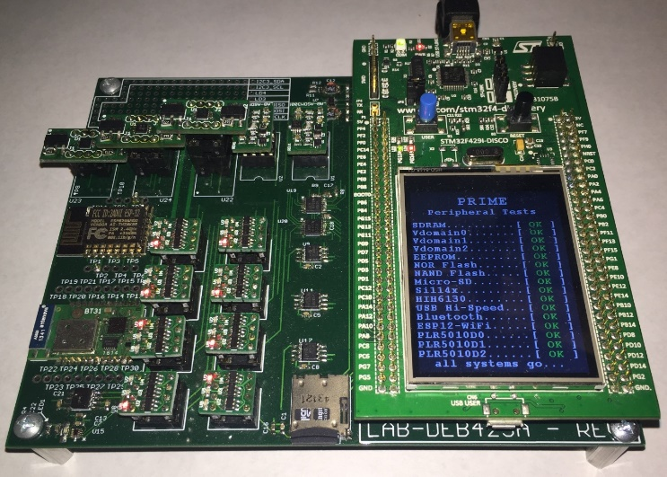

Figure : PRIME (Precise Real-Time In-Circuit Micro-EMS)

Each of the peripheral devices under test has some method of determining if an operation completed successfully. For the memory devices, a simple read-back verification is sufficient to determine correctness and is a common practice among embedded designs. The temperature and humidity sensor provides a status bit indicating if an operation is in progress, thus indicating that a requested operation has not yet completed.

Recall that when implementing IODVS, that the host MCU and peripheral devices are placed on different voltage domains throughout the course of the voltage-independent state. Because of this, it is not possible for the MCU to poll the peripheral device for operation completion. Polling is also shown to be a rather costly operation in and of itself. Without the ability to communicate to the peripheral device, PACER uses other methods to best judge operation completeness.

Power can be provided and modulated to each individual device on the domain using independently configurable power supplies. The ASDM-300F module provides a high-efficiency buck power supply, followed by a linear regulator with a high ripple-rejection ratio. A high-precision clean power supply is extremely important because PACER uses the current profile to make real-time decisions. If the power supply outputs a significant amount of noise, then it becomes more and more difficult to determine activity completion.

The ASDM-300F is also outfitted with a dual current measurement circuit using the Maxim MAXZZZ. This circuit allows the host to measure both the input and output current of the power supply with high analog bandwidth. Ultimately, these outputs are used to determine activity completion with the PACER-E and PACER-C algorithms. It is important to note the gain-bandwidth product of the MAX. High frequency content will be attenuated to some degree and the actionable data output would be of higher quality if a higher frequency device were available.

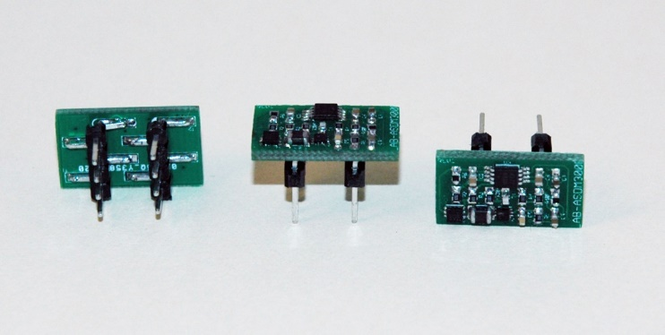

Figure : ASDM300F (Adjustable Step-Down Module with Feedback)

While measuring and classifying activity completion, it is important that each device be analyzed independently. The PPS-330D allows the host to switch the voltage domain of an individual peripheral to any one of three domains, or disconnect the device entirely (including the ground connection).

The PPS-330D devices are connected to each peripheral, and when a peripheral is under test, the other devices are switched to an alternate voltage domain. Thus, each device is can be independently classified in-system without removing other devices that may contribute to the current measurements.

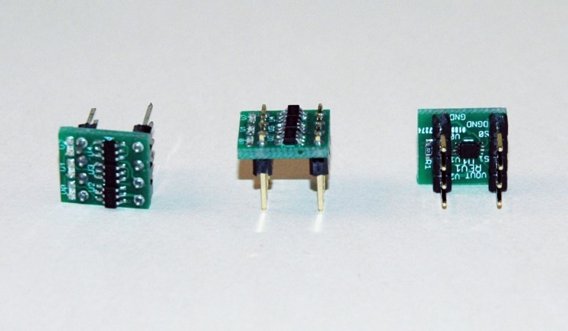

Figure : PPS-330D Peripheral Power Switch with Disconnect

# Results

Initial IODVS results were repeated so as to establish a baseline with which to compare the results of PACER. Previous experiments required the results to be averaged many times over. The PRIME assembly provides high enough signal to noise ratio that averaging multiple test results is unnecessary and a simple 50-sample moving average provides enough noise cancellation while maintaining a quick response time.

## MCP25AA512 EEPROM

The Microchip EEPROM is specified by the manufacturer for a 5ms mandatory wait period following the write command and data. This operation is highly deterministic with respect to time, energy and current profile. All PACER algorithms identified activity completion with a high degree of accuracy.





Figure : EEPROM Write Cycle Using IODVS and PACER-T

As can be inferred from the current profile, the EEPROM write operation appears to complete at approximately the 5ms mark of Figure 7 instead of the 6.5ms mark as is specified by the manufacturer. After applying the PACER-T algorithm, it is indeed true that the operation was complete at the 5ms mark, thus reducing the wait latency by 30%.

The PACER-E and PACER-C algorithms were also successful in identifying activity completion. The two algorithms do require additional computation to integrate or otherwise observe the current profile and therefore PACER-T is the best choice in this application, given identical performance.

## Numonyx M25PX16 NOR Serial Flash

NOR flash modules sacrifice byte-wise modification for overall capacity. In this fashion, the M25PX16 presents 16MBits of capacity in a small package, but the host must erase sub-sectors of flash (4K) to enable writes to pages of flash (128B). To perform a read-modify-write operation, one must read the contents of a sub-sector, modify the contents locally, erase the sub-sector in flash and finally write the modified contents back to the flash on a page-by-page basis.

Both the sub-sector erase and page write have a worst-case mandatory wait period specified by the manufacturer.





Figure : NOR Serial Flash Write Cycle Using IODVS and PACER-T

Although specified for 150ms, the initial sub-sector erase appears to complete at approximately 65ms after it begins. Page writes are specified for a worst-case completion time of 10ms but through the application of PACER-T, it is shown that they complete much faster.

## Microchip SST26VB Serial NAND Flash

NAND flash modules sacrifice byte-wise reads for the sake of overall capacity. The serial flash module must therefore read an entire page of flash into a local buffer before providing read data to the host. This can result in non-deterministic read and write access times.

As shown in Figure 9, the manufacturer specified erase time

|  |  |  |  |
| --- | --- | --- | --- |
| Stage | Mfg. Spec. | PACER-T | Diff. |
| Erase (4KB) | 25ms |  |  |
| 16x Write (256B) | 2ms |  |  |
| Total | 49ms |  |  |





Figure : NAND Serial Flash Write Cycle Using IODVS and PACER-T





Figure : A Micro-SD Card Cache Miss and a Cache Hit

# 

# Conclusions

Note that the “Active Total” items in the following tables encompass the test results ignoring the idle state contributions to both time and energy. The idle state is a byproduct of the test and in actual usage could be any arbitrary value. The value would be incorporated into the duty cycle discussion that was investigated in the results of IODVS.

# References

|  |  |
| --- | --- |
| [1] | D. Moore, "Intra-Operation Dynamic Voltage Scaling," in *2015 IEEE 3rd International Conference on Cyber-Physical Systems, Networks, and Applications*, Hong Kong, 2015. |
| [2] | D. Lee, Y. Kim, G. Pekhimenko, S. Khan, V. Seshadri, K. Chang and O. Mutlu, "Adaptive-latency DRAM: Optimizing DRAM timing for the common-case," in *IEEE 21st International Symposium on High Performance Computer Architecture (HPCA)*, 2015. |
| [3] | S. Sadeghi-Kohan, M. Kamal, J. McNeil, P. Prinetto and Z. Navabi, "Online self adjusting progressive age monitoring of timing variations," in *10th International Conference on Design & Technology of Integrated Systems in Nanoscale Era (DTIS)*, 2015. |
| [4] | D. S. S. Etter, "Adaptive Estimatation of Time Delays in Sampled Data Systems," in *IEEE Transactions on Acoustics Speech and Signal Processing*, 1981. |
| [5] | S. G. P. A. Z. E. Tarasov V, "Efficient I/O Scheduling with Accurately Estimated Disk Drive Latencies," in *The Proceedings of OSPERT 2012*, 2012. |
| [6] | H. Macicior, M. Oyarbide, O. Miguel, I. Cantero, J. Canales and A. Etxeberria, "Iterative capacity estimation of LiFePO4 cell over the lifecycle based on SoC estimation correction," in *Electric Vehicle Symposium and Exhibition (EVS27)*, 2013. |
| [7] | H. Mahanta, A. Azad and A. Khan, "Power analysis attack: A vulnerability to smart card security," in *International Conference on Signal Processing And Communication Engineering Systems (SPACES)*, 2015. |
| [8] | M. Petrvalsky, M. Drutarovsky and M. Varchola, "Differential power analysis attack on ARM based AES implementation without explicit synchronization," in *Radioelektronika 2014 24th International Conference*, 2014. |

# Prepare Your Paper Before Styling

Before you begin to format your paper, first write and save the content as a separate text file. Keep your text and graphic files separate until after the text has been formatted and styled. Do not use hard tabs, and limit use of hard returns to only one return at the end of a paragraph. Do not add any kind of pagination anywhere in the paper. Do not number text heads-the template will do that for you.

Finally, complete content and organizational editing before formatting. Please take note of the following items when proofreading spelling and grammar:

## Abbreviations and Acronyms

Define abbreviations and acronyms the first time they are used in the text, even after they have been defined in the abstract. Abbreviations such as IEEE, SI, MKS, CGS, sc, dc, and rms do not have to be defined. Do not use abbreviations in the title or heads unless they are unavoidable.

## Units

* Use either SI (MKS) or CGS as primary units. (SI units are encouraged.) English units may be used as secondary units (in parentheses). An exception would be the use of English units as identifiers in trade, such as “3.5-inch disk drive”.
* Avoid combining SI and CGS units, such as current in amperes and magnetic field in oersteds. This often leads to confusion because equations do not balance dimensionally. If you must use mixed units, clearly state the units for each quantity that you use in an equation.
* Do not mix complete spellings and abbreviations of units: “Wb/m2” or “webers per square meter”, not “webers/m2”. Spell out units when they appear in text: “. . . a few henries”, not “. . . a few H”.
* Use a zero before decimal points: “0.25”, not “.25”.

## Equations

The equations are an exception to the prescribed specifications of this template. You will need to determine whether or not your equation should be typed using either the Times New Roman or the Symbol font (please no other font). To create multileveled equations, it may be necessary to treat the equation as a graphic and insert it into the text after your paper is styled.

Number equations consecutively. Equation numbers, within parentheses, are to position flush right, as in (1), using a right tab stop. To make your equations more compact, you may use the solidus ( / ), the exp function, or appropriate exponents. Italicize Roman symbols for quantities and variables, but not Greek symbols. Use a long dash rather than a hyphen for a minus sign. Punctuate equations with commas or periods when they are part of a sentence, as in

       

Note that the equation is centered using a center tab stop. Be sure that the symbols in your equation have been defined before or immediately following the equation. Use “(1)”, not “Eq. (1)” or “equation (1)”, except at the beginning of a sentence: “Equation (1) is . . .”

## Some Common Mistakes

* The word “data” is plural, not singular.
* The subscript for the permeability of vacuum **0, and other common scientific constants, is zero with subscript formatting, not a lowercase letter “o”.
* In American English, commas, semi-/colons, periods, question and exclamation marks are located within quotation marks only when a complete thought or name is cited, such as a title or full quotation. When quotation marks are used, instead of a bold or italic typeface, to highlight a word or phrase, punctuation should appear outside of the quotation marks. A parenthetical phrase or statement at the end of a sentence is punctuated outside of the closing parenthesis (like this). (A parenthetical sentence is punctuated within the parentheses.)
* A graph within a graph is an “inset”, not an “insert”. The word alternatively is preferred to the word “alternately” (unless you really mean something that alternates).
* Do not use the word “essentially” to mean “approximately” or “effectively”.
* In your paper title, if the words “that uses” can accurately replace the word “using”, capitalize the “u”; if not, keep using lower-cased.
* Be aware of the different meanings of the homophones “affect” and “effect”, “complement” and “compliment”, “discreet” and “discrete”, “principal” and “principle”.
* Do not confuse “imply” and “infer”.
* The prefix “non” is not a word; it should be joined to the word it modifies, usually without a hyphen.
* There is no period after the “et” in the Latin abbreviation “et al.”.
* The abbreviation “i.e.” means “that is”, and the abbreviation “e.g.” means “for example”.

An excellent style manual for science writers is [7].

# Using the Template

After the text edit has been completed, the paper is ready for the template. Duplicate the template file by using the Save As command, and use the naming convention prescribed by your conference for the name of your paper. In this newly created file, highlight all of the contents and import your prepared text file. You are now ready to style your paper.

## Authors and Affiliations

The template is designed so that author affiliations are not repeated each time for multiple authors of the same affiliation. Please keep your affiliations as succinct as possible (for example, do not differentiate among departments of the same organization). This template was designed for two affiliations.

### For author/s of only one affiliation (Heading 3): To change the default, adjust the template as follows.

#### Selection (Heading 4): Highlight all author and affiliation lines.

#### Change number of columns: Select Format > Columns >Presets > One Column.

#### Deletion: Delete the author and affiliation lines for the second affiliation.

#### For author/s of more than two affiliations: To change the default, adjust the template as follows.

#### Selection: Highlight all author and affiliation lines.

#### Change number of columns: Select Format > Columns > Presets > One Column.

#### Highlight author and affiliation lines of affiliation 1 and copy this selection.

#### Formatting: Insert one hard return immediately after the last character of the last affiliation line. Then paste the copy of affiliation 1. Repeat as necessary for each additional affiliation.

#### Reassign number of columns: Place your cursor to the right of the last character of the last affiliation line of an even numbered affiliation (e.g., if there are five affiliations, place your cursor at end of fourth affiliation). Drag the cursor up to highlight all of the above author and affiliation lines. Go to Format > Columns and select “2 Columns”. If you have an odd number of affiliations, the final affiliation will be centered on the page; all previous will be in two columns.

## Identify the Headings

Headings, or heads, are organizational devices that guide the reader through your paper. There are two types: component heads and text heads.

Component heads identify the different components of your paper and are not topically subordinate to each other. Examples include Acknowledgments and References and, for these, the correct style to use is “Heading 5”. Use “figure caption” for your Figure captions, and “table head” for your table title. Run-in heads, such as “Abstract”, will require you to apply a style (in this case, italic) in addition to the style provided by the drop down menu to differentiate the head from the text.

Text heads organize the topics on a relational, hierarchical basis. For example, the paper title is the primary text head because all subsequent material relates and elaborates on this one topic. If there are two or more sub-topics, the next level head (uppercase Roman numerals) should be used and, conversely, if there are not at least two sub-topics, then no subheads should be introduced. Styles named “Heading 1”, “Heading 2”, “Heading 3”, and “Heading 4” are prescribed.

## Figures and Tables

### Positioning Figures and Tables: Place figures and tables at the top and bottom of columns. Avoid placing them in the middle of columns. Large figures and tables may span across both columns. Figure captions should be below the figures; table heads should appear above the tables. Insert figures and tables after they are cited in the text. Use the abbreviation “Fig. 1”, even at the beginning of a sentence.

1. Table Type Styles

| Table Head | Table Column Head | | |
| --- | --- | --- | --- |
| Table column subhead | Subhead | Subhead |
| copy | More table copya |  |  |

a. Sample of a Table footnote. (Table footnote)

We suggest that you use a text box to insert a graphic (ideally 300 dpi), with all fonts embedded) because, in an MSW document, this method is somewhat more stable than directly inserting a picture.

To have non-visible rules on your frame, use the MSWord pull-down menu, select Format > Borders and Shading > Select “None”.

1. Example of a ONE-COLUMN figure caption.

Please see last page of this document for AN EXAMPLE of a 2-COLUMN Figure.

Figure Labels: Use 8 point Times New Roman for Figure labels. Use words rather than symbols or abbreviations when writing Figure axis labels to avoid confusing the reader. As an example, write the quantity “Magnetization”, or “Magnetization, M”, not just “M”. If including units in the label, present them within parentheses. Do not label axes only with units. In the example, write “Magnetization (A/m)” or “Magnetization {A[m(1)]}”, not just “A/m”. Do not label axes with a ratio of quantities and units. For example, write “Temperature (K)”, not “Temperature/K”.

## Footnotes

Use footnotes sparingly (or not at all) and place them at the bottom of the column on the page on which they are referenced. Use Times 8-point type, single-spaced. To help your readers, avoid using footnotes altogether and include necessary peripheral observations in the text (within parentheses, if you prefer, as in this sentence).

##### Acknowledgment

The preferred spelling of the word “acknowledgment” in America is without an “e” after the “g”. Avoid the stilted expression, “One of us (R.B.G.) thanks . . .” Instead, try   
“R.B.G. thanks”. Put applicable sponsor acknowledgments here; DO NOT place them on the first page of your paper or as a footnote.

##### References

List and number all bibliographical references in 9-point Times, single-spaced, at the end of your paper. When referenced in the text, enclose the citation number in square brackets, for example [1]. Where appropriate, include the name(s) of editors of referenced books. The template will number citations consecutively within brackets [1]. The sentence punctuation follows the bracket [2]. Refer simply to the reference number, as in [3]—do not use “Ref. [3]” or “reference [3]” except at the beginning of a sentence: “Reference [3] was the first . . .”

Number footnotes separately in superscripts. Place the actual footnote at the bottom of the column in which it was cited. Do not put footnotes in the reference list. Use letters for table footnotes.

Unless there are six authors or more give all authors’ names; do not use “et al.”. Papers that have not been published, even if they have been submitted for publication, should be cited as “unpublished” [4]. Papers that have been accepted for publication should be cited as “in press” [5]. Capitalize only the first word in a paper title, except for proper nouns and element symbols.

For papers published in translation journals, please give the English citation first, followed by the original foreign-language citation [6].

1. G. Eason, B. Noble, and I. N. Sneddon, “On certain integrals of Lipschitz-Hankel type involving products of Bessel functions,” Phil. Trans. Roy. Soc. London, vol. A247, pp. 529–551, April 1955. *(references)*
2. J. Clerk Maxwell, A Treatise on Electricity and Magnetism, 3rd ed., vol. 2. Oxford: Clarendon, pp.68–73, 1892,
3. I. S. Jacobs and C. P. Bean, “Fine particles, thin films and exchange anisotropy,” in Magnetism, vol. III, G. T. Rado and H. Suhl, Eds. New York: Academic, pp. 271–350, 1963.
4. K. Elissa, “Title of paper if known,” unpublished.
5. R. Nicole, “Title of paper with only first word capitalized,” J. Name Stand. Abbrev., in press.
6. Y. Yorozu, M. Hirano, K. Oka, and Y. Tagawa, “Electron spectroscopy studies on magneto-optical media and plastic substrate interface,” IEEE Transl. J. Magn. Japan, vol. 2, pp. 740–741, August 1987 [Digests 9th Annual Conf. Magnetics Japan, p. 301, 1982].
7. M. Young, The Technical Writer’s Handbook. Mill Valley, CA: University Science, 1989.
8. Electronic Publication: Digital Object Identifiers (DOIs):

Article in a journal:

1. D. Kornack and P. Rakic, “Cell Proliferation without Neurogenesis in Adult Primate Neocortex,” Science, vol. 294, pp. 2127-2130, Dec. 2001, doi:10.1126/science.1065467.
2. European Space Agency. *ESA: Missions, Earth Observation: ENVISAT*. [Online]. Available from: http://envisat.esa.int/ 2008.06.25

Article in a conference proceedings:

1. A. Kito, Y. Mizumachi, K. Sato, Y. Matsuoka, “Emergent Design System Using Computer-Human Interactions and Serendipity” The Sixth International Conference on Advances in Computer-Human Interactions (ACHI 2013) IARIA, Feb. 2013, pp. 7-12, ISSN: 2308-4138, ISBN: 978-1-61208-250-9
2. H. Goto, Y. Hasegawa, and M. Tanaka, “Efficient Scheduling Focusing on the Duality of MPL Representatives,” Proc. IEEE Symp. Computational Intelligence in Scheduling (SCIS 07), IEEE Press, Dec. 2007, pp. 57-64, doi:10.1109/SCIS.2007.357670.

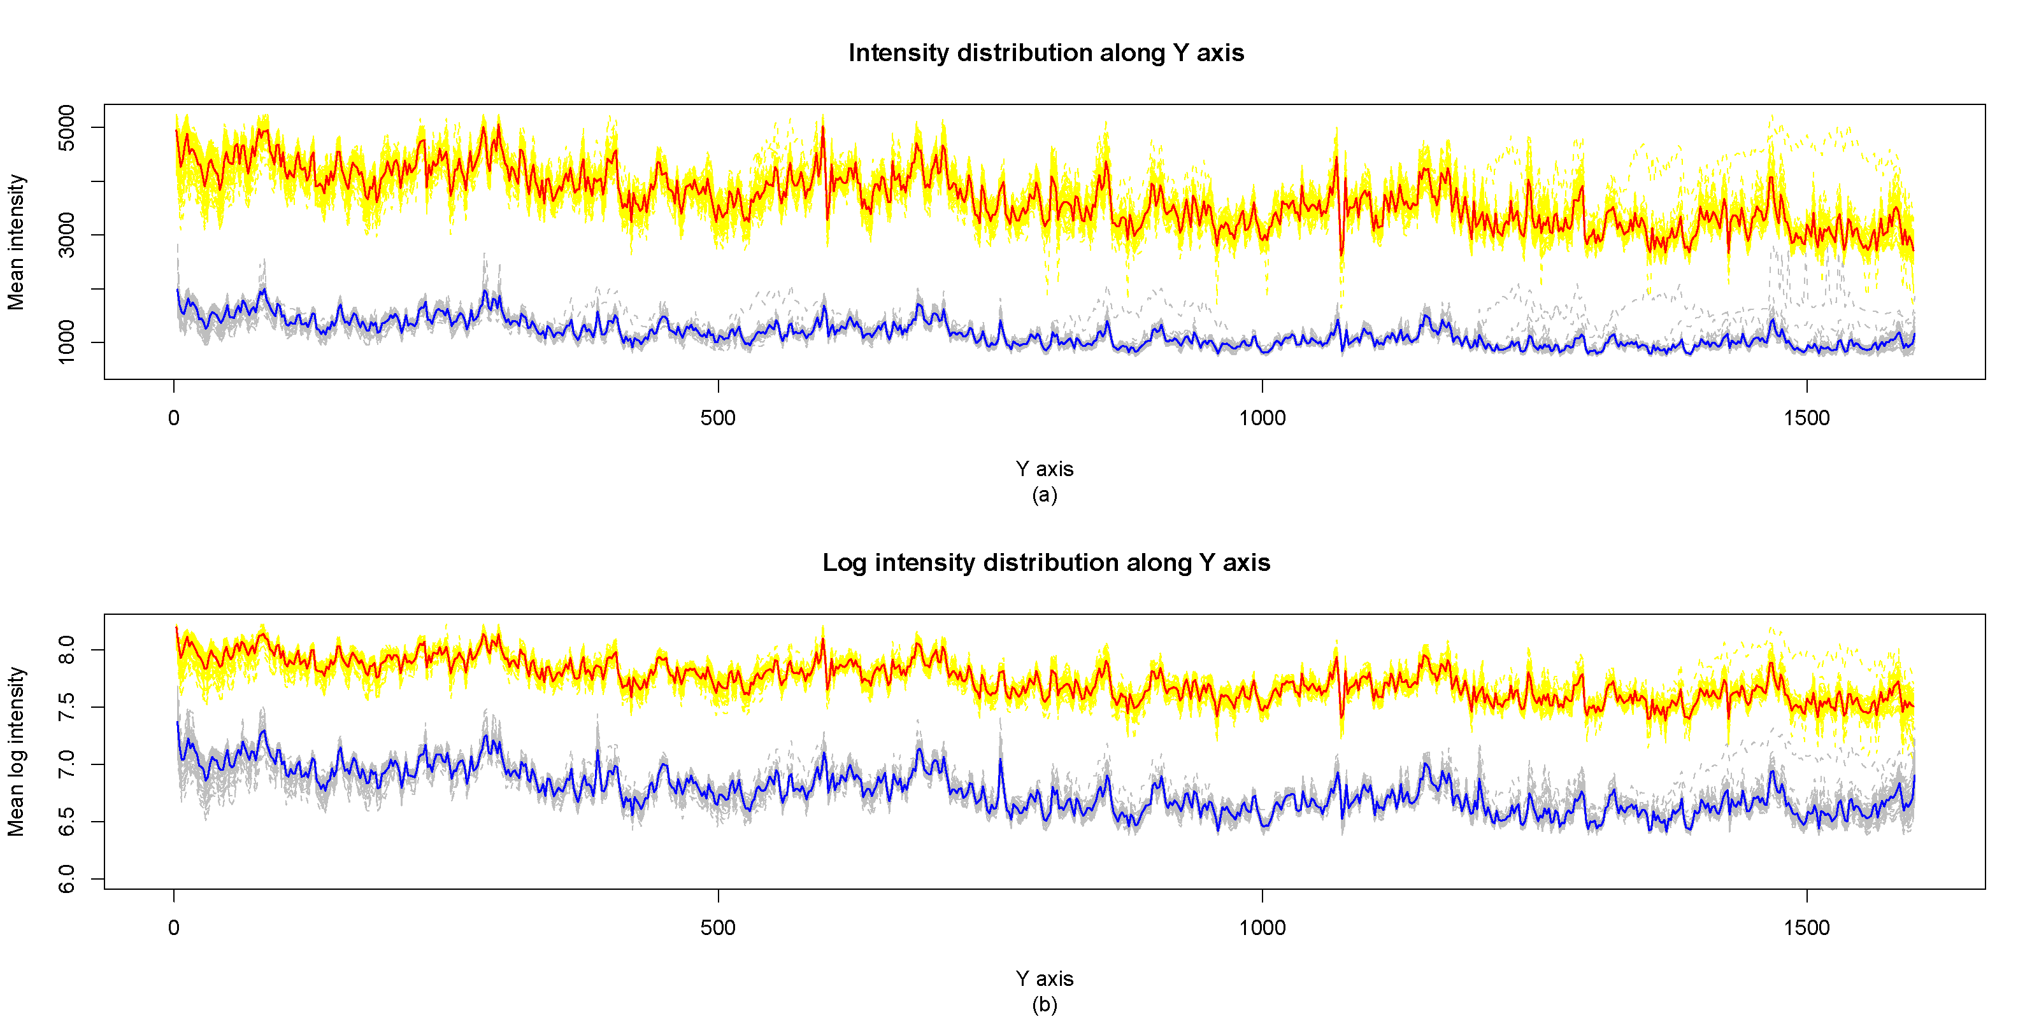 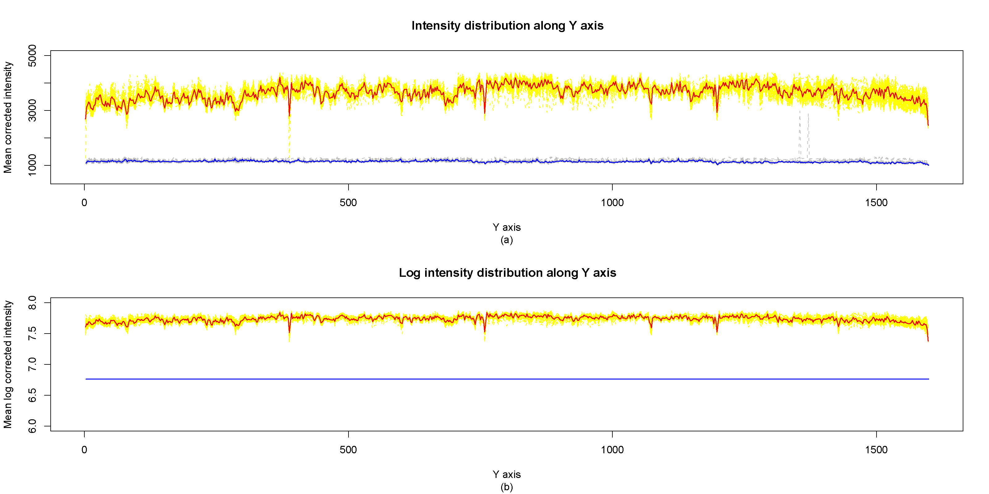

1. Example of a TWO-COLUMN figure caption: (a) this is the format for referencing parts of a figure.