We must not allow a

Mineshaft Gap

# Game Options Menu

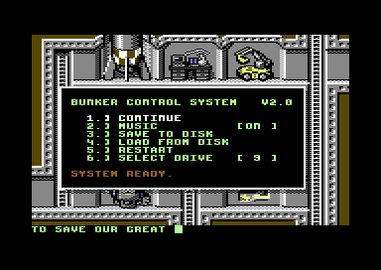

* CONTINUE : Continue the game, return from the menu
* MUSIC : Turn background music off/on
* SAVE TO DISK : Save the current game state to the floppy
* LOAD FROM DISK : Load the current game state from the floppy
* RESTART : Restart the game from the beginning
* SELECT DRIVE : Toggle between drive 8 and 9

# In Game Menu

The in game menu at the bottom of the screen allows you to control your bunker construction and dweller occupation. You can activate a menu item by pushing the first letter of the item name on the keyboard. An entry can also be activated by pushing the joystick button, selecting the entry with left/right and releasing the button again with the item selected.



* MAP : Select map mode, allows navigation on the game map with the joystick or cursor keys
* TEM : Shows the team menu with an overview of your bunker dwellers and lets you select one of them to assign for work
* DIG : Extend your bunker with a new room corridor or ladder
* BLD : Shows the building menu with an overview of your built rooms, and lets you start a new installation inside one of your unused bunker rooms
* ASG : Assigns your currently selected dweller to work at the installation in the room where your cursor is
* GRD : Assigns your currently selected dweller to guard the room
* HIS : Shows a history of messages
* LCH : Lauch a missile (if you should have one)
* SAV : Save the current game state
* OPT : Open the game options menu

# Status Display

The status display provides information on your bunker state as well as the currently selected bunker dweller.

The top eight bars show the current resource situation:

* E : Energy, needed by most installations to work
* W : Water, consumed by the diggers
* B : Building, needed to create installations
* H : Healing, restore the health of your diggers
* M : Metal, needed to build most installations
* C : Carbon, needed to build advanced installations
* U : Uranium
* F : Fuel

The X bar reflects the oxygen situation in the floors of your bunker.

The next line shows the name and current occupation of the selected digger as well as his or her health status. A digger may either be:

* I : Idle
* W : Working
* G : Guarding
* T : Training
* D : Dead

The next three bars show the diggers abilities and training:

* A : Aptitude, Needed for most work in installations, higher values will result in a greater production factor
* F : Fight, ability of the digger to withstand attacks and fight back
* I : Intelligence, helps with researching, healing or communication tasks

# Map Display

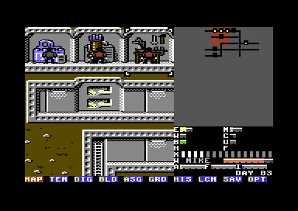

The map display is the main navigation view. You can use the cursor key or the joystick to navigate the cursor and the visible area. You cannot move the view beyond your bunker structure, so you might need to dig some exploration shafts.

The dig command will attach a new shaft or floor item to your bunker, once you have build it, you can use the build menu to put an installation into a free floor.

Only the top five floor get natural oxygen, and only the topmost floors have unlimited oxygen, so digging deeper will require some kind of ventilation to keep your diggers alive.

# Team Display

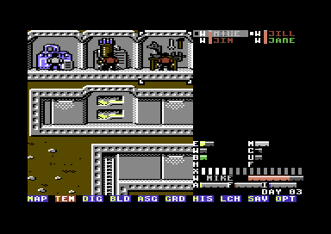

The team display shows all your dwellers, dead and alive. You can use the cursor keys or joystick to select a different digger. The color of each bunker dweller represents his or her major ability, and will change when training. The small bar besides the diggers shows their current health status.

# Building Menu

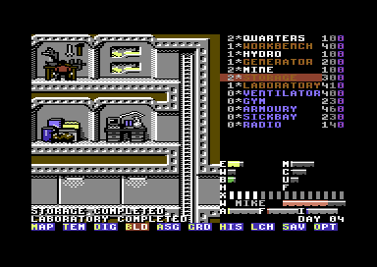

The building menu shows all your installations. The number to the left represents the already installed rooms of this type, the number to the right the resource cost. Buildings in blue are only blueprints, so you have some plans, but need to research them before you can build them.