The first level „Overture“ puts you against an enemy with the same setup, one flag, two infantry and three light tank squads.

At the same time, you have to defend your own flag, and attack the enemies flag. There is not enough time to first eliminate the enemy, so your first task is to split your forces and set up your defense.

We will need more than two infantry squads to defend our flag, but we also want the upper hand when attacking the enemy tank in the center. Time is of the essence, we may not give the enemy time to setup its own defense, so we move the rightmost tank squad as far into enemy territory as possible.

Moving the infantry into place in the first round, gives it time to dig in, before the first enemy arrives. The tanks cannot cross the forest, so they have to attack from the beach. Placing the infantry one field apart forces the attacker to accept cross fire, when targeting the flag.

Now it is time to attack the tank squad in the center with both adjacent squads, to gain experience and weaken the enemy.

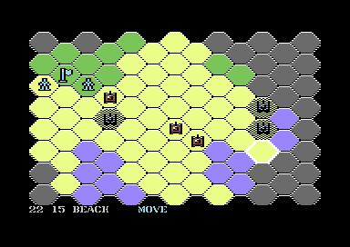

Next we split forces again, moving two squad further towards enemy territory and one squad in a pincer movement to block the approaching tank squad. The enemy will most likely attack the infantry unit in the forest. If your units are not severely decimated, attack the enemy with both squads.

If your attacking squad from the previous round was decimated, move it to the lower spot and have the complete squad approach the enemy infantry, otherwise do the opposite. Attacking the infantry will increase experience, but may also reduce the number of units in the squad.

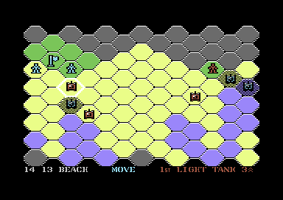

Keep blocking the enemy on the left, while approaching the enemy flag on the right. Switch tank squads next to the enemy infantry to allow for repair if required.

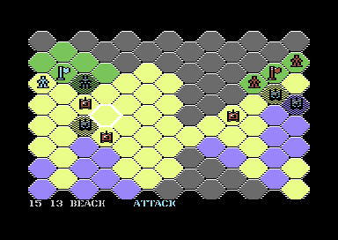

Start attacking the enemy flag as soon as you approach it. if you have only one unit in your attacking squad left – it would be wiser to repair. Each tank shoots only once per battle, so the best outcome you can expect with only one intact tank, would be one destroyed flag, which the enemy can easily recover in its repair round.

Finally we put the cork into our defensive position, by moving the tank between the two supporting infantry squads. You will also most likely need both tank squads on the right to take out the flag, as they will take heave casualties themselves from the attacking infantry and enemy tank squad. There is mostly not enough time to take them out first.

So good luck, and don’t forget, no battle plan survives contact with the enemy. There is enough random in the battle execution that you may have to adapt your strategy.