Correlation Between Two-Dimensional and Three-Dimensional Virtual Planning on Soft Tissue Prediction for Orthognathic Surgery Using Dolphin 3D Software
Statistical Methodology and Results

Statistical Methodology

Outcome variable
The primary outcome was the soft-tissue prediction error, defined as the linear difference (in millimetres) between the simulated (virtually planned) position and the actual postoperative position of three soft-tissue landmarks: upper lip, lower lip and soft-tissue pogonion. The error was recorded for every patient with both two-dimensional (2D) and three-dimensional (3D) virtual planning in Dolphin 3D software, so that each patient served as their own control (paired design). Errors were analysed as absolute values, without regard to direction. Recorded values of 0.00 mm represent a true zero error and were analysed as entered; all 10 patients were included.

Descriptive statistics
Continuous variables were described as mean ± standard deviation (SD), 95% confidence interval (CI) of the mean, median (interquartile range, IQR) and range (minimum–maximum). Categorical variables were described as frequency and percentage.

Comparison between 2D and 3D planning
Normality of the paired differences (2D − 3D) was tested with the Shapiro–Wilk test. The prediction errors of 2D and 3D planning were compared at each landmark with the paired t-test, and the mean difference was reported with its 95% CI. Because of the small sample size, the Wilcoxon signed-rank test was applied as a confirmatory non-parametric test. The effect size was expressed as Cohen's dz (mean difference divided by the SD of the differences) and interpreted as small (0.2), medium (0.5) or large (≥ 0.8). To control the family-wise error rate across the three landmarks, the paired t-test p values were additionally adjusted with the Holm method. The overall prediction error of each patient was calculated as the mean of the three landmarks and compared in the same way.

Correlation between 2D and 3D planning
The correlation between the 2D and 3D prediction errors at each landmark was assessed with Pearson's correlation coefficient (r). Spearman's rank correlation coefficient (ρ), which is robust to outliers, was reported alongside. Correlation strength was interpreted as weak (|r| < 0.3), moderate (0.3–0.7) or strong (> 0.7).

Clinical acceptability
A prediction error of ≤ 2 mm was considered clinically acceptable. The proportions of clinically acceptable predictions with 2D and 3D planning were compared at each landmark with the exact McNemar test for paired proportions.

Comparison among landmarks
Differences in prediction error among the three landmarks were tested separately for each planning method with the Friedman test, followed by pairwise Wilcoxon signed-rank tests with Bonferroni correction.

Planned movement and prediction error
The association between the magnitude of the planned surgical movement and the prediction error at the corresponding landmark (maxillary advancement – upper lip; mandibular setback – lower lip; genioplasty advancement – soft-tissue pogonion) was explored with Spearman's rank correlation.

Software and level of significance
Statistical analysis was performed with Python 3.13.17 using the SciPy (v1.18.1) and statsmodels (v0.15.0) libraries. All tests were two-tailed, and a p value < 0.05 was considered statistically significant.

Results

Sample characteristics
Ten patients with skeletal Class III deformity were included: six females (60%) and four males (40%), with a mean age of 21.7 ± 6.2 years (range 18–39). Nine patients (90%) underwent bimaxillary surgery (maxillary advancement with mandibular setback) and one (10%) underwent maxillary advancement only; seven patients (70%) also had an advancement genioplasty. The mean planned maxillary advancement was 6.8 ± 1.9 mm, the mandibular setback 5.0 ± 1.9 mm and the genioplasty advancement 4.9 ± 0.9 mm (Table 1).
Table 1. Patient characteristics and planned surgical movements
Patient | Sex | Age (years) | Maxillary advancement (mm) | Mandibular setback (mm) | Genioplasty advancement (mm)
P01 | Female | 19 | 6 | 4 | 4
P02 | Female | 18 | 8 | 4 | 6
P03 | Female | 18 | 5 | 9 | —
P04 | Male | 20 | 5 | 7 | 4
P05 | Female | 21 | 6 | 6 | 5
P06 | Female | 19 | 10 | 3 | —
P07 | Male | 20 | 6 | 4 | 6
P08 | Male | 39 | 10 | — | —
P09 | Male | 22 | 6 | 4 | 4
P10 | Female | 21 | 6 | 4 | 5
Mean ± SD | F 6 / M 4 | 21.7 ± 6.2 | 6.8 ± 1.9 | 5.0 ± 1.9 (n = 9) | 4.9 ± 0.9 (n = 7)
Range |  | 18–39 | 5–10 | 3–9 | 4–6
F = female; M = male; — = movement not performed. Mean ± SD of the mandibular setback and genioplasty is given for the patients who received that movement.

Soft-tissue prediction error
Table 2 summarises the prediction errors. With 2D planning, the mean error was 3.00 ± 1.20 mm at the upper lip, 4.43 ± 2.06 mm at the lower lip and 4.89 ± 3.94 mm at soft-tissue pogonion. With 3D planning, the corresponding errors were 1.63 ± 0.77 mm, 2.33 ± 2.33 mm and 4.90 ± 4.80 mm. The overall prediction error per patient (mean of the three landmarks) was 4.11 ± 1.98 mm with 2D and 2.95 ± 2.40 mm with 3D planning. The soft-tissue pogonion showed the widest variation with both methods (2D: 0.00–12.10 mm; 3D: 0.00–12.09 mm).
Table 2. Descriptive statistics of the soft-tissue prediction error (mm) with 2D and 3D planning
Landmark | Method | N | Mean ± SD | 95% CI | Median (IQR) | Min–Max
Upper lip | 2D | 10 | 3.00 ± 1.20 | 2.14 to 3.85 | 2.95 (2.63–3.34) | 1.10–5.50
 | 3D | 10 | 1.63 ± 0.77 | 1.08 to 2.18 | 1.85 (1.28–2.04) | 0.00–2.68
Lower lip | 2D | 10 | 4.43 ± 2.06 | 2.96 to 5.90 | 4.85 (3.58–5.63) | 0.00–7.30
 | 3D | 10 | 2.33 ± 2.33 | 0.66 to 3.99 | 1.52 (0.84–3.47) | 0.00–6.59
Soft-tissue pogonion | 2D | 10 | 4.89 ± 3.94 | 2.07 to 7.71 | 4.90 (1.65–6.15) | 0.00–12.10
 | 3D | 10 | 4.90 ± 4.80 | 1.47 to 8.34 | 3.87 (0.65–8.31) | 0.00–12.09
Overall (patient mean) | 2D | 10 | 4.11 ± 1.98 | 2.69 to 5.52 | 4.11 (2.97–5.68) | 0.87–6.97
 | 3D | 10 | 2.95 ± 2.40 | 1.23 to 4.67 | 2.50 (0.95–5.21) | 0.00–6.30
SD = standard deviation; CI = confidence interval; IQR = interquartile range. Overall = mean of the three landmarks for each patient.

Comparison of prediction error between 2D and 3D planning
The paired differences were normally distributed at all landmarks (Shapiro–Wilk p ≥ 0.23), so the paired t-test was appropriate. 3D planning produced a significantly smaller prediction error than 2D planning at the upper lip (mean difference 1.37 mm, 95% CI 0.40 to 2.34; p = 0.011; dz = 1.01) and at the lower lip (mean difference 2.10 mm, 95% CI 1.05 to 3.16; p = 0.001; dz = 1.43). No significant difference between the two methods was found at the soft-tissue pogonion (mean difference −0.01 mm, 95% CI −3.93 to 3.90; p = 0.994). All conclusions were unchanged after Holm correction for the three landmarks. The Wilcoxon signed-rank test led to the same conclusions in every comparison.
Averaged over the three landmarks, the overall prediction error per patient was 1.15 mm smaller with 3D planning (95% CI −0.45 to 2.76); this difference was not statistically significant (p = 0.139). At patient level (Figure 1), 3D planning gave the smaller error in 8 of 10 patients at the upper lip, 8 of 10 patients at the lower lip and 5 of 10 patients at the soft-tissue pogonion.
Table 3. Comparison of prediction error between 2D and 3D planning (paired t-test)
Landmark | Mean difference ± SD (mm) | 95% CI | Shapiro–Wilk p | t (df) | p | Holm p | Wilcoxon p | dz
Upper lip | 1.37 ± 1.35 | 0.40 to 2.34 | 0.550 | 3.20 (9) | 0.011* | 0.022* | 0.010* | 1.01
Lower lip | 2.10 ± 1.47 | 1.05 to 3.16 | 0.254 | 4.52 (9) | 0.001* | 0.004* | 0.008* | 1.43
Soft-tissue pogonion | −0.01 ± 5.48 | −3.93 to 3.90 | 0.515 | −0.01 (9) | 0.994 | 0.994 | 0.910 | 0.00
Overall (patient mean) | 1.15 ± 2.24 | −0.45 to 2.76 | 0.229 | 1.63 (9) | 0.139 | — | 0.084 | 0.51
Mean difference = 2D − 3D; positive values indicate a larger error with 2D planning. Shapiro–Wilk test applied to the paired differences. Holm p = paired t-test p adjusted for the three landmarks. dz = Cohen's effect size for paired data. *Statistically significant (p < 0.05).
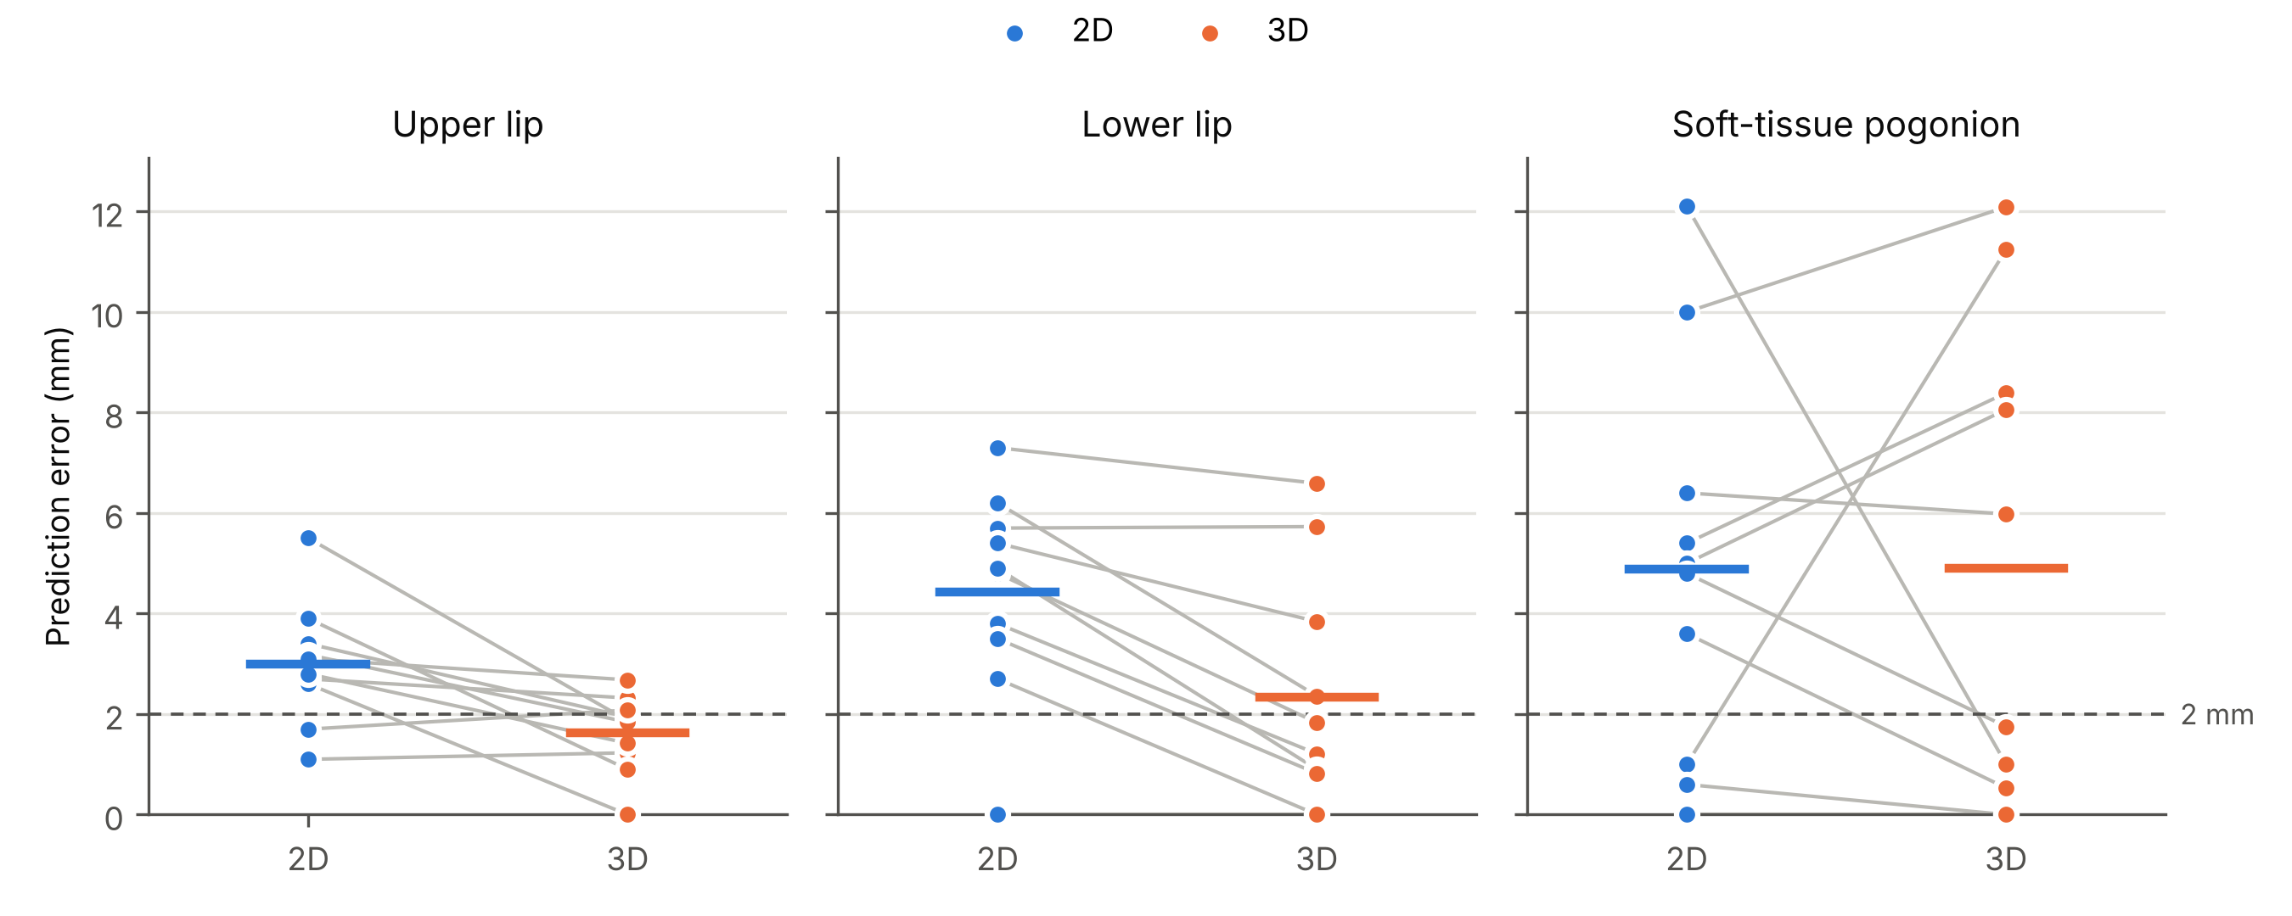
Figure 1. Soft-tissue prediction error with 2D and 3D planning at each landmark. Each grey line connects the 2D and 3D errors of one patient; short horizontal bars show the mean. The dashed line marks the 2 mm limit of clinical acceptability.

Correlation between 2D and 3D prediction errors
The correlation between the 2D and 3D prediction errors (Table 4, Figure 2) was weak and non-significant at the upper lip (r = 0.10, p = 0.773; ρ = 0.05, p = 0.881); strong and significant at the lower lip (r = 0.78, p = 0.008; ρ = 0.92, p < 0.001); weak and non-significant at the soft-tissue pogonion (r = 0.23, p = 0.529; ρ = 0.51, p = 0.132). Thus, patients whose lower lip was poorly predicted by 2D planning also tended to be poorly predicted by 3D planning. For the overall prediction error per patient, the correlation was moderate and non-significant (r = 0.49, p = 0.151).
Table 4. Correlation between 2D and 3D prediction errors
Landmark | N | Pearson r | p | Spearman ρ | p
Upper lip | 10 | 0.10 | 0.773 | 0.05 | 0.881
Lower lip | 10 | 0.78 | 0.008* | 0.92 | <0.001*
Soft-tissue pogonion | 10 | 0.23 | 0.529 | 0.51 | 0.132
Overall (patient mean) | 10 | 0.49 | 0.151 | 0.47 | 0.174
r = Pearson correlation coefficient; ρ = Spearman rank correlation coefficient. *Statistically significant (p < 0.05).
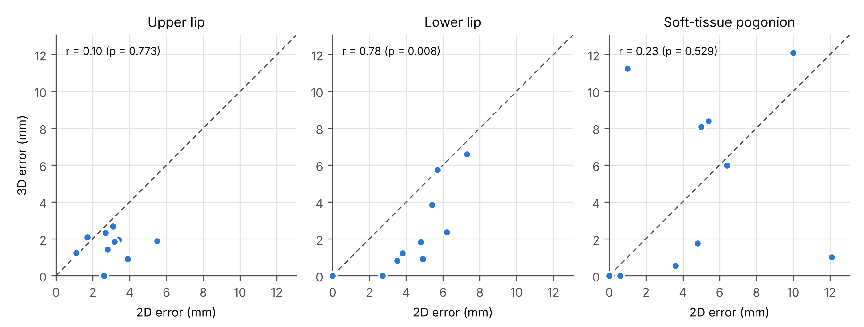
Figure 2. Relationship between 2D and 3D prediction errors at each landmark. The dashed diagonal is the line of equality: points below it are patients in whom 3D planning was more accurate. r = Pearson correlation coefficient.

Clinical acceptability of the prediction
Of the 30 landmark predictions, 18 (60.0%) were within the clinically acceptable limit of 2 mm with 3D planning, compared with 6 (20.0%) with 2D planning (Table 5). 3D planning gave more clinically acceptable predictions at every landmark (upper lip 7/10 vs 2/10; lower lip 6/10 vs 1/10; soft-tissue pogonion 5/10 vs 3/10, 3D vs 2D). However, none of the per-landmark differences reached statistical significance (McNemar p = 0.125, 0.063, 0.625, respectively), reflecting the small number of patients.
Table 5. Number (%) of predictions within the clinically acceptable limit (≤ 2 mm)
Landmark | N | 2D ≤ 2 mm, n (%) | 3D ≤ 2 mm, n (%) | McNemar p
Upper lip | 10 | 2 (20.0%) | 7 (70.0%) | 0.125
Lower lip | 10 | 1 (10.0%) | 6 (60.0%) | 0.063
Soft-tissue pogonion | 10 | 3 (30.0%) | 5 (50.0%) | 0.625
All predictions† | 30 | 6 (20.0%) | 18 (60.0%) | —
†All landmark predictions pooled (three per patient); shown descriptively without a test because the three landmarks of one patient are not independent observations. *Statistically significant (p < 0.05).

Comparison of prediction error among landmarks
The prediction error did not differ significantly among the three landmarks with either 2D (χ²(2) = 4.67, p = 0.097) or 3D (χ²(2) = 5.71, p = 0.058) planning (Table 6). None of the Bonferroni-adjusted pairwise comparisons was significant. With 3D planning, the median error at soft-tissue pogonion (3.87 mm) was higher than at the upper lip (1.85 mm) and lower lip (1.52 mm).
Table 6. Prediction error (mm) among the three landmarks for each planning method (Friedman test)
Method | Upper lip | Lower lip | Soft-tissue pogonion | Friedman χ² (df = 2) | p
2D | 2.95 (2.63–3.34) | 4.85 (3.58–5.63) | 4.90 (1.65–6.15) | 4.67 | 0.097
3D | 1.85 (1.28–2.04) | 1.52 (0.84–3.47) | 3.87 (0.65–8.31) | 5.71 | 0.058
Values are median (IQR). Bonferroni-adjusted pairwise Wilcoxon tests — 2D: upper lip vs lower lip p = 0.146, upper lip vs pogonion p = 0.697, lower lip vs pogonion p = 1.000; 3D: upper lip vs lower lip p = 1.000, upper lip vs pogonion p = 0.223, lower lip vs pogonion p = 0.070. *Statistically significant (p < 0.05).

Planned surgical movement and prediction error
No significant correlation was found between the magnitude of the planned surgical movement and the prediction error at the corresponding landmark, with either 2D (ρ = 0.05 to 0.25) or 3D planning (ρ = 0.01 to 0.25; all p ≥ 0.48) (Table 7). Given the small sample, this analysis is exploratory.
Table 7. Correlation between the magnitude of the planned movement and the prediction error (exploratory)
Landmark | Planned movement | 2D ρ | p | 3D ρ | p
Upper lip | Maxillary advancement | 0.25 | 0.479 | 0.01 | 0.972
Lower lip | Mandibular setback | 0.05 | 0.901 | 0.25 | 0.481
Soft-tissue pogonion | Genioplasty advancement | 0.06 | 0.877 | 0.11 | 0.769
ρ = Spearman rank correlation coefficient; a movement that was not performed was entered as 0 mm. *Statistically significant (p < 0.05).

Summary of the main findings
- Compared with 2D planning, 3D planning gave a significantly smaller prediction error at the upper lip (mean 1.63 vs 3.00 mm; dz = 1.01) and a significantly smaller error at the lower lip (2.33 vs 4.43 mm; dz = 1.43).
- At soft-tissue pogonion, the two methods were equally accurate (4.90 vs 4.89 mm), and both showed the largest and most variable errors.
- The 2D and 3D errors were significantly correlated only at the lower lip.
- 60% of 3D predictions versus 20% of 2D predictions were within the clinically acceptable limit of 2 mm.

