Revision notes: Table 9, manuscript text and Figures 2–5
Evaluation of Bone Fenestration, Dehiscence, and Maxillary Sinus Proximity in Maxillary Posterior Teeth: A CBCT Study on a Malaysian Subpopulation

1. Summary
- Table 9 total row: χ²(6) = 10.76, p = 0.096 (Pearson chi-square, computed from the Table 9 counts; all expected counts ≥ 5). The pooled association between ethnicity and vertical sinus relationship is not significant.
- Discussion p-value: χ²(6) = 18.94, p = 0.004 cannot be reproduced from any version of the counts. It came from an earlier, error-flagged ethnicity table in the statistics workbook and should be replaced (change 3).
- Table 9 corrections: one superscript letter (second molars, Chinese, Type 0: b → a, as in the SPSS output) and two typos.
- Figures 2–5: drawn from the published tables only; no raw data were used. Files are supplied as 600 dpi TIFF and PNG and as vector PDF.
- Checks: the four tooth-group p-values in Table 9 were re-computed with the Fisher–Freeman–Halton exact test (Monte Carlo, 100,000 samples) and agree with the reported values: 0.365, 0.019, 0.028, 0.032 vs 0.366, 0.019, 0.027, 0.032.

2. Revised Table 9
Table 9 Chi square analysis for ethnicity and vertical sinus relationship according to tooth group
Tooth group | Ethnicity | Vertical sinus relationship, N (%) |  |  |  | Total | p-value
Tooth group | Ethnicity | Type 0 | Type 1 | Type 2 | Type 3 | Total | p-value
First premolars | Malay | 84ª (76.4) | 12ª (10.9) | 12ª (10.9) | 2ª (1.8) | 110 | 0.366
First premolars | Chinese | 93ª (81.6) | 9ª (7.9) | 8ª (7.0) | 4ª (3.5) | 114 | 0.366
First premolars | Indian | 17ª (94.4) | 0ª (0.0) | 0ª (0.0) | 1ª (5.6) | 18 | 0.366
Second premolars | Malay | 18ª (26.9) | 20ª (29.9) | 14ª (20.9) | 15ª (22.4) | 67 | 0.019
Second premolars | Chinese | 35^{b} (47.9) | 14^{ab} (19.2) | 17ª (23.3) | 7^{b} (9.6) | 73 | 0.019
Second premolars | Indian | 6^{ab} (46.2) | 0^{b} (0.0) | 4ª (30.8) | 3^{ab} (23.1) | 13 | 0.019
First molars | Malay | 22^{ab} (22.0) | 22ª (22.0) | 21ª (21.0) | 35ª (35.0) | 100 | 0.027
First molars | Chinese | 28^{b} (30.4) | 14ª (15.2) | 29ª (31.5) | 21ª (22.8) | 92 | 0.027
First molars | Indian | 0ª (0.0) | 2ª (14.3) | 6ª (42.9) | 6ª (42.9) | 14 | 0.027
Second molars | Malay | 15ª (28.3) | 13ª (24.5) | 13ª (24.5) | 12ª (22.6) | 53 | 0.032
Second molars | Chinese | 12ª (27.9) | 18ª (41.9) | 2^{b} (4.7) | 11ª (25.6) | 43 | 0.032
Second molars | Indian | 8^{b} (57.1) | 4ª (28.6) | 1^{ab} (7.1) | 1ª (7.1) | 14 | 0.032
Total | Malay | 139 (42.1) | 67 (20.3) | 60 (18.2) | 64 (19.4) | 330 | 0.096
Total | Chinese | 168 (52.2) | 55 (17.1) | 56 (17.4) | 43 (13.4) | 322 | 0.096
Total | Indian | 31 (52.5) | 6 (10.2) | 11 (18.6) | 11 (18.6) | 59 | 0.096
N = number of roots; percentages are within each ethnic group. Within each tooth group and sinus type, ethnic groups sharing a superscript letter do not differ significantly (pairwise comparisons of proportions, Bonferroni-adjusted). p-values: Fisher–Freeman–Halton exact test within tooth groups; Pearson chi-square test for the total (χ²(6) = 10.76; all expected counts ≥ 5). Post hoc letters are not shown for the total because the overall test was not significant.
Shaded cells differ from the current manuscript (shading is for review only; remove it in the manuscript).

3. Changes to the manuscript
1. Table 9 (cells, total row and footnote)
Revised: Replace Table 9 with the revised table in section 2. Three things change: the total row gets its p-value (p = 0.096); second molars, Chinese, Type 0 becomes 12ᵃ (27.9) instead of 12ᵇ (27.9), as in the SPSS output; and the typos 93ᵃ ((81.6) and 1ᵃ 5.6) are corrected. The footnote is extended to name the tests.
Why: The total row had no test; the letter and typos are transcription errors.
2. Results, paragraph before Table 8 (sentence on Table 9)
Current: Table 9 shows that the distribution of vertical sinus relationship types varied by ethnicity, with significant differences detected in several tooth groups overall (second premolars p = 0.019, first molars p = 0.027, second molars p = 0.032).
Revised: Table 9 and Figure 5 show that the distribution of vertical sinus relationship types varied by ethnicity within second premolars (p = 0.019), first molars (p = 0.027) and second molars (p = 0.032), but not within first premolars (p = 0.366). When all tooth groups were pooled, ethnicity was not significantly associated with the vertical relationship (χ²(6) = 10.76, p = 0.096).
Why: Adds the pooled result and removes “overall”, which implied a significant pooled test.
3. Discussion, paragraph beginning “Ethnicity was significantly associated…” (first two sentences)
Current: Ethnicity was significantly associated with the vertical root–sinus relationship in this cohort (χ²(6)=18.94, p=0.004). Chinese and Indian participants showed a higher frequency of Type 0 (no contact), whereas Malay participants demonstrated a higher frequency of Type 3 (apical protrusion).
Revised: When all tooth groups were pooled, ethnicity was not significantly associated with the vertical root–sinus relationship (χ²(6) = 10.76, p = 0.096). Within tooth groups, significant differences were found in second premolars (p = 0.019), first molars (p = 0.027) and second molars (p = 0.032), but not in first premolars (p = 0.366). In second premolars, apical protrusion (Type 3) was more frequent in Malay than in Chinese participants (22.4% vs 9.6%), whereas Chinese participants more often showed no contact (Type 0: 47.9% vs 26.9%). In second molars, Type 0 was more frequent in Indian participants (57.1%) than in Malay (28.3%) or Chinese (27.9%) participants. Keep the rest of the paragraph from “Maxillary sinus dimensions vary by ethnicity…”.
Why: χ²(6) = 18.94, p = 0.004 cannot be reproduced from the Table 9 counts; it came from an earlier, error-flagged table in the statistics workbook. In both molar groups the three ethnic groups share the same letter for Type 3, so “Type 3 more frequent in Malay” holds only for second premolars.
4. Clinical Implications for Risk-Specific Treatment Planning, second paragraph
Current: In populations such as Malay patients, where Type 3 root–sinus relationships are more prevalent, bone augmentation or grafting may be necessary prior to extensive orthodontic movement or implant placement (35).
Revised: Where roots protrude into the sinus (Type 3), as seen most often in maxillary first molars, bone augmentation or grafting may be necessary prior to extensive orthodontic movement or implant placement (35).
Why: Type 3 was most frequent in first molars (30.0% of roots; Table 7), not tied to one ethnic group.
5. Conclusions
Current: In terms of demographics, Type 2 relationships were significantly more frequent in older age groups, and Type 3 relationships were more frequent among Malay patients.
Revised: In terms of demographics, Type 2 relationships were significantly more frequent in older age groups. Ethnicity was not associated with the vertical relationship overall, although in second premolars Type 3 relationships were more frequent among Malay than Chinese patients.
6. Abstract (optional)
Current: Additionally, apical protrusions were descriptively more frequent among Malay patients.
Revised: Apical protrusions were more frequent among Malay patients, although the overall association with ethnicity was not significant (p = 0.096).
Why: The current wording is already correct; this version states the p-value.
7. Methods, Statistical analysis (add after “…where significant differences were detected.”)
Revised: Within tooth groups, the association between ethnicity and vertical sinus relationship was tested with the Fisher–Freeman–Halton exact test; for all tooth groups pooled, the chi-square test was used because all expected counts were ≥ 5. In the figures, proportions are shown with 95% confidence intervals calculated by the Wilson score method.
Why: Names the test behind the new total-row p-value and the confidence intervals in Figures 2–3.
8. Limitations (add at the end of the paragraph)
Revised: In addition, the Indian subgroup was small (17 patients; 59 roots), so comparisons involving this group have limited precision. Analyses were performed at tooth and root level, and several teeth and roots came from the same patient; because these observations are not fully independent, p-values may be somewhat optimistic.
Why: Reviewers commonly raise both points.
9. Figure call-outs in Results
- Root fenestration paragraph: “…and second molars (4/33, 12.12%)” → “…and second molars (4/33, 12.12%; Figure 2)”.
- Dehiscence paragraph: “The distribution differed by tooth groups (χ² test, p < 0.001).” → “…(χ² test, p < 0.001; Figure 2).”
- “Table 2 shows that RF prevalence was broadly comparable…” → “Table 2 and Figure 3 show that RF prevalence was broadly comparable…”
- “Table 5 shows that an age gradient was observed for dehiscence…” → “Table 5 and Figure 3 show that an age gradient was observed for dehiscence…”
- “Table 7 shows that the vertical sinus relationship differed significantly by tooth group…” → “Table 7 and Figure 4 show that…”
- Figure 5 is cited in change 2.
10. Figure legends
Add the legends of Figures 2–5 (section 4) below each figure. Place each figure after the paragraph that first cites it, or at the end of the manuscript if the journal asks for figures separately, and upload the TIFF files as the figure files.

Other inconsistencies to check (not changed)
- Table 7 and Table 9 disagree in three cells: first premolars Type 1 (22 vs 21), first molars Type 0 (51 vs 50) and second molars Type 1 (33 vs 35); tooth-group totals 243/207/108 vs 242/206/110. Both total 711. Figure 4 uses Table 7 and Figure 5 uses Table 9 as published; once the counts are reconciled, the figures can be redrawn in a minute.
- Dehiscence severity: “mild defects being the most frequent observation (100/188, 53.5%)” should read 100/187, which matches Table 4 and the 53.5%.
- Gender and first premolars: χ²(3) = 12.18, p = 0.007 could not be reproduced from the gender counts in the statistics workbook (11.38, p = 0.010; still significant). Please check against the SPSS output.
- Root fenestration by tooth group (optional wording): p = 0.024 is the overall test across the four tooth groups. Suggested: “RF prevalence differed among tooth groups (χ² test, p = 0.024); post hoc comparison showed that first premolars were more affected than second premolars.”
- Age gradient (optional test): the Abstract states that dehiscence increased with age but no test is reported. From the Table 2 and 5 totals, a chi-square test for trend gives χ²(1) = 35.61, p < 0.001 for dehiscence and χ²(1) = 0.49, p = 0.482 for RF. These could be added to the Table 2 and Table 5 sentences.

4. Figures 2–5
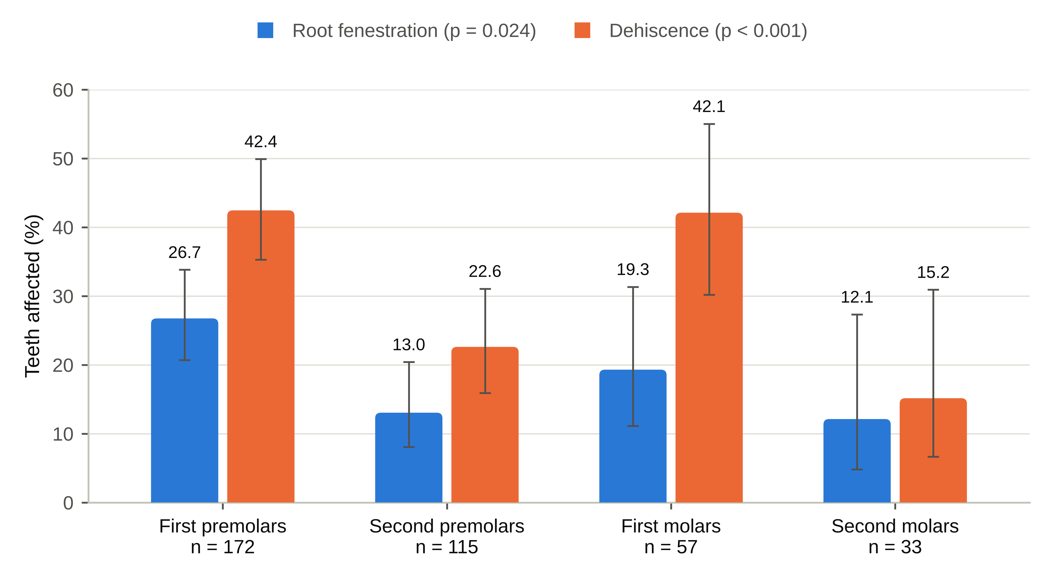
Figure 2. Prevalence of root fenestration and dehiscence by tooth group. Bars show the percentage of teeth affected, with 95% confidence intervals (Wilson); n, number of teeth examined. p-values: chi-square test comparing tooth groups.
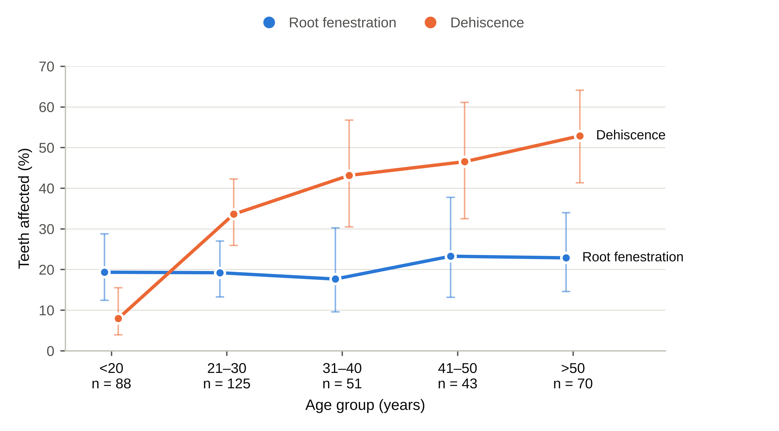
Figure 3. Prevalence of root fenestration and dehiscence by age group. Points show the percentage of teeth affected, with 95% confidence intervals (Wilson); n, number of teeth examined in each age group.
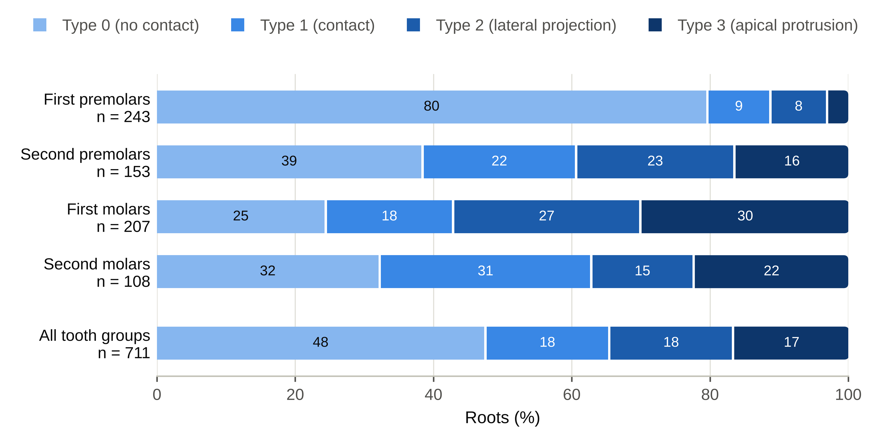
Figure 4. Vertical sinus–root relationship by tooth group. Bars show the percentage of roots of each type; n, number of roots. Type 0, no contact with the sinus floor; Type 1, contact; Type 2, lateral projection along the sinus with the apex outside it; Type 3, apical protrusion into the sinus. The distribution differed between tooth groups (chi-square test, p < 0.001; Table 7).
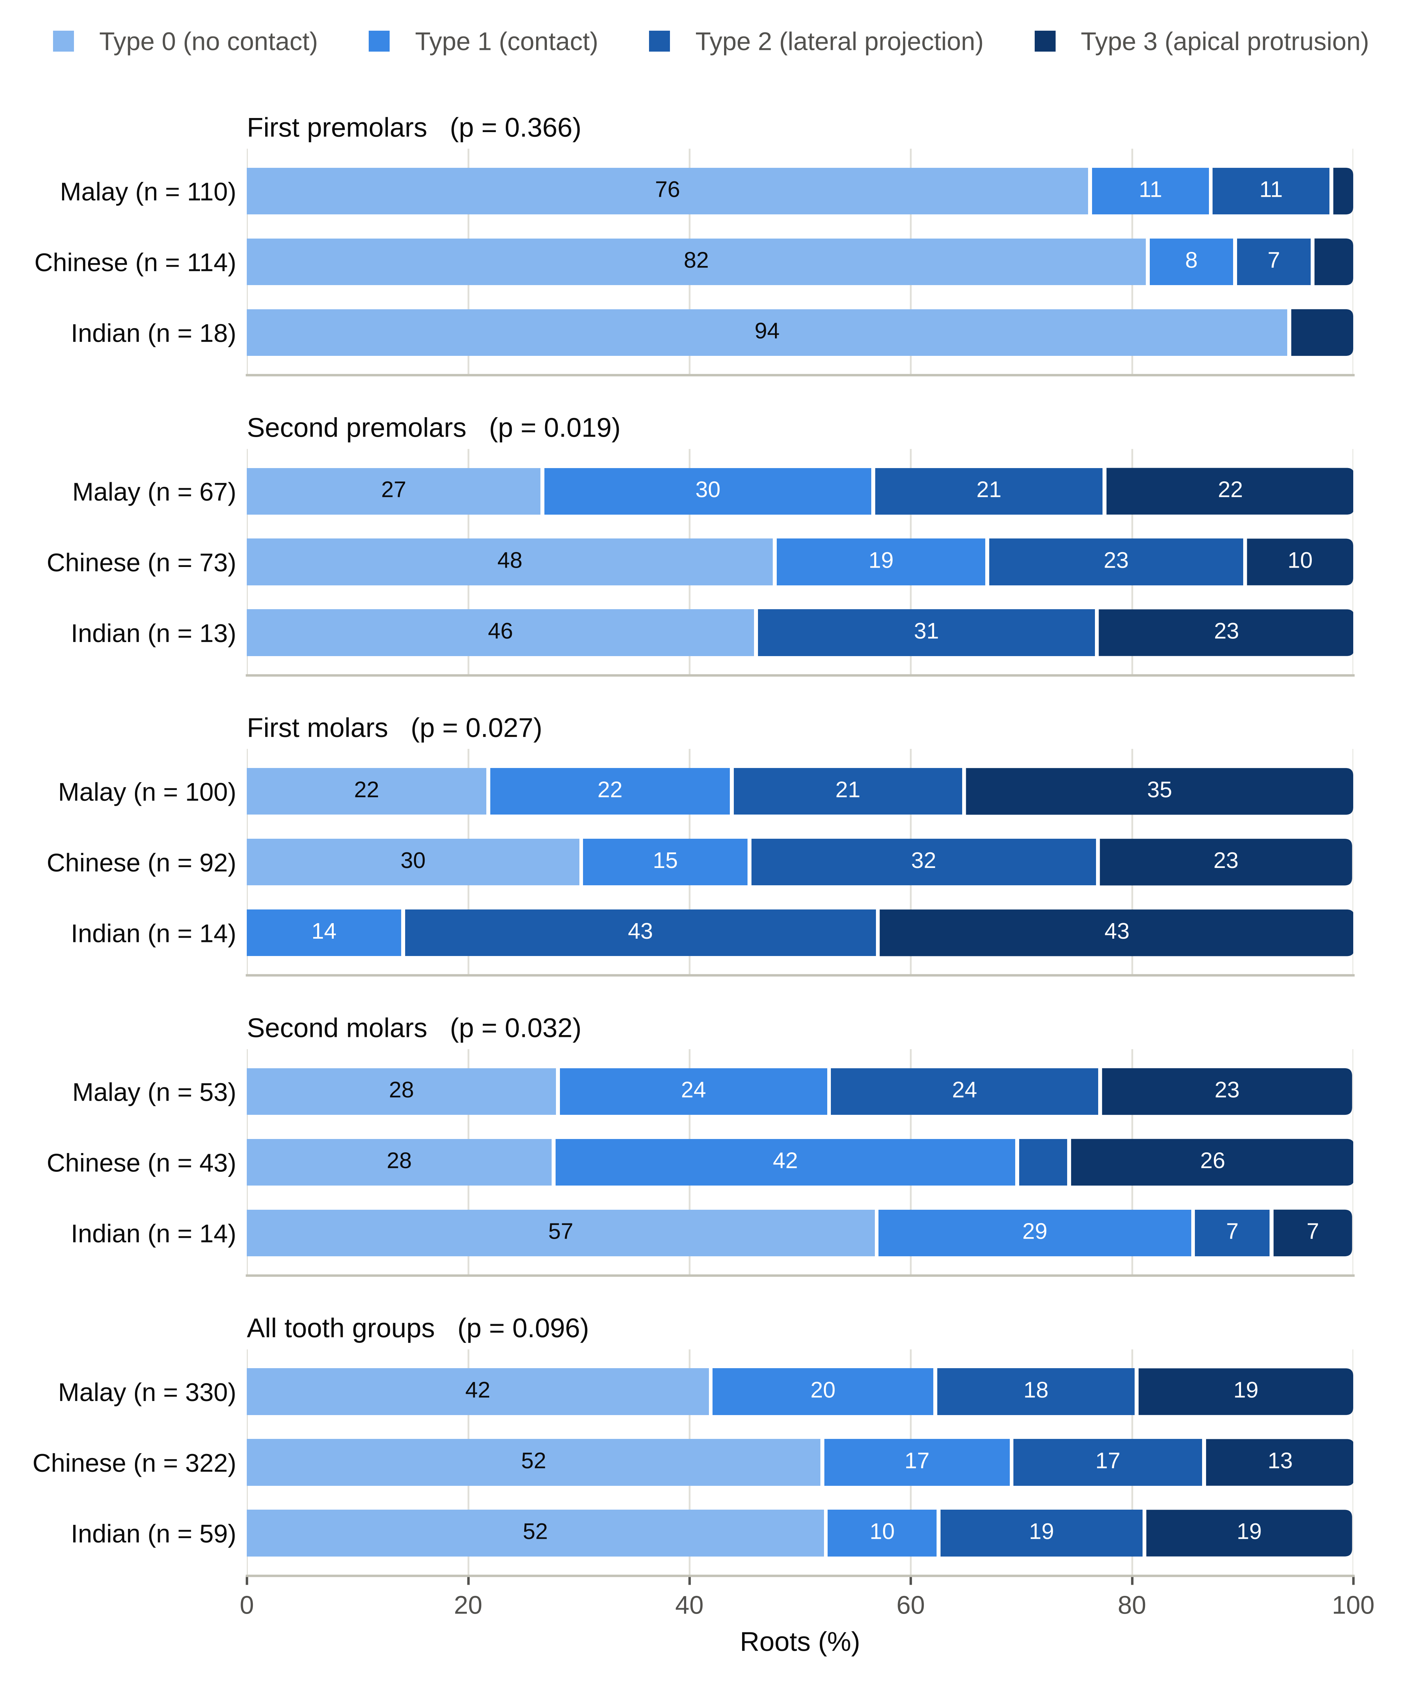
Figure 5. Vertical sinus–root relationship by ethnicity, for each tooth group and for all tooth groups pooled. Bars show the percentage of roots of each type; n, number of roots. p-values: Fisher–Freeman–Halton exact test within tooth groups; chi-square test for all tooth groups pooled (Table 9).

