Hi there all

I understand that you are all willing to contribute the newsletter. Hooray! I have been waiting for this day to come. Just as with the SOP, Security tips and other documents that I have shared please find here a document that you can all contribute to, in real-time, and collaborate on together so that we get the newsletter out in good time. I look forward to all of you working on this together and will take what you send me and lay it out in the DTP software to render the final layout of what you send.

Neal

This is what I have from the last post-AGM newsletter. Please edit your sub-committee section notes to reflect current affairs and what you want to see in the newsletter. I will only add an ICT section if we need a filler to complete 2 pages in the final layout.

Annual General Meeting

The Annual General Meeting was held on 29th April 2012 at Good News Productions.The members’ attendance was very poor, similar to the past two years.The poor attendance may be attributed to a number of reasons – commitment elsewhere, members out of town, busy at work, or simply indifference since the affairs in the Estate are stable! Whatever the reason, the residents should note that the AGM is a forum for the members to be briefed on the achievements made by the Committee, the challenges we face as a community and how best can we improve our services, security and other functions at the Estate.This is also a forum for the members to come together to interact, make friendship and meet their immediate neighbours. Furthermore your attendance at this event not only reflects your sense of social and communal responsibility, but also acts as a motivating factor for the members of the Committee, who devote a lot of time to ensure your safety and comfort in living in Nyari Estate.

It was disappointing to see so few residents at the AGM despite the event publicised through posters, emails and flyers at least a month in advance in order to provide sufficient notice to individual members. In addition much effort and time was spent in organizing this event by the Social Committee and it would have been nice to see more support given to the committee.

The Executive Committee nevertheless, would like to take this opportunity to thank all those who were present for their continuous support and their contributions at the event.

[Sent May 22nd by Salima Tejani - list of office bearers elected at the AGM].

1. Chairperson Mr. Rahmat Ghassmi
2. Vice Chairman Mr. Richard Kariuki
3. Treasurer Mr. Kirit Patel
4. Assistant Treasurer Mr. Geoffrey Naituli
5. Secretary Ms. Salima Tejani
6. Assistant Secretary Mrs. Rose Githaiga
7. Environment Mrs. Kirti Patel
8. Assistant Environment Mrs. Stefanie Hallberg
9. Maintenance Mr. Rob Holtrop
10. Assistant Maintenance Mr. Manraj Matharu
11. Assistant Maintenance Mr. Perminder Matharu
12. Lands & Utilities Mrs. Jane Nzibo Babsa
13. Assistant Lands & Utilities Mr. Zephania Aura
14. Assistant Lands & Utilities Mr. Spencer Ochieng
15. Assistant Lands & Utilities Mrs. Ester Ngaina
16. Social Mrs. Maleeha Ali
17. Assistant Social Mrs. Ruth Makau
18. Assistant Social Mrs. Jessica Kazina
19. Security Mr. Durgesh Shah
20. Assistant Security Mr. Yahya Yusuf
21. Assistant Security Mr. Amit Choda
22. Assistant Security Mr. Bharat Shah
23. Assistant Security Mr. Amin Premji
24. Assistant Security Mr. Jay Mediratta
25. IT Director Mr. Neal Aggarwal
26. Youth Mr. Paul Opondo

[Sent by Karanja - June 3rd, 2014). As discussed with Mr. Chairman to include New Members to our Newsletter. Below is list of New Members

1. Parin Sidi House no 36 NC
2. Samayog Karmocharya House no. 102 NC
3. Peter Kamau House no.40 nc
4. Mr. Okello House No 19 NC

3 House am waiting their Forms. House No 7NC,167NC, 327 NW.

Finance

The society continues to maintain sound financial status and to provide general service to members within the subscriptions provided. However it should be noted that this will be no longer sustainable as In the last Labour Day the Government increased the salaries by 13.1% and the cost of materials for maintenance of the Estate and security has also increased.The committee is currently reviewing members’ contributions and we will inform you of any proposals to meet these challenges.

In the meantime we would like to take this opportunity to thank all the dedicated members who pay their subscriptions promptly and request those who have not cleared their balance for last year, to do so at their earliest possible convenience.

While we are grateful to all those dedicated members, who pay their dues promptly, it should be noted that there are still a number of members, who have not cleared last years contribution or are behind in the payment for the current year.These uncleared balances put immense pressure on the Committee to fulfill its financial obligations that include salary payments, maintenance of the street lighting, road repair works and upkeep of the security systems. It is regretful to note that we continue to have residents who benefit from all the facilities and yet continue to refuse to join the Society and pay the monthly contribution and continue to have a free ride.
Development Levy

As you drive around in the Estate, you will have noticed that there is a lot of work being done in terms of road repairs and measures towards making our Estate beautiful and secure. In order to make this possible the Committee is undertaking a few development projects including repairs of the main roads, installation of CC TV cameras and the purchase of a pickup for Nyari.To fi- nance these projects members were invoiced a mini- mum development levy of KSh 7,500/-. In addition to this members were requested to contribute any further amounts they could manage since the total amount of the minimum levy would not be sufficient to meet the cost of the above projects. To date we have raised cash of only 450,000/- , which is far short of the amount estimated at 3,000,000/-.There are members who have made generous contributions in kind and cash far beyond the stipulated levy.The Committee would like to extend their sincere gratitude to these generous residents who are always ready to assist.

Projects

A pick up has already been purchased at the cost of Ksh 1.2 million and its body has been fabricated by Amit Choda to meet Nyari requirements.The pick up will be used as a rapid response car fitted with emergency equipment including fire extinguisher and communications equipment and will be used for patrol and maintenance work in the Estate.

The installation of CCTV Cameras is in advanced stages and should be operational shortly.This has been possible with a close collaboration of the Jamii Telecommunications Ltd who have installed the fibre optic cables within the Estate.

The road works is in the final stages and will be completed shortly. For the road works the Estate has purchased a compactor at the cost of 208,000/-.This will assist in road maintenance.We should thank Mr. Sarikas and his team for a job well done. We are certain that the above information about the development taking place in the Estate for their comfort and security will encourage all the residents to dig a little deeper and donate generously to meet these costs.Thank you in advance for your further contributions.

Security Update

Three weeks ago House No. 14 was targeted by a gang of 4 who entered the house under the pretext of being employees of the Nairobi Water Company stating that there was an issue with the water payment and they had to check the Meter. While in the compound and at gun point they robbed the owner of the house of his personal belongings. After a scuffle, with the gardener,the robbers left the premises.This robbery was well planned perhaps with inside information. As we have mentioned many times through these newsletters, you need to put in place appropriate security measures within your premises.This includes background check of your staff and denial of access to any unknown person wishing to enter your premises. Readings of Electricity and Water Meters are done on specific dates which are known to the Nyari Office. If you have any doubts about a visitor please inform the office immediately. The installation of the CCTV Cameras will assist in monitoring the people and cars that enter and exit the Estate and will service as a powerful deterrent to would-be thugs as the evidence provided from such camera recordings is admissible in court and has been used to convict perpetrators of crime in the past in Kenya.

Car Stickers

Residents are requested to prominently display their car stickers and avoid giving these stickers to their friends and staff. For those members who do not wish to indicate the name Nyari Estate on their cars, we have printed stickers which carry only the Logo. Please drop in at the office to obtain these.

Environment

[Stephane - sent these photos and write-up - 04 Jun, 2014. To decide which to include in newsletter]

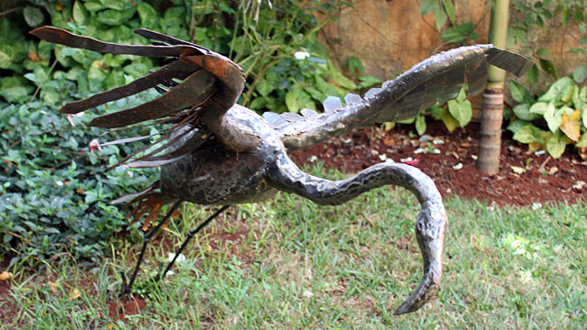
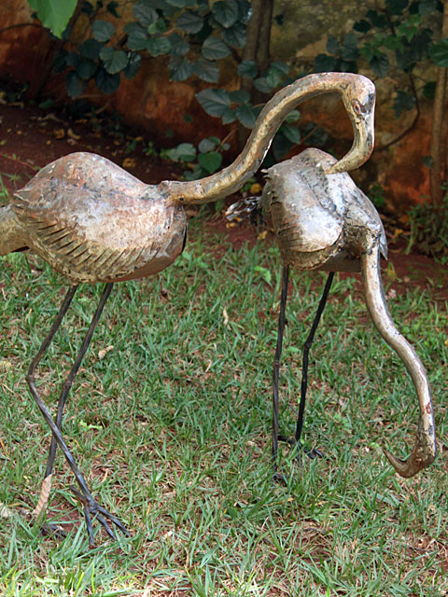
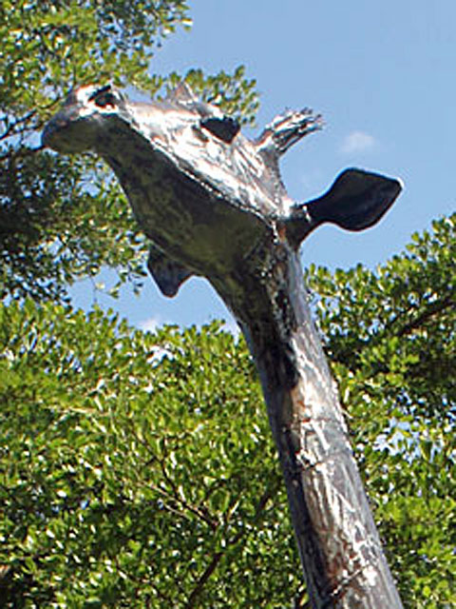
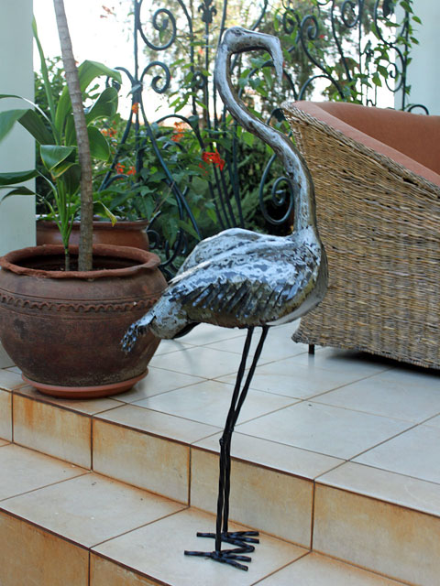
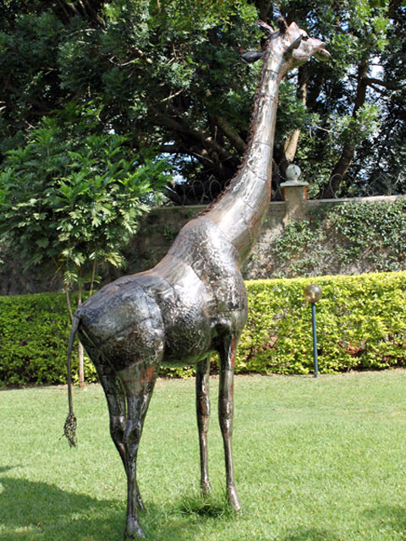
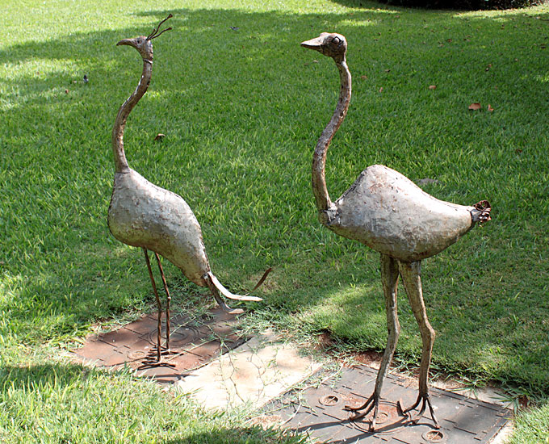
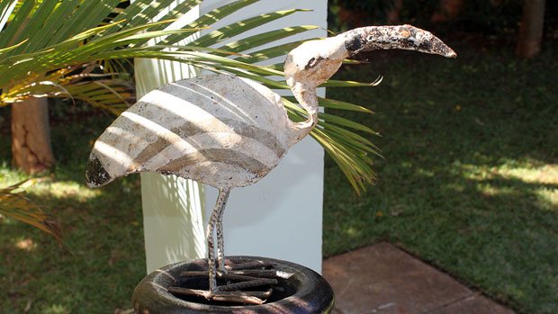
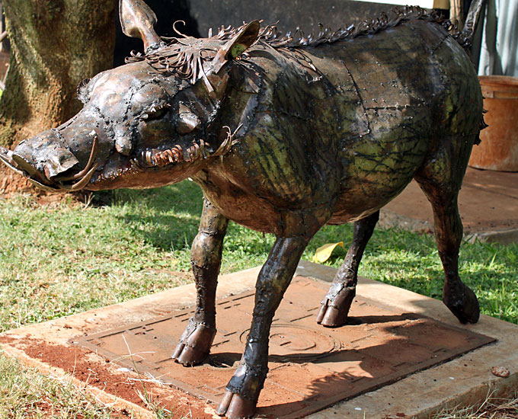
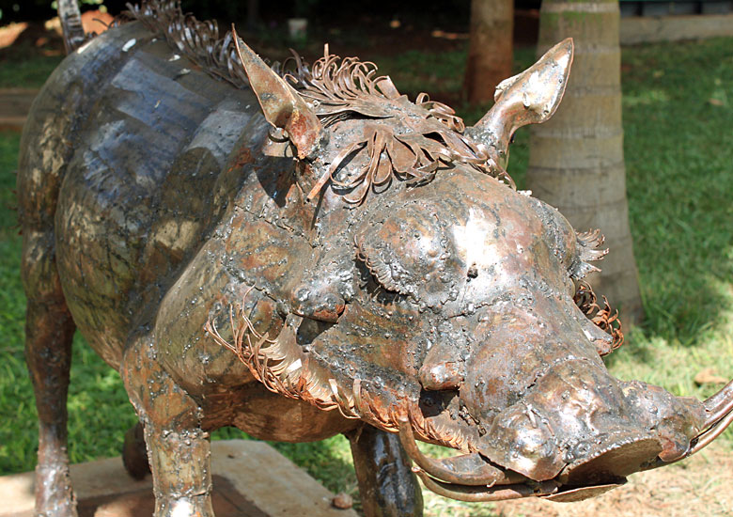

Environment
The next Clean-Up Day will be on July 5th from 9 am to 1 pm. Please send your gardener with appropriate tools to the Nyari office at 09.00 a.m. sharp. If it's not possible to send the gardener, please make a contribution of KSH. 500/= towards the employment of casual workers to undertake the clean-up.

Vote and win! Who has the most beautiful front garden in Nyari Estate? To answer that question, the Environment Team will hold a competition after the summer holidays. Already now you can send to us photos of your or other front gardens of which you think they are worth being prized. Please contact stefanie.hallberg@gmail.com.

We will publish the photos later on the Nyari Facebook website and at the Nyari Office so that all NRWS members can take a look at them and vote for their favourite front garden. The three most liked front gardens win a prize.

A few NRWS members have nice metal animals of all sizes in their gardens. Some of those metal statues are so decorative that we plan to install a few of them in different areas or at the barriers of Nyari Estate to make our estate look more beautiful and attractive, also for people who pass by. Whoever wants to sponsor such a metal animal and thus perpetuate his or her name in the Estate, commemorate a family member or a friend, please contact the chairman Rahmat Ghassmi, e-mail: rahmat@kenyaitreb.org

Social

Did you know that NRWS has a Facebook Site with information of all kinds? To find us on Facebook, log in and type in the search field “Nyari Residents” or click on this link https://www.facebook.com/nyari.residents. When the page opens, click on “add friend” to send a friend request.

