Overview:

This network takes a jpeged image as input, and outputs a recovered image.

Input:

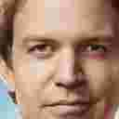

Output:

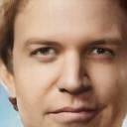

To run the code:

1. Change the training dataset directory at line 25~26 in the “train.py” file
2. The models will be saved in the “models” folder
3. To run the model on the testing image, refer to “inference.py” file