CARECOMPETENCIES
Duke University Health System
Orientee User Guide
Part of CareOps — Integrated Healthcare Operations

Introduction
CareCompetencies is a web-based application used by Duke University Health System (DUHS) to track and manage clinical competency verification for nursing staff. It is part of the CareOps suite of integrated healthcare operations tools.

This guide is written for orientees — nurses who are currently completing their orientation program. As an orientee, CareCompetencies gives you a clear, real-time view of your progress: which competencies you have achieved, which are in progress, and what remains before each stage is complete.

Your preceptor and unit administrator manage the sign-off process. Your role in the system is primarily to monitor your own progress and look up competency details.

About This Guide
This guide covers the following areas:
- Signing in to CareCompetencies
- Understanding your Home dashboard
- Browsing and searching for competencies
- Reading a competency detail page
- Generating your Competency Summary report

Signing In
CareCompetencies uses your standard Duke NetID and password — the same credentials you use for other DUHS systems. No separate account or registration is required.

[ Screenshot: Login screen — CareCompetencies sign-in page ]

To sign in:
- Open a web browser and navigate to the CareCompetencies URL provided by your unit.
- Enter your Duke NetID (for example: bnd01).
- Enter your Duke password.
- Click Sign in.

📌 Note: If you are unable to sign in, verify that you are using your Duke NetID — not your email address or employee ID. Contact your unit administrator if access problems persist.

Home Dashboard
After signing in you are taken directly to your Home dashboard. This is your primary view in CareCompetencies and gives you a complete snapshot of where you stand in your orientation program.

[ Screenshot: Home dashboard — full view showing all panels ]

Your Name and Stage Banner
At the top of the page you will see a personalised welcome banner showing your name, your assigned unit, and your primary preceptor. Immediately below is the Current Stage panel.

Current Stage panel
The Current Stage panel shows:
- Your current orientation stage (for example: Orientation).
- The day number of your orientation (for example: Day 86).
- The date range for the current stage and the number of days remaining.
- A progress bar showing how far through the stage you are.

💡 Tip: The progress bar turns red as the stage end date approaches. If you see only a few days remaining, speak with your preceptor about any outstanding competencies.

Summary Cards
Below the stage banner are three summary cards that give you an at-a-glance view of your competency status.

[ Screenshot: Dashboard summary cards — Competencies Achieved, Overdue, In Progress ]

Competencies Achieved card
This card shows your overall progress as a count and percentage (for example: 14 / 32 · 44%). Below the overall figure, each competency stage is broken out on its own row:
- Core — competencies required for all nurses in your role, regardless of unit.
- Orientation (marked CURRENT) — competencies specific to your current orientation stage.
- Education — additional competencies assigned for your unit or role development.

Each row shows how many competencies in that stage have been achieved out of the total assigned, along with a percentage and a colour-coded progress bar.

Hovering on a stage row
Hovering your mouse over any stage row (Core, Orientation, or Education) opens a detail pop-up showing the individual competencies that make up that stage. For stages that are partially complete, the pop-up is divided into two sections:
- Achieved — competencies with a green checkmark that have been signed off by your preceptor.
- Remaining — competencies shown with an empty circle that are not yet achieved.

[ Screenshot: Education stage hover — showing Achieved and Remaining sections ]

📌 Note: If you have completed competencies outside your assigned unit — for example through cross-training — these will appear in a fourth row labelled Other Competencies on the Achieved card.

Overdue card
The Overdue card shows any competencies that have passed their due date without being signed off. A count of zero (as shown for Stacy above) means you are on track. If overdue items appear, contact your preceptor to schedule an observation.

In Progress card
The In Progress card lists competencies where at least one step observation has been recorded but sign-off is not yet complete. Each item shows:
- The competency name — click it to go directly to that competency's detail page.
- The competency group (for example: Drainage Devices).
- A stage badge (for example: Orientation or Education) indicating which stage the competency belongs to.

💡 Tip: The competency names in the In Progress card are clickable links. Clicking a name takes you directly to the full competency detail page — the same page you would reach by searching for that competency in Search Competencies.

Up Next and Recent Activity
Scrolling down on the Home dashboard reveals two additional panels.

[ Screenshot: Dashboard lower section — Up Next and Recent Activity panels ]

Up Next panel
The Up Next panel lists the next competencies due in your current stage, in order of due date. For each item you can see:
- The competency name.
- The due date and the date of the most recent observation (if any).
- A status badge: In progress or Not started.

Recent Activity panel
The Recent Activity panel shows a chronological log of competencies that have been recently signed off, including the name of the preceptor who signed them off and the date. An Audit trail link in the top-right corner of the panel opens a full history of all activity on your record.

Search Competencies
The Search Competencies page provides a browsable, filterable list of all 183 clinical competencies in the system. Select Search Competencies from the left navigation to open it.

[ Screenshot: Search Competencies page — full list with filter controls ]

Filter Controls
Three filter controls appear at the top of the page. They work together — any combination of filters can be applied at the same time, and the list updates immediately.

- Search by name — Search by name
Type any part of a competency name to filter the list in real time. For example, typing "catheter" will narrow the list to competencies whose names contain that word.

- All groups — All groups
Filter by competency group (clinical category). Groups include Airway Management, Drainage Devices, IV Therapy, Skin Care, and others. Select a group from the dropdown to see only competencies within that category.

- All units — All units
Filter by unit assignment. Selecting a specific unit shows only the competencies required for nurses assigned to that unit. This is useful if you want to understand what would be required for a different unit, for example when exploring cross-training opportunities.

💡 Tip: The three filters are additive. For example, you can set the group to IV Therapy and select a specific unit to see only IV Therapy competencies required on that unit.

Competency List
The filtered list shows each competency as a row with its name and group. Some competencies display a Core badge, indicating they are required for all nurses regardless of unit. Click any row to open the competency detail page.

Competency Detail Page
Clicking any competency — whether from the Search Competencies list or from a link in your dashboard — opens the competency detail page. This page contains all the reference information for that competency.

[ Screenshot: Competency detail page — top section showing description, Unit Requirements, and References & Guidance ]

Competency Description
At the top of the page you will see the competency name and a plain-language description of what the competency covers. For example, the Alaris Medley Infusion Control Device competency describes the scope as covering module attachment, Guardrails library selection, primary and secondary infusion programming, titration, and alarm troubleshooting.

Unit Requirements
The Unit Requirements section shows whether this competency is required for your assigned unit, and if so, for which stage. A Request Change button is available if you believe the unit requirement information is incorrect — this sends a notification to your administrator.

References & Guidance
This section provides supporting information for the competency, including:
- Validation Method — how the competency is assessed (for example: Validation By Observation Of Behaviour).
- Knowledge Source — a link to the reference document or policy on the DUHS intranet. Click the link to open the source document in a new tab.
- Update Note — a note indicating when the competency was last reviewed or updated.

Steps
The Steps section lists the numbered performance criteria that your preceptor will observe and evaluate. Each step describes a specific observable behaviour or action. The total number of steps is shown in the section heading (for example: Steps (18)).

[ Screenshot: Competency detail page — Steps section showing numbered criteria ]

📌 Note: You cannot mark steps as complete yourself. Steps are recorded by your preceptor during a direct observation session. The Steps list is provided here so you can review what will be assessed before your observation.

Competency Summary Report
The Competency Summary is a formal, printable record of all your competency achievements. It is designed to serve as official evidence of competency for regulatory inspection purposes and includes every competency you are assigned, grouped by clinical category.

To open the report, click the Competency Summary button in the top-right corner of your Home dashboard.

[ Screenshot: Dashboard — Competency Summary button location (top right) ]

The report opens in a new browser window. A timestamp showing when the report was generated appears in the top-left corner.

Report Contents

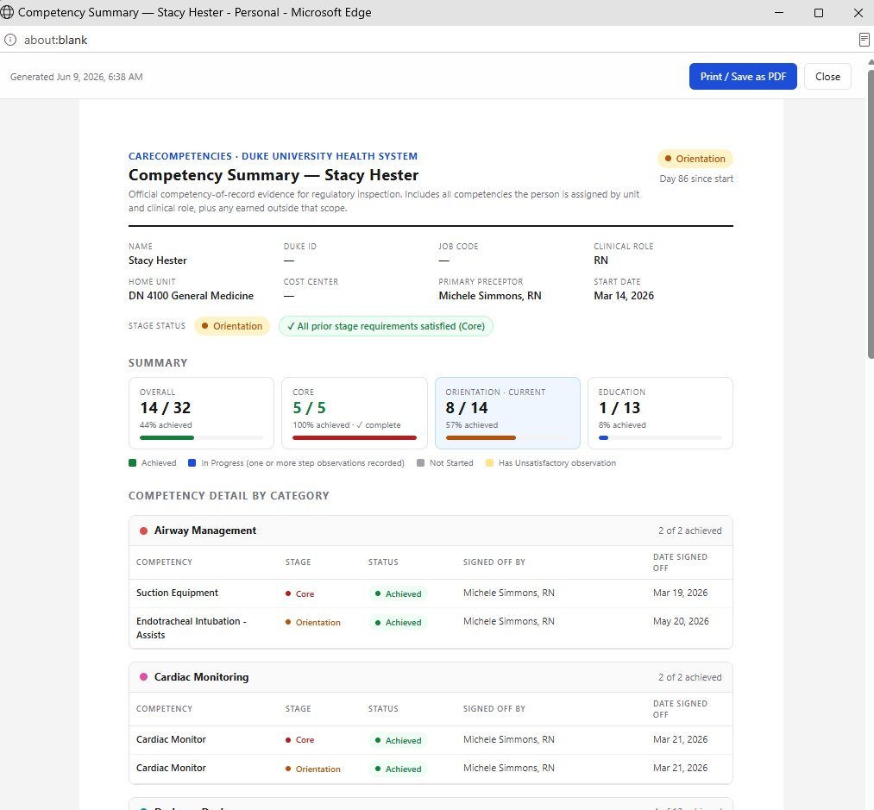
Figure: Competency Summary report
The report is divided into the following sections:

Header
Displays your name, current orientation stage, and the number of days since your start date. The CareCompetencies and Duke University Health System branding confirms this is an official DUHS document.

Orientee Details
A data block showing your Name, Duke ID, Job Code, Clinical Role, Home Unit, Cost Centre, Primary Preceptor, and Start Date. This information is pulled automatically from your HR and scheduling records.

Stage Status
Shows your current stage and confirms whether all requirements for prior stages have been satisfied. For example: All prior stage requirements satisfied (Core) indicates that your Core competencies are fully complete.

Summary Cards
Four cards summarise your progress across all competency stages:
- Overall — total competencies achieved out of all assigned, with percentage.
- Core — Core stage count and completion status.
- Orientation · Current — your active stage progress.
- Education — Education stage count and percentage.

A colour legend below the cards explains the progress bar colours: green for Achieved, blue for In Progress, grey for Not Started, and yellow for Has Unsatisfactory Observation.

Competency Detail by Category
The main body of the report lists every assigned competency, grouped by clinical category (for example: Airway Management, Cardiac Monitoring, Drainage Devices). For each competency the table shows:
- Competency name
- Stage (Core, Orientation, or Education)
- Status (Achieved, In Progress, or Not Started)
- Signed off by — the name and credentials of the preceptor who signed off the competency
- Date signed off

Printing or Saving the Report
Click the Print / Save as PDF button in the top-right corner of the report window to print a hard copy or save the report as a PDF file. Click Close to dismiss the window and return to the dashboard.

💡 Tip: Save a PDF copy of your Competency Summary at the end of each orientation stage. Your educator or manager may request this document during competency reviews or Joint Commission surveys.

Quick Reference

Task | How
Sign in | Navigate to the CareCompetencies URL · Enter Duke NetID and password · Click Sign in
Check your overall progress | Home dashboard → Competencies Achieved card
See which competencies you have earned in a stage | Home dashboard → hover over the Core, Orientation, or Education row
Go to a competency you are working on | Home dashboard → click its name in the In Progress card or Up Next panel
Browse all competencies | Left navigation → Search Competencies
Search by name | Search Competencies → type in the Search by name field
Filter by clinical category | Search Competencies → All groups dropdown
Filter by unit | Search Competencies → All units dropdown
View competency steps and reference documents | Click any competency from the list or dashboard to open the detail page
Print or save your competency record | Home dashboard → Competency Summary button → Print / Save as PDF
Sign out | Left navigation → Sign out

Support
CareCompetencies is managed by your unit's nurse educator and administrator. If you have questions about your competency assignments, due dates, or sign-off status, your first point of contact should be your primary preceptor.

For technical issues with the application (login problems, missing competencies, display errors), contact your unit administrator or the CareOps support team.

