Diane Roberts
8/24/26
DS7330
Mini Project 1
My Sql Database
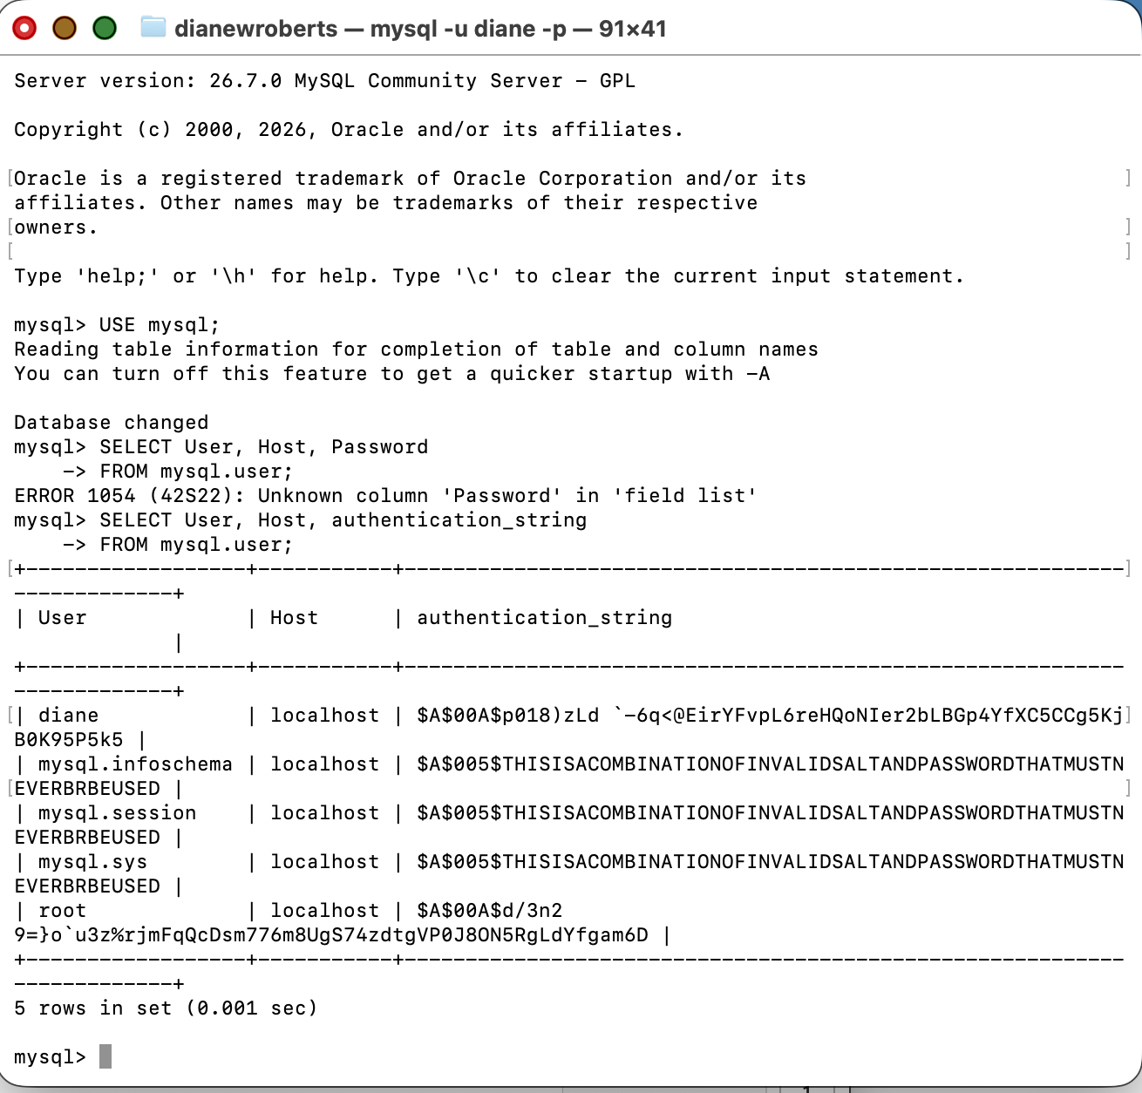

This command shows that diane, mysql.infoschema, mysql.session, mysql.sys and root have passwords stored as authentication strings(hashes) versus text.

