Escaper

Sequence Diagram Specification

Revision: 0.2

|  |  |
| --- | --- |
| No Magic |  |
| One Allen Center, 700 Central Expressway South, Suite 110 Allen, Texas 75013 USA | Date: junio 04, 2018 |

**Table of Contents**

Login 1

Message Summary 1

Messages 1

Lifeline 1

: User 1

Client 1

Server 1

Statistics On Screen 2

Message Summary 2

Messages 2

All Statistics 2

All Statistics 2

Desired Statistic 3

GetAllStatistics() 3

RequestStatisticsPanel() 3

selectDesirablestatistic() 3

selectDesirablestatistic() 3

showAllStatistics() 4

showStatisticPanel() 4

Lifeline 4

Administrator : Actor 4

Server : Server 4

Register Building Owner 4

Message Summary 4

Messages 5

checkData() 5

Create new user 5

introduceData() 5

restartForm() 5

sendRegisterData() 6

setUserData() 6

showErrorMessage() 6

showRegisterScreen() 6

specifyOwnerRegistration() 6

submitData() 7

Lifeline 7

: Facade 7

: Building Owner 7

: Server 7

: Building Owner 7

Change User 7

Message Summary 7

Messages 7

DataFilled 7

FillData() 8

GetUser() 8

modifyUser() 8

saveChanges() 8

selectUser() 9

userModified 9

UserSelected 9

Lifeline 9

: Administrator 9

: User 9

Manage Building Plans 10

Message Summary 10

Messages 10

Building 10

Building 10

changeMap 10

changeMap() 11

getBuilding() 11

manageBuilding() 11

manageBuilding() 11

Map changed 11

Map changed 12

setName() 12

setName() 12

Lifeline 12

: BuildingManager 12

: BuildingOwner 12

: Building1 12

: Facade 13

Register User 13

Register 13

Message Summary 13

Messages 13

checkData() 13

Create new user 13

introduceData() 14

requestRegistration() 14

restartForm() 14

sendRegisterData() 14

setUserData() 14

showErrorMessage() 15

showRegisterScreen() 15

submitData() 15

Lifeline 15

: User 15

: Facade 15

: Server 15

: User 15

Delete User 16

Message Summary 16

Messages 16

chooseUserToDelete() 16

DeleteUser() 16

GetUser() 16

selectUser() 17

userDeleted 17

userDeleted 17

UserSelected 17

Lifeline 17

: Administrator 17

: User 18

Login 18

Message Summary 18

Messages 18

checkData() 18

dataCorrect 18

dataNotCorrect 18

logIn() 19

restartForm 19

sendLoginData() 19

showErrorMessage 19

showLoginScreen() 20

validate() 20

validateData() 20

Lifeline 20

: User 20

: Facade 20

: Server 20

Upload Building Plan 21

Message Summary 21

Messages 21

Building 21

Building 21

create() 21

getBuilding() 22

manageBuilding() 22

mapUploaded 22

mapUploaded 22

uploadMapFromTestFile() 22

uploadMapFromTestFile() 23

Lifeline 23

: BuildingManager 23

: Building Owner 23

: Building1 23

: Facade 23

Delete Building Plan 24

Message Summary 24

Messages 24

Building 24

Building 24

deleteMap() 24

deleteMap() 25

getBuilding() 25

manageBuilding() 25

manageBuilding() 25

Map Deleted 25

Map Deleted 26

Lifeline 26

: BuildingOwner 26

: BuildingManager 26

: Building1 26

: Facade 26

Message Summary 26

Messages 26

Lifeline 26

GetAlternativeRoute 27

GetRouteToEscape 27

StartFinishSession 27

Statistic By Printer 27

Message Summary 27

Messages 27

All Statistics 27

All Statistics 28

Desired Statistic 28

getAllStatistics() 28

PrintStatistic() 28

RequestStatisticsPanel() 28

SelectDesirableStatistic() 29

SelectDesirableStatistic() 29

ShowAllStatistics() 29

showStatisticPanel() 29

Lifeline 29

: Facade 29

: Server 30

See current position on map 30

Message Summary 30

Messages 30

getMapWithPosition() 30

getMapWithPosition() 30

getPosition() 31

getPosition() 31

getRooms_() 31

provideMap 31

provideMapWithPositon 31

providePosition 32

providePosition 32

Lifeline 32

: User 32

: Server 32

: MapDrawer 32

: Map 32

application : Facade 32

Change Password 33

Message Summary 33

Messages 33

changePassword() 33

dataChanged 33

dataNotValidated 33

modifyUser() 34

passwordChanged 34

showErrorMessage() 34

Lifeline 34

: User 34

: Server 34

: Facade 34

Statistics On Screen 35

Add User 35

Message Summary 35

Messages 35

addUser() 35

FillData() 35

FillUserData 35

newUser() 36

UserAdded 36

Lifeline 36

: Administrator 36

: User 36

: Facade 36

View Statistics Panel 36

Message Summary 36

Messages 37

All Statistics 37

Desired Statistic 37

GetAllStatistics() 37

RequestStatisticsPanel() 37

SelectDesirableStatistic 38

SelectDesirableStatistic() 38

showStatisticPanel() 38

Lifeline 38

: Facade 38

: Server 38

Logout 39

Message Summary 39

Messages 39

Chosen User 39

Logout() 39

logOut() 39

User Logged Out 39

userRequestLogOut() 40

Lifeline 40

: User 40

: Facade 40

: Server 40

Get route to Escape 41

Message Summary 41

Messages 41

createRoute() 41

createRoute() 41

getMap() 42

getMap() 42

getRoute() 42

getRoute() 42

providesMap() 42

providesRoute() 43

providesRoute() 43

providesRoute() 43

providesRoute() 43

servesMap() 43

updateRoute() 44

Lifeline 44

: User 44

: RouteComputer 44

: Space 44

: Map 44

: Facade 44

Appendix A: Diagrams 45

Get route to Escape 45

Statistic By Printer 46

Logout 47

Change Password 47

View Statistics Panel 48

Manage Building Plans 48

Add User 49

Delete User 50

Upload Building Plan 51

Change User 52

Login 53

Delete Building Plan 53

See current position on map 54

Register 55

Statistics On Screen 56

Register Building Owner 57

**Table of Figures**

Figure 1. Get route to Escape 45

Figure 2. Statistic By Printer 46

Figure 3. Logout 47

Figure 4. Change Password 47

Figure 5. View Statistics Panel 48

Figure 6. Manage Building Plans 48

Figure 7. Add User 49

Figure 8. Delete User 50

Figure 9. Upload Building Plan 51

Figure 10. Change User 52

Figure 11. Login 53

Figure 12. Delete Building Plan 53

Figure 13. See current position on map 54

Figure 14. Register 55

Figure 15. Statistics On Screen 56

Figure 16. Register Building Owner 57

# Login

## Message Summary

|  |  |  |  |  |
| --- | --- | --- | --- | --- |
| **No.** | **Message Name** | **Sender** | **Receiver** | **Constraints** |
|  | 777528000.jpg | 469229824.jpg Client | 469229824.jpg Server |  |

## Messages

|  |  |
| --- | --- |
| **Message Sort** | synchCall |
| **Parameters** |  |
| **Sender** | 469229824.jpg Client |
| **Receiver** | 469229824.jpg Server |
| **Constraint** |  |

## Lifeline

### : User

### Client

### Server

# Statistics On Screen

## Message Summary

|  |  |  |  |  |
| --- | --- | --- | --- | --- |
| **No.** | **Message Name** | **Sender** | **Receiver** | **Constraints** |
| 1 | 777528000.jpg RequestStatisticsPanel() | -1737144090.jpg Administrator : Actor | 971534706.jpg  : Facade |  |
| 2 | 777528000.jpg showStatisticPanel() | 971534706.jpg  : Facade | 971534706.jpg  : Facade |  |
| 3 | 777528000.jpg showAllStatistics() | -1737144090.jpg Administrator : Actor | 971534706.jpg  : Facade |  |
| 4 | 777528000.jpg GetAllStatistics() | 971534706.jpg  : Facade | 971534706.jpg Server : Server |  |
| 5 | 1706772953.jpg All Statistics | 971534706.jpg Server : Server | 971534706.jpg  : Facade |  |
| 6 | 1706772953.jpg All Statistics | 971534706.jpg  : Facade | -1737144090.jpg Administrator : Actor |  |
| 7 | 777528000.jpg selectDesirablestatistic() | -1737144090.jpg Administrator : Actor | 971534706.jpg  : Facade |  |
| 8 | 777528000.jpg selectDesirablestatistic() | 971534706.jpg  : Facade | 971534706.jpg  : Facade |  |
| 9 | 1706772953.jpg Desired Statistic | 971534706.jpg  : Facade | -1737144090.jpg Administrator : Actor |  |

## Messages

### All Statistics

|  |  |
| --- | --- |
| **Message Sort** | reply |
| **Parameters** |  |
| **Sender** | 971534706.jpg Server : Server |
| **Receiver** | 971534706.jpg  : Facade |
| **Constraint** |  |

### All Statistics

|  |  |
| --- | --- |
| **Message Sort** | reply |
| **Parameters** |  |
| **Sender** | 971534706.jpg  : Facade |
| **Receiver** | -1737144090.jpg Administrator : Actor |
| **Constraint** |  |

### Desired Statistic

|  |  |
| --- | --- |
| **Message Sort** | reply |
| **Parameters** |  |
| **Sender** | 971534706.jpg  : Facade |
| **Receiver** | -1737144090.jpg Administrator : Actor |
| **Constraint** |  |

### GetAllStatistics()

|  |  |
| --- | --- |
| **Message Sort** | synchCall |
| **Parameters** |  |
| **Sender** | 971534706.jpg  : Facade |
| **Receiver** | 971534706.jpg Server : Server |
| **Constraint** |  |

### RequestStatisticsPanel()

|  |  |
| --- | --- |
| **Message Sort** | synchCall |
| **Parameters** |  |
| **Sender** | -1737144090.jpg Administrator : Actor |
| **Receiver** | 971534706.jpg  : Facade |
| **Constraint** |  |

### selectDesirablestatistic()

|  |  |
| --- | --- |
| **Message Sort** | synchCall |
| **Parameters** |  |
| **Sender** | -1737144090.jpg Administrator : Actor |
| **Receiver** | 971534706.jpg  : Facade |
| **Constraint** |  |

### selectDesirablestatistic()

|  |  |
| --- | --- |
| **Message Sort** | synchCall |
| **Parameters** |  |
| **Sender** | 971534706.jpg  : Facade |
| **Receiver** | 971534706.jpg  : Facade |
| **Constraint** |  |

### showAllStatistics()

|  |  |
| --- | --- |
| **Message Sort** | synchCall |
| **Parameters** |  |
| **Sender** | -1737144090.jpg Administrator : Actor |
| **Receiver** | 971534706.jpg  : Facade |
| **Constraint** |  |

### showStatisticPanel()

|  |  |
| --- | --- |
| **Message Sort** | synchCall |
| **Parameters** |  |
| **Sender** | 971534706.jpg  : Facade |
| **Receiver** | 971534706.jpg  : Facade |
| **Constraint** |  |

## Lifeline

### Administrator : Actor

### Server : Server

# Register Building Owner

## Message Summary

|  |  |  |  |  |
| --- | --- | --- | --- | --- |
| **No.** | **Message Name** | **Sender** | **Receiver** | **Constraints** |
| 1 | 777528000.jpg specifyOwnerRegistration() | -1737144090.jpg  : Building Owner | 971534706.jpg  : Facade |  |
| 2 | 777528000.jpg showRegisterScreen() | 971534706.jpg  : Facade | 971534706.jpg  : Facade |  |
| 3 | 777528000.jpg introduceData() | -1737144090.jpg  : Building Owner | 971534706.jpg  : Facade |  |
| 4 | 777528000.jpg submitData() | -1737144090.jpg  : Building Owner | 971534706.jpg  : Facade |  |
| 5 | 777528000.jpg checkData() | 971534706.jpg  : Facade | 971534706.jpg  : Facade |  |
| 6 | 777528000.jpg sendRegisterData() | 971534706.jpg  : Facade | 971534706.jpg  : Server |  |
| 7 | 1909669277.jpg Create new user | 971534706.jpg  : Server | 971534706.jpg  : Building Owner |  |
| 8 | 777528000.jpg setUserData() | 971534706.jpg  : Server | 971534706.jpg  : Building Owner |  |
| 9 | 777528000.jpg showErrorMessage() | 971534706.jpg  : Facade | 971534706.jpg  : Facade |  |
| 10 | 777528000.jpg restartForm() | 971534706.jpg  : Facade | 971534706.jpg  : Facade |  |

## Messages

### checkData()

|  |  |
| --- | --- |
| **Message Sort** | synchCall |
| **Parameters** |  |
| **Sender** | 971534706.jpg  : Facade |
| **Receiver** | 971534706.jpg  : Facade |
| **Constraint** |  |

### Create new user

|  |  |
| --- | --- |
| **Message Sort** | createMessage |
| **Parameters** |  |
| **Sender** | 971534706.jpg  : Server |
| **Receiver** | 971534706.jpg  : Building Owner |
| **Constraint** |  |

### introduceData()

|  |  |
| --- | --- |
| **Message Sort** | synchCall |
| **Parameters** |  |
| **Sender** | -1737144090.jpg  : Building Owner |
| **Receiver** | 971534706.jpg  : Facade |
| **Constraint** |  |

### restartForm()

|  |  |
| --- | --- |
| **Message Sort** | synchCall |
| **Parameters** |  |
| **Sender** | 971534706.jpg  : Facade |
| **Receiver** | 971534706.jpg  : Facade |
| **Constraint** |  |

### sendRegisterData()

|  |  |
| --- | --- |
| **Message Sort** | synchCall |
| **Parameters** |  |
| **Sender** | 971534706.jpg  : Facade |
| **Receiver** | 971534706.jpg  : Server |
| **Constraint** |  |

### setUserData()

|  |  |
| --- | --- |
| **Message Sort** | synchCall |
| **Parameters** |  |
| **Sender** | 971534706.jpg  : Server |
| **Receiver** | 971534706.jpg  : Building Owner |
| **Constraint** |  |

### showErrorMessage()

|  |  |
| --- | --- |
| **Message Sort** | synchCall |
| **Parameters** |  |
| **Sender** | 971534706.jpg  : Facade |
| **Receiver** | 971534706.jpg  : Facade |
| **Constraint** |  |

### showRegisterScreen()

|  |  |
| --- | --- |
| **Message Sort** | synchCall |
| **Parameters** |  |
| **Sender** | 971534706.jpg  : Facade |
| **Receiver** | 971534706.jpg  : Facade |
| **Constraint** |  |

### specifyOwnerRegistration()

|  |  |
| --- | --- |
| **Message Sort** | synchCall |
| **Parameters** |  |
| **Sender** | -1737144090.jpg  : Building Owner |
| **Receiver** | 971534706.jpg  : Facade |
| **Constraint** |  |

### submitData()

|  |  |
| --- | --- |
| **Message Sort** | synchCall |
| **Parameters** |  |
| **Sender** | -1737144090.jpg  : Building Owner |
| **Receiver** | 971534706.jpg  : Facade |
| **Constraint** |  |

## Lifeline

### : Facade

### : Building Owner

### : Server

### : Building Owner

# Change User

## Message Summary

|  |  |  |  |  |
| --- | --- | --- | --- | --- |
| **No.** | **Message Name** | **Sender** | **Receiver** | **Constraints** |
| 1 | 777528000.jpg selectUser() | -1737144090.jpg  : Administrator | 971534706.jpg  : Facade |  |
| 2 | 777528000.jpg GetUser() | 971534706.jpg  : Facade | 971534706.jpg  : User |  |
| 3 | 1706772953.jpg UserSelected | 971534706.jpg  : User | 971534706.jpg  : Facade |  |
| 4 | 777528000.jpg modifyUser() | -1737144090.jpg  : Administrator | 971534706.jpg  : Facade |  |
| 5 | 777528000.jpg saveChanges() | -1737144090.jpg  : Administrator | 971534706.jpg  : Facade |  |
| 6 | 777528000.jpg FillData() | 971534706.jpg  : Facade | 971534706.jpg  : User |  |
| 7 | 1706772953.jpg DataFilled | 971534706.jpg  : User | 971534706.jpg  : Facade |  |
| 8 | 1706772953.jpg userModified | 971534706.jpg  : Facade | -1737144090.jpg  : Administrator |  |

## Messages

### DataFilled

|  |  |
| --- | --- |
| **Message Sort** | reply |
| **Parameters** |  |
| **Sender** | 971534706.jpg  : User |
| **Receiver** | 971534706.jpg  : Facade |
| **Constraint** |  |

### FillData()

|  |  |
| --- | --- |
| **Message Sort** | synchCall |
| **Parameters** |  |
| **Sender** | 971534706.jpg  : Facade |
| **Receiver** | 971534706.jpg  : User |
| **Constraint** |  |

### GetUser()

|  |  |
| --- | --- |
| **Message Sort** | synchCall |
| **Parameters** |  |
| **Sender** | 971534706.jpg  : Facade |
| **Receiver** | 971534706.jpg  : User |
| **Constraint** |  |

### modifyUser()

|  |  |
| --- | --- |
| **Message Sort** | synchCall |
| **Parameters** |  |
| **Sender** | -1737144090.jpg  : Administrator |
| **Receiver** | 971534706.jpg  : Facade |
| **Constraint** |  |

### saveChanges()

|  |  |
| --- | --- |
| **Message Sort** | synchCall |
| **Parameters** |  |
| **Sender** | -1737144090.jpg  : Administrator |
| **Receiver** | 971534706.jpg  : Facade |
| **Constraint** |  |

### selectUser()

|  |  |
| --- | --- |
| **Message Sort** | synchCall |
| **Parameters** |  |
| **Sender** | -1737144090.jpg  : Administrator |
| **Receiver** | 971534706.jpg  : Facade |
| **Constraint** |  |

### userModified

|  |  |
| --- | --- |
| **Message Sort** | reply |
| **Parameters** |  |
| **Sender** | 971534706.jpg  : Facade |
| **Receiver** | -1737144090.jpg  : Administrator |
| **Constraint** |  |

### UserSelected

|  |  |
| --- | --- |
| **Message Sort** | reply |
| **Parameters** |  |
| **Sender** | 971534706.jpg  : User |
| **Receiver** | 971534706.jpg  : Facade |
| **Constraint** |  |

## Lifeline

### : Administrator

### : User

# Manage Building Plans

## Message Summary

|  |  |  |  |  |
| --- | --- | --- | --- | --- |
| **No.** | **Message Name** | **Sender** | **Receiver** | **Constraints** |
| 1 | 777528000.jpg manageBuilding() | 971534706.jpg  : BuildingOwner | 971534706.jpg  : Facade |  |
| 2 | 777528000.jpg manageBuilding() | 971534706.jpg  : Facade | 971534706.jpg  : BuildingManager |  |
| 3 | 777528000.jpg getBuilding() | 971534706.jpg  : BuildingManager | 971534706.jpg  : Building1 |  |
| 4 | 983147593.jpg Building | 971534706.jpg  : Building1 | 971534706.jpg  : Facade |  |
| 5 | 777528000.jpg Building | 971534706.jpg  : Facade | 971534706.jpg  : BuildingOwner |  |
| 6 | 777528000.jpg setName() | 971534706.jpg  : BuildingOwner | 971534706.jpg  : Facade |  |
| 7 | 777528000.jpg setName() | 971534706.jpg  : Facade | 971534706.jpg  : Building1 |  |
| 8 | 777528000.jpg changeMap | 971534706.jpg  : BuildingOwner | 971534706.jpg  : Facade |  |
| 9 | 777528000.jpg changeMap() | 971534706.jpg  : Facade | 971534706.jpg  : Building1 |  |
| 10 | 1706772953.jpg Map changed | 971534706.jpg  : Building1 | 971534706.jpg  : Facade |  |
| 11 | 1706772953.jpg Map changed | 971534706.jpg  : Facade | 971534706.jpg  : BuildingOwner |  |

## Messages

### Building

|  |  |
| --- | --- |
| **Message Sort** | asynchSignal |
| **Parameters** |  |
| **Sender** | 971534706.jpg  : Building1 |
| **Receiver** | 971534706.jpg  : Facade |
| **Constraint** |  |

### Building

|  |  |
| --- | --- |
| **Message Sort** | synchCall |
| **Parameters** |  |
| **Sender** | 971534706.jpg  : Facade |
| **Receiver** | 971534706.jpg  : BuildingOwner |
| **Constraint** |  |

### changeMap

|  |  |
| --- | --- |
| **Message Sort** | synchCall |
| **Parameters** |  |
| **Sender** | 971534706.jpg  : BuildingOwner |
| **Receiver** | 971534706.jpg  : Facade |
| **Constraint** |  |

### changeMap()

|  |  |
| --- | --- |
| **Message Sort** | synchCall |
| **Parameters** |  |
| **Sender** | 971534706.jpg  : Facade |
| **Receiver** | 971534706.jpg  : Building1 |
| **Constraint** |  |

### getBuilding()

|  |  |
| --- | --- |
| **Message Sort** | synchCall |
| **Parameters** |  |
| **Sender** | 971534706.jpg  : BuildingManager |
| **Receiver** | 971534706.jpg  : Building1 |
| **Constraint** |  |

### manageBuilding()

|  |  |
| --- | --- |
| **Message Sort** | synchCall |
| **Parameters** |  |
| **Sender** | 971534706.jpg  : BuildingOwner |
| **Receiver** | 971534706.jpg  : Facade |
| **Constraint** |  |

### manageBuilding()

|  |  |
| --- | --- |
| **Message Sort** | synchCall |
| **Parameters** |  |
| **Sender** | 971534706.jpg  : Facade |
| **Receiver** | 971534706.jpg  : BuildingManager |
| **Constraint** |  |

### Map changed

|  |  |
| --- | --- |
| **Message Sort** | reply |
| **Parameters** |  |
| **Sender** | 971534706.jpg  : Building1 |
| **Receiver** | 971534706.jpg  : Facade |
| **Constraint** |  |

### Map changed

|  |  |
| --- | --- |
| **Message Sort** | reply |
| **Parameters** |  |
| **Sender** | 971534706.jpg  : Facade |
| **Receiver** | 971534706.jpg  : BuildingOwner |
| **Constraint** |  |

### setName()

|  |  |
| --- | --- |
| **Message Sort** | synchCall |
| **Parameters** |  |
| **Sender** | 971534706.jpg  : BuildingOwner |
| **Receiver** | 971534706.jpg  : Facade |
| **Constraint** |  |

### setName()

|  |  |
| --- | --- |
| **Message Sort** | synchCall |
| **Parameters** |  |
| **Sender** | 971534706.jpg  : Facade |
| **Receiver** | 971534706.jpg  : Building1 |
| **Constraint** |  |

## Lifeline

### : BuildingManager

### : BuildingOwner

### : Building1

### : Facade

# Register User

# Register

## Message Summary

|  |  |  |  |  |
| --- | --- | --- | --- | --- |
| **No.** | **Message Name** | **Sender** | **Receiver** | **Constraints** |
| 1 | 777528000.jpg requestRegistration() | -1737144090.jpg  : User | 971534706.jpg  : Facade |  |
| 2 | 777528000.jpg showRegisterScreen() | 971534706.jpg  : Facade | 971534706.jpg  : Facade |  |
| 3 | 777528000.jpg introduceData() | -1737144090.jpg  : User | 971534706.jpg  : Facade |  |
| 4 | 777528000.jpg submitData() | -1737144090.jpg  : User | 971534706.jpg  : Facade |  |
| 5 | 777528000.jpg checkData() | 971534706.jpg  : Facade | 971534706.jpg  : Facade |  |
| 6 | 777528000.jpg sendRegisterData() | 971534706.jpg  : Facade | 971534706.jpg  : Server |  |
| 7 | 1909669277.jpg Create new user | 971534706.jpg  : Server | 971534706.jpg  : User |  |
| 8 | 777528000.jpg setUserData() | 971534706.jpg  : Server | 971534706.jpg  : User |  |
| 9 | 777528000.jpg showErrorMessage() | 971534706.jpg  : Facade | 971534706.jpg  : Facade |  |
| 10 | 777528000.jpg restartForm() | 971534706.jpg  : Facade | 971534706.jpg  : Facade |  |

## Messages

### checkData()

|  |  |
| --- | --- |
| **Message Sort** | synchCall |
| **Parameters** |  |
| **Sender** | 971534706.jpg  : Facade |
| **Receiver** | 971534706.jpg  : Facade |
| **Constraint** |  |

### Create new user

|  |  |
| --- | --- |
| **Message Sort** | createMessage |
| **Parameters** |  |
| **Sender** | 971534706.jpg  : Server |
| **Receiver** | 971534706.jpg  : User |
| **Constraint** |  |

### introduceData()

|  |  |
| --- | --- |
| **Message Sort** | synchCall |
| **Parameters** |  |
| **Sender** | -1737144090.jpg  : User |
| **Receiver** | 971534706.jpg  : Facade |
| **Constraint** |  |

### requestRegistration()

|  |  |
| --- | --- |
| **Message Sort** | synchCall |
| **Parameters** |  |
| **Sender** | -1737144090.jpg  : User |
| **Receiver** | 971534706.jpg  : Facade |
| **Constraint** |  |

### restartForm()

|  |  |
| --- | --- |
| **Message Sort** | synchCall |
| **Parameters** |  |
| **Sender** | 971534706.jpg  : Facade |
| **Receiver** | 971534706.jpg  : Facade |
| **Constraint** |  |

### sendRegisterData()

|  |  |
| --- | --- |
| **Message Sort** | synchCall |
| **Parameters** |  |
| **Sender** | 971534706.jpg  : Facade |
| **Receiver** | 971534706.jpg  : Server |
| **Constraint** |  |

### setUserData()

|  |  |
| --- | --- |
| **Message Sort** | synchCall |
| **Parameters** |  |
| **Sender** | 971534706.jpg  : Server |
| **Receiver** | 971534706.jpg  : User |
| **Constraint** |  |

### showErrorMessage()

|  |  |
| --- | --- |
| **Message Sort** | synchCall |
| **Parameters** |  |
| **Sender** | 971534706.jpg  : Facade |
| **Receiver** | 971534706.jpg  : Facade |
| **Constraint** |  |

### showRegisterScreen()

|  |  |
| --- | --- |
| **Message Sort** | synchCall |
| **Parameters** |  |
| **Sender** | 971534706.jpg  : Facade |
| **Receiver** | 971534706.jpg  : Facade |
| **Constraint** |  |

### submitData()

|  |  |
| --- | --- |
| **Message Sort** | synchCall |
| **Parameters** |  |
| **Sender** | -1737144090.jpg  : User |
| **Receiver** | 971534706.jpg  : Facade |
| **Constraint** |  |

## Lifeline

### : User

### : Facade

### : Server

### : User

# Delete User

## Message Summary

|  |  |  |  |  |
| --- | --- | --- | --- | --- |
| **No.** | **Message Name** | **Sender** | **Receiver** | **Constraints** |
| 1 | 777528000.jpg selectUser() | -1737144090.jpg  : Administrator | 971534706.jpg  : Facade |  |
| 2 | 777528000.jpg GetUser() | 971534706.jpg  : Facade | 971534706.jpg  : User |  |
| 3 | 1706772953.jpg UserSelected | 971534706.jpg  : User | 971534706.jpg  : Facade |  |
| 4 | 777528000.jpg chooseUserToDelete() | -1737144090.jpg  : Administrator | 971534706.jpg  : Facade |  |
| 5 | 777528000.jpg DeleteUser() | 971534706.jpg  : Facade | 971534706.jpg  : User |  |
| 6 | 1706772953.jpg userDeleted | 971534706.jpg  : User | 971534706.jpg  : Facade |  |
| 7 | 1706772953.jpg userDeleted | 971534706.jpg  : Facade | -1737144090.jpg  : Administrator |  |

## Messages

### chooseUserToDelete()

|  |  |
| --- | --- |
| **Message Sort** | synchCall |
| **Parameters** |  |
| **Sender** | -1737144090.jpg  : Administrator |
| **Receiver** | 971534706.jpg  : Facade |
| **Constraint** |  |

### DeleteUser()

|  |  |
| --- | --- |
| **Message Sort** | synchCall |
| **Parameters** |  |
| **Sender** | 971534706.jpg  : Facade |
| **Receiver** | 971534706.jpg  : User |
| **Constraint** |  |

### GetUser()

|  |  |
| --- | --- |
| **Message Sort** | synchCall |
| **Parameters** |  |
| **Sender** | 971534706.jpg  : Facade |
| **Receiver** | 971534706.jpg  : User |
| **Constraint** |  |

### selectUser()

|  |  |
| --- | --- |
| **Message Sort** | synchCall |
| **Parameters** |  |
| **Sender** | -1737144090.jpg  : Administrator |
| **Receiver** | 971534706.jpg  : Facade |
| **Constraint** |  |

### userDeleted

|  |  |
| --- | --- |
| **Message Sort** | reply |
| **Parameters** |  |
| **Sender** | 971534706.jpg  : User |
| **Receiver** | 971534706.jpg  : Facade |
| **Constraint** |  |

### userDeleted

|  |  |
| --- | --- |
| **Message Sort** | reply |
| **Parameters** |  |
| **Sender** | 971534706.jpg  : Facade |
| **Receiver** | -1737144090.jpg  : Administrator |
| **Constraint** |  |

### UserSelected

|  |  |
| --- | --- |
| **Message Sort** | reply |
| **Parameters** |  |
| **Sender** | 971534706.jpg  : User |
| **Receiver** | 971534706.jpg  : Facade |
| **Constraint** |  |

## Lifeline

### : Administrator

### : User

# Login

## Message Summary

|  |  |  |  |  |
| --- | --- | --- | --- | --- |
| **No.** | **Message Name** | **Sender** | **Receiver** | **Constraints** |
| 1 | 777528000.jpg logIn() | -1737144090.jpg  : User | 971534706.jpg  : Facade |  |
| 2 | 777528000.jpg showLoginScreen() | 971534706.jpg  : Facade | 971534706.jpg  : Facade |  |
| 3 | 777528000.jpg sendLoginData() | -1737144090.jpg  : User | 971534706.jpg  : Facade |  |
| 4 | 777528000.jpg validateData() | 971534706.jpg  : Facade | 971534706.jpg  : Server |  |
| 5 | 777528000.jpg checkData() | 971534706.jpg  : Server | 971534706.jpg  : Server |  |
| 6 | 983147593.jpg validate() | 971534706.jpg  : Server | 971534706.jpg  : Facade |  |
| 7 | 1706772953.jpg dataCorrect | 971534706.jpg  : Facade | -1737144090.jpg  : User |  |
| 8 | 1706772953.jpg dataNotCorrect | 971534706.jpg  : Server | 971534706.jpg  : Facade |  |
| 9 | 777528000.jpg showErrorMessage | 971534706.jpg  : Facade | 971534706.jpg  : Facade |  |
| 10 | 777528000.jpg restartForm | 971534706.jpg  : Facade | 971534706.jpg  : Facade |  |

## Messages

### checkData()

|  |  |
| --- | --- |
| **Message Sort** | synchCall |
| **Parameters** |  |
| **Sender** | 971534706.jpg  : Server |
| **Receiver** | 971534706.jpg  : Server |
| **Constraint** |  |

### dataCorrect

|  |  |
| --- | --- |
| **Message Sort** | reply |
| **Parameters** |  |
| **Sender** | 971534706.jpg  : Facade |
| **Receiver** | -1737144090.jpg  : User |
| **Constraint** |  |

### dataNotCorrect

|  |  |
| --- | --- |
| **Message Sort** | reply |
| **Parameters** |  |
| **Sender** | 971534706.jpg  : Server |
| **Receiver** | 971534706.jpg  : Facade |
| **Constraint** |  |

### logIn()

|  |  |
| --- | --- |
| **Message Sort** | synchCall |
| **Parameters** |  |
| **Sender** | -1737144090.jpg  : User |
| **Receiver** | 971534706.jpg  : Facade |
| **Constraint** |  |

### restartForm

|  |  |
| --- | --- |
| **Message Sort** | synchCall |
| **Parameters** |  |
| **Sender** | 971534706.jpg  : Facade |
| **Receiver** | 971534706.jpg  : Facade |
| **Constraint** |  |

### sendLoginData()

|  |  |
| --- | --- |
| **Message Sort** | synchCall |
| **Parameters** |  |
| **Sender** | -1737144090.jpg  : User |
| **Receiver** | 971534706.jpg  : Facade |
| **Constraint** |  |

### showErrorMessage

|  |  |
| --- | --- |
| **Message Sort** | synchCall |
| **Parameters** |  |
| **Sender** | 971534706.jpg  : Facade |
| **Receiver** | 971534706.jpg  : Facade |
| **Constraint** |  |

### showLoginScreen()

|  |  |
| --- | --- |
| **Message Sort** | synchCall |
| **Parameters** |  |
| **Sender** | 971534706.jpg  : Facade |
| **Receiver** | 971534706.jpg  : Facade |
| **Constraint** |  |

### validate()

|  |  |
| --- | --- |
| **Message Sort** | asynchSignal |
| **Parameters** |  |
| **Sender** | 971534706.jpg  : Server |
| **Receiver** | 971534706.jpg  : Facade |
| **Constraint** |  |

### validateData()

|  |  |
| --- | --- |
| **Message Sort** | synchCall |
| **Parameters** |  |
| **Sender** | 971534706.jpg  : Facade |
| **Receiver** | 971534706.jpg  : Server |
| **Constraint** |  |

## Lifeline

### : User

### : Facade

### : Server

# Upload Building Plan

## Message Summary

|  |  |  |  |  |
| --- | --- | --- | --- | --- |
| **No.** | **Message Name** | **Sender** | **Receiver** | **Constraints** |
| 1 | 777528000.jpg manageBuilding() | -1737144090.jpg  : Building Owner | 971534706.jpg  : Facade |  |
| 2 | 777528000.jpg create() | 971534706.jpg  : Facade | 971534706.jpg  : BuildingManager |  |
| 3 | 777528000.jpg getBuilding() | 971534706.jpg  : BuildingManager | 971534706.jpg  : Building1 |  |
| 4 | 777528000.jpg Building | 971534706.jpg  : Building1 | 971534706.jpg  : Facade |  |
| 5 | 777528000.jpg Building | 971534706.jpg  : Facade | -1737144090.jpg  : Building Owner |  |
| 6 | 777528000.jpg uploadMapFromTestFile() | -1737144090.jpg  : Building Owner | 971534706.jpg  : Facade |  |
| 7 | 777528000.jpg uploadMapFromTestFile() | 971534706.jpg  : Facade | 971534706.jpg  : Building1 |  |
| 8 | 1706772953.jpg mapUploaded | 971534706.jpg  : Building1 | 971534706.jpg  : Facade |  |
| 9 | 1706772953.jpg mapUploaded | 971534706.jpg  : Facade | -1737144090.jpg  : Building Owner |  |

## Messages

### Building

|  |  |
| --- | --- |
| **Message Sort** | synchCall |
| **Parameters** |  |
| **Sender** | 971534706.jpg  : Building1 |
| **Receiver** | 971534706.jpg  : Facade |
| **Constraint** |  |

### Building

|  |  |
| --- | --- |
| **Message Sort** | synchCall |
| **Parameters** |  |
| **Sender** | 971534706.jpg  : Facade |
| **Receiver** | -1737144090.jpg  : Building Owner |
| **Constraint** |  |

### create()

|  |  |
| --- | --- |
| **Message Sort** | synchCall |
| **Parameters** |  |
| **Sender** | 971534706.jpg  : Facade |
| **Receiver** | 971534706.jpg  : BuildingManager |
| **Constraint** |  |

### getBuilding()

|  |  |
| --- | --- |
| **Message Sort** | synchCall |
| **Parameters** |  |
| **Sender** | 971534706.jpg  : BuildingManager |
| **Receiver** | 971534706.jpg  : Building1 |
| **Constraint** |  |

### manageBuilding()

|  |  |
| --- | --- |
| **Message Sort** | synchCall |
| **Parameters** |  |
| **Sender** | -1737144090.jpg  : Building Owner |
| **Receiver** | 971534706.jpg  : Facade |
| **Constraint** |  |

### mapUploaded

|  |  |
| --- | --- |
| **Message Sort** | reply |
| **Parameters** |  |
| **Sender** | 971534706.jpg  : Building1 |
| **Receiver** | 971534706.jpg  : Facade |
| **Constraint** |  |

### mapUploaded

|  |  |
| --- | --- |
| **Message Sort** | reply |
| **Parameters** |  |
| **Sender** | 971534706.jpg  : Facade |
| **Receiver** | -1737144090.jpg  : Building Owner |
| **Constraint** |  |

### uploadMapFromTestFile()

|  |  |
| --- | --- |
| **Message Sort** | synchCall |
| **Parameters** |  |
| **Sender** | -1737144090.jpg  : Building Owner |
| **Receiver** | 971534706.jpg  : Facade |
| **Constraint** |  |

### uploadMapFromTestFile()

|  |  |
| --- | --- |
| **Message Sort** | synchCall |
| **Parameters** |  |
| **Sender** | 971534706.jpg  : Facade |
| **Receiver** | 971534706.jpg  : Building1 |
| **Constraint** |  |

## Lifeline

### : BuildingManager

### : Building Owner

### : Building1

### : Facade

# Delete Building Plan

## Message Summary

|  |  |  |  |  |
| --- | --- | --- | --- | --- |
| **No.** | **Message Name** | **Sender** | **Receiver** | **Constraints** |
| 1 | 777528000.jpg manageBuilding() | 971534706.jpg  : BuildingOwner | 971534706.jpg  : Facade |  |
| 2 | 777528000.jpg manageBuilding() | 971534706.jpg  : Facade | 971534706.jpg  : BuildingManager |  |
| 3 | 777528000.jpg getBuilding() | 971534706.jpg  : BuildingManager | 971534706.jpg  : Building1 |  |
| 4 | 983147593.jpg Building | 971534706.jpg  : Building1 | 971534706.jpg  : Facade |  |
| 5 | 983147593.jpg Building | 971534706.jpg  : Facade | 971534706.jpg  : BuildingOwner |  |
| 6 | 777528000.jpg deleteMap() | 971534706.jpg  : BuildingOwner | 971534706.jpg  : Facade |  |
| 7 | 777528000.jpg deleteMap() | 971534706.jpg  : Facade | 971534706.jpg  : Building1 |  |
| 8 | 1706772953.jpg Map Deleted | 971534706.jpg  : Building1 | 971534706.jpg  : Facade |  |
| 9 | 1706772953.jpg Map Deleted | 971534706.jpg  : Facade | 971534706.jpg  : BuildingOwner |  |

## Messages

### Building

|  |  |
| --- | --- |
| **Message Sort** | asynchSignal |
| **Parameters** |  |
| **Sender** | 971534706.jpg  : Building1 |
| **Receiver** | 971534706.jpg  : Facade |
| **Constraint** |  |

### Building

|  |  |
| --- | --- |
| **Message Sort** | asynchSignal |
| **Parameters** |  |
| **Sender** | 971534706.jpg  : Facade |
| **Receiver** | 971534706.jpg  : BuildingOwner |
| **Constraint** |  |

### deleteMap()

|  |  |
| --- | --- |
| **Message Sort** | synchCall |
| **Parameters** |  |
| **Sender** | 971534706.jpg  : BuildingOwner |
| **Receiver** | 971534706.jpg  : Facade |
| **Constraint** |  |

### deleteMap()

|  |  |
| --- | --- |
| **Message Sort** | synchCall |
| **Parameters** |  |
| **Sender** | 971534706.jpg  : Facade |
| **Receiver** | 971534706.jpg  : Building1 |
| **Constraint** |  |

### getBuilding()

|  |  |
| --- | --- |
| **Message Sort** | synchCall |
| **Parameters** |  |
| **Sender** | 971534706.jpg  : BuildingManager |
| **Receiver** | 971534706.jpg  : Building1 |
| **Constraint** |  |

### manageBuilding()

|  |  |
| --- | --- |
| **Message Sort** | synchCall |
| **Parameters** |  |
| **Sender** | 971534706.jpg  : BuildingOwner |
| **Receiver** | 971534706.jpg  : Facade |
| **Constraint** |  |

### manageBuilding()

|  |  |
| --- | --- |
| **Message Sort** | synchCall |
| **Parameters** |  |
| **Sender** | 971534706.jpg  : Facade |
| **Receiver** | 971534706.jpg  : BuildingManager |
| **Constraint** |  |

### Map Deleted

|  |  |
| --- | --- |
| **Message Sort** | reply |
| **Parameters** |  |
| **Sender** | 971534706.jpg  : Building1 |
| **Receiver** | 971534706.jpg  : Facade |
| **Constraint** |  |

### Map Deleted

|  |  |
| --- | --- |
| **Message Sort** | reply |
| **Parameters** |  |
| **Sender** | 971534706.jpg  : Facade |
| **Receiver** | 971534706.jpg  : BuildingOwner |
| **Constraint** |  |

## Lifeline

### : BuildingOwner

### : BuildingManager

### : Building1

### : Facade

## Message Summary

|  |  |  |  |  |
| --- | --- | --- | --- | --- |
| **No.** | **Message Name** | **Sender** | **Receiver** | **Constraints** |
|  | 777528000.jpg | 469229824.jpg StartFinishSession | 469229824.jpg GetRouteToEscape |  |

## Messages

|  |  |
| --- | --- |
| **Message Sort** | synchCall |
| **Parameters** |  |
| **Sender** | 469229824.jpg StartFinishSession |
| **Receiver** | 469229824.jpg GetRouteToEscape |
| **Constraint** |  |

## Lifeline

### GetAlternativeRoute

### GetRouteToEscape

### StartFinishSession

# Statistic By Printer

## Message Summary

|  |  |  |  |  |
| --- | --- | --- | --- | --- |
| **No.** | **Message Name** | **Sender** | **Receiver** | **Constraints** |
| 1 | 777528000.jpg RequestStatisticsPanel() | -1737144090.jpg Administrator : Actor | 971534706.jpg  : Facade |  |
| 2 | 777528000.jpg showStatisticPanel() | 971534706.jpg  : Facade | 971534706.jpg  : Facade |  |
| 3 | 777528000.jpg ShowAllStatistics() | -1737144090.jpg Administrator : Actor | 971534706.jpg  : Facade |  |
| 4 | 777528000.jpg getAllStatistics() | 971534706.jpg  : Facade | 971534706.jpg  : Server |  |
| 5 | 1706772953.jpg All Statistics | 971534706.jpg  : Server | 971534706.jpg  : Facade |  |
| 6 | 1706772953.jpg All Statistics | 971534706.jpg  : Facade | -1737144090.jpg Administrator : Actor |  |
| 7 | 777528000.jpg SelectDesirableStatistic() | -1737144090.jpg Administrator : Actor | 971534706.jpg  : Facade |  |
| 8 | 777528000.jpg SelectDesirableStatistic() | 971534706.jpg  : Facade | 971534706.jpg  : Facade |  |
| 9 | 1706772953.jpg Desired Statistic | 971534706.jpg  : Facade | -1737144090.jpg Administrator : Actor |  |
| 10 | 983147593.jpg PrintStatistic() | -1737144090.jpg Administrator : Actor | 971534706.jpg  : Facade |  |

## Messages

### All Statistics

|  |  |
| --- | --- |
| **Message Sort** | reply |
| **Parameters** |  |
| **Sender** | 971534706.jpg  : Server |
| **Receiver** | 971534706.jpg  : Facade |
| **Constraint** |  |

### All Statistics

|  |  |
| --- | --- |
| **Message Sort** | reply |
| **Parameters** |  |
| **Sender** | 971534706.jpg  : Facade |
| **Receiver** | -1737144090.jpg Administrator : Actor |
| **Constraint** |  |

### Desired Statistic

|  |  |
| --- | --- |
| **Message Sort** | reply |
| **Parameters** |  |
| **Sender** | 971534706.jpg  : Facade |
| **Receiver** | -1737144090.jpg Administrator : Actor |
| **Constraint** |  |

### getAllStatistics()

|  |  |
| --- | --- |
| **Message Sort** | synchCall |
| **Parameters** |  |
| **Sender** | 971534706.jpg  : Facade |
| **Receiver** | 971534706.jpg  : Server |
| **Constraint** |  |

### PrintStatistic()

|  |  |
| --- | --- |
| **Message Sort** | asynchSignal |
| **Parameters** |  |
| **Sender** | -1737144090.jpg Administrator : Actor |
| **Receiver** | 971534706.jpg  : Facade |
| **Constraint** |  |

### RequestStatisticsPanel()

|  |  |
| --- | --- |
| **Message Sort** | synchCall |
| **Parameters** |  |
| **Sender** | -1737144090.jpg Administrator : Actor |
| **Receiver** | 971534706.jpg  : Facade |
| **Constraint** |  |

### SelectDesirableStatistic()

|  |  |
| --- | --- |
| **Message Sort** | synchCall |
| **Parameters** |  |
| **Sender** | 971534706.jpg  : Facade |
| **Receiver** | 971534706.jpg  : Facade |
| **Constraint** |  |

### SelectDesirableStatistic()

|  |  |
| --- | --- |
| **Message Sort** | synchCall |
| **Parameters** |  |
| **Sender** | -1737144090.jpg Administrator : Actor |
| **Receiver** | 971534706.jpg  : Facade |
| **Constraint** |  |

### ShowAllStatistics()

|  |  |
| --- | --- |
| **Message Sort** | synchCall |
| **Parameters** |  |
| **Sender** | -1737144090.jpg Administrator : Actor |
| **Receiver** | 971534706.jpg  : Facade |
| **Constraint** |  |

### showStatisticPanel()

|  |  |
| --- | --- |
| **Message Sort** | synchCall |
| **Parameters** |  |
| **Sender** | 971534706.jpg  : Facade |
| **Receiver** | 971534706.jpg  : Facade |
| **Constraint** |  |

## Lifeline

### : Facade

### : Server

# See current position on map

## Message Summary

|  |  |  |  |  |
| --- | --- | --- | --- | --- |
| **No.** | **Message Name** | **Sender** | **Receiver** | **Constraints** |
| 1 | 777528000.jpg getMapWithPosition() | -1737144090.jpg  : User | 971534706.jpg application : Facade |  |
| 2 | 777528000.jpg getMapWithPosition() | 971534706.jpg application : Facade | 971534706.jpg  : MapDrawer |  |
| 3 | 777528000.jpg getRooms_() | 971534706.jpg  : MapDrawer | 971534706.jpg  : Map |  |
| 4 | 1706772953.jpg provideMap | 971534706.jpg  : Map | 971534706.jpg  : MapDrawer |  |
| 5 | 777528000.jpg getPosition() | 971534706.jpg  : MapDrawer | 971534706.jpg application : Facade |  |
| 6 | 777528000.jpg getPosition() | 971534706.jpg application : Facade | -1737144090.jpg  : User |  |
| 7 | 1706772953.jpg providePosition | -1737144090.jpg  : User | 971534706.jpg application : Facade |  |
| 8 | 1706772953.jpg providePosition | 971534706.jpg application : Facade | 971534706.jpg  : MapDrawer |  |
| 9 | 1706772953.jpg provideMapWithPositon | 971534706.jpg  : MapDrawer | -1737144090.jpg  : User |  |

## Messages

### getMapWithPosition()

|  |  |
| --- | --- |
| **Message Sort** | synchCall |
| **Parameters** |  |
| **Sender** | -1737144090.jpg  : User |
| **Receiver** | 971534706.jpg application : Facade |
| **Constraint** |  |

### getMapWithPosition()

|  |  |
| --- | --- |
| **Message Sort** | synchCall |
| **Parameters** |  |
| **Sender** | 971534706.jpg application : Facade |
| **Receiver** | 971534706.jpg  : MapDrawer |
| **Constraint** |  |

### getPosition()

|  |  |
| --- | --- |
| **Message Sort** | synchCall |
| **Parameters** |  |
| **Sender** | 971534706.jpg  : MapDrawer |
| **Receiver** | 971534706.jpg application : Facade |
| **Constraint** |  |

### getPosition()

|  |  |
| --- | --- |
| **Message Sort** | synchCall |
| **Parameters** |  |
| **Sender** | 971534706.jpg application : Facade |
| **Receiver** | -1737144090.jpg  : User |
| **Constraint** |  |

### getRooms_()

|  |  |
| --- | --- |
| **Message Sort** | synchCall |
| **Parameters** |  |
| **Sender** | 971534706.jpg  : MapDrawer |
| **Receiver** | 971534706.jpg  : Map |
| **Constraint** |  |

### provideMap

|  |  |
| --- | --- |
| **Message Sort** | reply |
| **Parameters** |  |
| **Sender** | 971534706.jpg  : Map |
| **Receiver** | 971534706.jpg  : MapDrawer |
| **Constraint** |  |

### provideMapWithPositon

|  |  |
| --- | --- |
| **Message Sort** | reply |
| **Parameters** |  |
| **Sender** | 971534706.jpg  : MapDrawer |
| **Receiver** | -1737144090.jpg  : User |
| **Constraint** |  |

### providePosition

|  |  |
| --- | --- |
| **Message Sort** | reply |
| **Parameters** |  |
| **Sender** | -1737144090.jpg  : User |
| **Receiver** | 971534706.jpg application : Facade |
| **Constraint** |  |

### providePosition

|  |  |
| --- | --- |
| **Message Sort** | reply |
| **Parameters** |  |
| **Sender** | 971534706.jpg application : Facade |
| **Receiver** | 971534706.jpg  : MapDrawer |
| **Constraint** |  |

## Lifeline

### : User

### : Server

### : MapDrawer

### : Map

### application : Facade

# Change Password

## Message Summary

|  |  |  |  |  |
| --- | --- | --- | --- | --- |
| **No.** | **Message Name** | **Sender** | **Receiver** | **Constraints** |
| 1 | 777528000.jpg changePassword() | -1737144090.jpg  : User | 971534706.jpg  : Facade |  |
| 2 | 777528000.jpg modifyUser() | 971534706.jpg  : Facade | 971534706.jpg  : Server |  |
| 3 | 1706772953.jpg dataChanged | 971534706.jpg  : Server | 971534706.jpg  : Facade |  |
| 4 | 1706772953.jpg passwordChanged | 971534706.jpg  : Facade | -1737144090.jpg  : User |  |
| 5 | 1706772953.jpg dataNotValidated | 971534706.jpg  : Server | 971534706.jpg  : Facade |  |
| 6 | 777528000.jpg showErrorMessage() | 971534706.jpg  : Facade | 971534706.jpg  : Facade |  |

## Messages

### changePassword()

|  |  |
| --- | --- |
| **Message Sort** | synchCall |
| **Parameters** |  |
| **Sender** | -1737144090.jpg  : User |
| **Receiver** | 971534706.jpg  : Facade |
| **Constraint** |  |

### dataChanged

|  |  |
| --- | --- |
| **Message Sort** | reply |
| **Parameters** |  |
| **Sender** | 971534706.jpg  : Server |
| **Receiver** | 971534706.jpg  : Facade |
| **Constraint** |  |

### dataNotValidated

|  |  |
| --- | --- |
| **Message Sort** | reply |
| **Parameters** |  |
| **Sender** | 971534706.jpg  : Server |
| **Receiver** | 971534706.jpg  : Facade |
| **Constraint** |  |

### modifyUser()

|  |  |
| --- | --- |
| **Message Sort** | synchCall |
| **Parameters** |  |
| **Sender** | 971534706.jpg  : Facade |
| **Receiver** | 971534706.jpg  : Server |
| **Constraint** |  |

### passwordChanged

|  |  |
| --- | --- |
| **Message Sort** | reply |
| **Parameters** |  |
| **Sender** | 971534706.jpg  : Facade |
| **Receiver** | -1737144090.jpg  : User |
| **Constraint** |  |

### showErrorMessage()

|  |  |
| --- | --- |
| **Message Sort** | synchCall |
| **Parameters** |  |
| **Sender** | 971534706.jpg  : Facade |
| **Receiver** | 971534706.jpg  : Facade |
| **Constraint** |  |

## Lifeline

### : User

### : Server

### : Facade

# Statistics On Screen

# Add User

## Message Summary

|  |  |  |  |  |
| --- | --- | --- | --- | --- |
| **No.** | **Message Name** | **Sender** | **Receiver** | **Constraints** |
| 1 | 777528000.jpg newUser() | -1737144090.jpg  : Administrator | 971534706.jpg  : Facade |  |
| 2 | 777528000.jpg addUser() | 971534706.jpg  : Facade | 971534706.jpg  : User |  |
| 3 | 1706772953.jpg FillUserData | 971534706.jpg  : User | 971534706.jpg  : Facade |  |
| 4 | 777528000.jpg FillData() | 971534706.jpg  : Facade | 971534706.jpg  : User |  |
| 5 | 1706772953.jpg UserAdded | 971534706.jpg  : User | 971534706.jpg  : Facade |  |

## Messages

### addUser()

|  |  |
| --- | --- |
| **Message Sort** | synchCall |
| **Parameters** |  |
| **Sender** | 971534706.jpg  : Facade |
| **Receiver** | 971534706.jpg  : User |
| **Constraint** |  |

### FillData()

|  |  |
| --- | --- |
| **Message Sort** | synchCall |
| **Parameters** |  |
| **Sender** | 971534706.jpg  : Facade |
| **Receiver** | 971534706.jpg  : User |
| **Constraint** |  |

### FillUserData

|  |  |
| --- | --- |
| **Message Sort** | reply |
| **Parameters** |  |
| **Sender** | 971534706.jpg  : User |
| **Receiver** | 971534706.jpg  : Facade |
| **Constraint** |  |

### newUser()

|  |  |
| --- | --- |
| **Message Sort** | synchCall |
| **Parameters** |  |
| **Sender** | -1737144090.jpg  : Administrator |
| **Receiver** | 971534706.jpg  : Facade |
| **Constraint** |  |

### UserAdded

|  |  |
| --- | --- |
| **Message Sort** | reply |
| **Parameters** |  |
| **Sender** | 971534706.jpg  : User |
| **Receiver** | 971534706.jpg  : Facade |
| **Constraint** |  |

## Lifeline

### : Administrator

### : User

### : Facade

# View Statistics Panel

## Message Summary

|  |  |  |  |  |
| --- | --- | --- | --- | --- |
| **No.** | **Message Name** | **Sender** | **Receiver** | **Constraints** |
| 1 | 777528000.jpg RequestStatisticsPanel() | -1737144090.jpg Administrator : Actor | 971534706.jpg  : Facade |  |
| 2 | 777528000.jpg showStatisticPanel() | 971534706.jpg  : Facade | 971534706.jpg  : Facade |  |
| 3 | 983147593.jpg SelectDesirableStatistic() | -1737144090.jpg Administrator : Actor | 971534706.jpg  : Facade |  |
| 4 | 983147593.jpg GetAllStatistics() | 971534706.jpg  : Facade | 971534706.jpg  : Server |  |
| 5 | 1706772953.jpg All Statistics | 971534706.jpg  : Server | 971534706.jpg  : Facade |  |
| 6 | 777528000.jpg SelectDesirableStatistic | 971534706.jpg  : Facade | 971534706.jpg  : Facade |  |
| 7 | 1706772953.jpg Desired Statistic | 971534706.jpg  : Facade | -1737144090.jpg Administrator : Actor |  |

## Messages

### All Statistics

|  |  |
| --- | --- |
| **Message Sort** | reply |
| **Parameters** |  |
| **Sender** | 971534706.jpg  : Server |
| **Receiver** | 971534706.jpg  : Facade |
| **Constraint** |  |

### Desired Statistic

|  |  |
| --- | --- |
| **Message Sort** | reply |
| **Parameters** |  |
| **Sender** | 971534706.jpg  : Facade |
| **Receiver** | -1737144090.jpg Administrator : Actor |
| **Constraint** |  |

### GetAllStatistics()

|  |  |
| --- | --- |
| **Message Sort** | asynchSignal |
| **Parameters** |  |
| **Sender** | 971534706.jpg  : Facade |
| **Receiver** | 971534706.jpg  : Server |
| **Constraint** |  |

### RequestStatisticsPanel()

|  |  |
| --- | --- |
| **Message Sort** | synchCall |
| **Parameters** |  |
| **Sender** | -1737144090.jpg Administrator : Actor |
| **Receiver** | 971534706.jpg  : Facade |
| **Constraint** |  |

### SelectDesirableStatistic

|  |  |
| --- | --- |
| **Message Sort** | synchCall |
| **Parameters** |  |
| **Sender** | 971534706.jpg  : Facade |
| **Receiver** | 971534706.jpg  : Facade |
| **Constraint** |  |

### SelectDesirableStatistic()

|  |  |
| --- | --- |
| **Message Sort** | asynchSignal |
| **Parameters** |  |
| **Sender** | -1737144090.jpg Administrator : Actor |
| **Receiver** | 971534706.jpg  : Facade |
| **Constraint** |  |

### showStatisticPanel()

|  |  |
| --- | --- |
| **Message Sort** | synchCall |
| **Parameters** |  |
| **Sender** | 971534706.jpg  : Facade |
| **Receiver** | 971534706.jpg  : Facade |
| **Constraint** |  |

## Lifeline

### : Facade

### : Server

# Logout

## Message Summary

|  |  |  |  |  |
| --- | --- | --- | --- | --- |
| **No.** | **Message Name** | **Sender** | **Receiver** | **Constraints** |
| 1 | 777528000.jpg Logout() | -1737144090.jpg  : User | 971534706.jpg  : Facade |  |
| 2 | 983147593.jpg userRequestLogOut() | 971534706.jpg  : Facade | 971534706.jpg  : Server |  |
| 3 | 1706772953.jpg Chosen User | 971534706.jpg  : Server | 971534706.jpg  : Facade |  |
| 4 | 777528000.jpg logOut() | 971534706.jpg  : Facade | 971534706.jpg  : Facade |  |
| 5 | 1706772953.jpg User Logged Out | 971534706.jpg  : Facade | -1737144090.jpg  : User |  |

## Messages

### Chosen User

|  |  |
| --- | --- |
| **Message Sort** | reply |
| **Parameters** |  |
| **Sender** | 971534706.jpg  : Server |
| **Receiver** | 971534706.jpg  : Facade |
| **Constraint** |  |

### Logout()

|  |  |
| --- | --- |
| **Message Sort** | synchCall |
| **Parameters** |  |
| **Sender** | -1737144090.jpg  : User |
| **Receiver** | 971534706.jpg  : Facade |
| **Constraint** |  |

### logOut()

|  |  |
| --- | --- |
| **Message Sort** | synchCall |
| **Parameters** |  |
| **Sender** | 971534706.jpg  : Facade |
| **Receiver** | 971534706.jpg  : Facade |
| **Constraint** |  |

### User Logged Out

|  |  |
| --- | --- |
| **Message Sort** | reply |
| **Parameters** |  |
| **Sender** | 971534706.jpg  : Facade |
| **Receiver** | -1737144090.jpg  : User |
| **Constraint** |  |

### userRequestLogOut()

|  |  |
| --- | --- |
| **Message Sort** | asynchSignal |
| **Parameters** |  |
| **Sender** | 971534706.jpg  : Facade |
| **Receiver** | 971534706.jpg  : Server |
| **Constraint** |  |

## Lifeline

### : User

### : Facade

### : Server

# Get route to Escape

## Message Summary

|  |  |  |  |  |
| --- | --- | --- | --- | --- |
| **No.** | **Message Name** | **Sender** | **Receiver** | **Constraints** |
| 1 | 777528000.jpg getRoute() | -1737144090.jpg  : User | 971534706.jpg  : Facade |  |
| 2 | 777528000.jpg getMap() | 971534706.jpg  : Facade | 971534706.jpg  : Space |  |
| 3 | 777528000.jpg getMap() | 971534706.jpg  : Space | 971534706.jpg  : Map |  |
| 4 | 777528000.jpg servesMap() | 971534706.jpg  : Map | 971534706.jpg  : Space |  |
| 5 | 777528000.jpg providesMap() | 971534706.jpg  : Space | 971534706.jpg  : RouteComputer |  |
| 6 | 777528000.jpg createRoute() | 971534706.jpg  : RouteComputer | 971534706.jpg  : RouteComputer |  |
| 7 | 777528000.jpg providesRoute() | 971534706.jpg  : RouteComputer | 971534706.jpg  : Facade |  |
| 8 | 777528000.jpg providesRoute() | 971534706.jpg  : Facade | -1737144090.jpg  : User |  |
| 9 | 777528000.jpg getRoute() | -1737144090.jpg  : User | 971534706.jpg  : Facade |  |
| 10 | 777528000.jpg updateRoute() | 971534706.jpg  : Facade | 971534706.jpg  : RouteComputer |  |
| 11 | 777528000.jpg createRoute() | 971534706.jpg  : RouteComputer | 971534706.jpg  : RouteComputer |  |
| 12 | 777528000.jpg providesRoute() | 971534706.jpg  : RouteComputer | 971534706.jpg  : Facade |  |
| 13 | 777528000.jpg providesRoute() | 971534706.jpg  : Facade | -1737144090.jpg  : User |  |

## Messages

### createRoute()

|  |  |
| --- | --- |
| **Message Sort** | synchCall |
| **Parameters** |  |
| **Sender** | 971534706.jpg  : RouteComputer |
| **Receiver** | 971534706.jpg  : RouteComputer |
| **Constraint** |  |

### createRoute()

|  |  |
| --- | --- |
| **Message Sort** | synchCall |
| **Parameters** |  |
| **Sender** | 971534706.jpg  : RouteComputer |
| **Receiver** | 971534706.jpg  : RouteComputer |
| **Constraint** |  |

### getMap()

|  |  |
| --- | --- |
| **Message Sort** | synchCall |
| **Parameters** |  |
| **Sender** | 971534706.jpg  : Facade |
| **Receiver** | 971534706.jpg  : Space |
| **Constraint** |  |

### getMap()

|  |  |
| --- | --- |
| **Message Sort** | synchCall |
| **Parameters** |  |
| **Sender** | 971534706.jpg  : Space |
| **Receiver** | 971534706.jpg  : Map |
| **Constraint** |  |

### getRoute()

|  |  |
| --- | --- |
| **Message Sort** | synchCall |
| **Parameters** |  |
| **Sender** | -1737144090.jpg  : User |
| **Receiver** | 971534706.jpg  : Facade |
| **Constraint** |  |

### getRoute()

|  |  |
| --- | --- |
| **Message Sort** | synchCall |
| **Parameters** |  |
| **Sender** | -1737144090.jpg  : User |
| **Receiver** | 971534706.jpg  : Facade |
| **Constraint** |  |

### providesMap()

|  |  |
| --- | --- |
| **Message Sort** | synchCall |
| **Parameters** |  |
| **Sender** | 971534706.jpg  : Space |
| **Receiver** | 971534706.jpg  : RouteComputer |
| **Constraint** |  |

### providesRoute()

|  |  |
| --- | --- |
| **Message Sort** | synchCall |
| **Parameters** |  |
| **Sender** | 971534706.jpg  : RouteComputer |
| **Receiver** | 971534706.jpg  : Facade |
| **Constraint** |  |

### providesRoute()

|  |  |
| --- | --- |
| **Message Sort** | synchCall |
| **Parameters** |  |
| **Sender** | 971534706.jpg  : RouteComputer |
| **Receiver** | 971534706.jpg  : Facade |
| **Constraint** |  |

### providesRoute()

|  |  |
| --- | --- |
| **Message Sort** | synchCall |
| **Parameters** |  |
| **Sender** | 971534706.jpg  : Facade |
| **Receiver** | -1737144090.jpg  : User |
| **Constraint** |  |

### providesRoute()

|  |  |
| --- | --- |
| **Message Sort** | synchCall |
| **Parameters** |  |
| **Sender** | 971534706.jpg  : Facade |
| **Receiver** | -1737144090.jpg  : User |
| **Constraint** |  |

### servesMap()

|  |  |
| --- | --- |
| **Message Sort** | synchCall |
| **Parameters** |  |
| **Sender** | 971534706.jpg  : Map |
| **Receiver** | 971534706.jpg  : Space |
| **Constraint** |  |

### updateRoute()

|  |  |
| --- | --- |
| **Message Sort** | synchCall |
| **Parameters** |  |
| **Sender** | 971534706.jpg  : Facade |
| **Receiver** | 971534706.jpg  : RouteComputer |
| **Constraint** |  |

## Lifeline

### : User

### : RouteComputer

### : Space

### : Map

### : Facade

# Appendix A: Diagrams

## Get route to Escape

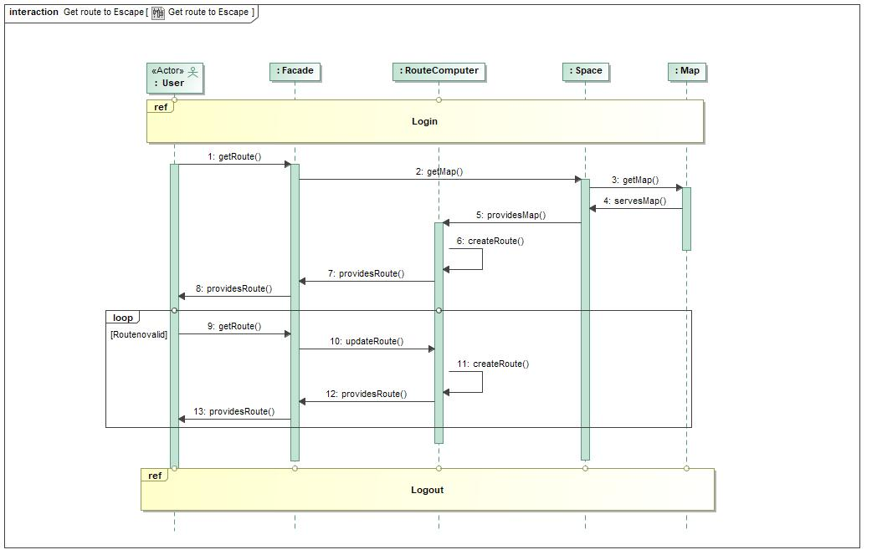

1. Get route to Escape

## Statistic By Printer

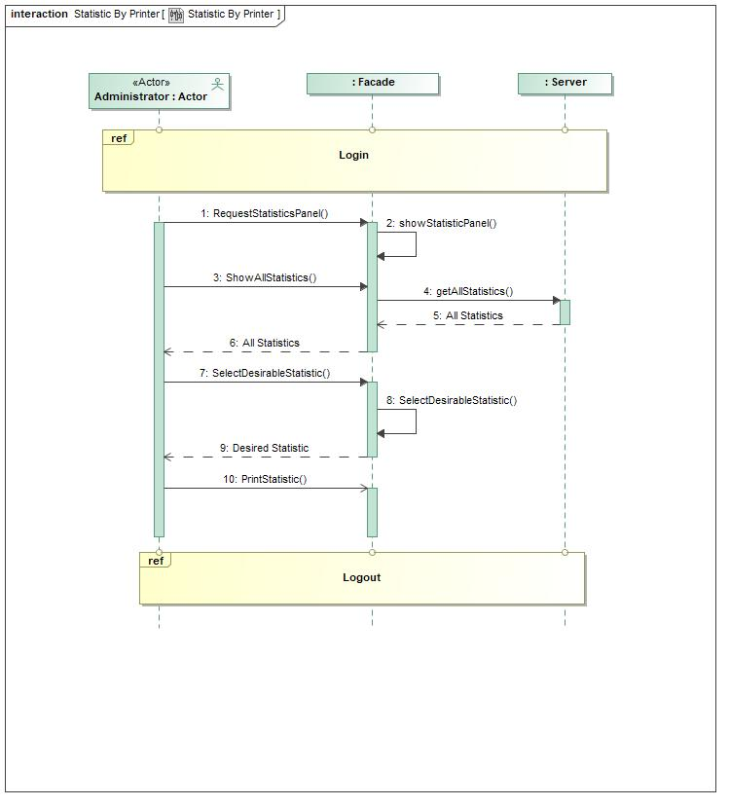

1. Statistic By Printer

## Logout

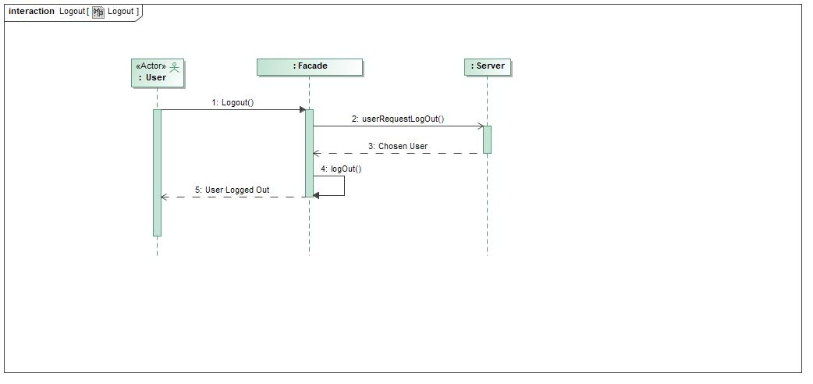

1. Logout

## Change Password

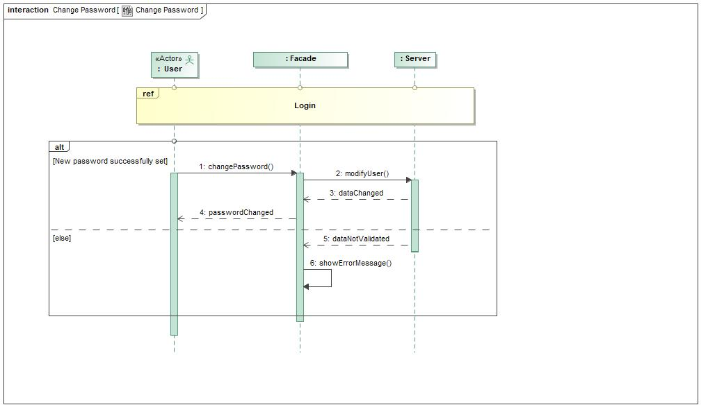

1. Change Password

## View Statistics Panel

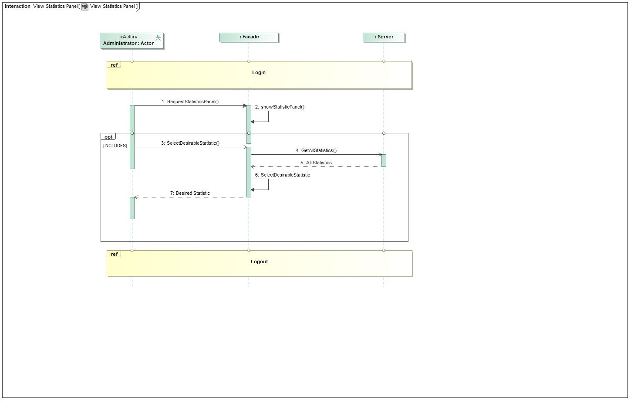

1. View Statistics Panel

## Manage Building Plans

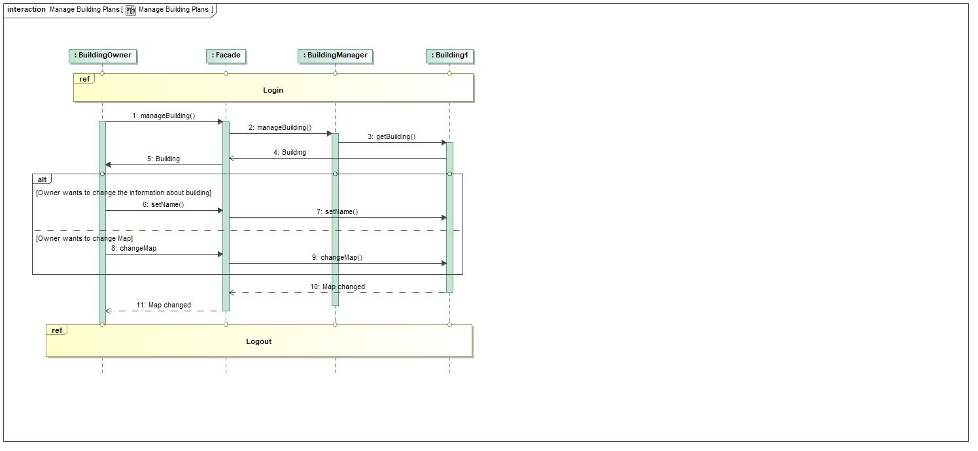

1. Manage Building Plans

## Add User

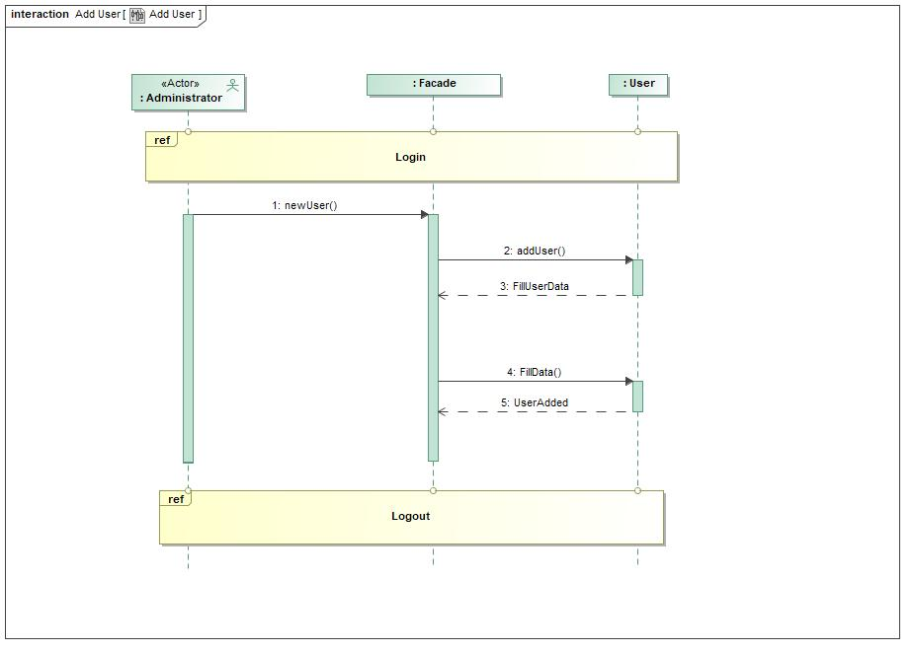

1. Add User

## Delete User

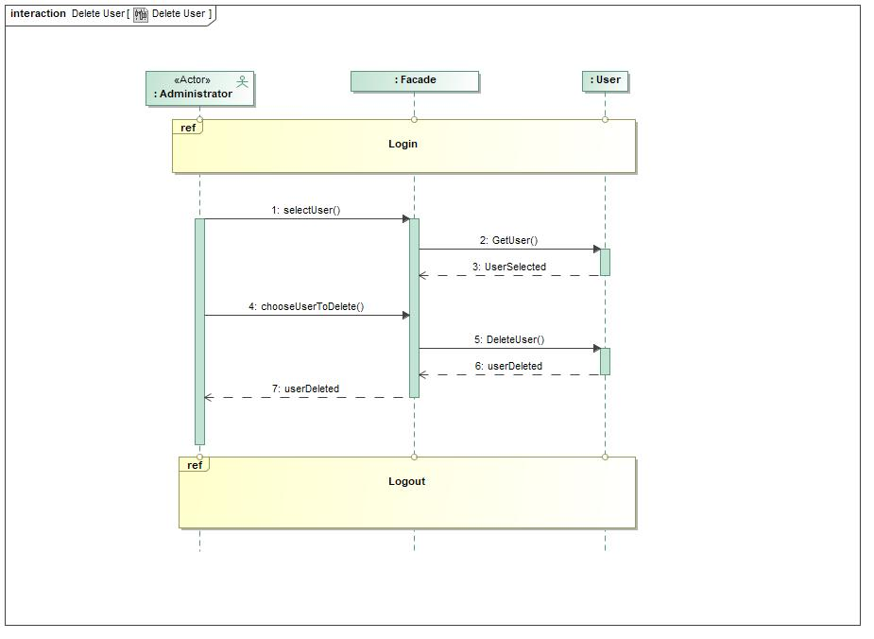

1. Delete User

## Upload Building Plan

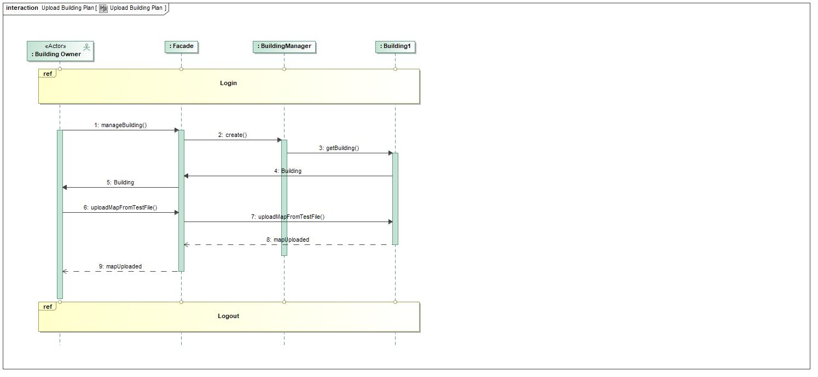

1. Upload Building Plan

## Change User

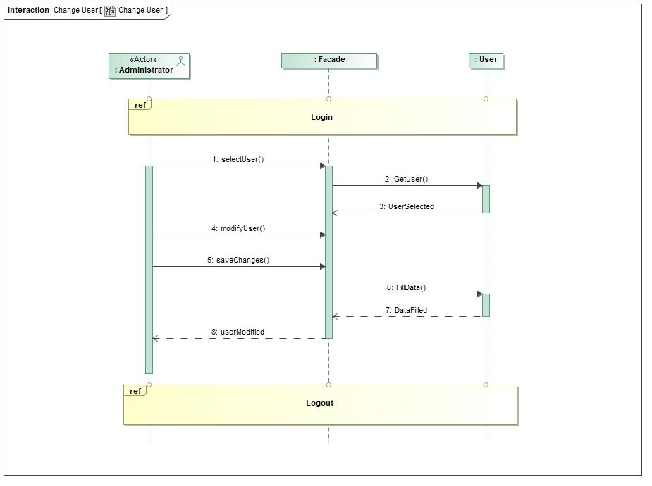

1. Change User

## Login

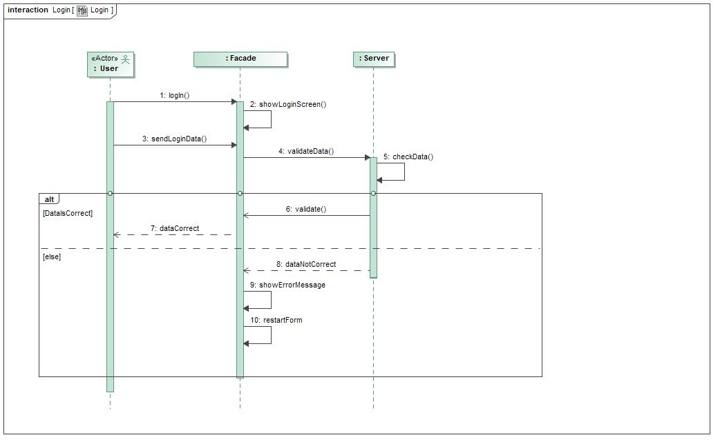

1. Login

## Delete Building Plan

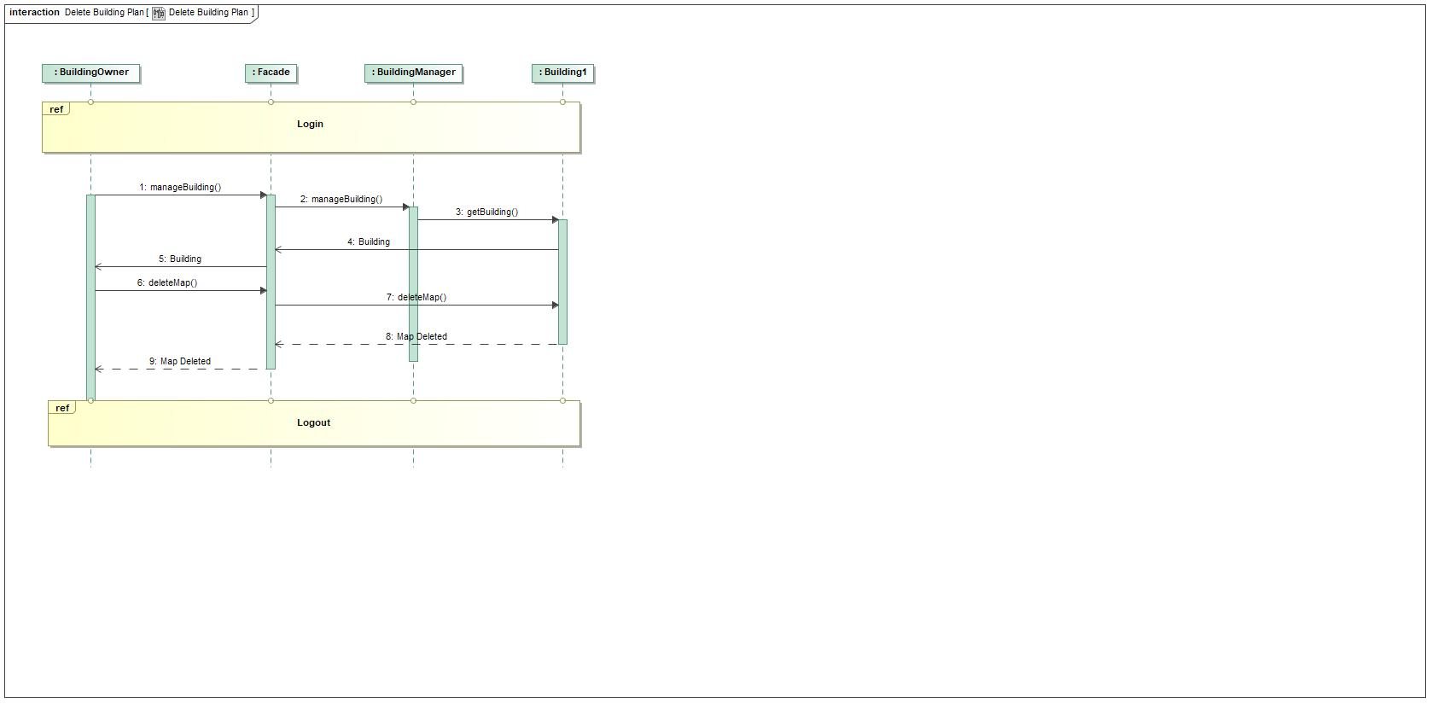

1. Delete Building Plan

## See current position on map

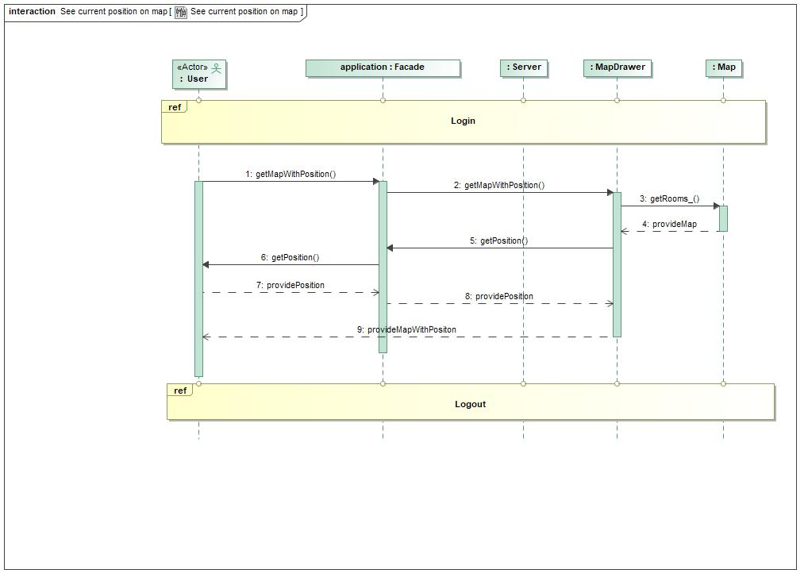

1. See current position on map

## Register

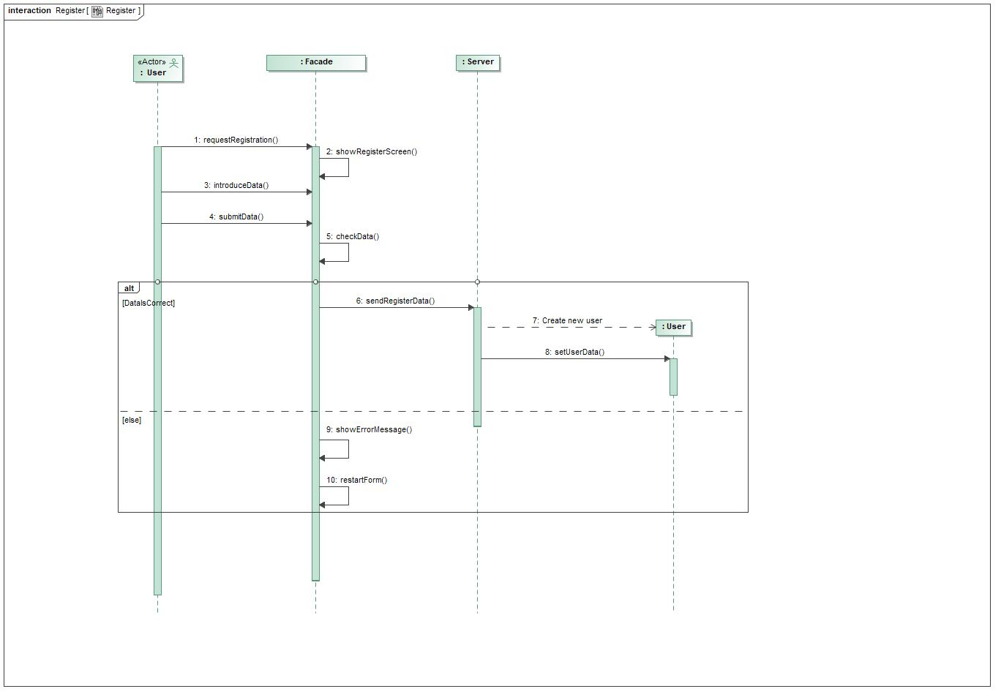

1. Register

## Statistics On Screen

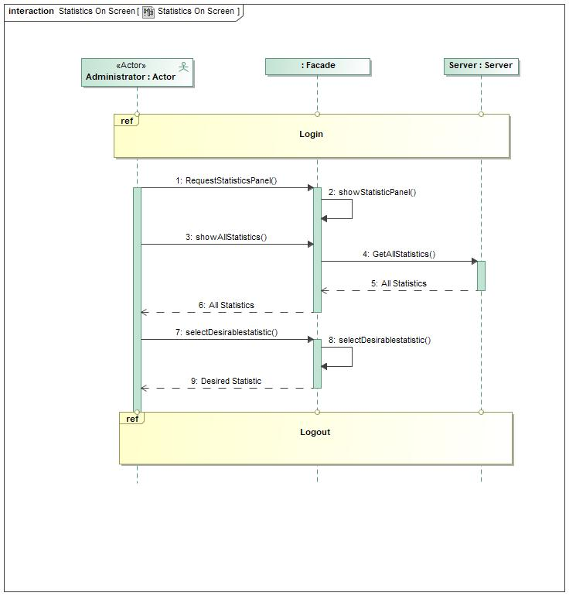

1. Statistics On Screen

## Register Building Owner

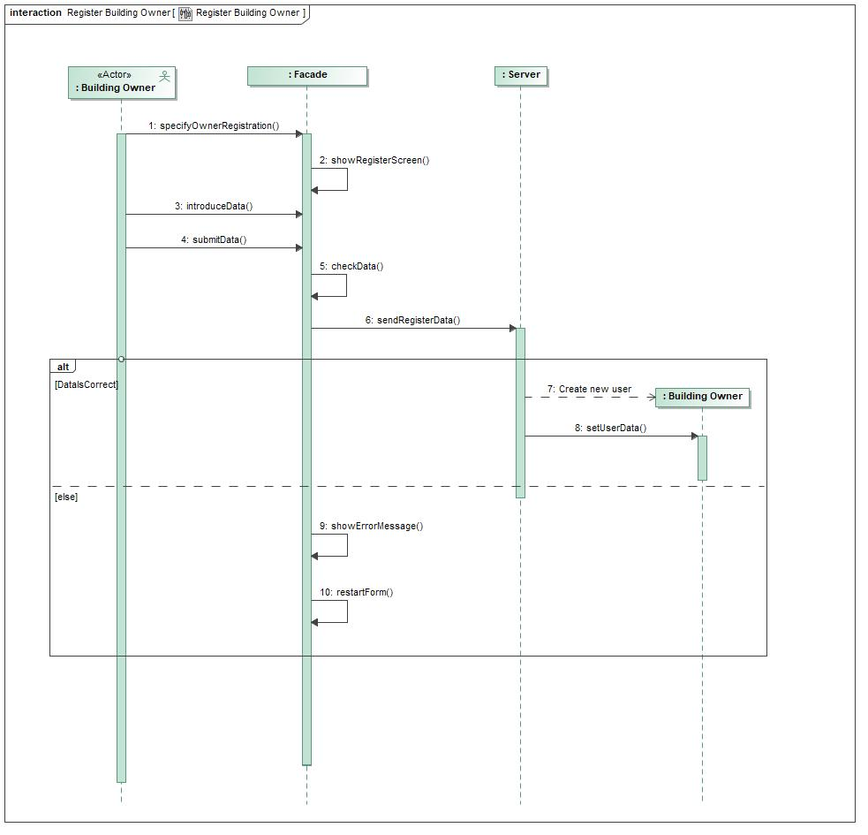

1. Register Building Owner