FuncionalRequirementsEscaper

Requirement Report

Author: <Denis Drobny>

Revision: 0.1

|  |  |
| --- | --- |
| NA |  |
| NA | Date: apríla 20, 2018 |

**Revision History**

|  |  |  |  |
| --- | --- | --- | --- |
| **Revision** | **Date** | **Reason For Changes** | **Author** |
| 0.1 | Apr 20, 2018 | <Initial draft> | <Denis Drobny> |

**Table of Contents**

Introduction 1

Purpose 1

Scope 1

Overview 1

3.1 Functional requirements 2

2.6.2 Delete plan 2

FR-2.4 Preview map of a building 2

FR-2.5 Select position 2

FR-2.6.1 Upload map of building 3

FR-2.7.1 Admin adds a user 3

FR-2.7.2 Admin deletes a user 3

FR-2.7.3 Admin modifies user 4

FR-2.7.4 Show statistics 4

FR-18 NA 4

FR-1 Compute escape paths 4

FR-1.1 Compute path of user 5

FR-1.2 Database of maps of buildings 5

FR-1.2.1 Load map 5

FR-1.3 Database of users 6

3.1.1 Use cases 9

NA NA 9

Appendix A: Diagram 10

Flow 10

Flow 10

Flow 11

FR diagram 11

FR table 11

Get location 12

Use case diagram 12

**Table of Figures**

1. Get location 6
2. Flow 10
3. Flow 10
4. Flow 11
5. FR diagram 11
6. FR table 12
7. Get location 12
8. Use case diagram 13

**Executive Summary**

This section previews the main points of a report. The executive summary contains enough information for a reader to get familiarized with what is discussed in the full report without having to read it.

Introduction

Purpose

<This document provides requirements with their properties including requirement id, requirement name, requirement text and the dependencies.>

Scope

<Provide a short description of the system being specified and its purpose, including relevant benefits, objectives, and goals.>

Overview

<Describe what the document contains and explain how the document is organized>

3.1 Functional requirements

2.6.2 Delete plan

The system shall allow delete plan of a building by its owner

**Derived From:**

|  |  |
| --- | --- |
| 739815772.png | FR-2.6 Building owner's actions |

**Verified By:**

|  |  |
| --- | --- |
| 837664800.png | Delete previously uploaded plan of a builting by its owner |

**Traced To:**

|  |  |
| --- | --- |
| 739815772.png | FR-2.6 Building owner's actions |

**Traced From:**

|  |  |
| --- | --- |
| 837664800.png | Delete previously uploaded plan of a builting by its owner |

FR-2.4 Preview map of a building

The system shall show user map of a building

**Derived From:**

|  |  |
| --- | --- |
| 739815772.png | FR-2 Users' actions |

**Verified By:**

|  |  |
| --- | --- |
| 837664800.png | Show user map of requested building |

**Traced To:**

|  |  |
| --- | --- |
| 739815772.png | FR-2 Users' actions |

**Traced From:**

|  |  |
| --- | --- |
| 837664800.png | Show user map of requested building |

FR-2.5 Select position

The system shall allow users select his building and position in it

**Derived From:**

|  |  |
| --- | --- |
| 739815772.png | FR-2 Users' actions |

**Verified By:**

|  |  |
| --- | --- |
| 837664800.png | Provide position to the system |

**Traced To:**

|  |  |
| --- | --- |
| 739815772.png | FR-2 Users' actions |

**Traced From:**

|  |  |
| --- | --- |
| 837664800.png | Provide position to the system |

FR-2.6.1 Upload map of building

The system shall allow person that is in charge of some building upload its map

**Derived From:**

|  |  |
| --- | --- |
| 739815772.png | FR-2.6 Building owner's actions |

**Verified By:**

|  |  |
| --- | --- |
| 837664800.png | Upload map of a building by its owner |

**Traced To:**

|  |  |
| --- | --- |
| 739815772.png | FR-2.6 Building owner's actions |

**Traced From:**

|  |  |
| --- | --- |
| 837664800.png | Upload map of a building by its owner |

FR-2.7.1 Admin adds a user

The system shall allow admin add new user

**Derived From:**

|  |  |
| --- | --- |
| 739815772.png | FR-2.7 Admin's management of users |

**Verified By:**

|  |  |
| --- | --- |
| 837664800.png | Add user with same personal info as one that has been deleted |

|  |  |
| --- | --- |
| 837664800.png | Add new user |

**Traced To:**

|  |  |
| --- | --- |
| 739815772.png | FR-2.7 Admin's management of users |

**Traced From:**

|  |  |
| --- | --- |
| 837664800.png | Add user with same personal info as one that has been deleted |

|  |  |
| --- | --- |
| 837664800.png | Add new user |

FR-2.7.2 Admin deletes a user

The system shall allow admin delete a user

**Derived From:**

|  |  |
| --- | --- |
| 739815772.png | FR-2.7 Admin's management of users |

**Verified By:**

|  |  |
| --- | --- |
| 837664800.png | Add user with same personal info as one that has been deleted |

|  |  |
| --- | --- |
| 837664800.png | Delete existing user |

**Traced To:**

|  |  |
| --- | --- |
| 739815772.png | FR-2.7 Admin's management of users |

**Traced From:**

|  |  |
| --- | --- |
| 837664800.png | Add user with same personal info as one that has been deleted |

|  |  |
| --- | --- |
| 837664800.png | Delete existing user |

FR-2.7.3 Admin modifies user

The system shall allow admin modify user

**Derived From:**

|  |  |
| --- | --- |
| 739815772.png | FR-2.7 Admin's management of users |

**Verified By:**

|  |  |
| --- | --- |
| 837664800.png | Modify personal information of existing user by admin |

**Traced To:**

|  |  |
| --- | --- |
| 739815772.png | FR-2.7 Admin's management of users |

**Traced From:**

|  |  |
| --- | --- |
| 837664800.png | Modify personal information of existing user by admin |

FR-2.7.4 Show statistics

The system shall allow admin to list all statistics about the system

**Derived From:**

|  |  |
| --- | --- |
| 739815772.png | FR-2.7 Admin's management of users |

**Verified By:**

|  |  |
| --- | --- |
| 837664800.png | Get statistics about system by admin |

**Traced To:**

|  |  |
| --- | --- |
| 739815772.png | FR-2.7 Admin's management of users |

**Traced From:**

|  |  |
| --- | --- |
| 837664800.png | Get statistics about system by admin |

FR-18 NA

FR-1 Compute escape paths

The system shall compute escape path for all of its users

**Verified By:**

|  |  |
| --- | --- |
| 837664800.png | Get all escape paths of registered users |

**Traced From:**

|  |  |
| --- | --- |
| 837664800.png | Get all escape paths of registered users |

#### FR-1.1 Compute path of user

The system shall provide user its own escape path from a building

**Derived From:**

|  |  |
| --- | --- |
| 1720936231.png | BR-1.1 Business requirement2 |

**Derived:**

|  |  |
| --- | --- |
| 739815772.png | FR-2.1 Show the escape path |

**Verified By:**

|  |  |
| --- | --- |
| 837664800.png | Get escape path of a user |

**Traced To:**

|  |  |
| --- | --- |
| 1720936231.png | BR-1.1 Business requirement2 |

**Traced From:**

|  |  |
| --- | --- |
| 739815772.png | FR-2.1 Show the escape path |

|  |  |
| --- | --- |
| 837664800.png | Get escape path of a user |

**Refines:**

|  |  |
| --- | --- |
| -16128697.png | Use case1 |

#### FR-1.2 Database of maps of buildings

The system shall store all maps provided by users of building

**Derived:**

|  |  |
| --- | --- |
| 739815772.png | FR-1.2.1 Load map |

**Traced From:**

|  |  |
| --- | --- |
| 739815772.png | FR-1.2.1 Load map |

#### FR-1.2.1 Load map

The system shall load map of a building

**Derived From:**

|  |  |
| --- | --- |
| 1720936231.png | BR-1.2 Business requirement3 |

|  |  |
| --- | --- |
| 739815772.png | FR-1.2 Database of maps of buildings |

**Verified By:**

|  |  |
| --- | --- |
| 837664800.png | Upload map |

**Traced To:**

|  |  |
| --- | --- |
| 1720936231.png | BR-1.2 Business requirement3 |

|  |  |
| --- | --- |
| 739815772.png | FR-1.2 Database of maps of buildings |

**Traced From:**

|  |  |
| --- | --- |
| 837664800.png | Upload map |

#### FR-1.3 Database of users

The system shall store all registered users and their positions

**Verified By:**

|  |  |
| --- | --- |
| 837664800.png | Compare database status with history of changes of users |

**Traced From:**

|  |  |
| --- | --- |
| 837664800.png | Compare database status with history of changes of users |

##### FR-1.3.1 Get location

The system shall be able to obtain location of every user

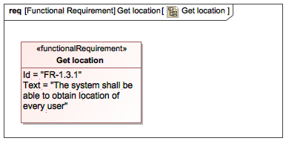

1. Get location

**Hyperlinks:**

|  |  |
| --- | --- |
| 1422318115.png | Get location |

**Verified By:**

|  |  |
| --- | --- |
| 837664800.png | Get location of user |

**Traced From:**

|  |  |
| --- | --- |
| 837664800.png | Get location of user |

##### FR-2 Users' actions

The system shall allow user manage his account

**Derived:**

|  |  |
| --- | --- |
| 739815772.png | FR-2.1 Show the escape path |

|  |  |
| --- | --- |
| 739815772.png | FR-2.2 User register |

|  |  |
| --- | --- |
| 739815772.png | FR-2.2 User register |

|  |  |
| --- | --- |
| 739815772.png | FR-2.3 User log in/out |

|  |  |
| --- | --- |
| 739815772.png | FR-2.4 Preview map of a building |

|  |  |
| --- | --- |
| 739815772.png | FR-2.5 Select position |

|  |  |
| --- | --- |
| 739815772.png | FR-2.9 Password change |

**Traced From:**

|  |  |
| --- | --- |
| 739815772.png | FR-2.1 Show the escape path |

|  |  |
| --- | --- |
| 739815772.png | FR-2.2 User register |

|  |  |
| --- | --- |
| 739815772.png | FR-2.3 User log in/out |

|  |  |
| --- | --- |
| 739815772.png | FR-2.4 Preview map of a building |

|  |  |
| --- | --- |
| 739815772.png | FR-2.5 Select position |

|  |  |
| --- | --- |
| 739815772.png | FR-2.9 Password change |

###### FR-2.1 Show the escape path

The system shall provide user graphical representation of computed path

**Derived From:**

|  |  |
| --- | --- |
| 739815772.png | FR-1.1 Compute path of user |

|  |  |
| --- | --- |
| 739815772.png | FR-2 Users' actions |

**Verified By:**

|  |  |
| --- | --- |
| 837664800.png | Provide user graphical representation of his escape path |

**Traced To:**

|  |  |
| --- | --- |
| 739815772.png | FR-1.1 Compute path of user |

|  |  |
| --- | --- |
| 739815772.png | FR-2 Users' actions |

**Traced From:**

|  |  |
| --- | --- |
| 837664800.png | Provide user graphical representation of his escape path |

###### FR-2.6 Building owner's actions

The system shall register user that is also owner of building

**Derived:**

|  |  |
| --- | --- |
| 739815772.png | 2.6.2 Delete plan |

|  |  |
| --- | --- |
| 739815772.png | FR-2.6.1 Upload map of building |

**Traced From:**

|  |  |
| --- | --- |
| 739815772.png | 2.6.2 Delete plan |

|  |  |
| --- | --- |
| 739815772.png | FR-2.6.1 Upload map of building |

###### FR-2.7 Admin's management of users

The system shall allow admin manage registered users

**Derived:**

|  |  |
| --- | --- |
| 739815772.png | FR-2.7.1 Admin adds a user |

|  |  |
| --- | --- |
| 739815772.png | FR-2.7.2 Admin deletes a user |

|  |  |
| --- | --- |
| 739815772.png | FR-2.7.3 Admin modifies user |

|  |  |
| --- | --- |
| 739815772.png | FR-2.7.4 Show statistics |

**Traced From:**

|  |  |
| --- | --- |
| 739815772.png | FR-2.7.1 Admin adds a user |

|  |  |
| --- | --- |
| 739815772.png | FR-2.7.2 Admin deletes a user |

|  |  |
| --- | --- |
| 739815772.png | FR-2.7.3 Admin modifies user |

|  |  |
| --- | --- |
| 739815772.png | FR-2.7.4 Show statistics |

###### FR-2.9 Password change

The system shall allow logged user to change his password

**Derived From:**

|  |  |
| --- | --- |
| 739815772.png | FR-2 Users' actions |

**Verified By:**

|  |  |
| --- | --- |
| 837664800.png | Change password by user |

**Traced To:**

|  |  |
| --- | --- |
| 739815772.png | FR-2 Users' actions |

**Traced From:**

|  |  |
| --- | --- |
| 837664800.png | Change password by user |

##### FR-2.2 User register

The system shall register new user

**Derived From:**

|  |  |
| --- | --- |
| 739815772.png | FR-2 Users' actions |

**Verified By:**

|  |  |
| --- | --- |
| 837664800.png | Register basic user |

|  |  |
| --- | --- |
| 837664800.png | Register user that is also owner of a building |

**Traced To:**

|  |  |
| --- | --- |
| 739815772.png | FR-2 Users' actions |

**Traced From:**

|  |  |
| --- | --- |
| 837664800.png | Register basic user |

|  |  |
| --- | --- |
| 837664800.png | Register user that is also owner of a building |

##### FR-2.3 User log in/out

The system shall allow existing user to log in and after that to log out

**Derived From:**

|  |  |
| --- | --- |
| 739815772.png | FR-2 Users' actions |

**Verified By:**

|  |  |
| --- | --- |
| 837664800.png | Log in user |

**Traced To:**

|  |  |
| --- | --- |
| 739815772.png | FR-2 Users' actions |

**Traced From:**

|  |  |
| --- | --- |
| 837664800.png | Log in user |

3.1.1 Use cases

NA NA

Appendix A: Diagram

Flow

NA

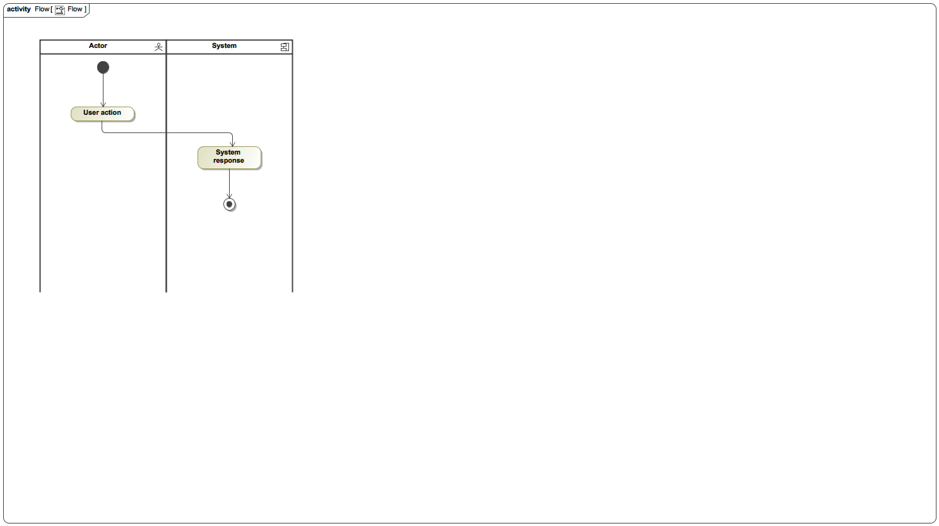

1. Flow

Flow

NA



1. Flow

Flow

NA



1. Flow

FR diagram

NA

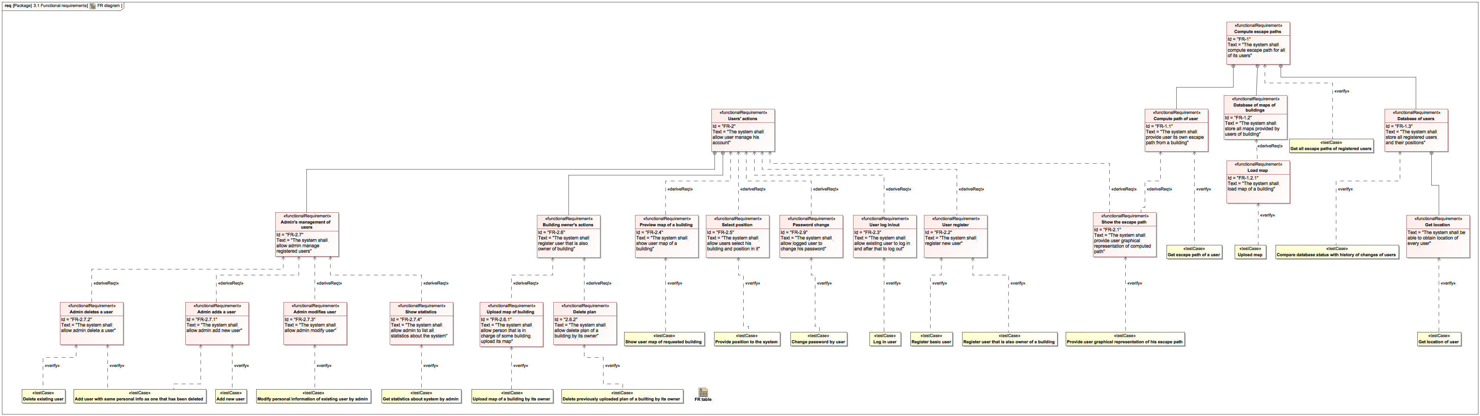

1. FR diagram

FR table

NA

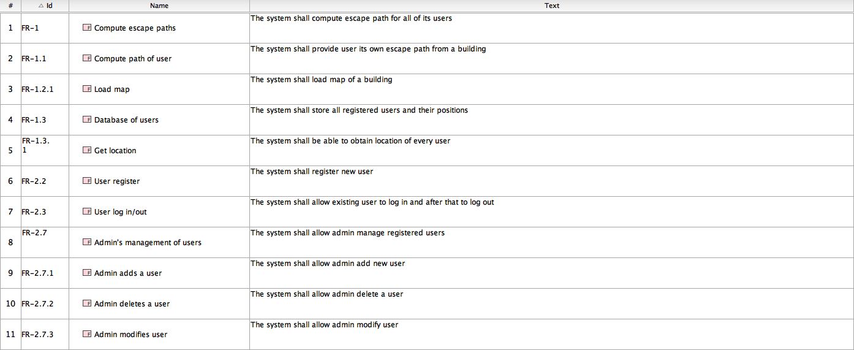

1. FR table

Get location

NA



1. Get location

Use case diagram

NA

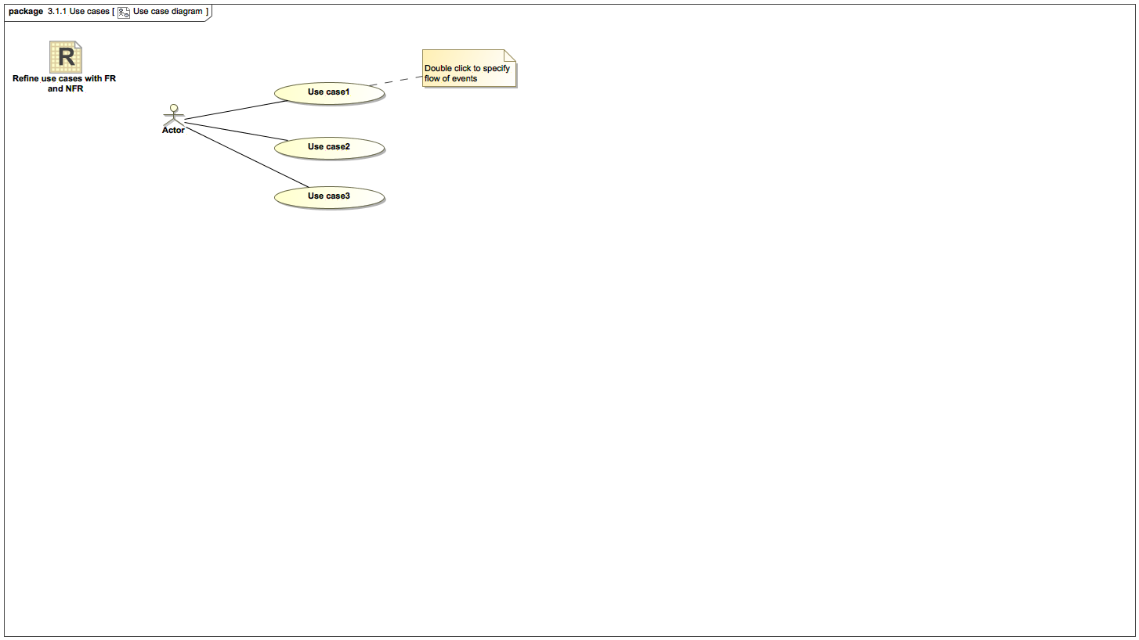

1. Use case diagram