# Rover vehicle overview.

## Rover vehicle description.

Explorer 1 (EX1) is a 4-wheel robot designed with a AWD/4WS (All Wheel Drive/4 Wheel Steering) configuration. EX1 was designed based off ElDorado 2 platform in order to reduce development costs. ElDorado 2 was an old rover platform that was inoperative at the time. The parts inherited from ElDorado 2 included: steering motors, 3-gear differentials, chassis frame, bottom body panel, and both rocker arms.

The current version of the EX1 rover supports functions that allow the rover to be **teleoperated at an ample range of speeds**, with a **maximum operational speed of 1 m/s**. The prototyping character of EX1, for which about 50% of mechanical parts were made out of 3D-printed ABS, implies that extreme operational conditions, such as long drives at maximum speed or the negotiation of large obstacles at increased speed, should be avoided or exceptionally attempted. EX1 design supports the implementation of autonomous capabilities, which can be developed by future students without the need to expand the current rover sensor suite or to remodel the rover systems architecture. The rover in its current state is capable of providing the following functions:

* Power storage, regulation, and distribution.
* Data processing and storage.
* Communication to user/pilot through the Ground Control Station (GCS).
* Teleoperation of the main locomotive functions:
  + Forward and backward driving at speeds in the range of 0.1-1 m/s.
  + 2-wheel front steering while driving at speeds in the range of 0.1-1 m/s.
  + Fixed-speed point-turn steering mode. Speed currently set at 0.2 m/s.

In order to provide this set of functions, the rover is structured around a number of systems and subsystems as illustrated in the following figure:

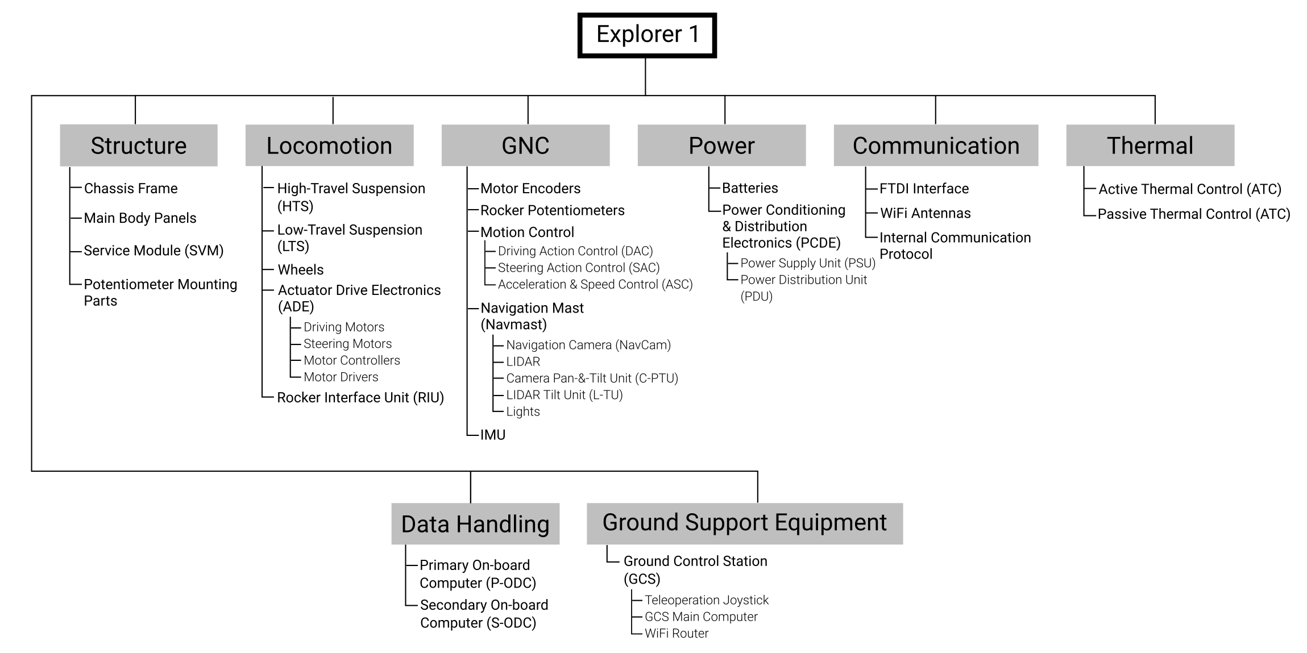

***Fig. 1-1****. Explorer 1systems and subsystems architecture.*

## Configuration overview.

EX1 simplified configuration is based on a cuboidal chassis on which the majority of the rover subsystems are mounted. The suspension subsystem is divided into a high-travel, conventional suspension—i.e., passive rocker arms connected by 3-gear differentials—and a low-travel, elastic suspension. This new mechanically hybrid suspension or MHS design is what provides the rover its efficient high-speed capability.

A navigation mast referred to as NAVMAST was included in the design despite not being necessary for basic, visual-based teleoperation[1]. The navmast was included in the design with the intention that future students could increase the rover autonomous capabilities. Vital electronics are accommodated and protected from the environment inside the main body. The electronics and harnessing of EX1 are integrated on a mounting plate designed with the objective of facilitating maintenance and troubleshooting. This mounting plate can be extracted from the main body (details are provided in Section 3.4.). A light system that includes a pair of lights on top of the navmast and a LED bar attached to the main body was included to allow for low-visibility tests to be conducted in the future.

Several of the rover subsystems are identified in the figure below. Details of each system and subsystem are provided in the following sections.

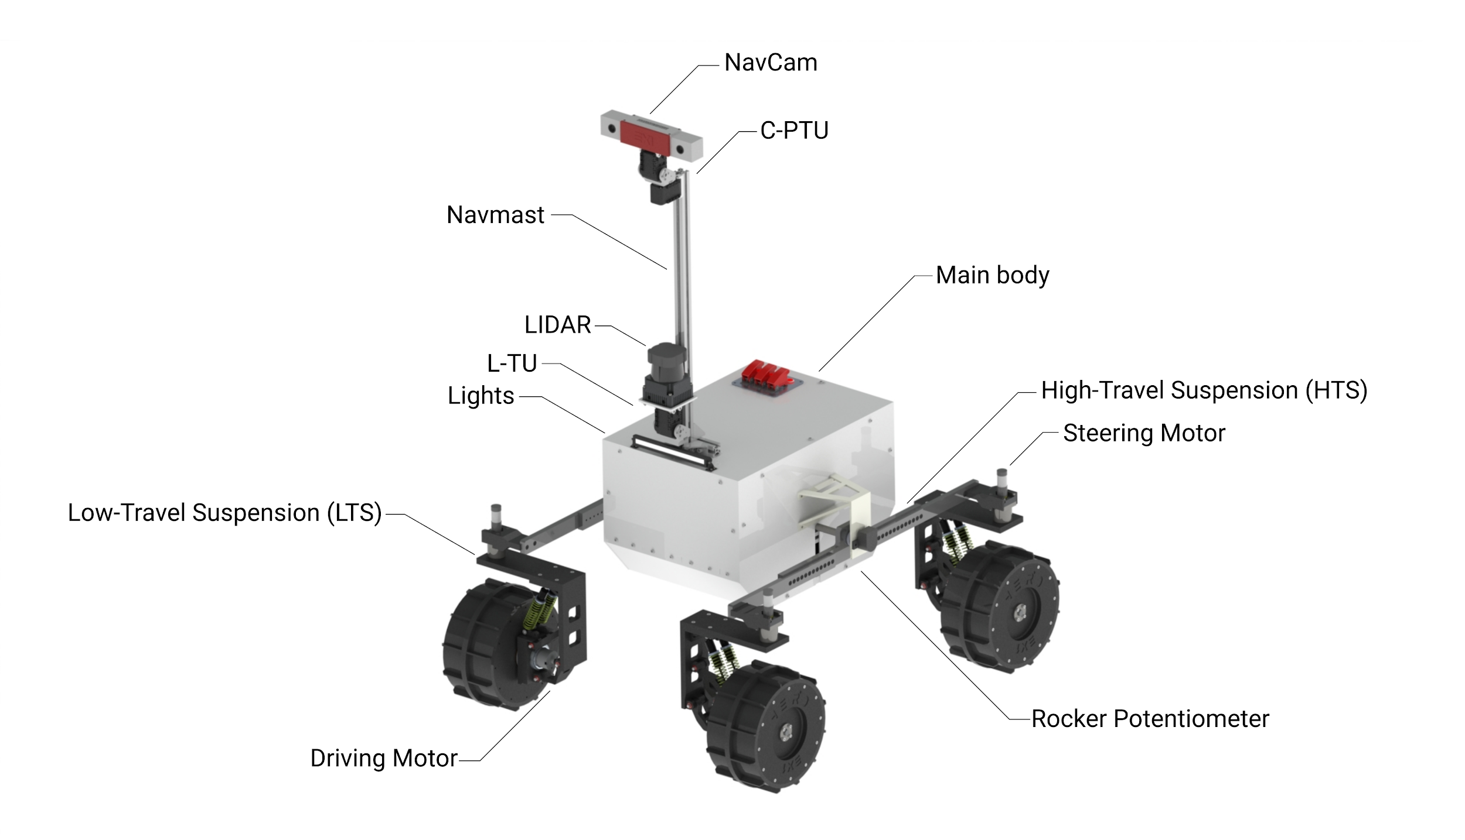

***Fig. 1-2****. Explorer 1standard configuration.*

1. Visual-based teleoperation implies that the pilot is capable of maintaining sight of the rover at all times as opposed to instrument-based teleoperation in which the pilot relies exclusively on the output from proprio and exteroceptive sensors to operate the rover; e.g. teleoperation based on real-time video feed from the navigation cameras. Mixed-teleoperation would refer to a combination of both visual and instrument-based teleoperation.