# Mechanical design and configuration.

## Rover chassis.

The rover main body consists of a cuboidal aluminum frame chassis inherited from the old ElDorado 2 platform. Unlike in the old rover, to the chassis is now mounted 2 mm-thick white acrylic panels that, alongside the chassis frame, provide accommodation, protection, and mechanical support for the majority of systems and subsystems. These panels enclosed the Service Module (SVM, see Section 3.4.)—a MDF wood board attached to the chassis in which all the electronics are mounted. The SVM also provides mechanical accommodation for the wire harness of the rover and facilitates maintenance and troubleshooting of the electronics due to its simple extraction method.

Attached to the top panel are the Navigation Mast (NAVMAST), the battery connectors, and an Emergency Off (EMO) switch, which should be engaged at all times when the robot is not being operated. The NAVMAST includes the Camera Pan & Tilt Unit (C-PTU) and the LIDAR Tilt Unit (L-TU), two mechanisms that increase the dexterity and potential for autonomy of EX1. These mechanisms are controlled by the Secondary On-Board Computer (S-OBC). Further information on the NAVMAST is provided in Section 3.3.. The location for the batteries was chosen to counteract the negative effects of an otherwise poorly balanced gearbox. Batteries were positioned so as to bring the center of mass of the rover as close as possible to the geometric center of the chassis. To the sides of the main chassis two rocker potentiometers are mounted via a couple of 3D-printed ABS parts. This mounting system was inherited from the old ElDorado2 platform. Attached to the back panel are the P-OBC WiFi antennas and two toggle switches that allow power to flow through the lines of the P-OBC and both driving and steering motors.

In its current state, EX1 only supports a fully-deployed configuration mode. However, the design is easily adaptable to also include a stowed configuration if required by future projects (e.g., to ease transportability) provided that four extra motors (“deployment motors”) are incorporated into the design at the interface between the High-Travel and Low-Travel Suspension (HTS and LTS, respectively). No energy generation devices were incorporated into the design. In the future, a photovoltaic (PV) solar module can be attached to the top panel either by avoiding the batteries or by relocating them to a different part of the rover. As previously mentioned, EX1 incorporates a set of lights for low-visibility testing that includes a pair of LED sets attached to the Optical Bench of the NAVMAST and a LED bar mounted on the chassis front panel. These lights are controlled from the teleoperation joystick of the P-OBC and their brightness can be independently modified through the Lights Control Board (LCB) inside the SVM (see Section 4.4. for further information).

Layout drawings of the rover and its key dimensions are displayed in Fig. 3-1 and 3-2.

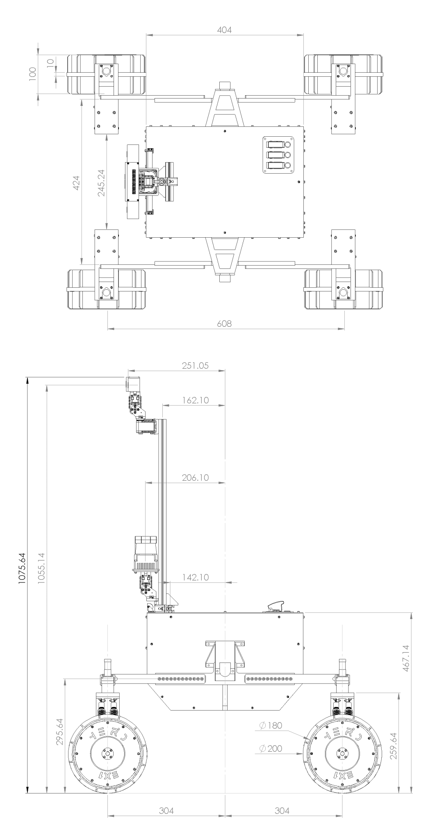

***Fig. 3-1****. EX1 deployed configuration top and side views*

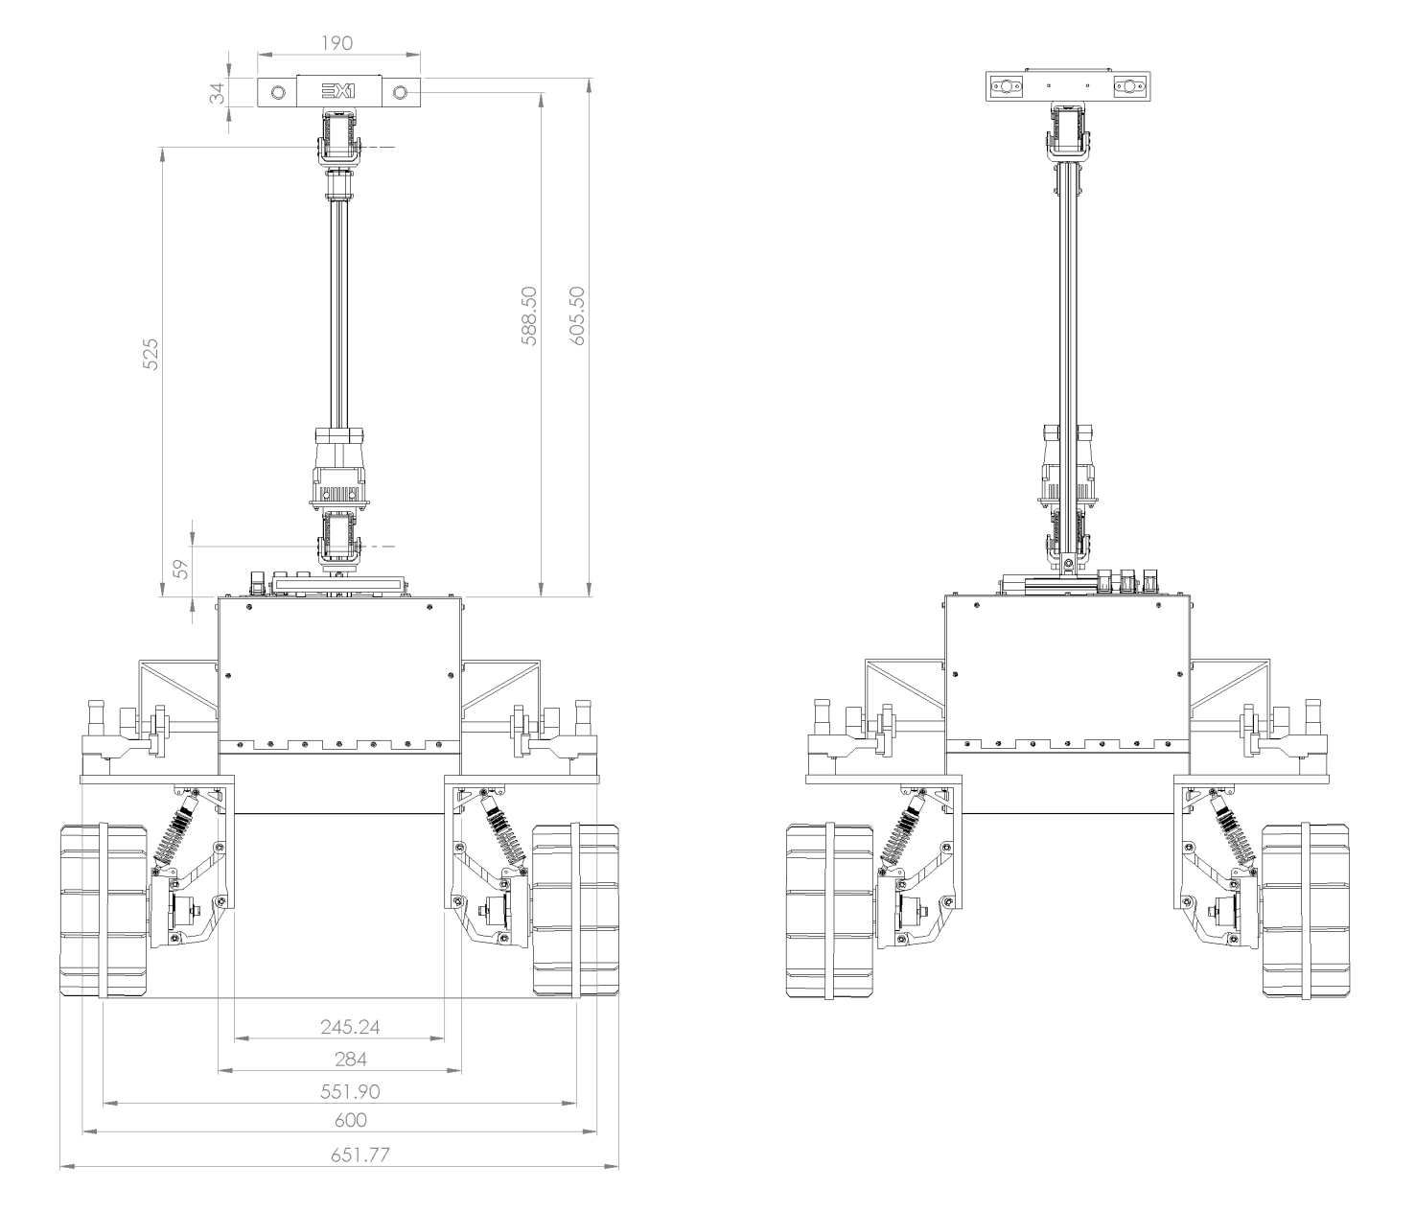 ***Fig. 3-2****. EX1 deployed configuration front and rear views.*

## Locomotion system.

EX1 locomotion system consists of an innovative mechanically-hybrid suspension (MHS) system attached to the input shafts of two 3-gear differential boxes housed inside the rover chassis. A depiction of the suspension is shown in Fig. 3-3. As the name suggests, the suspension is formed by two mechanical parts that work in unison: a high-travel, rigid suspension (HTS) coupled to a low-travel, elastic suspension (LTS). The combination of both the rigid suspension mode of the HTS and the elastic mode of the LTS is what allows the rover to withstand the impact loads and vibrations resulting from high-speed driving while being able to overcome individual obstacles of sizes comparable to the rover wheel size. The HTS has a travel range of 250 mm only limited by the length of the wire harness of the Actuator Drive Electronics (ADE) (for information on the ADE refer to Section 4.2.). The LTS has a maximum travel range of 35 mm, limited by the maximum travel range of the dampers.

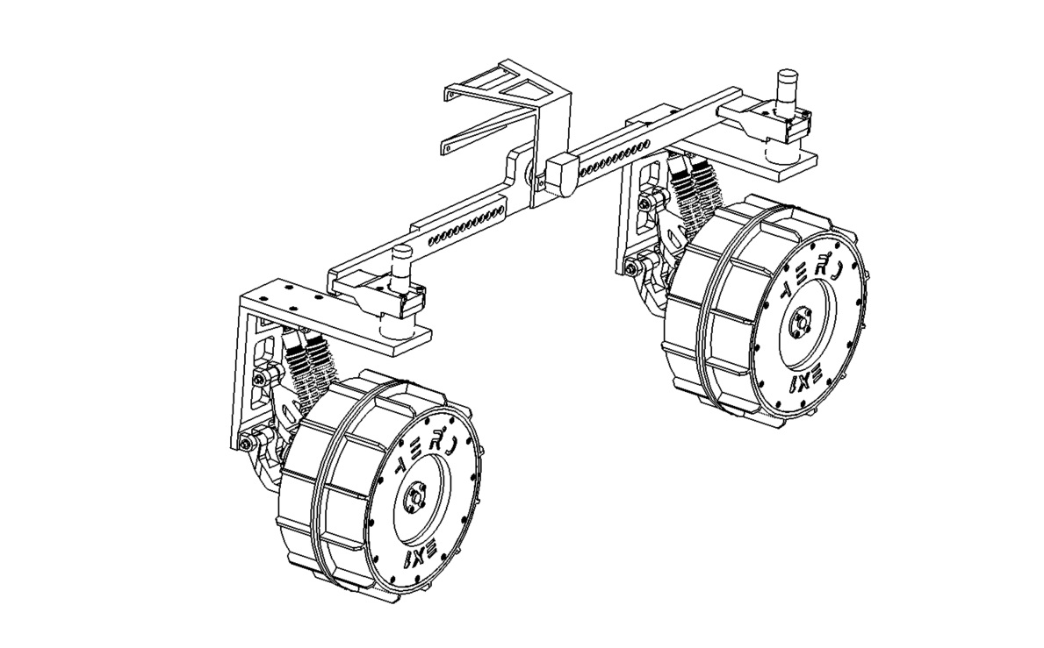

***Fig. 3-3****. EX1 mechanically-hybrid suspension design.*

The HTS is nothing else but a pair of free-balancing arms, called rockers, directly attached to the shaft of the differential at one end—to keep the main body on a steady position at all times—and to the LTS at the other end. The steering motor acts as the connecting piece between the HTS rocker arms and the LTS bracket. This allows the LTS to rotate with the wheel when the steering motors are actuated. The LTS consists of a 3D-printed bracket, where the head of the shock absorbers and the lower and upper control arms of the suspension are mounted, a pair of shock absorbers, formed by a replaceable spring and an adjustable damper, and the wheel knuckle, which connects to the driving motor housing and where the tail end of the shock absorbers are mounted. Both the bracket and the wheel knuckle present multiple mounting points on which the shock absorbers can be attached. The overall stiffness of the LTS can be slightly tweak by varying the orientation in which the shocks are mounted without having to completely replace the springs and/or the damper oil. A depiction of the LTS and its components can be seen in Fig. 3-4. For information on how to assemble and disassemble the suspension together with a more in-depth look into all the different parts refer to Section 8.7..

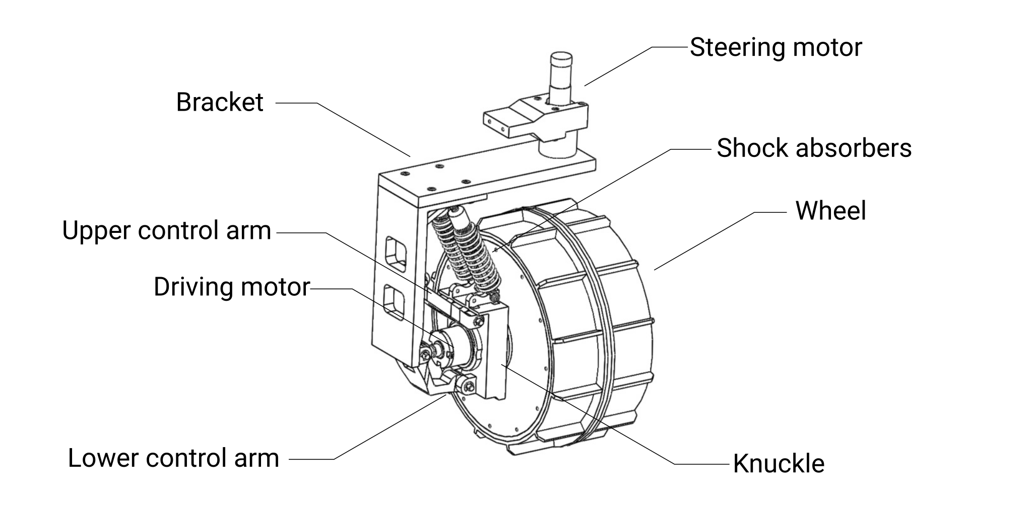

***Fig. 3-4.*** *Low-Travel Suspension (LTS) design.*

## Navigation Mast (NAVMAST).

The NAVMAST consists of an aluminum extrusion frame of length 600 mm fixed to the top panel of the chassis by a pair of M4x15 screws attached to post-assembly insertion nuts. Attached to the frame are the LIDAR Tilt Unit (L-TU) and the Camera Pan & Tilt Unit (C-PTU). The L-TU is a simple tilting mechanism composed of a **Dynamixel AX-12A servo motor** that controls the movement of a **Hokuyo UTM-30LX Scanning Laser Rangefinder**. The C-PTU is also conformed by two Dynamixel AX-12A that provide the pan and tilt motion to the Optical Bench. The Optical bench is a 3D-printed case enclosing an **Intel Realsense D435 camera**, hereinafter referred to as Navigation Camera or NavCam, and two sets of LED lights. A camera protective cover is attached to the Optical Bench by four 4 mm neodymium magnets.

The vertical position of both the NavCam and the LIDAR can be adjusted. In order to facilitate the transportation of the rover, the NAVMAST can be easily detached from the top panel by first removing the front chassis panel and loosening the screws that hold it on top.

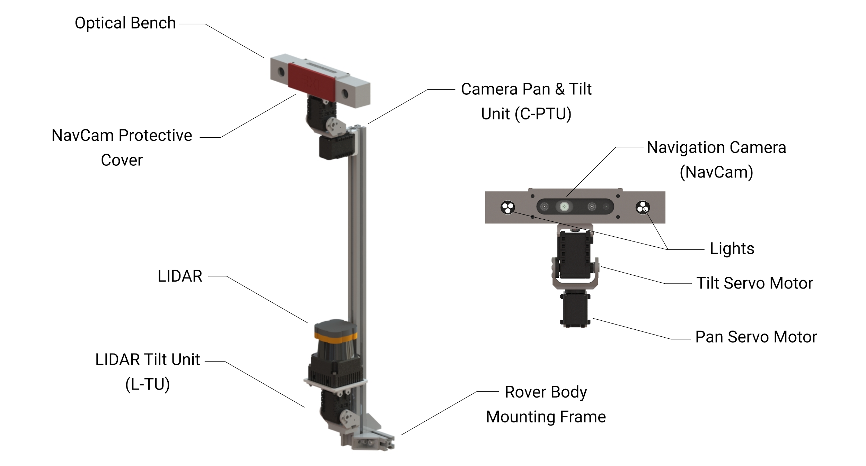

***Fig. 3-5.*** *Navigation Mast (NAVMAST).*

## Service Module (SVM).

All the equipment housed within the rover body is mounted onto a MDF wood board referred to as the Service Module or SVM. This module provides mechanical support to the main stack of electronics of the rover, which includes: the Power Conditioning & Distribution Electronics (PCDE)—formed by the Power Supply Unit (PSU) and the Power Distribution Unit (PDU)—the Rocker Interface Unit (RIU) part of the ADE, the Inertial Measurement Unit (IMU), and the P-OBC. At the same time, the SVM helps arrange the wire harness, facilitating maintenance and troubleshooting. A footprint for the attachment of the S-OBC was included in the design of the SVM and can be found underneath the Lights Control Board (LCB). Additionally, the LCB was designed so that in the future it could be mounted on top of the S-OBC. The underside of the panel has been left free of components. Future projects can make use of the available space underneath the SVM. However, it should be kept in mind that the SVM is only accessible from the upper surface when the side panels of the chassis are mounted.

The SVM is suspended from the chassis by 8 pieces of polyethylene foam and held by two M4x40 screws on the front and rear side. The SVM was designed in such a way that, after all the external connections have been disconnected (see Section 8.6. for chassis panels disassembly instructions), the entire stack of electronics, including the wire harness, can be pulled out of the chassis facilitating maintenance and repair tasks. As will be described in Section 4.3., electrical connections between individual components outside the SVM have been minimized for this purpose. See Fig. 3-6 for an overview of the systems mounted on the SVM.

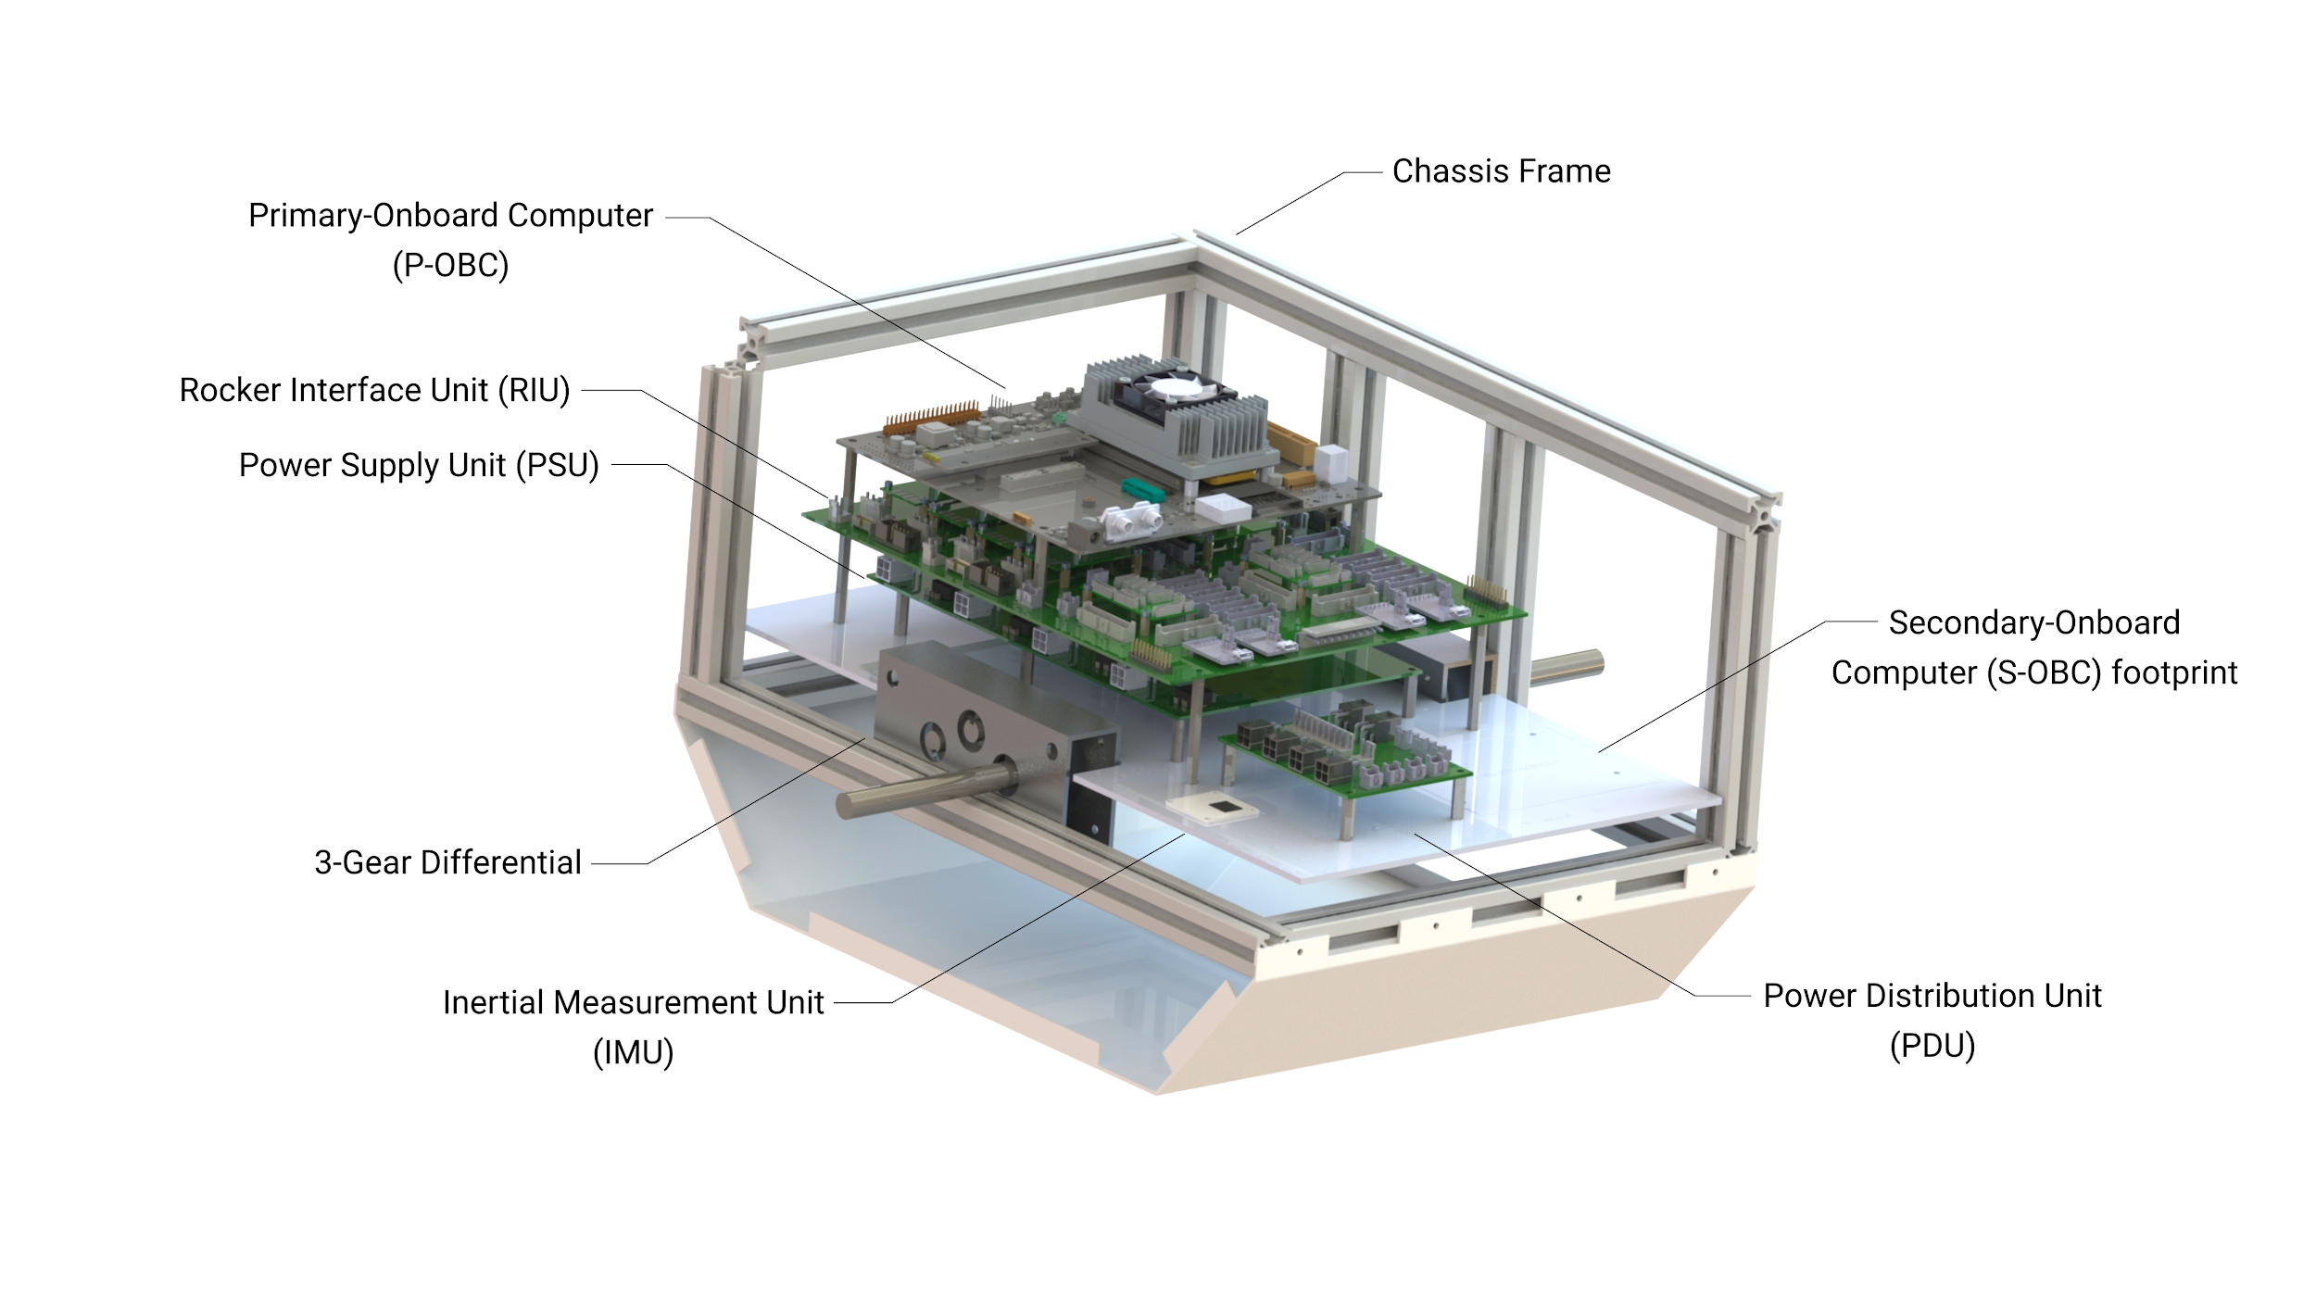

***Fig. 3-6****. Service Module (SVM).*