# Power system design.

## General architecture.

EX1 power system was designed with the objective to minimize the overall size and weight required to provide with sufficient power to all rover systems and subsystems while guaranteeing that peaks of power demand could be met and that individual components were properly protected from potential power surges. To accomplish this, power is provided exclusively through two **18V 6000mAh LiFe batteries** weighing 650 gr each. LiFe batteries were chosen over LiPo batteries due to their overcharge and overdischarge protection. These batteries are mounted onto the top chassis panel. Five different power lines are required to provide all rover systems with their required voltages: 5 V, 12 V, 14.5 V, 24 V., and 36 V.

In the absence of power generation devices, such as PV solar panels, EX1 power system comprises primarily two battery units and the **Power Conditioning and Distribution Electronics (PCDE) module**; i.e., a set of two PCBs that work together to convert input power into required output power and redistribute this to the different components in the system. The two PCBs that comprised the PCDE are called the **Power Supply Unit (PSU)** and the **Power Distribution Unit (PDU)**, both of which are described in the following sections.

In order to protect the different subsystems against power surges a series of 10 A fuses were allocated throughout the high-power lines. To make sure power output is always controlled by the operator, an Emergency Off (EMO) switch and a set of toggle switches were incorporated into the design (for more details, refer to Section 5.2 and Fig. 8-1.). For details on the procedure to power up the rover, refer to Section 8.1.

The general power system architecture is depicted in Fig. 5-1.

*Note: A simpler design for the PSU was proposed due to some manufacturing- and logistics-related issues experienced during the development of the initial PSU design. The current version in use does not incorporate specifically designed (external) power protection systems. The current design of the PSU should be regarded as a functional prototype designed and built by people with limited experience in power systems. Future students are encouraged to reassess the design of the power system to increase its robustness and reliability.*

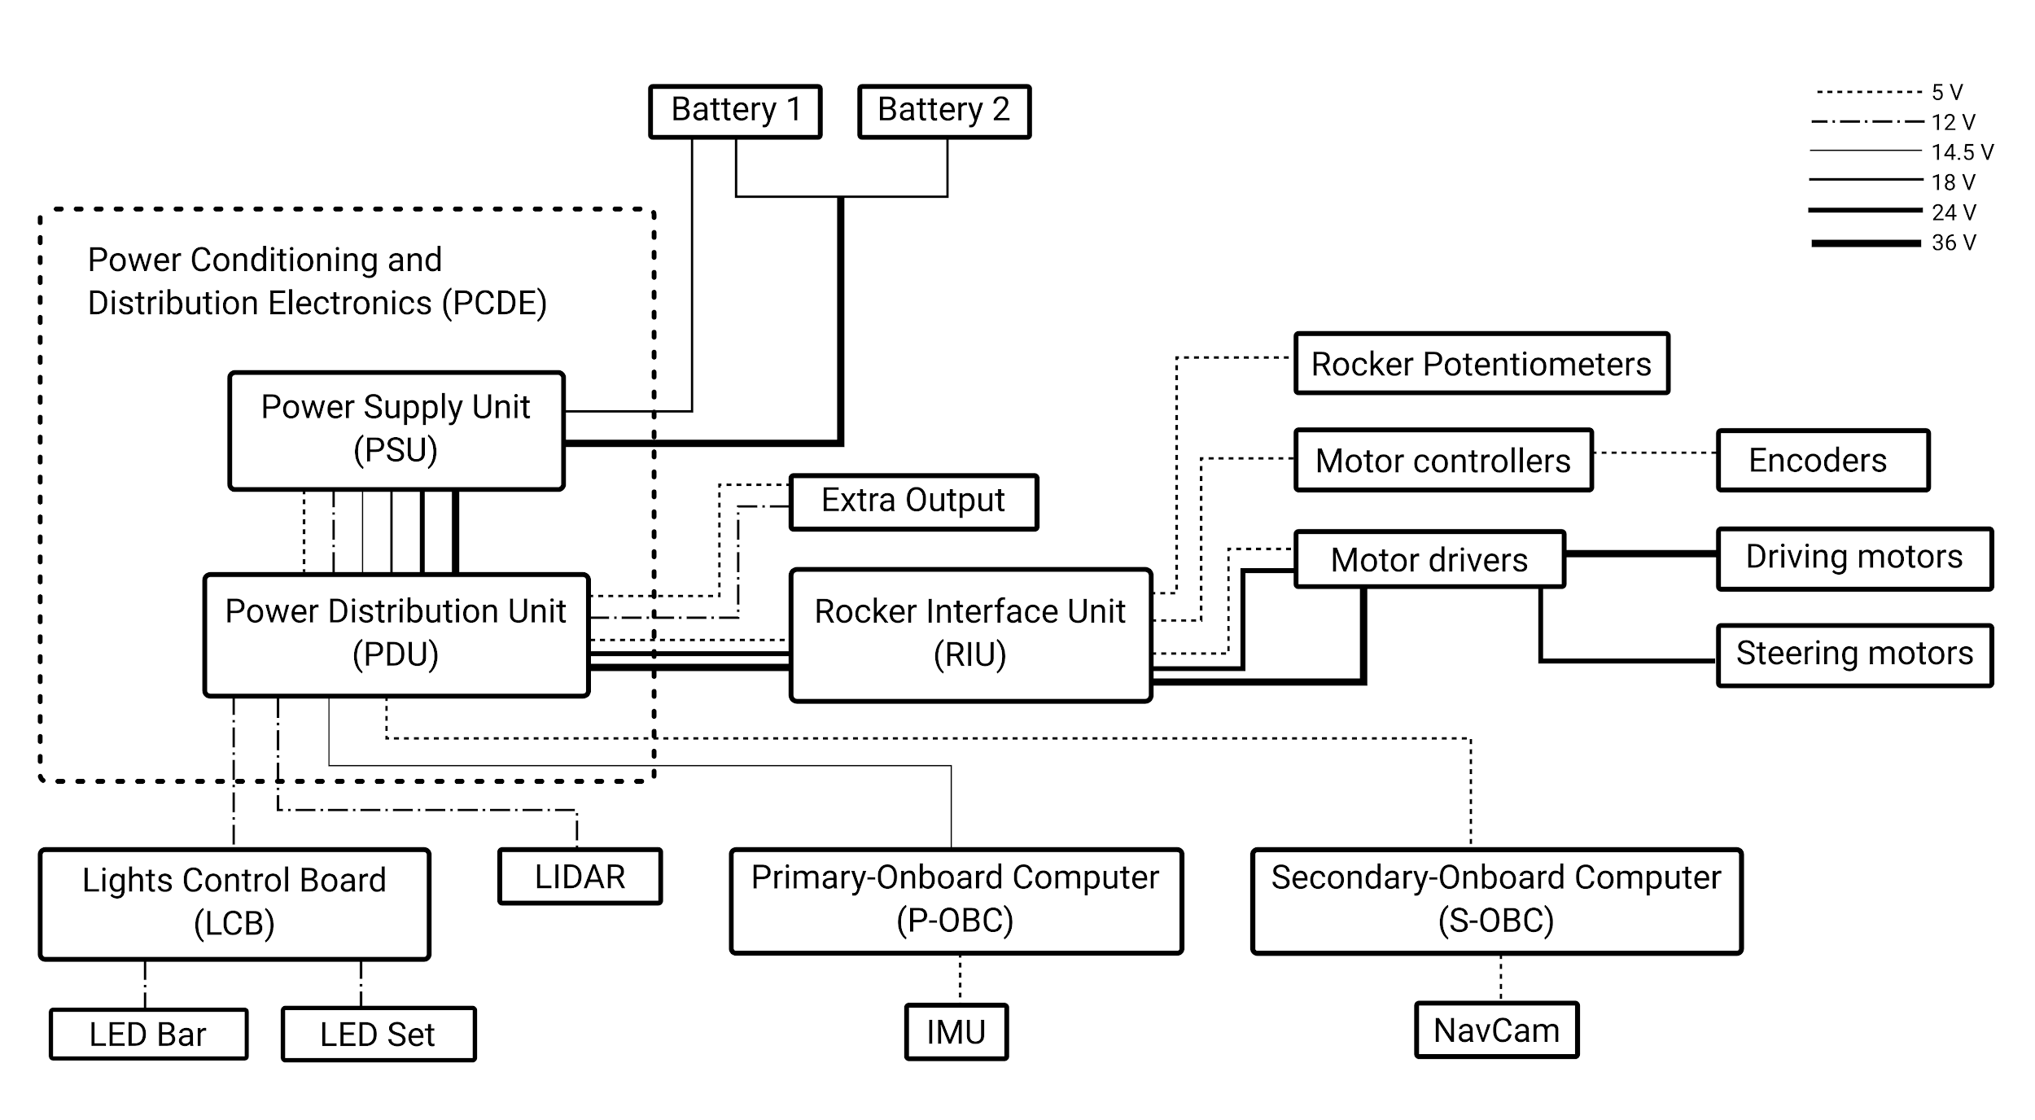

***Fig. 5-1****. EX1 power system architecture.*

## Power Supply Unit (PSU)

The Power Supply Unit (PSU) is a simple prototyping board in which main power inputs and outputs are allocated. In order to simplify the design, off-the-shelf DC-DC converters were used. In particular, the 24 and 14.5 V conversion was accomplished by means of two programmable **Mini-box DCDC-USB Intelligent buck-boost converters**. General characteristics of these two modules are provided in Table 5-1. In the case of the 5 and 12 V conversion, a **Cosel MGFS302412 and a Cosel MGFS302405 DC-DC power conversion modules** were used. These two modules were previously mounted on ElDorado 2 rover. Refer to Table 5-2 and Table 5-3 for general specifications. Further details can be found in *Appendix C - Datasheets*. A schematic of the PSU is presented in Fig. 5-2.

***Table 5-1****. Mini-box DCDC-USB converter specifications.*

|  |  |
| --- | --- |
| Characteristics | Value |
| Power | 100 W |
| Input range | 6-34 V |
| Output range | 5-24 V |
| Max. current | 10 A |

***Table 5-2****. Cosel MGFS302412 DC-DC converter specifications.*

|  |  |
| --- | --- |
| Characteristics | Value |
| Power | 30 W |
| Input range | 9-36 V |
| Default output | 12 V |
| Max. current | 2.5 A |

***Table 5-3****. Cosel MGFS302405 DC-DC converter specifications.*

|  |  |
| --- | --- |
| Characteristics | Value |
| Power | 30 W |
| Input range | 9-36 V |
| Default output | 5 V |
| Max. current | 6 A |

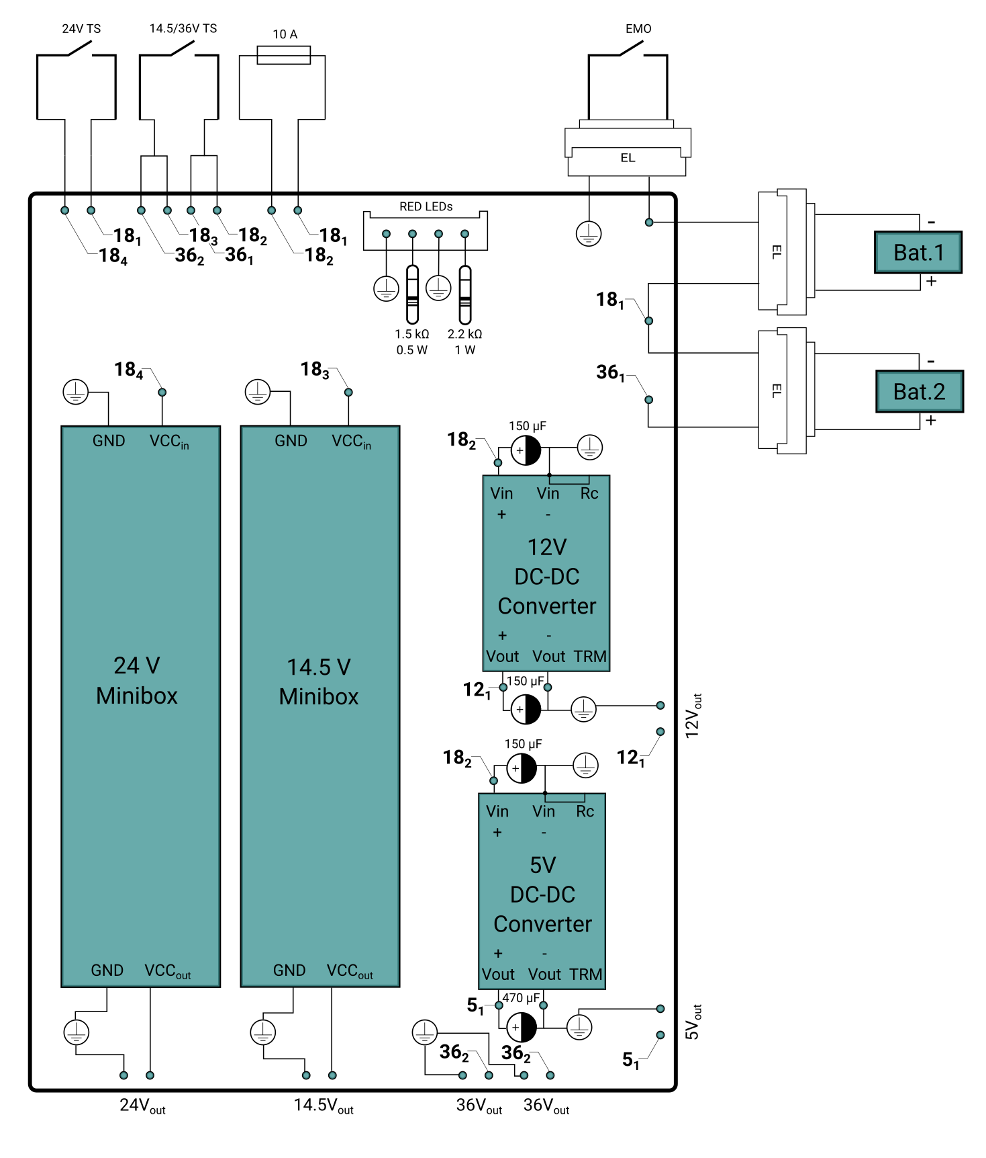

***Fig. 5-2.*** *Power Supply Unit (PSU).*

## Power Distribution Unit (PDU)

The Power Distribution Unit (PDU) consists of a rather simple PCB, the objective of which is to reroute the power outputs from the PSU to the different components in the system. The final PDU design can be seen in Fig. 5-3.

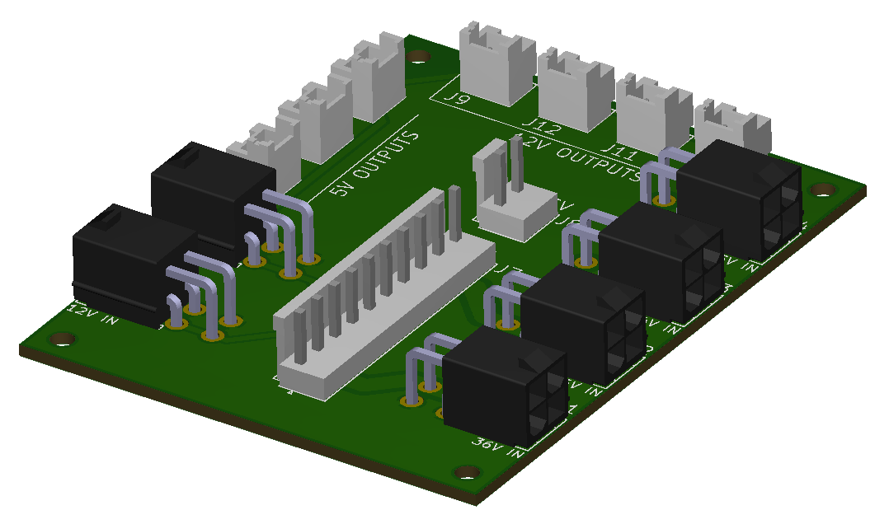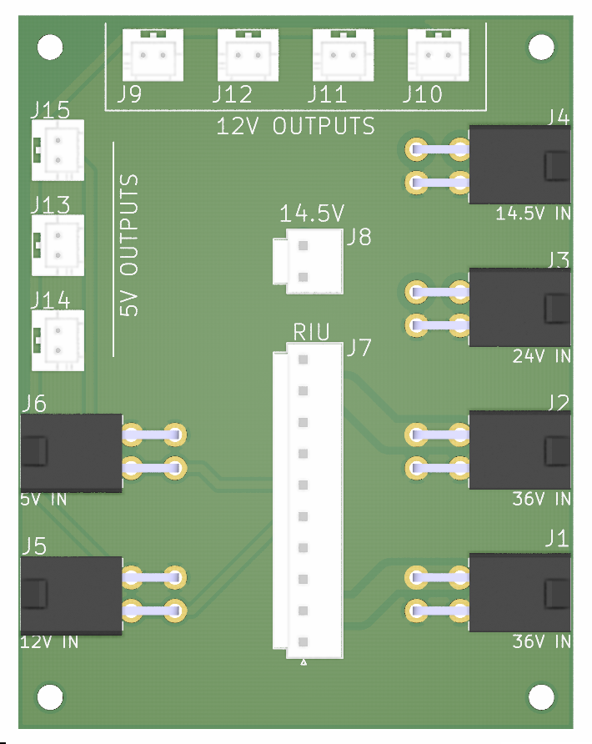

***Fig. 5-3.*** *Power Distribution Unit (PDU) 3D and top views.*