Databases Project – Spring 2017

Prof. Anastasia Ailamaki

Team No: 18

Names: Romain Gehrig, Dominique Roduit, Thierry Treyer

Contents

Contents 1

Deliverable 1 2

Assumptions 2

Entity Relationship Schema 2

Schema 2

Description 2

Relational Schema 2

ER schema to Relational schema 2

DDL 3

General Comments 3

Deliverable 2 4

Assumptions 4

Data Loading 4

Query Implementation 4

Query a: 4

Description of logic: 4

SQL statement 4

Interface 4

Design logic Description 4

Screenshots 4

General Comments 4

Deliverable 3 5

Assumptions 5

Query Implementation 5

Query a: 5

Description of logic: 5

SQL statement 5

Query Analysis 5

Selected Queries (and why) 5

Query 1 5

Query 2 5

Query 3 5

Interface 6

General Comments 6

# Deliverable 1

## Assumptions

<In this section write down the assumptions you made about the data. Write a sentence for each assumption you made>

**Story**

We exploded the attributes of this table in many tables, especially for all the fields containing multiples comma separated values. We describe above the replacement of attributes by new tables.

**script, pencils, inks, colors, letters**

These 5 attributes were replaced by 2 new tables :

1. **person**

this table will contain all the persons (artists or editors) who were contained in the 5 attributes above (and in the deleted attribute “editing”, explanation below). It is thus made of the attributes “alias_id” who refers to a person, to reproduce the fact that sometimes some artists have an alias name. “firstname” and “lastname”.

1. **Participate**

This is the link between person and story to attribute artists to the stories. This single table fully replace the 5 attributes above, each different attribute can be identified by the “role” field whose the type is an enum which express which of the 5 attribute is concerned by the record.

**characters, feature**

2 attributes replaces by 3 tables. On table “hero” which will store the list of all heros, and one intermediate table by attribute which allow to split each comma separated values in many single record linked to the story.

**genre**

This attribute was replaced by two tables : one table “genre” to contain all the genre and avoid duplicata, and an intermediate table “story_genre” with two identifying relationships, in order to explode the separated values in multiples records. Each genre associated to a story is a record in this table.

**editing**

this attribute was deleted because we can retrieve it via the “editing_id” attribute linked to its indicia_publisher, itself link to the issue containing the story. The editor is now in a separated table “edit” containing only editors and linking a person (an editor in this case) to the issue containing the story published by the indicia_publisher linked to the concerned story. The credits are stored in the “note” attribute of this table.

**Issue**

**valid_isbn**

this attribute was removed, we only kept “isbn”.

**price**

attribute replaced by a new table “price” containing the issue concerned by the price, the amount (price itself) and the currency in which this price is exprimed (currency is simply an enum, since the values of currency are a finite set of same values).

## Entity Relationship Schema

<In this section you should have figure of the ER schema as well as descriptions about entities and relations>

### Schema



### Description <Describe all the choices you made for Entities and Relationships>

**Story (relations)**

**story.id - story_reprint.origin_id**

An origin story (old printed story) is 0 or one story.

A story can be the origin story 0, 1 or many times (if reprinted many times).

Identifying relationship because the origin story printing is itself a story.

**story.id - story_reprint.target_id**

A target story (old printed story) is exactly one story.

A story can be the target story 1 or many times (if reprinted many times).

Identifying relationship because the target story printing is itself a story.

**story.type_id - story_type.id**

A story can be of zero or one type.

A story type could be attributed to 0 or many stories.

**story.issue_id – issue.id**

A story is contained by 1 issue

An issue contains 1 or many issues.

**story.id – participate.story_id**

A person can participate in one or many stories

A story can have one or many artists who participated to its realisation

**story.id – feature.story_id**

A feature can be part of zero or one story

A story can have none or many feature.

**story.id – character.story_id**

A character can be attributed to none or many stories

A story have at least one characters, or many.

**story.id – story_genre.story_id**

A genre can be attributed to 1 or many stories

A story can be of one or many genre

**Indicia_publisher.id – issue.indicia_publisher_id**

A story can be published by 0 or 1 indicia publisher

An indicia publisher can publish 1 or many stories

**Issue (relations)**

**Issue_reprint.origin_id – issue.id**

An origin issue (old printed issue) is exactly one issue.

An issue can be the origin issue 1 or many times (if reprinted many times).

Identifying relationship because the origin issue is itself an issue.

**Issue_reprint.target_id – issue.id**

A target (new printed issue) is exactly one issue.

An issue can be the target issue 1 or many times (if reprinted many times).

Identifying relationship because the target issue is itself an issue.

**Indicia_publisher.id – issue.indicia_publisher_id**

An indicia_publisher can publish 1 or many issue.

An issue can be published by 0 or one indicia publisher

**issue.id – price.issue_id**

An issue can be sold to 1 or many price

An a price with its currency can be attributed to only one issue.

**publisher (relations)**

**Publisher.id – indicia_publisher.publisher_id**

An indicia publisher can be owned by only one publisher.

A publisher can be the owner of 0 or many indicia publishers.

Identifying relationship because an indicia_publisher depends directly of a publisher, it can't exists without a publisher.

**Publisher.id – brand_group.publisher_id**

A brand is owned by exactly one publisher.

A publisher can own 0 or many brands.

Identifying relationship because an brand_group depends directly of a publisher, it can't exists without a publisher.

**Publisher.id – series.publisher_id**

A publisher can publish 0, one or many series.

A serie can be published by one publisher.

**Country (relations)**

**Indicia_publisher.country_id – country.id**

An indicia publisher comes from one country

A country can be attributed to 0 or many company

**Country.id – publisher.country_id**

A publisher comes from one country.

A country can be assign to many publisher.

**Series.country_id – country.id**

A country can be attributed to 0, one or many series.

A serie comes from one country.

**Language (relations)**

**Language.id – series.language_id**

A language can be attributed to 0, one or many series.

A series can be in one language.

**Series (relations)**

**Series_publication_type.id – series.publication_type_id**

A publication type can be attributed to 0, one or many series.

A serie can be of one publication type.

**Series.id – issue.series_id**

An issue belongs to 0 or one serie.

A serie can wrap 1 or many issues.

**Issue.id – series.first_issue_id**

It could exists 0 or 1 first issue for a serie

An issue can be the first issue of 0, 1 or many series.

**Issue.id – series.last_issue_id**

It could exists 0 or 1 last issue for a serie

An issue can be the last issue of 0, 1 or many series.

## Relational Schema

### ER schema to Relational schema

<Describe the transition from ER schema to Relational schema>



The relations made only of single strokes as above (thin or bold but without arrows), generate the creation of a new table containing two foreign keys who link together the two tables concerned.

C:\Users\Dominique\AppData\Local\Microsoft\Windows\INetCache\Content.Word\notnullrelation.png

The relations who contains one arrow are reduced to a NON NULL foreign key in the table in front of the arrow.

In the example above, the relation could be translated by a NON NULL foreign key in the table B.



In the relations who are only made of one-one (two bold arrows) and zero-one (one bold and one thin arrows as in this example) constraints, the foreign key must be UNIQUE.

In the example above, the relation could be translated by a UNIQUE foreign key in the table A.

The participation constraints “at least one” (denoted by a bold stroke) can’t be captured in SQL without check constraint or assertion.

### 

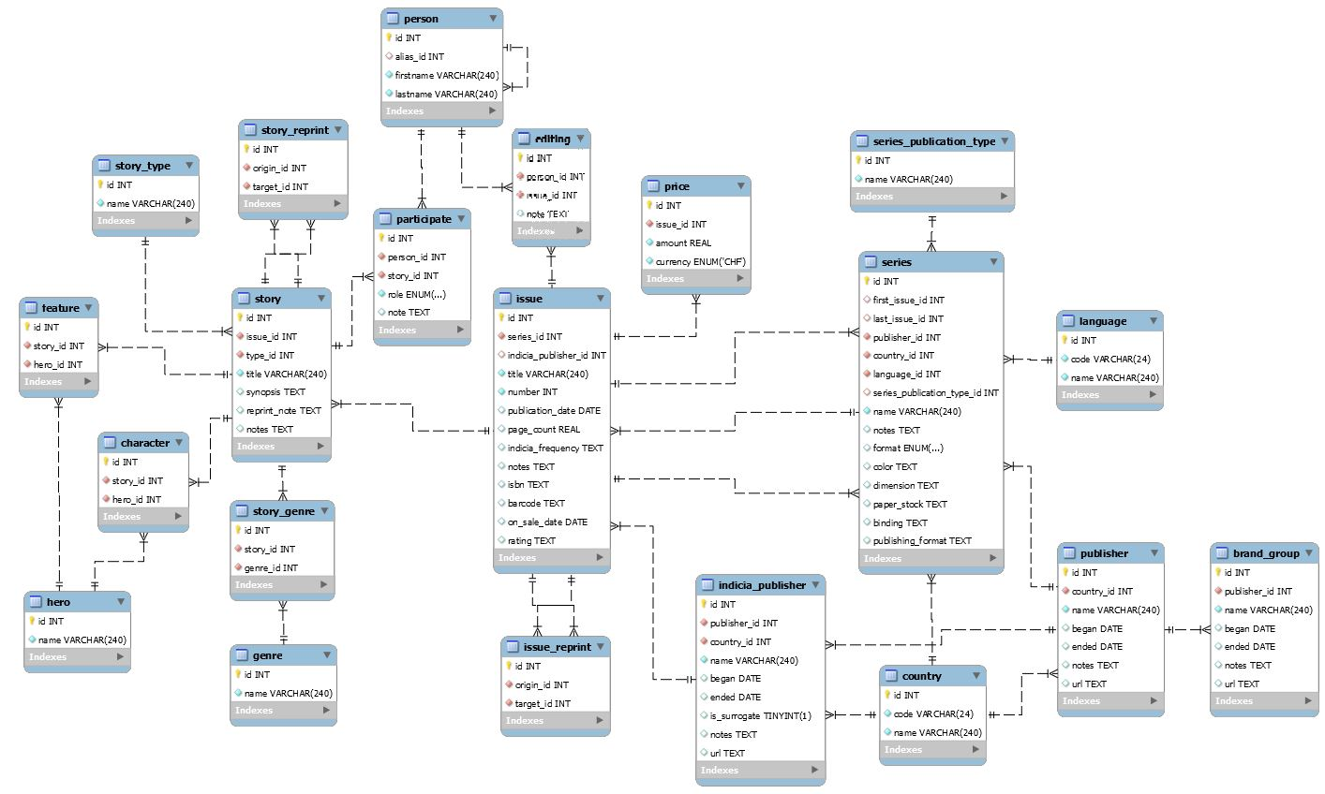

### DDL

-- -----------------------------------------------------

-- Table story_type

-- -----------------------------------------------------

**CREATE** **TABLE** **IF** **NOT** **EXISTS** story_type **(**

id **INT** **NOT** **NULL** AUTO_INCREMENT**,**

name **VARCHAR(**240**)** **NOT** **NULL,**

**PRIMARY** **KEY** **(**id**)**

**);**

-- -----------------------------------------------------

-- Table country

-- -----------------------------------------------------

**CREATE** **TABLE** **IF** **NOT** **EXISTS** country **(**

id **INT** **NOT** **NULL** AUTO_INCREMENT**,**

code **VARCHAR(**24**)** **NOT** **NULL,**

name **VARCHAR(**240**)** **NOT** **NULL,**

**PRIMARY** **KEY** **(**id**)**

**);**

-- -----------------------------------------------------

-- Table publisher

-- -----------------------------------------------------

**CREATE** **TABLE** **IF** **NOT** **EXISTS** publisher **(**

id **INT** **NOT** **NULL** AUTO_INCREMENT**,**

country_id **INT** **NOT** **NULL,**

name **VARCHAR(**240**)** **NOT** **NULL,**

began **DATE** **NULL** **COMMENT** ' '**,**

ended **DATE** **NULL,**

notes TEXT **NULL,**

url TEXT **NULL,**

**PRIMARY** **KEY** **(**id**),**

**INDEX** country_country_id_idx **(**country_id **ASC),**

**CONSTRAINT** country_country_id

**FOREIGN** **KEY** **(**country_id**)**

**REFERENCES** country **(**id**)**

**ON** **DELETE** **CASCADE**

**);**

-- -----------------------------------------------------

-- Table indicia_publisher

-- -----------------------------------------------------

**CREATE** **TABLE** **IF** **NOT** **EXISTS** indicia_publisher **(**

id **INT** **NOT** **NULL** AUTO_INCREMENT**,**

publisher_id **INT** **NOT** **NULL,**

country_id **INT** **NOT** **NULL,**

name **VARCHAR(**240**)** **NOT** **NULL,**

began **DATE** **NULL,**

ended **DATE** **NULL,**

is_surrogate **TINYINT(**1**)** **NULL** **COMMENT** 'A Boolean indicating whether the indicia publisher is a company related to the master publisher or an unrelated company who published on behalf of the master publisher.'**,**

notes TEXT **NULL,**

url TEXT **NULL,**

**PRIMARY** **KEY** **(**id**),**

**INDEX** country_country_id_idx **(**country_id **ASC),**

**INDEX** publisher_publisher_id_idx **(**publisher_id **ASC),**

**CONSTRAINT** country_country_id

**FOREIGN** **KEY** **(**country_id**)**

**REFERENCES** country **(**id**)**

**ON** **DELETE** **RESTRICT** **,**

**CONSTRAINT** publisher_publisher_id

**FOREIGN** **KEY** **(**publisher_id**)**

**REFERENCES** publisher **(**id**)**

**ON** **DELETE** **RESTRICT**

**);**

-- -----------------------------------------------------

-- Table language

-- -----------------------------------------------------

**CREATE** **TABLE** **IF** **NOT** **EXISTS** **language** **(**

id **INT** **NOT** **NULL** AUTO_INCREMENT**,**

code **VARCHAR(**24**)** **NOT** **NULL,**

name **VARCHAR(**240**)** **NOT** **NULL,**

**PRIMARY** **KEY** **(**id**)**

**);**

-- -----------------------------------------------------

-- Table series_publication_type

-- -----------------------------------------------------

**CREATE** **TABLE** **IF** **NOT** **EXISTS** series_publication_type **(**

id **INT** **NOT** **NULL** AUTO_INCREMENT**,**

name **VARCHAR(**240**)** **NOT** **NULL,**

**PRIMARY** **KEY** **(**id**)**

**);**

-- -----------------------------------------------------

-- Table series

-- -----------------------------------------------------

**CREATE** **TABLE** **IF** **NOT** **EXISTS** series **(**

id **INT** **NOT** **NULL** AUTO_INCREMENT**,**

first_issue_id **INT** **NULL,**

last_issue_id **INT** **NULL,**

publisher_id **INT** **NOT** **NULL,**

country_id **INT** **NOT** **NULL,**

language_id **INT** **NOT** **NULL,**

series_publication_type_id **INT** **NULL,**

name **VARCHAR(**240**)** **NOT** **NULL,**

notes TEXT **NULL,**

**format** ENUM**(**'Hardcover'**,** 'Comics'**)** **NULL** **COMMENT** 'Description of physical format (Hardcover, comics, etc.)'**,**

color TEXT **NULL,**

dimension TEXT **NULL,**

paper_stock TEXT **NULL,**

binding TEXT **NULL,**

publishing_format TEXT **NULL** **COMMENT** 'UNKNOWN FIELD IN THE WIKI'**,**

**PRIMARY** **KEY** **(**id**),**

**INDEX** issue_first_issue_id_idx **(**first_issue_id **ASC),**

**INDEX** issue_last_issue_id_idx **(**last_issue_id **ASC),**

**INDEX** country_country_id_idx **(**country_id **ASC),**

**INDEX** language_language_id_idx **(**language_id **ASC),**

**INDEX** publisher_publisher_id_idx **(**publisher_id **ASC),**

**INDEX** series_publication_type_publication_type_idx **(**series_publication_type_id **ASC),**

**CONSTRAINT** issue_first_issue_id

**FOREIGN** **KEY** **(**first_issue_id**)**

**REFERENCES** issue **(**id**)**

**ON** **DELETE** **SET** **NULL,**

**CONSTRAINT** issue_last_issue_id

**FOREIGN** **KEY** **(**last_issue_id**)**

**REFERENCES** issue **(**id**)**

**ON** **DELETE** **SET** **NULL,**

**CONSTRAINT** country_country_id

**FOREIGN** **KEY** **(**country_id**)**

**REFERENCES** country **(**id**)**

**ON** **DELETE** **RESTRICT,**

**CONSTRAINT** language_language_id

**FOREIGN** **KEY** **(**language_id**)**

**REFERENCES** **language** **(**id**)**

**ON** **DELETE** **RESTRICT,**

**CONSTRAINT** publisher_publisher_id

**FOREIGN** **KEY** **(**publisher_id**)**

**REFERENCES** publisher **(**id**)**

**ON** **DELETE** **RESTRICT,**

**CONSTRAINT** series_publication_type_publication_type_id

**FOREIGN** **KEY** **(**series_publication_type_id**)**

**REFERENCES** series_publication_type **(**id**)**

**ON** **DELETE** **SET** **NULL**

**);**

-- -----------------------------------------------------

-- Table issue

-- -----------------------------------------------------

**CREATE** **TABLE** **IF** **NOT** **EXISTS** issue **(**

id **INT** **NOT** **NULL** AUTO_INCREMENT**,**

series_id **INT** **NOT** **NULL,**

indicia_publisher_id **INT** **NULL,**

title **VARCHAR(**240**)** **NOT** **NULL,**

**number** **INT** **NOT** **NULL** **COMMENT** 'Issue number'**,**

publication_date **DATE** **NULL** **COMMENT** 'May be approximate (circa 1870) or a precise date'**,**

page_count **REAL** **NULL** **COMMENT** 'Is a real number!?!'**,**

indicia_frequency TEXT **NULL** **COMMENT** 'Publication frequency (monthly, quarterly, etc.)'**,**

notes TEXT **NULL** **COMMENT** 'Freeform notes'**,**

isbn TEXT **NULL** **COMMENT** 'UNKNOWN FIELD IN WIKI'**,**

barcode TEXT **NULL,**

on_sale_date **DATE** **NULL** **COMMENT** 'UNKNOWN FIELD IN WIKI'**,**

rating TEXT **NULL** **COMMENT** 'Approval and age rating'**,**

**PRIMARY** **KEY** **(**id**),**

**INDEX** indicia_publisher_indica_publisher_id_idx **(**indicia_publisher_id **ASC),**

**INDEX** series_series_id_idx **(**series_id **ASC),**

**CONSTRAINT** indica_publisher_id

**FOREIGN** **KEY** **(**indicia_publisher_id**)**

**REFERENCES** indicia_publisher **(**id**)**

**ON** **DELETE** **SET** **NULL,**

**CONSTRAINT** series_series_id

**FOREIGN** **KEY** **(**series_id**)**

**REFERENCES** series **(**id**)**

**ON** **DELETE** **RESTRICT**

**);**

-- -----------------------------------------------------

-- Table story

-- -----------------------------------------------------

**CREATE** **TABLE** **IF** **NOT** **EXISTS** story **(**

id **INT** **NOT** **NULL** AUTO_INCREMENT**,**

issue_id **INT** **NOT** **NULL,**

type_id **INT** **NOT** **NULL,**

title **VARCHAR(**240**)** **NOT** **NULL** **COMMENT** 'Name of the story'**,**

synopsis TEXT **NULL,**

reprint_note TEXT **NULL,**

notes TEXT **NULL** **COMMENT** 'Arbitrary notes'**,**

**PRIMARY** **KEY** **(**id**),**

**INDEX** story_type_type_id_idx **(**type_id **ASC),**

**INDEX** issue_issue_id_idx **(**issue_id **ASC),**

**CONSTRAINT** story_type_type_id

**FOREIGN** **KEY** **(**type_id**)**

**REFERENCES** story_type **(**id**)**

**ON** **DELETE** **RESTRICT,**

**CONSTRAINT** issue_issue_id

**FOREIGN** **KEY** **(**issue_id**)**

**REFERENCES** issue **(**id**)**

**ON** **DELETE** **RESTRICT**

**);**

-- -----------------------------------------------------

-- Table story_reprint

-- -----------------------------------------------------

**CREATE** **TABLE** **IF** **NOT** **EXISTS** story_reprint **(**

id **INT** **NOT** **NULL** AUTO_INCREMENT**,**

origin_id **INT** **NOT** **NULL,**

target_id **INT** **NOT** **NULL,**

**PRIMARY** **KEY** **(**id**),**

**INDEX** story_origin_id_idx **(**origin_id **ASC),**

**INDEX** story_target_id_idx **(**target_id **ASC),**

**CONSTRAINT** story_origin_id

**FOREIGN** **KEY** **(**origin_id**)**

**REFERENCES** story **(**id**)**

**ON** **DELETE** **CASCADE,**

**CONSTRAINT** story_target_id

**FOREIGN** **KEY** **(**target_id**)**

**REFERENCES** story **(**id**)**

**ON** **DELETE** **CASCADE**

**);**

-- -----------------------------------------------------

-- Table issue_reprint

-- -----------------------------------------------------

**CREATE** **TABLE** **IF** **NOT** **EXISTS** issue_reprint **(**

id **INT** **NOT** **NULL** AUTO_INCREMENT**,**

origin_id **INT** **NOT** **NULL,**

target_id **INT** **NOT** **NULL,**

**PRIMARY** **KEY** **(**id**),**

**INDEX** issue_origin_id_idx **(**origin_id **ASC),**

**INDEX** issue_target_id_idx **(**target_id **ASC),**

**CONSTRAINT** issue_origin_id

**FOREIGN** **KEY** **(**origin_id**)**

**REFERENCES** issue **(**id**)**

**ON** **DELETE** **CASCADE,**

**CONSTRAINT** issue_target_id

**FOREIGN** **KEY** **(**target_id**)**

**REFERENCES** issue **(**id**)**

**ON** **DELETE** **CASCADE**

**);**

-- -----------------------------------------------------

-- Table brand_group

-- -----------------------------------------------------

**CREATE** **TABLE** **IF** **NOT** **EXISTS** brand_group **(**

id **INT** **NOT** **NULL** AUTO_INCREMENT**,**

publisher_id **INT** **NOT** **NULL,**

name **VARCHAR(**240**)** **NOT** **NULL,**

began **DATE** **NULL,**

ended **DATE** **NULL,**

notes TEXT **NULL,**

url TEXT **NULL,**

**PRIMARY** **KEY** **(**id**),**

**INDEX** publisher_publisher_id_idx **(**publisher_id **ASC),**

**CONSTRAINT** publisher_publisher_id

**FOREIGN** **KEY** **(**publisher_id**)**

**REFERENCES** publisher **(**id**)**

**ON** **DELETE** **RESTRICT**

**);**

-- -----------------------------------------------------

-- Table hero

-- -----------------------------------------------------

**CREATE** **TABLE** **IF** **NOT** **EXISTS** hero **(**

id **INT** **NOT** **NULL** AUTO_INCREMENT**,**

name **VARCHAR(**240**)** **NOT** **NULL,**

**PRIMARY** **KEY** **(**id**)**

**);**

-- -----------------------------------------------------

-- Table feature

-- -----------------------------------------------------

**CREATE** **TABLE** **IF** **NOT** **EXISTS** feature **(**

id **INT** **NOT** **NULL** AUTO_INCREMENT**,**

story_id **INT** **NOT** **NULL,**

hero_id **INT** **NOT** **NULL,**

**INDEX** story_story_id_idx **(**story_id **ASC),**

**INDEX** hero_hero_id_idx **(**hero_id **ASC),**

**PRIMARY** **KEY** **(**id**),**

**CONSTRAINT** hero_hero_id

**FOREIGN** **KEY** **(**hero_id**)**

**REFERENCES** hero **(**id**)**

**ON** **DELETE** **CASCADE,**

**CONSTRAINT** story_story_id

**FOREIGN** **KEY** **(**story_id**)**

**REFERENCES** story **(**id**)**

**ON** **DELETE** **CASCADE**

**);**

-- -----------------------------------------------------

-- Table person

-- -----------------------------------------------------

**CREATE** **TABLE** **IF** **NOT** **EXISTS** person **(**

id **INT** **NOT** **NULL** AUTO_INCREMENT**,**

alias_id **INT** **NULL,**

firstname **VARCHAR(**240**)** **NOT** **NULL,**

lastname **VARCHAR(**240**)** **NOT** **NULL,**

**PRIMARY** **KEY** **(**id**),**

**INDEX** person_alias_id_idx **(**alias_id **ASC),**

**CONSTRAINT** person_alias_id

**FOREIGN** **KEY** **(**alias_id**)**

**REFERENCES** person **(**id**)**

**ON** **DELETE** **SET** **NULL**

**);**

-- -----------------------------------------------------

-- Table character

-- -----------------------------------------------------

**CREATE** **TABLE** **IF** **NOT** **EXISTS** **character** **(**

id **INT** **NOT** **NULL** AUTO_INCREMENT**,**

story_id **INT** **NOT** **NULL,**

hero_id **INT** **NOT** **NULL,**

**INDEX** story_story_id_idx **(**story_id **ASC),**

**INDEX** hero_hero_id_idx **(**hero_id **ASC),**

**PRIMARY** **KEY** **(**id**),**

**CONSTRAINT** hero_hero_id

**FOREIGN** **KEY** **(**hero_id**)**

**REFERENCES** hero **(**id**)**

**ON** **DELETE** **CASCADE,**

**CONSTRAINT** story_story_id

**FOREIGN** **KEY** **(**story_id**)**

**REFERENCES** story **(**id**)**

**ON** **DELETE** **CASCADE**

**);**

-- -----------------------------------------------------

-- Table genre

-- -----------------------------------------------------

**CREATE** **TABLE** **IF** **NOT** **EXISTS** genre **(**

id **INT** **NOT** **NULL** AUTO_INCREMENT**,**

name **VARCHAR(**240**)** **NOT** **NULL,**

**PRIMARY** **KEY** **(**id**)**

**);**

-- -----------------------------------------------------

-- Table story_genre

-- -----------------------------------------------------

**CREATE** **TABLE** **IF** **NOT** **EXISTS** story_genre **(**

id **INT** **NOT** **NULL** AUTO_INCREMENT**,**

story_id **INT** **NOT** **NULL,**

genre_id **INT** **NOT** **NULL,**

**PRIMARY** **KEY** **(**id**),**

**INDEX** story_story_id_idx **(**story_id **ASC),**

**INDEX** genre_genre_id_idx **(**genre_id **ASC),**

**CONSTRAINT** story_story_id

**FOREIGN** **KEY** **(**story_id**)**

**REFERENCES** story **(**id**)**

**ON** **DELETE** **CASCADE,**

**CONSTRAINT** genre_genre_id

**FOREIGN** **KEY** **(**genre_id**)**

**REFERENCES** genre **(**id**)**

**ON** **DELETE** **CASCADE**

**);**

-- -----------------------------------------------------

-- Table price

-- -----------------------------------------------------

**CREATE** **TABLE** **IF** **NOT** **EXISTS** price **(**

id **INT** **NOT** **NULL** AUTO_INCREMENT**,**

issue_id **INT** **NOT** **NULL,**

amount **REAL** **NOT** **NULL,**

-- We must put in the ENUM() the list of currencies

currency ENUM**(**'CHF'**)** **NOT** **NULL,**

**PRIMARY** **KEY** **(**id**),**

**INDEX** issue_issue_id_idx **(**issue_id **ASC),**

**CONSTRAINT** issue_issue_id

**FOREIGN** **KEY** **(**issue_id**)**

**REFERENCES** issue **(**id**)**

**ON** **DELETE** **CASCADE**

**);**

-- -----------------------------------------------------

-- Table participate

-- -----------------------------------------------------

**CREATE** **TABLE** **IF** **NOT** **EXISTS** participate **(**

id **INT** **NOT** **NULL,**

person_id **INT** **NOT** **NULL,**

story_id **INT** **NOT** **NULL,**

role ENUM**(**'script'**,** 'pencil'**,** 'ink'**,** 'color'**,** 'letter'**,** 'editing'**)** **NOT** **NULL,**

note TEXT **NULL,**

**PRIMARY** **KEY** **(**id**),**

**INDEX** person_person_id_idx **(**person_id **ASC),**

**INDEX** story_story_id_idx **(**story_id **ASC),**

**CONSTRAINT** person_person_id

**FOREIGN** **KEY** **(**person_id**)**

**REFERENCES** person **(**id**)**

**ON** **DELETE** **CASCADE,**

**CONSTRAINT** story_story_id

**FOREIGN** **KEY** **(**story_id**)**

**REFERENCES** story **(**id**)**

**ON** **DELETE** **CASCADE**

**);**

-- -----------------------------------------------------

-- Table editing

-- -----------------------------------------------------

**CREATE** **TABLE** **IF** **NOT** **EXISTS** editing **(**

id **INT** **NOT** **NULL** AUTO_INCREMENT**,**

person_id **INT** **NOT** **NULL,**

issue_id **INT** **NOT** **NULL,**

note TEXT **NULL,**

**PRIMARY** **KEY** **(**id**),**

**INDEX** person_person_id_idx **(**person_id **ASC),**

**INDEX** issue_issue_id_idx **(**issue_id **ASC),**

**CONSTRAINT** person_person_id

**FOREIGN** **KEY** **(**person_id**)**

**REFERENCES** person **(**id**)**

**ON** **DELETE** **CASCADE,**

**CONSTRAINT** issue_issue_id

**FOREIGN** **KEY** **(**issue_id**)**

**REFERENCES** issue **(**id**)**

**ON** **DELETE** **CASCADE**

**);**

## General Comments

<In this section write general comments about your deliverable (comments and work allocation between team members>

**Thierry** : Relational Schema

**Dominique** : ER scheme and review / modifications / corrections of the relational schema (type of data, split of some tables and cardinality of relations). Filling of this project template.

# Deliverable 2

## Assumptions

<In this section write down the assumptions you made about the data. Write a sentence for each assumption you made>

I corrected a lot of things from part 1 according to the comments done after the feedback, and wrote several php scripts to load the data into the database. The data had to be formatted to fit into our data type for some fields (for example for publication_date who contains a lot of different date format, sometimes in the form of text). I also had the need to wrap the values of each lines of the csv with quotes, in order to read easily each line, since with comma as a separator, all commas into the quotes didn’t have to be considered as a separator.

## Data Loading

For the small files, it was relatively straightforward.

To treat the big files, however, I mainly wrote 3 scripts :

* **An “error detector”** : who read each line of the csv and if something abnormal is detected in the line, write it in a file for errors, otherwise write it in a file for good lines. (errors can be for example a number of values who doesn’t match with the header, often due to the fact that we read each values with the “,” separator and if the values are not wrapped with quotes, we read the values in a wrong way)
* **A chunker** : who split the big files in multiple files containing 100’000 records each.
* **A “parser”/”inserter”** : who read each chunk separately, construct the SQL queries for insertions (by groups of 500 insertions in once), and execute the queries on the database.

First, after error detector, I corrected the files containing lines with error (with a script who added quotes to the values, to avoid reading a comma in a value like a separator), and then applied this 3 scripts on the files. If an error occurred in the insertion, I displayed the errors, and with some try all happened very well. Once the data loaded in the database I checked that the number of records was the same that the number of lines in the csv files.

Other techniques like manipulating the data with SQL and INSERTION of a SELECT statement were also used but it’s sometimes mainly DIY.

## Query Implementation

### Query a: Print the brand group names with the highest number of Belgian indicia publishers

#### Description of logic:

What I want is to count how many indicia_publisher from Belgium each publisher has, and then to pick the publisher who has the most indicia publisher in Belgium, and finally to retrieve the associed brang group.

To do so, we proceed from the inner to the outer of the request below. First, I select the country id for Belgium. Then, I select all indicia publishers who has begium for country id. I make a join with the corresponding publishers in order to be able to retrieve the corresponding brand_group, and I make a group by to have the count of indicia publisher associate to each publisher. I sorted by the number of indicia publisher associate in descending order and kept only the first result to have the max.

The query displays 15 results.

#### SQL statement

**SELECT** name **FROM** brand_group **WHERE** publisher_id **=** **(**

**SELECT** p**.**id **FROM** indicia_publisher **as** ind

**LEFT** **JOIN** publisher **as** p **ON** ind**.**publisher_id **=** p**.**id

**WHERE** ind**.**country_id **=** **(SELECT** id **FROM** country **WHERE** name **=** 'Belgium'**)**

**GROUP** **BY** p**.**id

**ORDER** **BY** **count(**p**.**id**)** **DESC**

**LIMIT** 1

**)**

### Query b: Print the ids and names of publishers of Danish book series.

#### Description of logic:

We first select the country id for Denmark, then select the publisher id of all series from this country, and retain only the id and name of the publishers in this list.

The query displays 112 results.

#### SQL statement

**SELECT** id**,** name **FROM** publisher **WHERE** id **IN** **(**

**SELECT** publisher_id **FROM** series

**WHERE** country_id **=** **(SELECT** id **FROM** country **WHERE** name **=** 'Denmark'**)**

**)**

### Query c: Print the names of all Swiss series that have been published in magazines.

#### Description of logic:

I first retrieve the country id for Switzerland and select all series from this country. Then I select the id for the publication type “magazine” and keep only the series with this publication type.

Result :

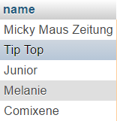

#### SQL statement

**SELECT** name **FROM** series **WHERE**

country_id **=** **(SELECT** id **FROM** country **WHERE** code **=** 'ch'**)** **AND**

publication_type_id **=** **(SELECT** id **FROM** series_publication_type **WHERE** name **=** 'magazine'**)**

### Query d: Starting from 1990, print the number of issues published each year

#### Description of logic:

We first display only issues with publication date greater than 1990, and keep only the year and count of records for each years in doing a group by years. We finally group by publication date.

#### SQL statement

**SELECT** **YEAR(**publication_date**)** **as** years**,** **count(**id**)** **as** number **FROM** issue

**WHERE** **YEAR(**publication_date**)** **>=** 1990

**GROUP** **BY** years

**ORDER** **BY** publication_date **ASC**

### Query e: Print the number of series for each indicia publisher whose name resembles ‘DC comics’.

#### Description of logic:

**Solving** : one can firstly search all indicia publishers who contains “DC comics” in their names with the LIKE statement (with % at the beginning who means that something can be written before “DC comics” and the % at the end that something can be written after “DC comics”). We can then make a join to list all series associated to the indicia publishers, and finally group by name to have the number of series for each indicia publisher.

#### SQL statement

**SELECT** ind**.**name **as** name**,** **count(**ind**.**id**)** **as** nb_series **FROM** indicia_publisher ind

**LEFT** **JOIN** series s **ON** s**.**publisher_id **=** ind**.**publisher_id

**WHERE** ind**.**name **LIKE** '%DC comics%'

**GROUP** **BY** ind**.**name

### Query f: Print the titles of the 10 most reprinted stories

#### Description of logic:

**Solving** : We have to list all the reprint for all stories, and to group by stories to count the number of reprint for each story. Afterward, we can order by the number of reprint in descending order and keep only the 10 first result (the 10 higher number of reprint).

**Results** : there is a story with NULL title (in fact there is a lot of stories with NULL title), and 3 stories with the title Spider Man written in 3 different ways, but it’s normal, I checked and it’s really 3 different stories and all reprint for these 3 stories have no link.

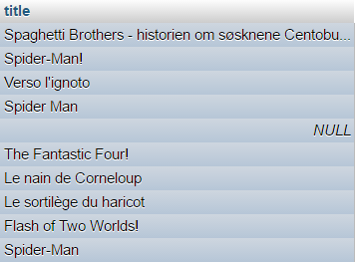

#### SQL statement

**SELECT** s**.**title **FROM** story_reprint sr

**LEFT** **JOIN** story s **ON** sr**.**origin_id **=** s**.**id

**GROUP** **BY** s**.**id

**ORDER** **BY** **COUNT(**s**.**id**)** **DESC**

**LIMIT** 10

### Query g: Print the artists that have scripted, drawn, and colored at least one of the stories they were involved in.

#### Description of logic:

I firstly select (inner select statement) all instances of participation who has for roles (script, pencil, ink, color), and group them by id of the person, and by id of story to have the number of roles associated to each persons for each stories, and then keep only the persons who have 4 associated results for a story (that is, for a story, we have 4 results associated to the 4 roles enumerated above). Finally, we select the ids of the persons corresponding to the results of the inner select statement, and distinct by the name to have only one time the same person (because an artist might have scripted, drawn and colored more than one story).

#### SQL statement

**SELECT** **distinct** name **FROM** person **WHERE** id **IN** **(**

**SELECT** person_id **FROM** participate

**WHERE** role **IN** **(**'script'**,** 'pencil'**,** 'ink'**,** 'color'**)**

**GROUP** **BY** person_id**,** story_id

**HAVING** **count(**person_id**)** **=** 4

**)**

### Query h: Print all non-reprinted stories involving Batman as a non-featured character.

#### Description of logic:

First, one can write the inner select statement who will retrieve the ids of the stories containing Batman as character and not as a feature. To do so, we select from hero the row for which the name is Batman, and do a left join on character to retrieve the id of all stories associated to this character. Then, we do another join on feature, but a RIGHT join to keep only the stories who doesn’t contain this hero as a feature. And we group by stories to have only one id of each stories who match these conditions.

Then, we select the stories who has the ids in the list of the results from the inner select statement, and do a left join on story_reprint to have the associated reprint or NONE as origin_id if the story doesn’t contain any reprint. We thus retain only the rows who has a NULL origin_id.

#### SQL statement

**SELECT** **\*** **FROM** story s

**LEFT** **JOIN** story_reprint sr **ON** sr**.**origin_id **=** s**.**id

**WHERE** sr**.**origin_id **IS** **NULL** **AND** s**.**id **IN** **(**

**SELECT** c**.**story_id **FROM** hero h

**LEFT** **JOIN** `**character**` c **ON** c**.**hero_id **=** h**.**id

**RIGHT** **JOIN** feature f **ON** f**.**story_id **=** c**.**story_id **AND** f**.**hero_id **!=** h**.**id

**WHERE** h**.**name **=** 'Batman'

**GROUP** **BY** c**.**story_id

**)**

## Interface

### Design logic Description

**Design logic**:

**Insertion / Deletion**

We can choose the table into which we want to insert some data with a custom handmade select component, and according to the choice, an include is done to display the appropriate form for each tables. However, a class Table was written in order to generate the insertion sql statement and do it automatically, without writing the sql statement for every table. This class also allow to display the 5 last records, in order to display our newly entered record once the “Insert” button is clicked.

**Search :**

The search is done using a lot of javascript (jquery), in order to retrieve the results in a parallel way. Firstly, we send to a first php script the search key and the tables the user want to search in (by default all tables at the beginning). This php script will then build a search request for each table (it checks if the search key is just a numerical argument, or a text and search strictly the number entered if it’s a numerical key, or in all varchar and text field if it’s a text). When the queries are built, they are sent to another php script who will manage the execution of the query and yields the results. Each time a table returns its results, I update a progressbar who shows in which table we are currently searching, and the remaining part of work to do. But usually, the progressbar is very quickly filled because the request are rather fast. For a numerical search, the result is instantaneous.

We display a limit of 5 results for each table. If there is more of 5 results in a table, we mentioned that we only display the 5 first results, and we give the possibility to display all the results for the table in a floating window loaded over the main view, in order to keep the search interface clean and user-friendly.

The table in which it doesn’t make sense to search are not displayed in the list of searchable table (all intermediate table who contains only foreign keys). However, all is retrieved automatically from the database. That is, nothing is written by hand, all list of tables and list of fields for each tables are directly given by the database itself. This way, we could add field or table and our interface will always be updated.

**Technologies used** : MySQL for the DB, PHP, with of course CSS, HTML, and JS for the interface.

### Screenshots

**Insertion / deletion**

One can select the table we want to insert into …

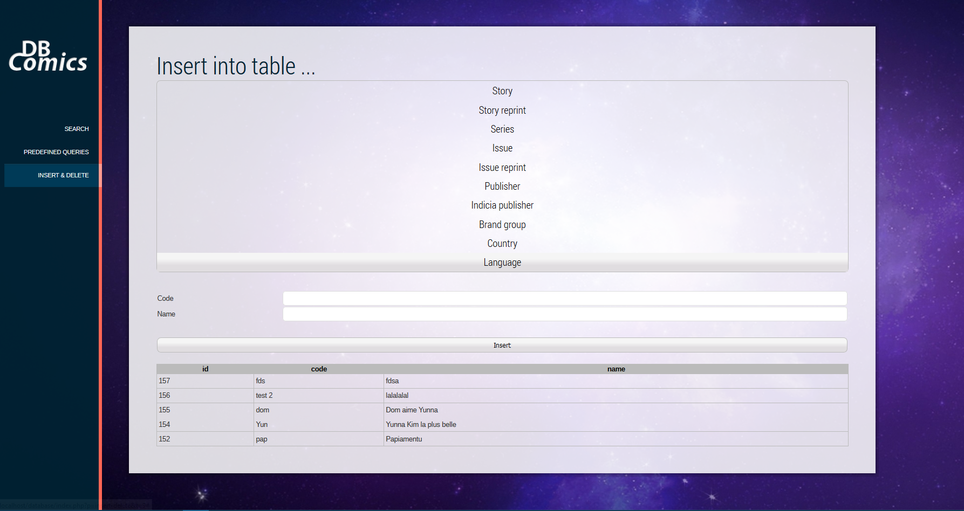

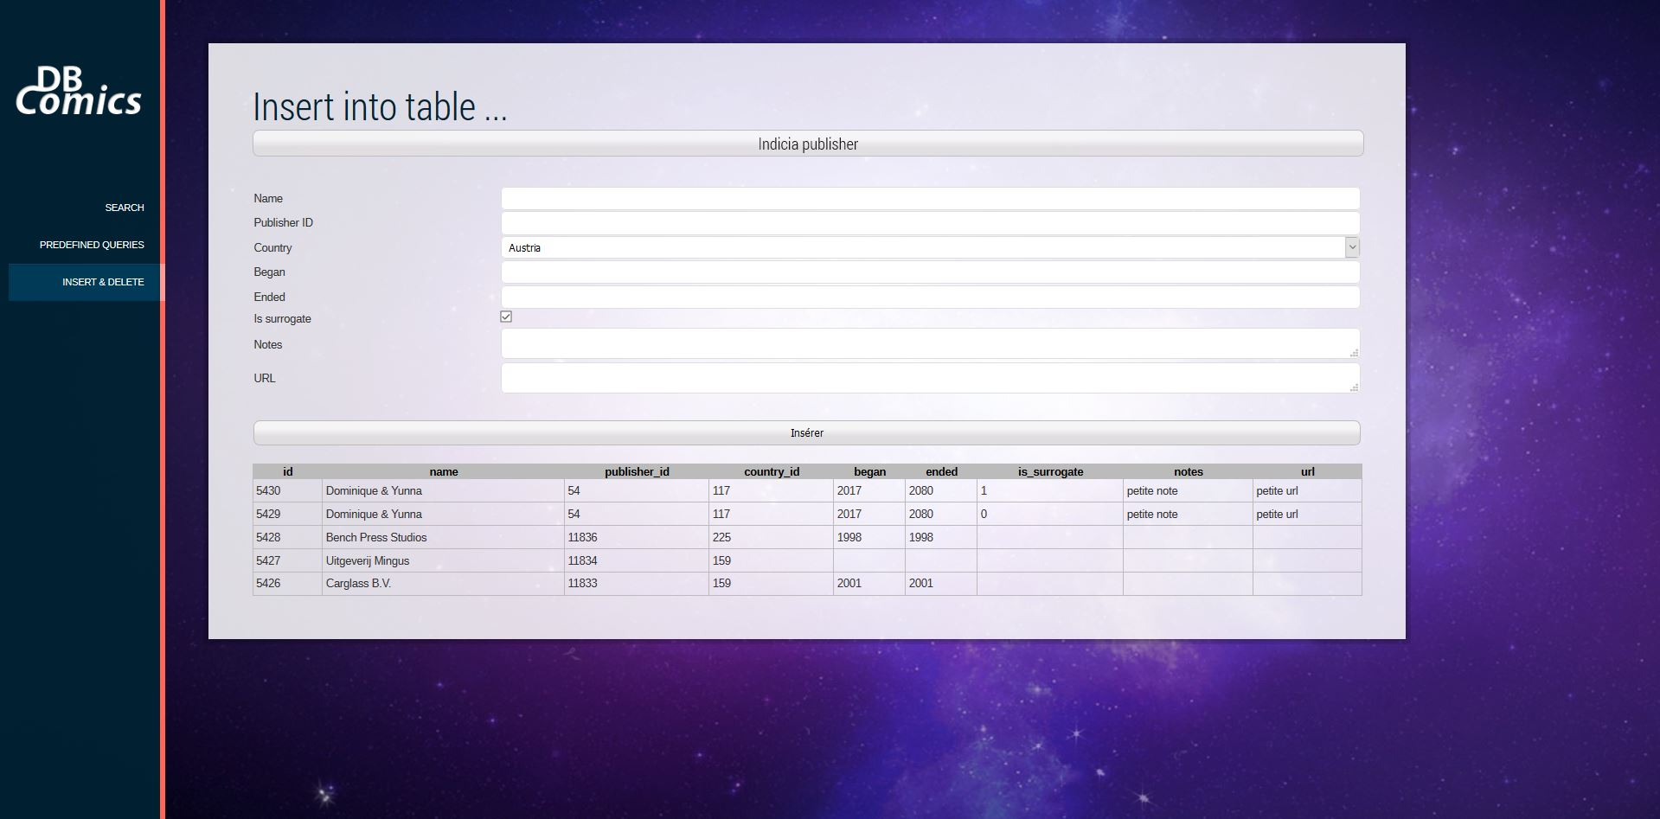

**Search**

One can type what we are searching for …

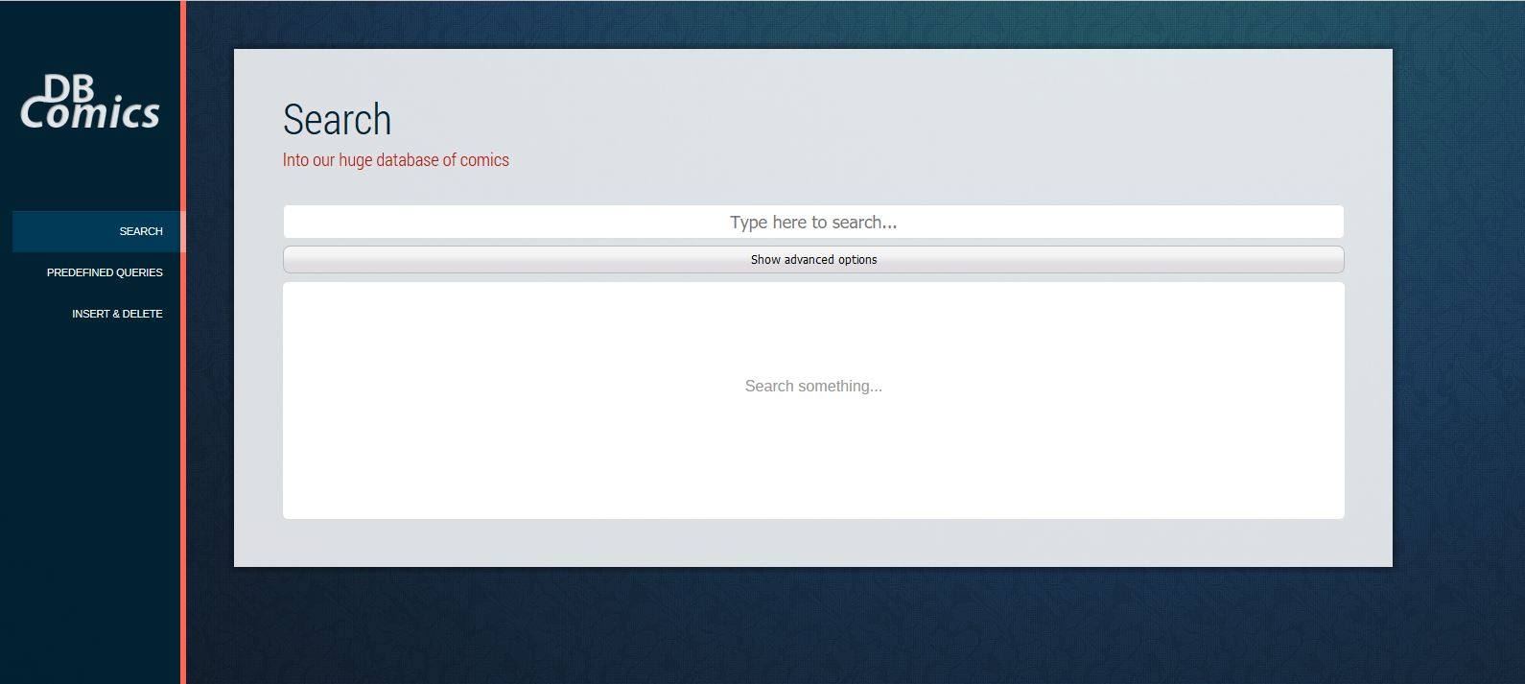

Then, the results are given for each table. A progressbar shows the progression of the research, but globally the running time is very fast, since the research is done in parallel for each table (using AJAX).

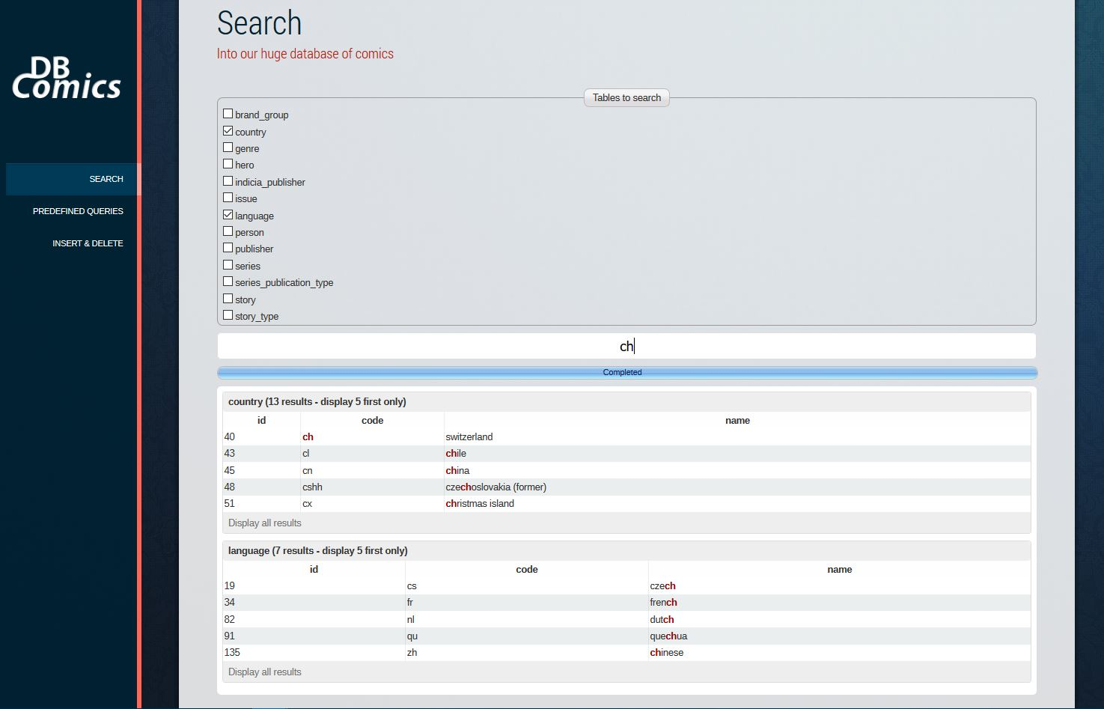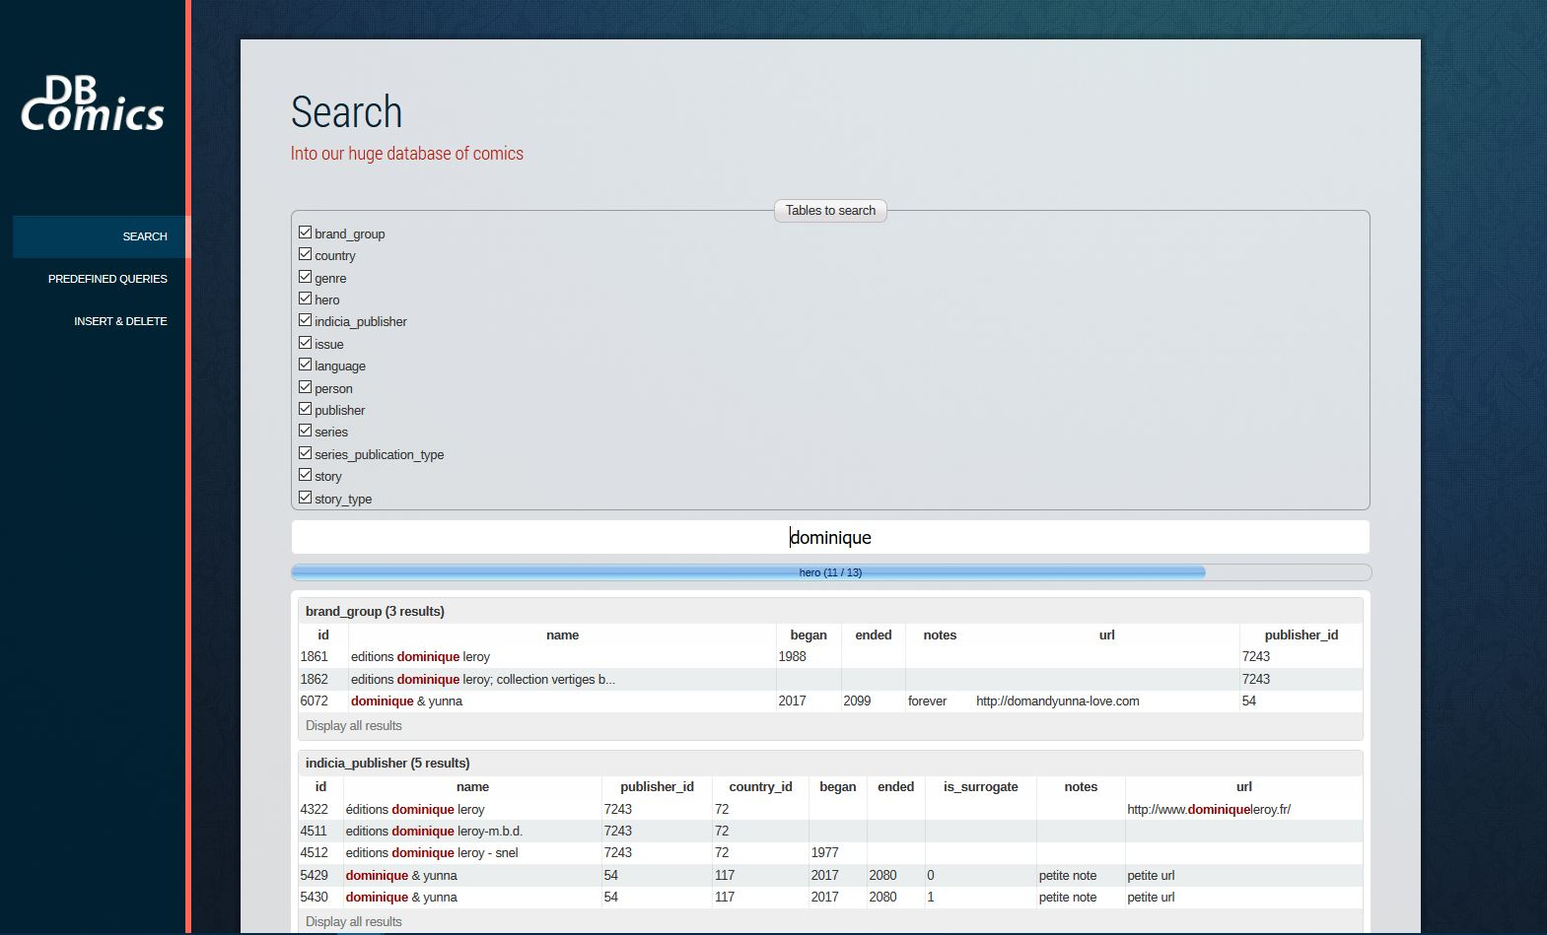

By default, a maximum of 5 results per table are displayed (to keep the interface clean and confortable). We have the possibility to display all the results for a given table, by clicking on the “Display all results” button.

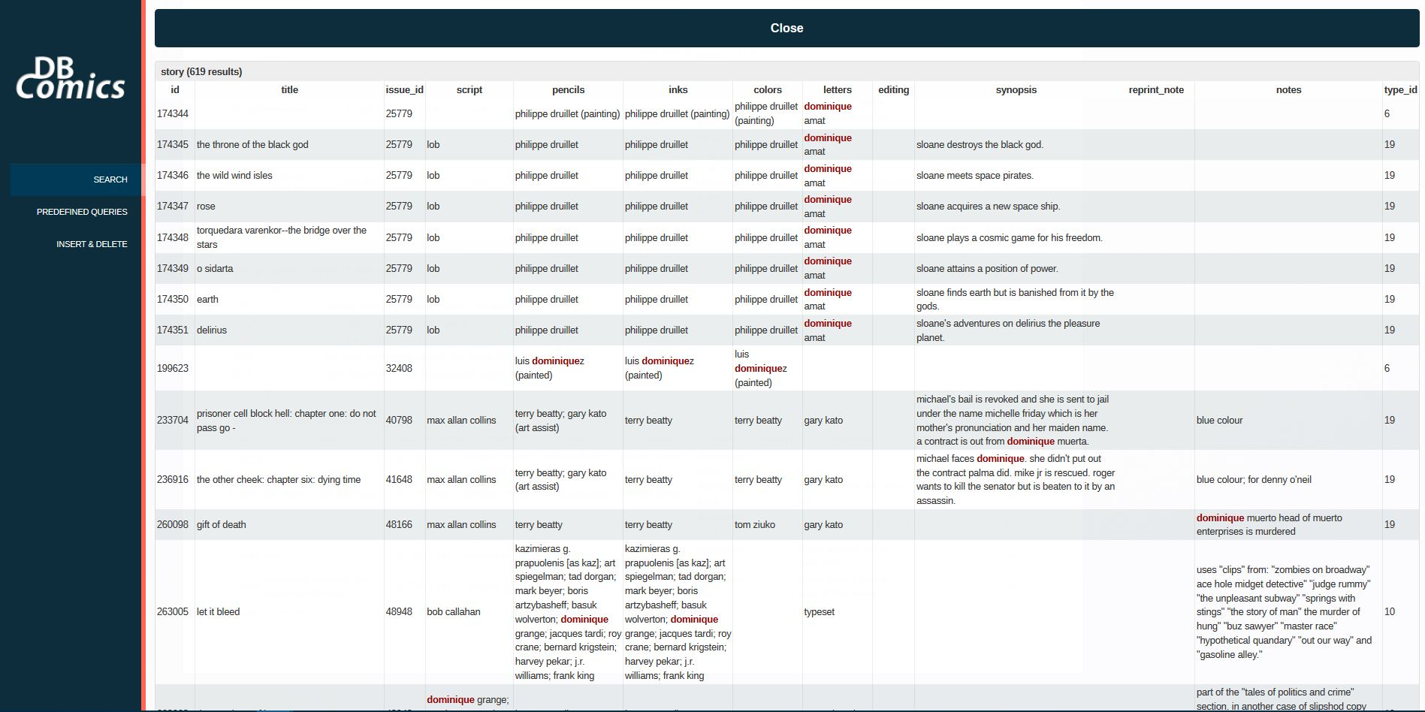

## General Comments

<In this section write general comments about your deliverable (comments and work allocation between team members>

**Dominique** : Data loading, queries implementation, Interface (search and insertion parts)

# Deliverable 3

# Assumptions

<In this section write down the assumptions you made about the data. Write a sentence for each assumption you made>

## Query Implementation

<For each query>

### Query a:

#### Description of logic:

<What does the query do and how do I decide to solve it>

#### SQL statement

<The SQL statement>

## Query Analysis

### Selected Queries (and why)

#### Query 1

<Initial Running time:

Optimized Running time:

Explain the improvement:

Initial plan

Improved plan>

#### Query 2

<Initial Running time:

Optimized Running time:

Explain the improvement:

Initial plan

Improved plan>

#### Query 3

<Initial Running time:

Optimized Running time:

Explain the improvement:

Initial plan

Improved plan>

# Interface

### Design logic Description

<Describe the general logic of your design as well as the technology you decided to use>

### Screenshots

<Provide some initial screen shots of your interface>

# General Comments

<In this section write general comments about your deliverable (comments and work allocation between team members>