crear un bucket en Amazon S3

[ec2-user@ip-10-200-0-92 ~]$ aws s3api create-bucket --bucket ccsilva256 --region us-west-2 --create-bucket-configuration LocationConstraint=us-west-2
{
"Location": "http://ccsilva256.s3.amazonaws.com/"
}
[ec2-user@ip-10-200-0-92 ~]$

crear un usuario de IAM nuevo que tenga acceso completo a Amazon S3

[ec2-user@ip-10-200-0-92 ~]$ aws iam create-user --user-name awsS3user
{
"User": {
"UserName": "awsS3user",
"Path": "/",
"CreateDate": "2026-03-14T00:03:02Z",
"UserId": "AIDAWVVQ57APBCYMEFL45",
"Arn": "arn:aws:iam::458858821662:user/awsS3user"
}
}
[ec2-user@ip-10-200-0-92 ~]$

[ec2-user@ip-10-200-0-92 ~]$ aws iam create-login-profile --user-name awsS3user --password Training123!
{
"LoginProfile": {
"UserName": "awsS3user",
"CreateDate": "2026-03-14T00:03:57Z",
"PasswordResetRequired": false
}
}
[ec2-user@ip-10-200-0-92 ~]$

Iniciamos sesión

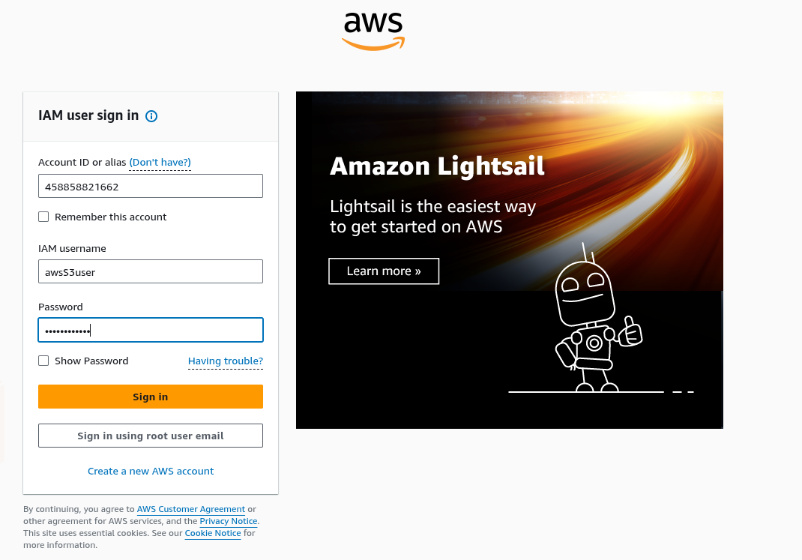
vamos a S3

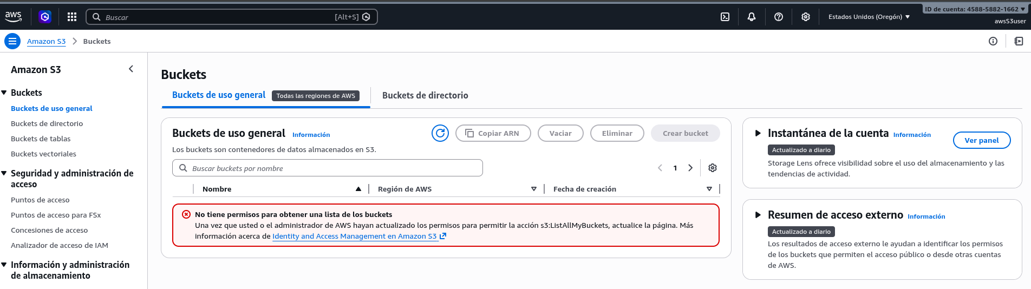
no se tiene acceso a el bucket

Vamos a buscar la politica que nos da acceso al recurso de S3

[ec2-user@ip-10-200-0-92 ~]$ aws iam list-policies --query "Policies[?contains(PolicyName,'S3')]"
[
{
"PolicyName": "AmazonS3FullAccess",
"PermissionsBoundaryUsageCount": 0,
"CreateDate": "2015-02-06T18:40:58Z",
"AttachmentCount": 0,
"IsAttachable": true,
"PolicyId": "ANPAIFIR6V6BVTRAHWINE",
"DefaultVersionId": "v2",
"Path": "/",
"Arn": "arn:aws:iam::aws:policy/AmazonS3FullAccess",
"UpdateDate": "2021-09-27T20:16:37Z"
},

vamos a utilizar la política para dar permisos al usuario

[ec2-user@ip-10-200-0-92 ~]$ aws iam attach-user-policy --policy-arn arn:aws:iam::aws:policy/AmazonS3FullAccess --user-name awsS3user

revisamos de nuevo el s3

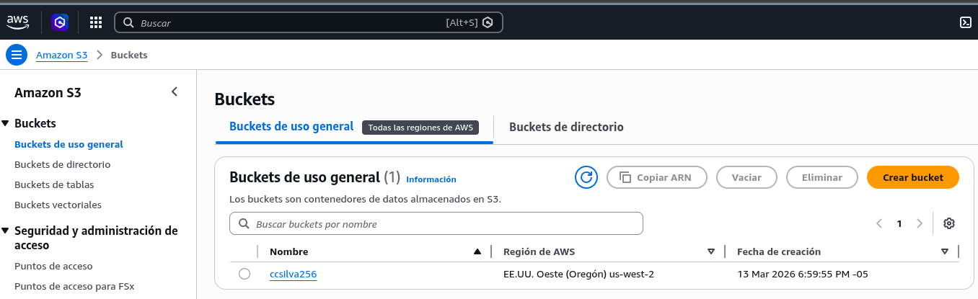
vamos a desbloquear el acceso publico

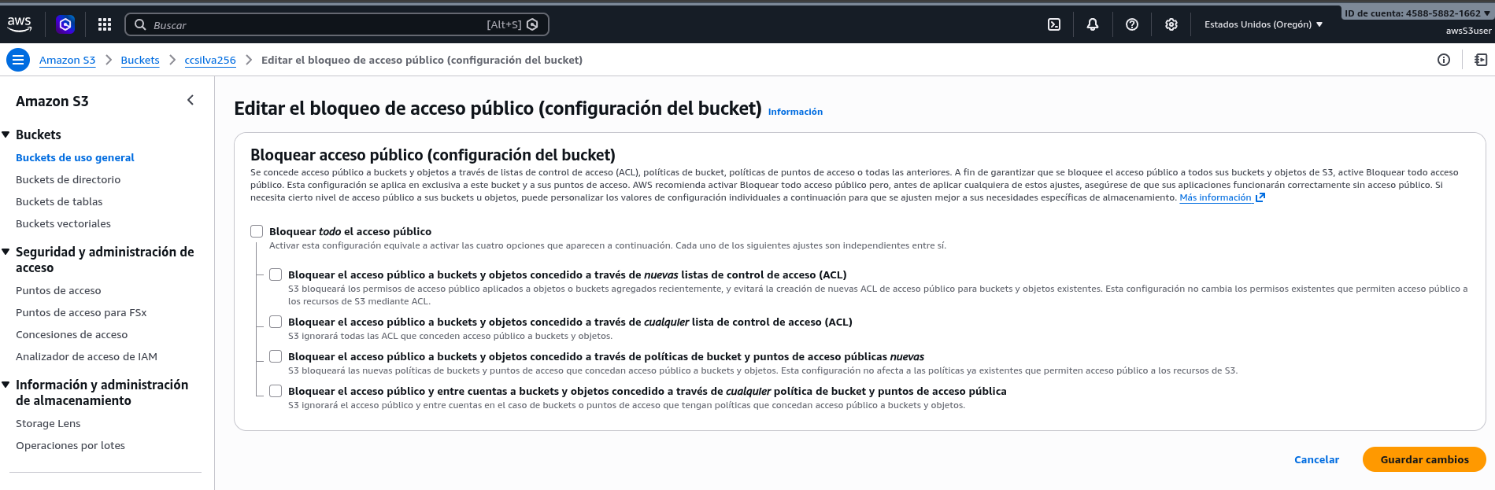
editamos la propiedad del objeto
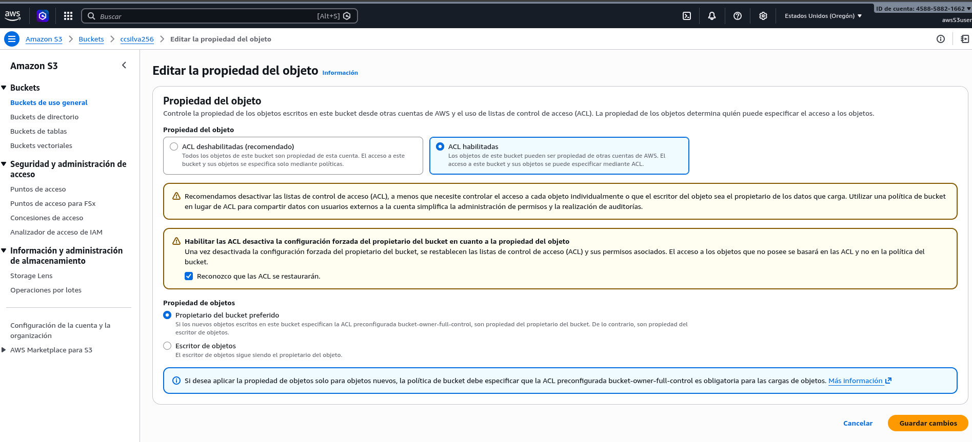
vamos a extraer ahora los componentes del sitio web estatico

[ec2-user@ip-10-200-0-92 ~]$ cd ~/sysops-activity-files
[ec2-user@ip-10-200-0-92 sysops-activity-files]$ tar xvzf static-website-v2.tar.gz
static-website/
static-website/css/
static-website/css/styles.css
static-website/images/
static-website/images/Cafe-Owners.png
static-website/images/Cake-Vitrine.png
static-website/images/Coffee-and-Pastries.png
static-website/images/Coffee-Shop.png
static-website/images/Cookies.png
static-website/images/Cup-of-Hot-Chocolate.png
static-website/images/Strawberry-&-Blueberry-Tarts.png
static-website/images/Strawberry-Tarts.png
static-website/index.html
[ec2-user@ip-10-200-0-92 sysops-activity-files]$ cd static-website
[ec2-user@ip-10-200-0-92 static-website]$

ahora vamos a cargar los archivos al bucket de s3 que habiamos creado previamente

[ec2-user@ip-10-200-0-92 static-website]$ aws s3 website s3://ccsilva256/ --index-document index.html
[ec2-user@ip-10-200-0-92 static-website]$ aws s3 cp /home/ec2-user/sysops-activity-files/static-website/ s3://ccsilva256/ --recursive --acl public-read
upload: css/styles.css to s3://ccsilva256/css/styles.css
upload: images/Coffee-Shop.png to s3://ccsilva256/images/Coffee-Shop.png
upload: ./index.html to s3://ccsilva256/index.html
upload: images/Coffee-and-Pastries.png to s3://ccsilva256/images/Coffee-and-Pastries.png
upload: images/Cake-Vitrine.png to s3://ccsilva256/images/Cake-Vitrine.png
upload: images/Strawberry-&-Blueberry-Tarts.png to s3://ccsilva256/images/Strawberry-&-Blueberry-Tarts.png
upload: images/Cookies.png to s3://ccsilva256/images/Cookies.png
upload: images/Cafe-Owners.png to s3://ccsilva256/images/Cafe-Owners.png
upload: images/Cup-of-Hot-Chocolate.png to s3://ccsilva256/images/Cup-of-Hot-Chocolate.png
upload: images/Strawberry-Tarts.png to s3://ccsilva256/images/Strawberry-Tarts.png
[ec2-user@ip-10-200-0-92 static-website]$

verificamos el cargue

[ec2-user@ip-10-200-0-92 static-website]$ aws s3 ls ccsilva256
PRE css/
PRE images/
2026-03-14 00:20:58 2980 index.html
[ec2-user@ip-10-200-0-92 static-website]$

Vamos al bucket a verificar que tenga habilitado sitios estaticos, en propiedades
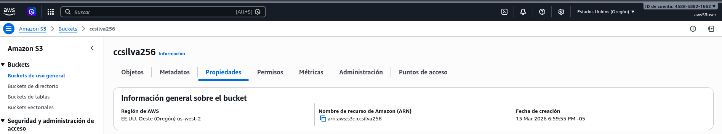

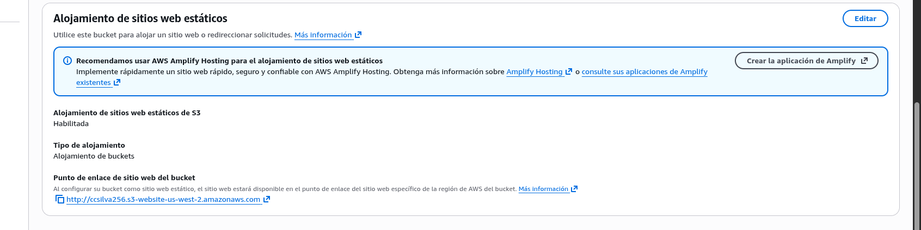
consumimos el punto de enlace del s3 estatico

