__________________________________________

Phrases

__________________________________________

e.g. English

Mary had a little lamb.
____ ___ _ ______ ____
noun verb adjective noun
article
_____________
object
____ _________________
subject predicate

e.g. C++

With the customary CFG for C++:

x = y + z ;
_ ___________
var expression

___________________________
assignment statement

>> Sections Of A String

_____________________

Defn A section α[i:j] of a string α is the 3-tuple (α, i, j) where 1<=i<=j<=|α|.

Note A section represents a particular portion of a string.

e.g.
α =
"a b c x y z a b c x y z"
_____ _____
α[1:3] α[7:9]

different sections

Note Sections are “non-empty.”

>> Phrases Of A Sentence

_______________________

Defn Let σ be a sentence and A be a non-terminal in a parse tree for it. Then, the section of σ consisting of the non-ε leaves of A’s subtree is said to be a phrase of sentence σ for non-terminal A.

e.g. Gse3

e

t mt

f mf t mt

f mf f mf ε

ε f mf

ε

x * x + x * x
_______ _ _______
σ[2:3] σ[5:5] σ[6:7]
phrase phrase phrase
for mf for f for mf

different phrases
for mf

e.g. Underline the phrases for e in the sentence:
x * ( x + x )

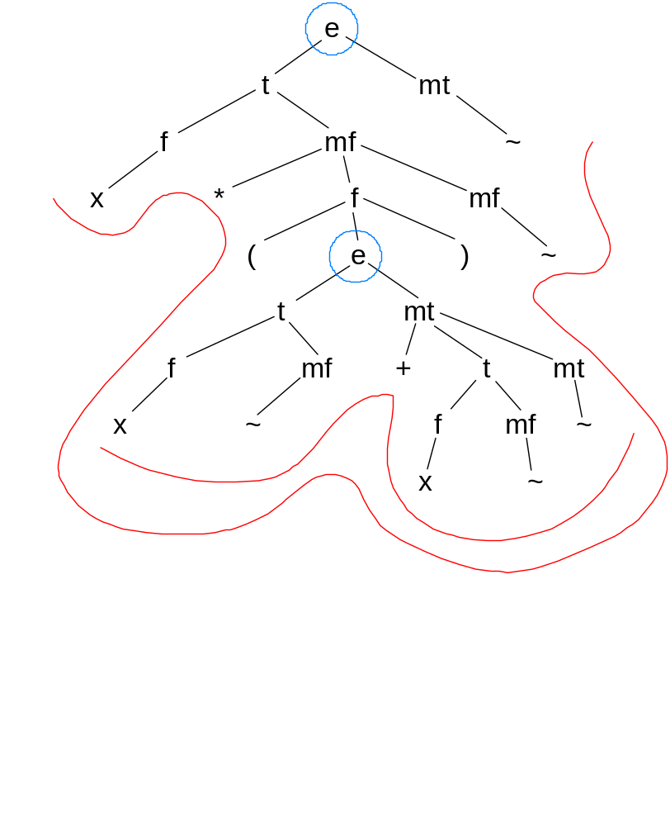

i.e. the phrases for e are:

x * ( x + x )
-------
-------------------

Each phrase is a frontier of a subtree – shown in red – whose root is e – shown in blue.

Thus, phrases for e are the whole sentence or anything enclosed within parentheses
e.g. Underline the phrases for e in the below sentence:
x * ( x + x ) * ( ( x + x ) )
------- -------
-------------
--------------------------------------------

This follows from the previous conclusion. If in doubt, we can draw a parse tree.

e.g. Underline the phrases for mt in the sentence: x + x + x

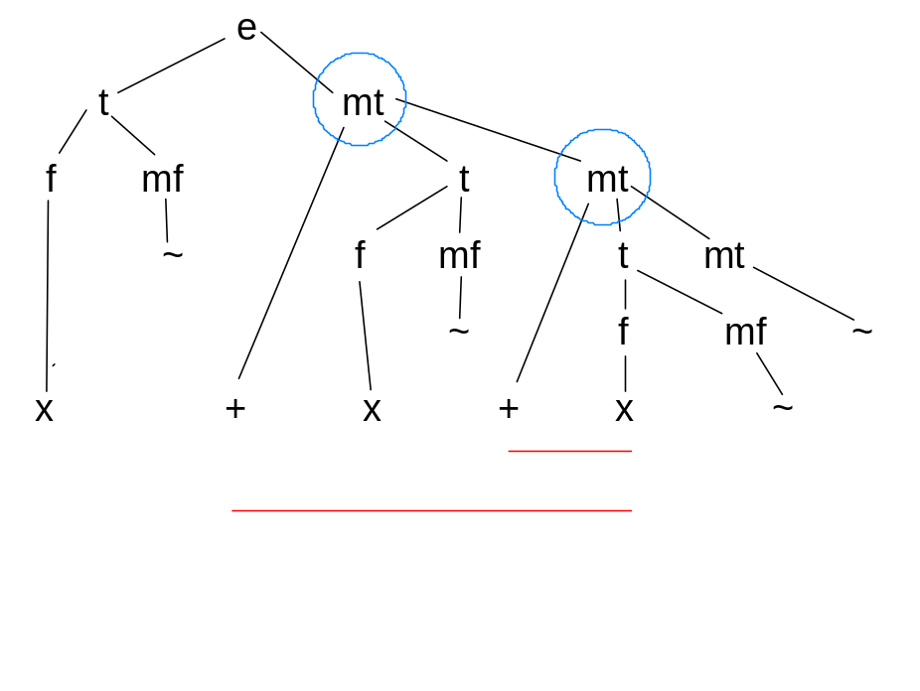

Thus, mt phrases begin with a + and continue to the end of the containing e phrase.

e.g. Underline the phrases for mt in the below sentence:
x + x + x + x
----
----------
----------------

e.g. Underline the phrases for mt in the below sentence:
x * ( x + x + x ) + x
---- ----
----------

These follow from the previous conclusion. If in doubt, we can draw a parse tree.

Problem

Consider the below sentence generated by Gse3:

(x+x+x)*(x*x*x)*x*x+x*x*x+x*x*x

Underline all phrases in the above sentence for:
a) e b) t c) mt d) f e) mf

Note: You might find it useful to construct parse trees in order to arrive at the answers to the above. However, you do not need to turn in these parse trees as part of your answer.

Project - Phrases

Consider the following CFG:

terminal set =
{'int', 'x', ';', '=', '+', '*', '(', ')'}
non-terminal set =
{p, decls, decl, states, state, e, mt, t, mf, f}
goal symbol = p
rules=
p -> decls states
decls -> decl decls
decls -> 
decl -> 'int' 'x' ';'
states -> state states
states -> 
state -> 'x' '=' e ';'
e -> t mt
mt -> '+' t mt
mt -> 
t -> f mf
mf -> '*' f mf
mf -> 
f -> 'x'
f -> '(' e ')'

The below is one sentence generated by the above CFG (with the terminal symbol single quotes left out):

int x; int x; int x; int x; int x;

x = x+x+x+x; x = x*x*x*x;

x = x*x*x*x+x*x*x*x + x*x*x*x+x*x*x*x;

x =

(x*x*x+x*x*x+x*x*x) * (x*x*x+x*x*x+x*x*x) +

(x*x*x+x*x*x+x*x*x) * (x*x*x+x*x*x+x*x*x) +

(x*x*x+x*x*x+x*x*x) * (x*x*x+x*x*x+x*x*x) ;

(Of course, formatting of the sentence onto lines and the use of spaces above does not affect the sentence. i.e. The sentence is just a sequence of terminal symbols.)

For every non-terminal in the grammar, identify all the phrases for that non-terminal that occur in the above sentence as done in the examples in class. i.e. Identify all the phrases for p, decls, decl, states, state, e, mt, t, mf, and, f. You could do this by either underlining or circling the phrases.

You probably will need multiple copies of the above to keep things readable.

For example, if the sentence had instead been:

int x; int x;

x = x+x+x+x;

then part of the solution could be written:

phrases for mt:
int x; int x;
x = x+x+x+x;
--
----
------

>> More Phrase Examples

_______________________

e.g. Find all f phrases in x*(x+x)

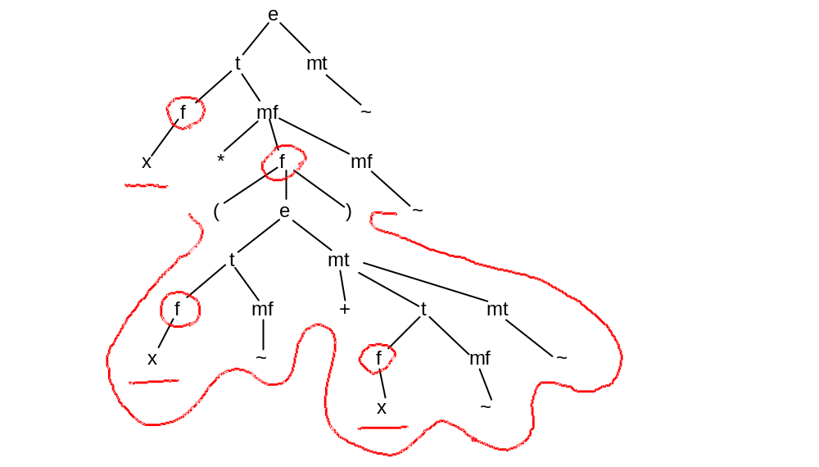

i.e. x * ( x + x )
- - -
-------------

e.g. Find all f phrases in x*x*(x*(x+x*x))

x * x * ( x * ( x + x * x ) )
- - - - - -
-------------------
-------------------------------

e.g. Find all mf phrases in x*x*x*x+x*x*x

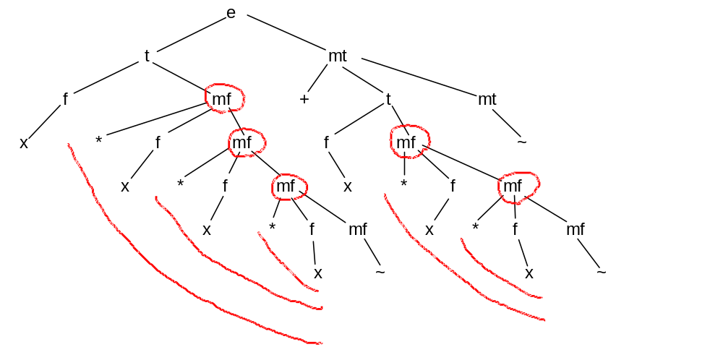

i.e. x * x * x * x + x * x * x
---- ----
---------- ----------
----------------

e.g. Find all mf phrases in (x*x)*x

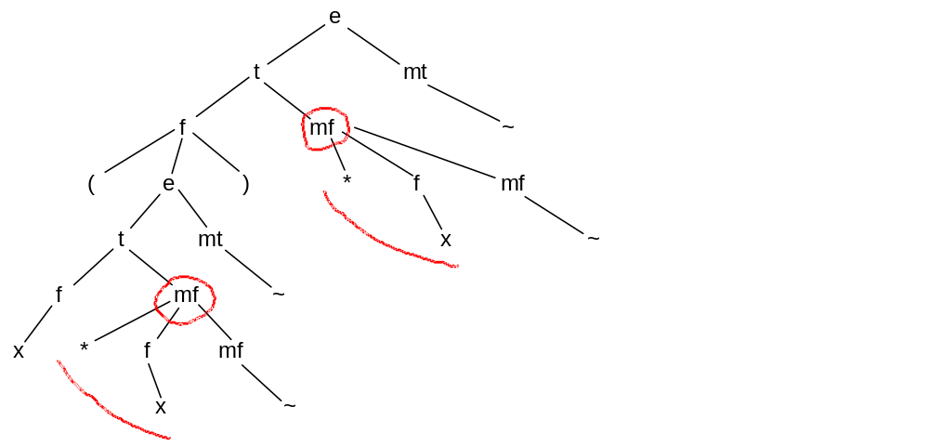

i.e. ( x * x ) * x
---- ----

e.g. Find all mf phrases in (x*x*x)*x*(x+x*x)

( x * x * x ) * x * ( x + x * x )
---- ----
---------- ----------------------
----------------------------

