Prof. J. Daley

Constructing LL(1)  Parsing Tables | _________  _______________  ___________________  _______________  _________

__________________________________________

Conventions

__________________________________________

≡ means "defined to be equal." V ≡ T ∪ N. The start symbol is S unless otherwise specified.
*
=>* means =>

__________________________________________

Reduced Grammars

__________________________________________

defn A CFG G is said to be reduced iff:
1) For every terminal x: there is some sentence containing x. ("no useless terminals")
2) For every nonterminal X: X is contained in some sentential form, and X derives a non-empty string of terminals. ("no useless non-terminals")
3) For every rule r: removing r from G removes at least one sentence from L(G). ("no useless rules")

e.g. a CFG that is not reduced

T={ 'x', 'y'}
N={ S, A }
S is the start symbol
P=
1) S -> 'x' A
2) A -> ε
3) S -> S

Note that y is a useless terminal, A is a useless nonterminal, and 3) is a useless rule. So, the CFG is not reduced.

Many theorems, including the key theorem at the end of this section, apply only to reduced CFG's. It is clear that for every non-reduced CFG, there is an equivalent reduced CFG. We will sometimes make a statement concerning a "CFG" where we really mean a "reduced CFG."

__________________________________________

Valid Parsers and Tables, LL(1) Grammars

__________________________________________

defn Consider the LL(1) Parsing Algorithm with CFG G in its Rule table and with Parse Action table PA. Suppose that for every string α ∈ T* as input, the algorithm outputs:
1) 'reject', iff α ∉ L(G).
2) 'accept' and a derivation from S to α, iff α ∈ L(G).
Then, PA is said to be valid for G.

e.g. the PA table used in the previous playthrough appeared to be valid for Gse3

defn
A CFG G is said to be LL(1) iff both:
1) G is unambiguous.
2) There exists a PA table that is valid for G.

e.g. GSE3 is LL(1) since it has a valid PA matrix - namely the one in the previous description of the LL(1) algorithm - and is also unambiguous. GSE1 and GSE2 are not LL(1) since they don't have valid PA tables. (We have not yet proved these facts yet.)

__________________________________________

Nullable Strings, First Sets, Follow Sets

__________________________________________

defn Let α ∈ V*. α is said to be nullable iff α =>* ε .

e.g. GSE3

"mf mt" is nullable.
ε is nullable.
"e" is not nullable
"'+' t mt" is not nullable

defn Let α ∈ V*. first(α) ≡ {x ∈ T | α =>* x ...} .

Note that "..." is shorthand for "any string in V*" . i.e. more technically the above means first(α) ≡ {x ∈ T | there exists a β ∈ V* such that α =>* x β }.

e.g. GSE3

string | first(string)
t mt | { 'x', '(' }
'+' t mt | { '+' }
ε | empty set
f mf | { 'x', '(' }
'*' f mf | { '*' }
'x' | { 'x' }
'(' e ')' | { '(' }
mf '+' | { '*', '+' }

Problem

1. With respect to GSE3, for each of the following strings, decide whether it is nullable and list its first set: "'*' f mf", "'x' '+' 'x'", "mt mt mt", "t t t", "'x' 'x'", "e", "e e", "mf 'x'", "mf mt 'x'", "'x'"

2. For the right part string of each rule of GSE1, decide whether it is nullable and list its first set (e.g. one such string to consider is "e '+' t" since it is the rightpart of the rule is e -> e '+' t )

3. Imagine a CFG for the C++ programming language having as some of its nonterminal symbols: IntegerConstant, RealConstant, IfStatement, WhileStatement, AssignmentStatement. For each of the following strings, decide whether it is nullable and list its first set: "IntegerConstant", "RealConstant", "IfStatement", "WhileStatement", "AssignmentStatement"
(i.e. each of the above strings consists of a single nonterminal symbol)

defn Let X ∈ N. follow(X) ≡ {x ∈ (T ∪ {#}) | S # =>* ... X x ... } .

*e.g. GSE3

e # =>* t mt #
Therefore, # ∈ follow(mt)

e # =>* '(' t mt ')' #
Therefore, ')' ∈ follow(mt)

e # =>* f mf #
Therefore, # ∈ follow(mf)

e # =>* '(' f mf ')' #
Therefore, ')' ∈ follow(mf)

e # =>* f mf '+' t mt #
Therefore, '+' ∈ follow(mf)

__________________________________________

Finding Follow Sets "By Inspection"

__________________________________________

Although the above is an adequate definition of "follow set," it does not offer a method for finding it. There is a simple algorithm presented later that is appropriate for programming, but it is tedious to exercise without a computer. The following presents a method for finding follow sets "by inspection." Of course there is a small probability of making a mistake with this method, but it is sufficient for our purposes and is a good grammatical skill anyway.

Recall the concept of phrase for a non-terminal.

*e.g. Underline the phrases for mt in the sentence: x + x + x
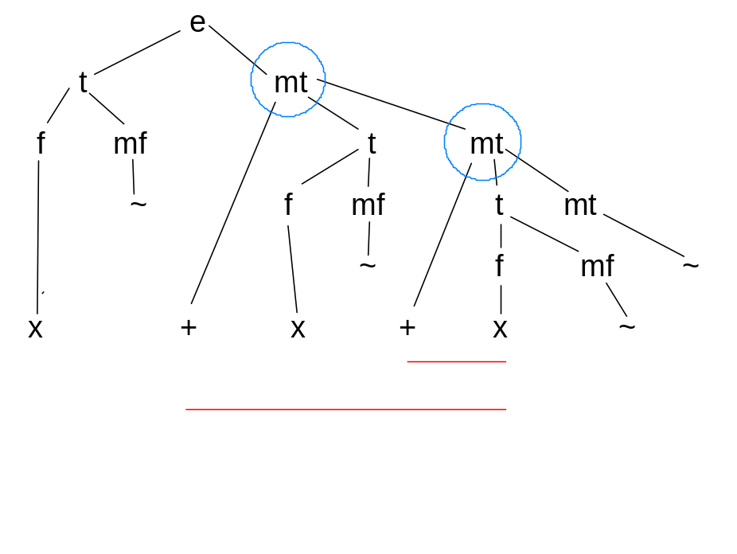
Thus, mt phrases begin with a '+' and continue to the end of the containing e phrase.

*e.g. Underline the phrases for mt in the below sentence:

x + x + x + x
----
----------
----------------

*e.g. Underline the phrases for mt in the below sentence:

x * ( x + x + x ) + x
---- ----
----------

These follow from the previous conclusion that mt phrases begin with a '+' and continue to the end of the containing e phrase. If in doubt, we can draw a parse tree.

theorem For a reduced CFG, a terminal or # symbol is in follow(A) iff that symbol immediately follows a phrase for A in some sentence catenated with #.

e.g. Find follow(mt)

First, write down some representative sentences and catenate each with #. Then, underline the phrases for mt in the sentences.

x + x + x + x #
----
----------
----------------

x * ( x + x + x ) + x #
---- ----
----------

Now note the terminals or # that follow these phrases. Then, the above theorem tells us that # and ')' are members of follow(mt).

From the facts inferred earlier that expression phrases are the whole sentence and sections of it surrounded by parentheses, and that mt phrases are tails of expression phrases, it follows that # and ')' are the only members of follow(mt).

Problem

1. Find the follow set for every nonterminal of GSE3.

2. Find the follow set for every nonterminal of GSE1.

3. Imagining a CFG for the C++ programming language, find the follow set for each of these nonterminals: BooleanExpression, Statement.

*e.g. of why theorem is true

Suppose '+' follows a phrase for mf in a sentence. For example:

x * x + x #

phrase for mf

Let’s look at the parse tree for this sentence:

e

t mt

f mf + t mt

x * f mf f mf ε

x ε x ε

Thus, e # => t mt # => f mf mt # => f mf + t mt #

Then, '+' ∈ follow(mf)

The converse is true by a reverse geometrical argument, noting that there are no “useless” non-terminals in a reduced CFG.

__________________________________________

Selection Sets, Valid Parse Action Sets

__________________________________________

defn For a grammar rule X -> α, define the associated selection set s(X -> α) as:

s(X -> α) ≡
first(α) if α is not nullable
first(α) ∪ follow(X) if α is nullable

e.g. GSE3

s(e -> t mt) = first("t mt") = { 'x', '(' }

s(mt -> '+' t mt) = first(" '+' t mt ") = { '+' }

s(mt -> ε) = first(ε) ∪ follow(mt) =
EmptySet ∪ { #, ')' } = { #, ')' }

s(t -> f mf) = first("f mf") = { 'x', '(' }

s(mf -> '*' f mf) = first(" '*' f mf ") = { '*' }

s(mf -> ε) = first(ε) ∪ follow(mf) =
EmptySet ∪ { #, ')', '+' } = { #, ')', '+' }

s(f -> 'x') = first(" 'x' ") = { 'x' }

s(f -> '(' e ')') = first(" '(' e ')' ") = { '(' }

theorem
The following are equivalent statements concerning a reduced CFG G:

1) For every nonterminal X: if X -> α1 and X -> α2 are two different rules with left part X, then s(X -> α1) ∩ s(X -> α2) = EmptySet. (i.e. For each nonterminal, the selection sets for the different rules for that nonterminal are pairwise disjoint)

2) The selection sets are also valid PA sets.

3) G is LL(1).

e.g. GSE3

Consider each nonterminal which is the leftpart of more than one rule:

mt
s(mt -> '+' t mt) ∩ s(mt -> ε) =
{ '+' } ∩ { #, ')' } = EmptySet

mf
s(mf -> '*' f mf) ∩ s(mf -> ε) =
{ '*' } ∩ { #, ')', '+' } = EmptySet

f
s(f -> 'x') ∩ s(f -> '(' e ')' ) =
{ 'x' } ∩ { '(' } = EmptySet

The above shows that statement 1) above is true for GSE3. Thus, according to the theorem, statement 2) is true as well. So, we can use the selection sets found above as the parse action sets in our LL(1) parser knowing they will be valid for GSE3.

The fact that statement 1) is true for GSE3 also means that statement 3) is true as well. i.e. that GSE3 is an LL(1) CFG. Recall that a CFG G is said to be LL(1) iff both:
1) G is unambiguous.
2) There exists a PA table that is valid for G.

The first part of this tells us that GSE3 is unambiguous.

Problem

1. Consider "semi-simple expressions" such as:

-$id * ( - $id - $int ) / $id + $int

i.e. the simple expressions already recognized by PARSE.CPP with the addition of the operand $int, the binary operators - and /, and the unary operators + and - . Note that the unary operators are allowed only at the beginning of expression phrases.

Construct an LL(1) CFG that generates the above language and valid PA sets for it. Hand in the CFG and PA sets.

2. Incorporate the results of problem 1 into PARSE.CPP. Run the upgraded version with the parse trace on and with the example sentence of problem 1 as the input string. Hand in the test run.

3. Repeat problem 1 but for "semi-simple assignments" such as:

$id = -$id * ( - $id - $int ) / $id + $int

i.e. assignments of the form:

$id = semi-simple expression

Note that a "semi-simple expression" is not also a "semi-simple assignment."

4. Incorporate the results of problem 3 into PARSE.CPP. Run the upgraded version with the parse trace on and with the example sentence of problem 3 as the input string. Hand in the test run.

