Translation Scheme Mechanics

Upgrading parse.cpp with a translation scheme

We want to translate sentences into IL.

e.g. L(Gse3)

$id + $id maps onto lit 1 ldi lit 1 ldi add

i.e. simple expr maps onto VM code that evaluates it

Possibly, parser can generate this code while it does the parse. This general idea is called syntax-directed translation. i.e. translation is driven by syntax analysis.

e.g. translate L(Gse3)

e -> t mt
mt -> '+' t 1 mt
mt -> 
t -> f mf
mf -> '*' f 2 mf
mf -> 
f -> '$id' 3
f -> '(' e ')'

Above is Gse3, but with addition of action symbols . A CFG with embedded action symbols is called a translation scheme (TS).

Now incorporate above into parse.cpp. i.e. Function UseRule now includes code like the following:

else if (ontop("f"))
{
if (athead("$id"))
replace("$id 3");
else if (athead("("))
replace("( e )");
else
*successp=false;
}

Note that we are, in effect, using the same ParseAction sets as before, but have inserted action symbols into rules.

What happens when an action symbol "floats" to the top of the parse stack? Modify cycle() function to be:

parsing=true;
do /* while parsing */ {
/* do case on alphabet of stack top */
if (is_action(topstack())) {
doaction();
pop(); }
else if (is_nonterm(topstack())) {
... (same as before)
else /* topstack is a terminal */
... (same as before)
while (parsing); /* end do */

i.e. When action floats to top of stack, call doaction() and pop action from stack.

Doaction() is:

void doaction(void)
{
/* do case on particular action on top of stack */
if (ontop("1"))
emit("add");
else if (ontop("2"))
emit("mult");
else if (ontop("3"))
{
emit("lit");
emit("1");
emit("ldi");
}
else
printf("bad action on stack:%s\n",topstack());
} /* end doaction */

emit() puts its string argument into the next empty element of 'Code' array . This array will eventually be written to CodeFile, which in turn will be loaded into the VM code memory.

e.g. play through upgraded parse.cpp with $id + $id

popped terminal or action | stack | input | activity
 | e % | $id + $id #
 | t mt % | $id + $id #
 | f mf mt % | $id + $id #
 | $id 3 mf mt % | $id + $id # | match $id
$id | 3 mf mt % | + $id # | execute 3  (i.e. emit:  lit 1 ldi)
$id 3 | mf mt % | + $id #
$id 3 | mt % | + $id #
$id 3 | + t 1 mt % | + $id # | match +
$id 3 + | t 1 mt % | $id #
$id 3 + | f mf 1 mt % | $id #
$id 3 + | $id 3 mf 1 mt % | $id # | match $id
$id 3 + $id | 3 mf 1 mt % | # | execute 3  (i.e. emit:  lit 1 ldi)
$id 3 + $id 3 | mf 1 mt % | #
$id 3 + $id 3 | 1 mt % | # | execute 1  (i.e. emit: add)
$id 3 + $id 3 1 | mt % | #
$id 3 + $id 3 1 | % | # | accept string

Notes:

-Above outputs to Code array: lit 1 ldi lit 1 ldi add
(7 elements). i.e. the translation we want.

-Above is a lm derivation of a sentence, but using a TS rather than a CFG. Analogous to CFG's, define for a TS: direct derivation, derivation, sentential form, sentence, phrase for non-terminal etc.

-Parser "match" and "execute" activities are done in same order as they occur in TS sentence.

Terminology and notation

For the TS sentence $id 3 + $id 3 1 :

$id + $id is the terminal part

3 3 1 is the action part

3 3 1 is the translation of $id + $id

More terminology:

Gse3 is the underlying CFG of above TS.

$id + $id is an underlying sentence for above TS.

Note: A TS scheme effectively defines two things:

- a language L (i.e. the one generated by the underlying CFG)

- a corresponding translation for every sentence in L

To avoid having to memorize what actions 1, 2, 3 etc. are, sometimes it is convenient to use mnemonic names for action symbols.

e.g. Gse3 based TS with mnemonic action names

e -> t mt
mt -> '+' t {add} mt
mt -> 
t -> f mf
mf -> '*' f {mult} mf
mf -> 
f -> '$id' {lit 1 ldi}
f -> '(' e ')'

"{add}" reminds us that this action emits a VM 'add' instruction.

"{lit 1 ldi}" reminds us that this action emits the three word VM instruction sequence: lit 1 ldi

Finding a TS scheme for the translation you want

Given a desired translation, how do you find a translation scheme that produces it? Four steps. We illustrate with L(Gse3) with the semantics that $id is symbolic for VM data[1] .

1) Take a simple but representative string in the source language and then write down the corresponding desired IL translation.

$id + $id maps to lit 1 ldi lit 1 ldi add

2) Look for pairs of

- a terminal symbol in the source string

- a substring of the desired IL translation

that should always occur together.

For example, below should always occur in pairs:

'$id' in L(Gse3) source code

lit 1 ldi sequence in IL translation

3) Create an action symbol whose action is to create the above IL substring. Place it and the terminal symbol in the right part of the same rule. There are generally several possibilities.

Create an:

{lit 1 ldi}

action that emits the sequence:

lit 1 ldi .

We already have the rule:

f -> '$id'

whose right part contains '$id' .

Insert this new action into right part of above rule. There are two possibilities:

f -> '$id' {lit 1 ldi}

f -> {lit 1 ldi} '$id'

Each of these rules will guarantee that a '$id' in the source code will always occur together with a lit 1 ldi sequence in the corresponding IL translation.

e.g. If the source code contains four occurrences of '$id' then above rules will have to be used four times in parsing it, and the IL translation will thus contain four occurrences of lit 1 ldi .

4) Choose the possibility of step 3), if any, that gives you the translation you want.

Either of:

f -> '$id' {lit 1 ldi}

f -> {lit 1 ldi} '$id'

will give us the desired translation.

The rule:

f -> '$id' {lit 1 ldi}

will cause the parser to first match '$id' and then emit lit 1 ldi . The other rule will first emit lit 1 ldi and then match the '$id' . To catch errors earlier, it is a little better to go with the first rule above:

f -> '$id' {lit 1 ldi}

where {lit 1 ldi} means "emit lit 1 ldi"

Let's repeat the above steps again to add another action symbol to the CFG.

1)

$id + $id maps to lit 1 ldi lit 1 ldi add

2)

'+' in L(Gse3) source code

and

add in IL translation

should occur in pairs.

3)

Create the action symbol {add} whose action is to emit add .

We already have the rule:

mt -> '+' t mt

whose right part contains '+' . So, insert {add} into right part of above rule. There are four possibilities:

mt -> {add} '+' t mt

mt -> '+' {add} t mt

mt -> '+' t {add} mt

mt -> '+' t mt {add}

4)

In this case, it is more difficult to see which, if any, of the above gives us the translation we want.

Suppose we use the rule:

mt -> '+' t {add} mt

along with the rule

f -> '$id' {lit 1 ldi}

which we just inferred.

i.e. Our TS at this point is:

e -> t mt
mt -> '+' t {add} mt
mt -> 
t -> f mf
mf -> '*' f mf
mf -> 
f -> '$id' {lit 1 ldi}
f -> '(' e ')'

Now, consider parsing the input string:

$id + $id

using above TS.

Since the parser is still using the same ParseAction sets as before with Gse3 (the underlying CFG), it will use the same sequence of rules as before. With the added action symbols, this will result in a derivation of the translation scheme sentence:

$id {lit 1 ldi} + $id {lit 1 ldi} {add}

Rather than actually doing the derivation step-by-step to see this, it is less tedious to just draw the parse tree:

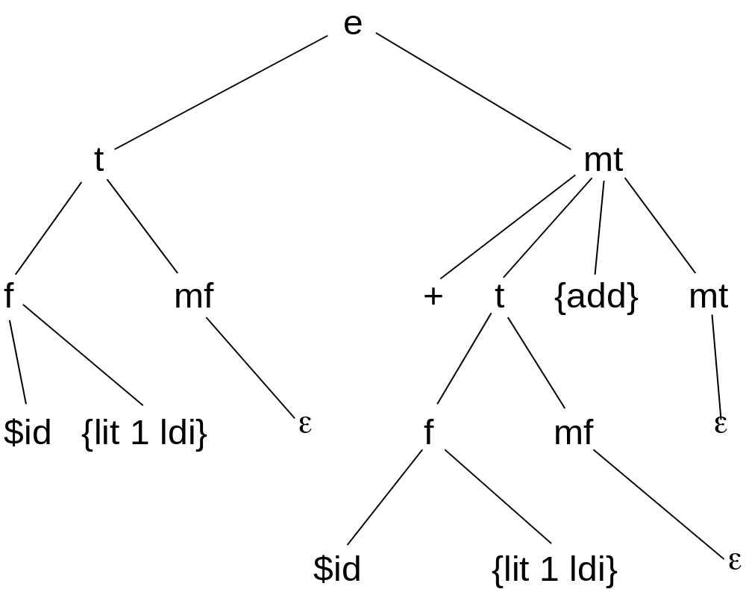

Now recall the critical fact observed while playing through the parser with the TS earlier:

"match" and "execute" activities are done in same order as they occur in TS sentence.

So:

$id {lit 1 ldi} + $id {lit 1 ldi} {add}

tells us that the paser will emit the:

add

after it has emitted the code to emit its operands:

lit 1 ldi lit 1 ldi

i.e. a postfix translation. This is what we want.

Note by looking at the above parse tree that if were instead to use the rule:

mt -> '+' {add} t mt

this would have the effect of switching two children of the interior node mt.

This would result in the translation scheme sentence:

$id {lit 1 ldi} + {add} $id {lit 1 ldi}

This would be an infix translation which is not what we want.

A similar analysis leads to the new TS rule:

mf -> '*' f {mult} mf

