Prof. J. Daley

Scanning | _________  _______________  ___________________  _______________  _________

As we saw earlier, the scanner is a preprocessor for the parser that:

- removes non-essential characters such as blanks, tabs, eol's, and comments

- consolidates the remaining characters into larger entities such as integer constants and identifiers

Theoretically, the parser doesn't need a scanner; the parser could operate on the source code directly. The reason for splitting the work between a parser and a scanner is division of labor: the scanner uses a very fast but limited algorithm, whereas the parser uses a slow algorithm but one that can process a wide class of languages.

In terms of automata theory, the parser is a push-down automaton (PDA): a deterministic machine that uses an unbounded memory accessible as a stack. The scanner is a deterministic finite automaton (DFA): a deterministic machine that uses only a finite amount of memory. The PDA's unbounded memory gives it more language recognition power than a DFA, but pushing and popping a stack makes it slow compared to a DFA.

We will first study DFA's in the abstract, and then design a scanner as a DFA.

__________________________________________

Deterministic Finite Automata (DFA's)

__________________________________________

>> language recognition with a DFA

_______________________________

e.g.

Consider the language:

L = { "x y"^{m} z^{n} | m,n>=0}

over the alphabet:

A = { x, y, z}

The language can also be written:

{ , xy, z, xyxy, xyz, zz, ...}

We want to build a recognizer for this language based on a DFA, and then demonstrate it on the subject string xyxyzzz . The data structures for this DFA would be:
CurrentState Input
S x y x y z z z

NextInput

State Diagram
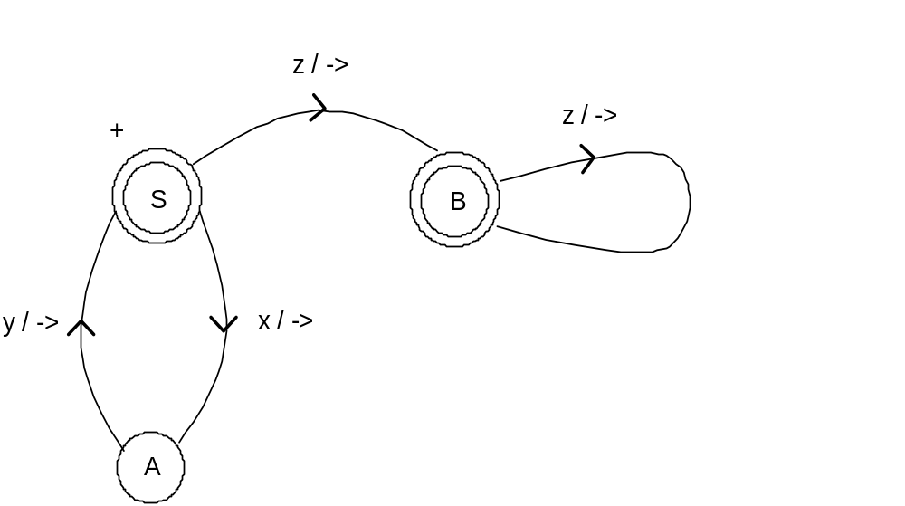

'Input' is a queue initialized to the subject string to be recognized. Its front element is also called 'NextInput'. 'StateDiagram' is a labeled directed graph. The nodes are called states. The arcs are labeled by the symbols of the alphabet of the language being recognized. Following this symbol are optional actions, preceded by a / . Arcs in the above diagram have an '->' action, which means to discard NextInput so as to advance Input. 'CurrentState' is a variable whose value is always one of the states in StateDiagram.

One requirement in the DFA definition is that there not be two arcs with the same alphabet label that originate from the same state. (If there were, the machine would be called a non-deterministic finite automaton.) Also, there should be exactly one start state, indicated in the above diagram with a +. The states with a double circle are called final states. There can be 0 or more of these.

The DFA algorithm is:

Initialize Input with the subject string;
CurrentState <- the start state;
WHILE
Input is non-empty AND there is an arc A from CurrentState labeled with NextInput
DO
CurrentState <- successor state of arc A;
Perform the actions on A;
ENDWHILE;
IF CurrentState is a final state AND Input is empty THEN
Output 'accept';
ELSE
Output 'reject';
ENDIF

Let's do a playthrough of the algorithm with x y x y z z z as the subject string.

CurrentState | Input | Output
S | xyxyzzz
A | yxyzzz
S | xyzzz
A | yzzz
S | zzz
B | zz
B | z
B | ε | accept

Consider two more examples.

e.g. L = ϕ

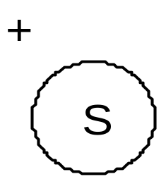

e.g. L = { ε}

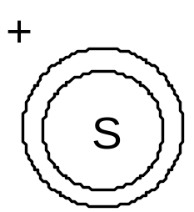

Note that in the standard definition of DFA, the "->" action is assumed to be on every arc. Making it optional, as was done above, does not increase the set of recognizable languages, but does allow simpler state diagrams.

Another name for DFA is finite state machine.

Problem

1. Construct a state diagram for a DFA to recognize the following language:

A = { x, y, z}

L1 = { x^{n} y^{m} z | n, m >=1}⁺

One member of L1 is:

xxyyyzxxxxxxyyyyzxxyz

2. Repeat the preceding problem for:

L2 = { x^{n} y^{m} z | n, m >=0}*

One member of L2 is:

xxxyyzxxxxzyyyyyzxyzzz

>> language translation with a DFA

_______________________________

We can easily enhance a DFA so as to recognize and additionally translate a language. We just add more actions to the arcs.

e.g.

Recognize

L = { "x y"^{m} z^{n} | m, n >=0}

and translate it according to the substitutions:

x -> a
y -> b
z -> ε

We add 'put' actions, meaning to output its argument, to the previous DFA state diagram:

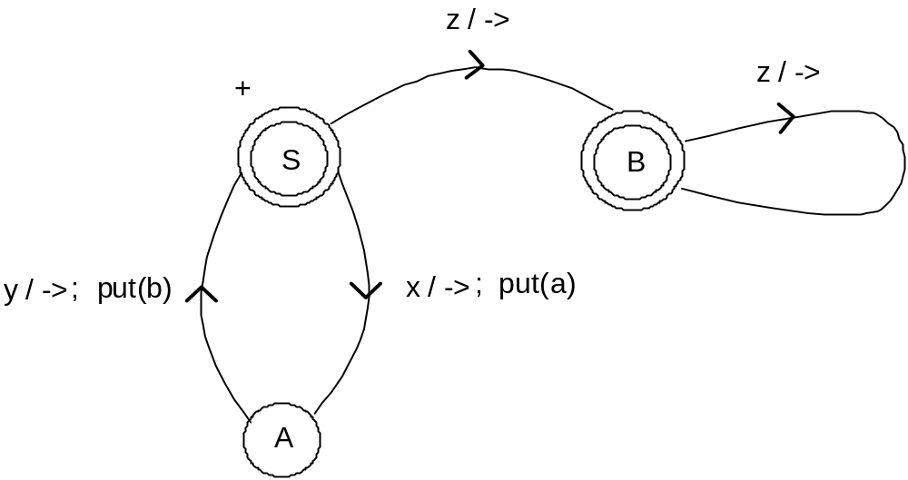

__________________________________________

Designing a Scanner as a DFA

__________________________________________

We want to build a scanner whose mapping of textual elements to tokens is as previously specified. First, we will construct a DFA for this. Then, we will be able to mechanically translate the DFA into scan.cpp .

For purposes of the DFA State Diagram, we assume that end-of-line and end-of-file appear in the source code as @ and # respectively. This appearance will be created internally by scan.cpp and will not impose any requirement on the user.

It pays to define subsets of the ASCII alphabet so we can make the DFA simpler. These subsets are:

d = digit
l = letter (lower or upper case)
a = alphanumeric (letter or digit)
b = blank
#
@
s = special except @ and #
o = other (ASCII characters not listed above)

We will also use a 'Save' variable that will collect contiguous characters for eventual output as a token value.

The DFA State Diagram is then:

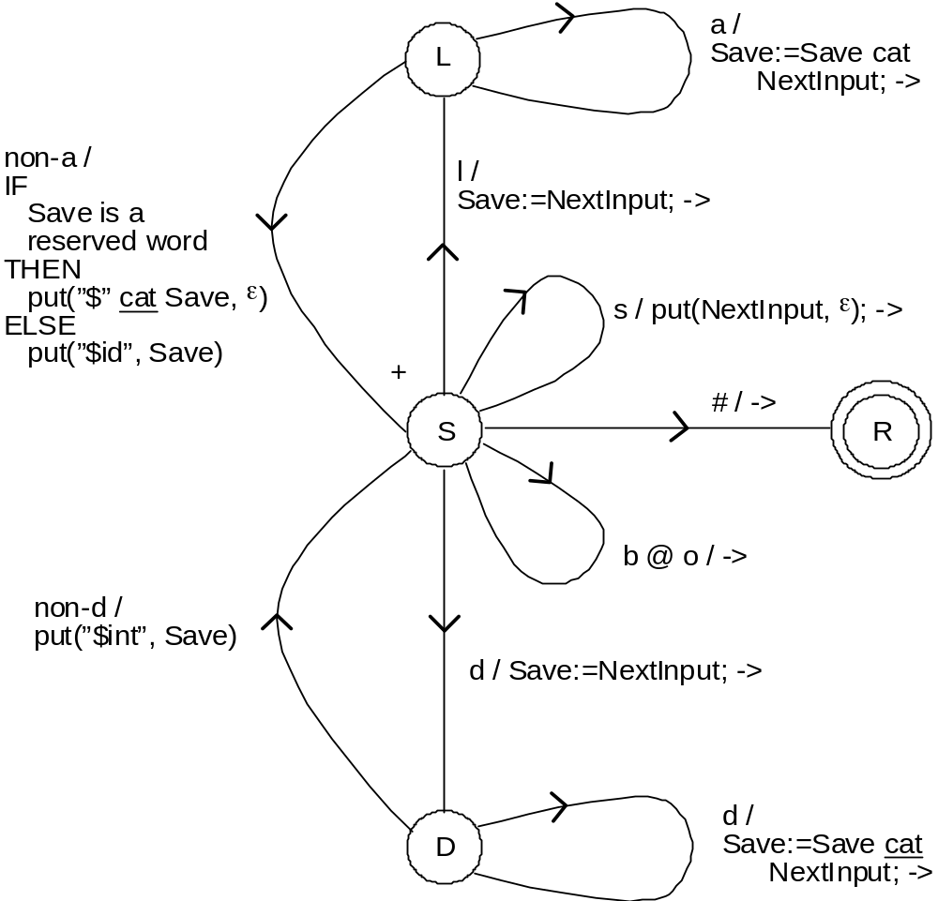

Project - Scanner

Upgrade the instructor's scanner so as to additionally output real constant tokens, output string constant tokens, and skip over comments.

Specifically:

1. Enhance the previous scanner state diagram so as to also process the textual elements listed in the 'Additional Tokens' table of a previous file. i.e. produce real constant and string constant tokens, and skip over comments. You may limit token values to 10 characters or to whatever is convenient. Since 'string constant' is being added as a token, 'single quote' should be removed as a token.

The actions on the arcs can include '->', calls to 'put', assignments to 'Save', but nothing else. In particular, there should be no questions about 'NextInput' and no loops.

Turn in the enhanced scanner diagram.

Then:
2. Enhance the instructor's scanner to implement the state diagram produced in problem 1 above. The new scanner should be a direct translation of the state diagram of problem 1. In particular, there should be no changes to the arc action logic.

Run your enhanced scanner with the following source file as input so as to produce a token file.

'test 123' 314 3.14 abc /* this is 1 comment */
a.bc 3/4*5

This run should be done with the scanner trace on. Turn in the enhanced scanner listing, trace, and token file.

Submit your project as a printed copy, not by e-mail. Attach as the first page the project #3 cover sheet.

You may work with at most one other person. In that case, turn in one copy with the names of both people on the cover sheet.

CS 4110 Sanner Project Cover Sheet
(to be attached to front of what you turn in)

Name(s):
Date turned in:
Where turned in:

Answer all the below for full credit or maximum partial credit:

Did you include a scanner diagram? If not, explain.

Did you implement all the textual elements specified in the problem statement in your diagram? If not, which ones did you implement?

Does your scanner compile without compilation errors?

Does your scanner run without crashing?

Did you include the scan trace in what you are turning in? If not, explain.

Did you include the tokfile produced by the scanner in what you are turning in? If not, explain.

Did you use the test source file specified in the problem statement for your test run? If not, explain.

Was the token file output correct for the test run?

Any other comments about what works and what doesn't work in what you are turning in?
__________________________________________

Scanner Implementation

__________________________________________

See the file scan.cpp or scan.txt which is the source code for a scanner that is based on the previous DFA state diagram. Note that aside from a "shell," the code is a "mechanical" translation of the state diagram.

