1) Load the configuration (File / Load) syncope.xml

SynScopeV will show the time series and video, although scrolling is not synchronised by default.

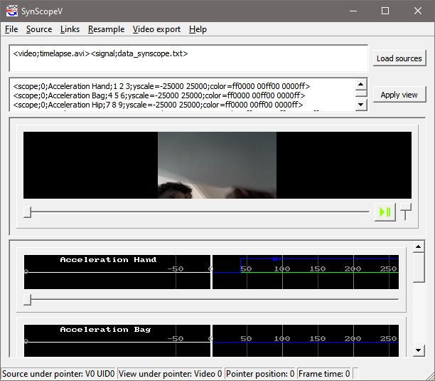

2) Activate synchronised scrolling in Links/Edit reference points and links.

The project file already includes synchronisation info, and these just need to be activated.

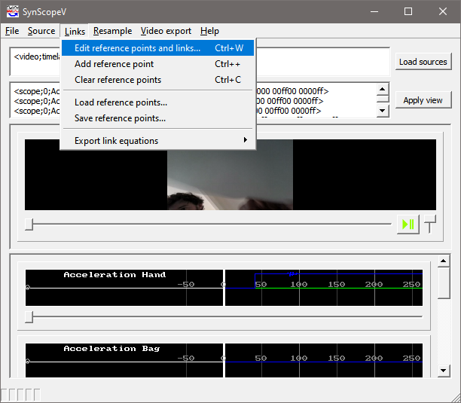

Select “Enable source linking” and link S0 and V0.

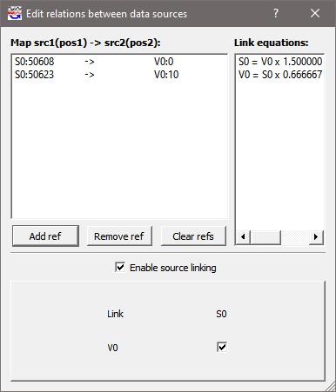

At this stage playing the video or scrolling through the video or time series will control the display of the other channels.

3) Export a video

Videos are created with “Video export / Mosaic of signals”

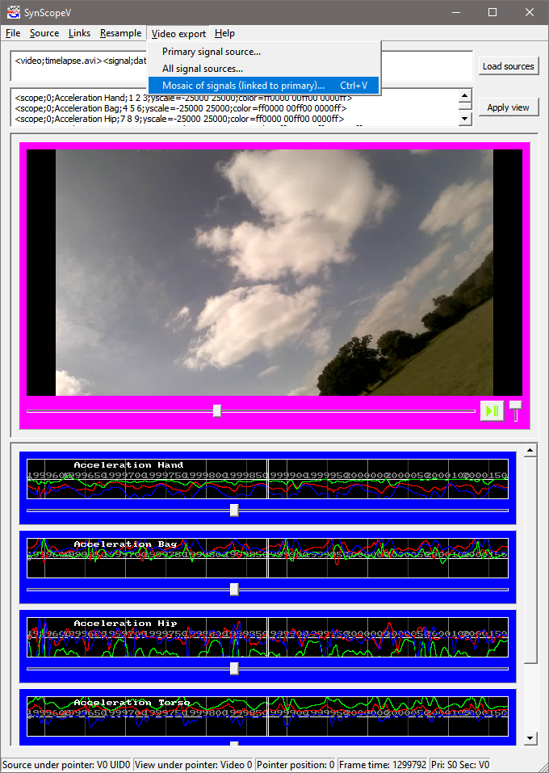

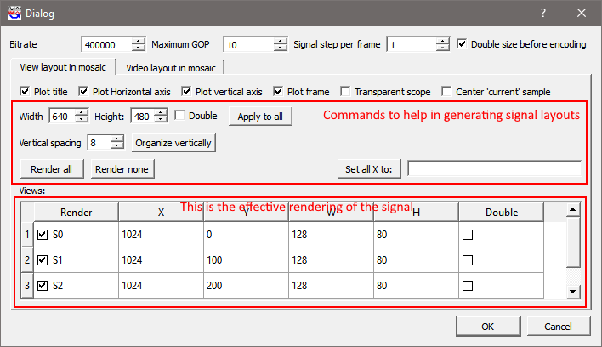

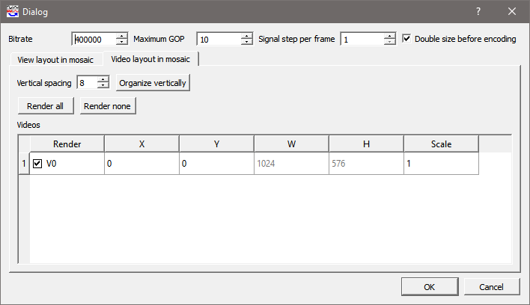

1. Select some main options:
   1. bitrate (e.g. 400000 for 400kbps);
   2. GOP (number of frames between keyframes);
   3. signal step: how much the signal is advanced between each frame. The output is a 25 FPS video. If the data has to be played back in realtime and the signals are at 25FPS then set the step to 1. If the signal is 100Hz, then set the step to 4.
   4. It is recommended to select “double size before encoding” because the coded uses a YUV representations which downsamples the color component and this leads to poor rendering of the signals.
2. In the “View” tab, select whether to plot title, axes, frame around signals, etc.
3. Each signal can be individually selected for rendering (Render checkbox), it’s top left location specified (X,Y), it’s width and height (W, H), and whether to double the size of the render to work around the YUV colorspace. If the overall video size is not doubled, it is recommended to double the scope size here.
4. In the “Video” tab select the render location of the video. The video cannot be rescaled; only the top left position specified.
5. Select “Ok” to start rendering. The file extension must be .mpg (mpeg 2 file)
6. Rendering can be interrupted at any time; the file can still be played up to the interruption.

For example, the following settings lead to the video on the side.

|  |  |
| --- | --- |
|  |  |

4) Generating reference points for synchronisation

Video and scopes are synchronised with reference points through a linear regression.

SynScopeV has a concept of “Primary” and “Secondary” channel. This can be selected by right clicking on the video or scopes. Blue indicates primary; pink is secondary. Reference points link the currently displayed data in the “primary” channel to the currently displayed data on the “secondary” channel.

Which is which does not matter as the linear relationship between the time of the primary and secondary is computed both ways.

|  |  |
| --- | --- |
| Once the config file is loaded. | Right click on the video: video is primary. |
| First right click on the video, then right click on the signal: video is primary and signal secondary. | First right click on the signal, then right click on the video: signal is primary and video secondary. |

1. Videos and signals should be unlinked initially (Link/Edit reference points and links); the reference points cleared (Link / Clear reference points)
2. Scroll to the video and signals to a common time point (e.g. a clap which is visible in the time series as well as the video). Select “Link/Add reference point).
3. Repeat the process; at least 2 reference points are needed, but more can be specified if necessary. SynScopeV does a linear regression to identify the mapping between sensor and video time scales
4. Eventually, activate the link between signals and videos (Link/Edit reference points and links).
5. Verify that the synchronisation works as expected.