Assignment 4

Part A

The deterministic finite state automate was implemented by defining a integer variable state that holds the current state. The lexical analyzer then calls a function switch_state with a parameter depending on the input. In the switch_state function the state gets switched depending on the current state and the input.

Part B

To replace the lexical analyzer a flex file was created that scans all the specific tokens needed by the parser and returns the token identifier. In the bison file parser.y the tokens were defined and the characters were substituted by the token identifier.

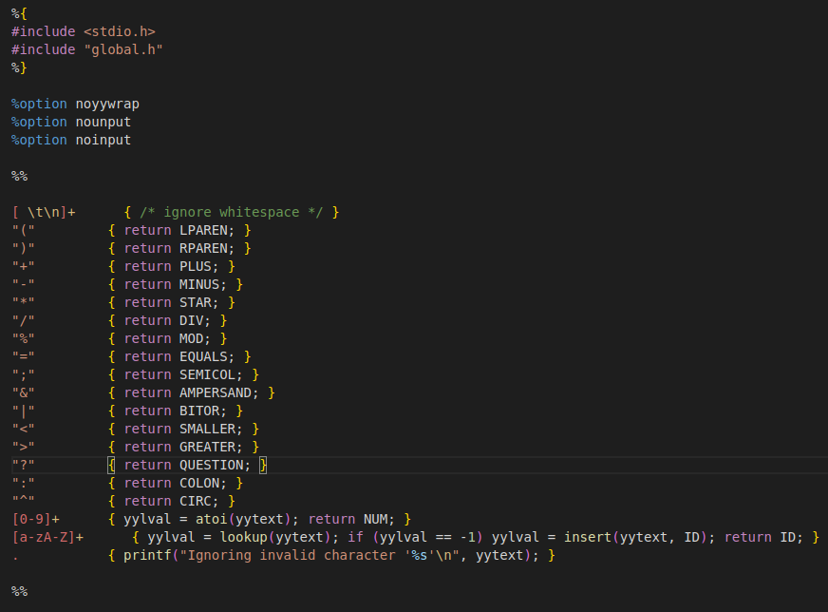Figure 1: Flex file scanner.l

