Assignment 2

Part A

Grammar for both assignments and expressions

start -> list eof
list -> assignment ; list
| expr ; list
| empty
assignment -> id { print(id.lexeme) } = expr { print('=') }
expr -> term moreterms
moreterms -> + term { print('+') } moreterms
| - term { print('-') } moreterms
| empty
term -> factor morefactors
morefactors -> * factor { print('*') } morefactors
| / factor { print('/') } morefactors
| div factor { print('DIV') } morefactors
| mod factor { print('MOD') } morefactors
| empty
factor -> ( expr )
| id { print(id.lexeme) }
| num { print(num.value) }

Would it be possible to write a predictive recursive-descent parser for your grammar?

Nooo?
Ambigous? No
left-recursive?
Disjoint first sets?
FIRST(assignment) = id
FIRST(expr) = id | num
→ FIRST conflict: expr and assignment can both start with an id

Part B
- Modify list function to call assignment instead of expr
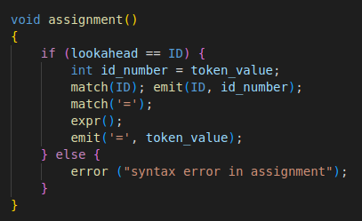
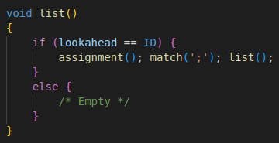
- add function assignment according to the rules described by the grammar

Part C

Part D
First, change the grammar to:

start -> list eof
list -> assignment ; list
| empty
assignment -> id { print(id.lexeme) } = expr { print('=') }
expr -> term moreterms
moreterms -> + term { print('+') } moreterms
| - term { print('-') } moreterms
| empty
term -> exponential morefactors
morefactors -> * exponential { print('*') } morefactors
| / exponential { print('/') } morefactors
| div exponential { print('DIV') } morefactors
| mod exponential { print('MOD') } morefactors
| empty
exponential -> factor moreexponential
moreexponential -> ^ factor { print('^') } moreexponential
factor -> ( expr )
| id { print(id.lexeme) }
| num { print(num.value) }
This can be implemented by creating the two functions exponential and moreexponential that are called instead of factor in the term and morefactors function. Also in the calc function the case for the exponential has to be added.
