Chi-Square Tests

Derek H. Ogle

## First Commands

> library(NCStats)

## Chi-Square Distribution Calculations

An example of computing the p-value $χ^{2}$ =2.67 and df=3.

> ( distrib(2.67,distrib="chisq",df=3,lower.tail=FALSE) )

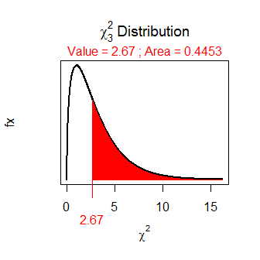

[1] 0.4453496

An example of computing the p-value if $χ^{2}$ =16.82 and df=8.

> ( distrib(16.82,distrib="chisq",df=8,lower.tail=FALSE) )

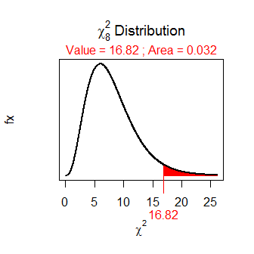

[1] 0.03203895

## Chi-Square Test

### From Summarized Observed Table

Do the dominant food items in lake trout and chinook salmon differ at the 5% level? The summarized observed table was given in class.

> freq <- c(32,10,8,18,18,4)  
> ( obs <- matrix(freq,nrow=2,byrow=TRUE) )

[,1] [,2] [,3]  
[1,] 32 10 8  
[2,] 18 18 4

> rownames(obs) <- c("lake trout","chinook salmon")  
> colnames(obs) <- c("lake herring","smelt","mysis")  
> obs

lake herring smelt mysis  
lake trout 32 10 8  
chinook salmon 18 18 4

> chi1 <- chisq.test(obs,correct=FALSE)  
> chi1$expected

lake herring smelt mysis  
lake trout 27.77778 15.55556 6.666667  
chinook salmon 22.22222 12.44444 5.333333

> chi1$expected >= 5

lake herring smelt mysis  
lake trout TRUE TRUE TRUE  
chinook salmon TRUE TRUE TRUE

> chi1

Pearson's Chi-squared test with obs   
X-squared = 6.5083, df = 2, p-value = 0.03861

> chi1$residuals

lake herring smelt mysis  
lake trout 0.8011103 -1.408590 0.5163978  
chinook salmon -0.8956686 1.574852 -0.5773503

> percTable(obs,margin=1,digits=1)

lake herring smelt mysis Sum  
lake trout 64 20 16 100  
chinook salmon 45 45 10 100

> ( obs2 <- obs[,-2] )

lake herring mysis  
lake trout 32 8  
chinook salmon 18 4

> ( chi2 <- chisq.test(obs2,correct=FALSE) )

Warning in chisq.test(obs2, correct = FALSE): Chi-squared approximation may be incorrect

Pearson's Chi-squared test with obs2   
X-squared = 0.0301, df = 1, p-value = 0.8624

> chi2

Pearson's Chi-squared test with obs2   
X-squared = 0.0301, df = 1, p-value = 0.8624

### From Raw Data

On the GSS, respondents were asked to state their opinion on how true the following statement was "All radioactivity is made by humans." Respondents were also categorized by their highest educational degree. Use the results in the [SciTest1.csv](https://github.com/droglenc/NCData/blob/master/SciTest1.csv) data file to determine, at the 5% level, if the response to the question differs among levels of education

> setwd("C:/aaaWork/Web/GitHub/NCMTH107/lecture/HOs")  
> ST1 <- read.csv("SciTest1.csv")  
> str(ST1)

'data.frame': 2549 obs. of 2 variables:  
 $ degree : Factor w/ 5 levels "bach","grad",..: 5 5 5 5 5 5 5 5 5 5 ...  
 $ scitest: Factor w/ 4 levels "def.not","def.true",..: 2 2 2 2 2 2 2 2 2 2 ...

> levels(ST1$degree)

[1] "bach" "grad" "hs" "jc" "lt.hs"

> ST1$fdegree <- factor(ST1$degree,levels=c("lt.hs","hs","jc","bach","grad"))  
> levels(ST1$scitest)

[1] "def.not" "def.true" "prob.not" "prob.true"

> ST1$fscitest <- factor(ST1$scitest,levels=c("def.not","prob.not","prob.true","def.true"))

> ( freq.tbl <- xtabs(~fdegree+fscitest,data=ST1) )

fscitest  
fdegree def.not prob.not prob.true def.true  
 lt.hs 52 112 155 70  
 hs 366 451 437 114  
 jc 60 44 36 9  
 bach 214 135 78 12  
 grad 123 57 18 6

> ST1.chi <- chisq.test(freq.tbl,correct=FALSE)  
> ST1.chi$expected

fscitest  
fdegree def.not prob.not prob.true def.true  
 lt.hs 124.37623 121.93448 110.48882 32.20047  
 hs 437.39506 428.80816 388.55708 113.23970  
 jc 47.64025 46.70498 42.32091 12.33386  
 bach 140.36289 137.60730 124.69047 36.33935  
 grad 65.22558 63.94508 57.94272 16.88662

> ST1.chi$expected >= 5

fscitest  
fdegree def.not prob.not prob.true def.true  
 lt.hs TRUE TRUE TRUE TRUE  
 hs TRUE TRUE TRUE TRUE  
 jc TRUE TRUE TRUE TRUE  
 bach TRUE TRUE TRUE TRUE  
 grad TRUE TRUE TRUE TRUE

> all(chi1$expected >= 5)

[1] TRUE

> ST1.chi

Pearson's Chi-squared test with freq.tbl   
X-squared = 288.2331, df = 12, p-value < 2.2e-16

> ST1.chi$residuals

fscitest  
fdegree def.not prob.not prob.true def.true  
 lt.hs -6.4897392 -0.8996675 4.2345762 6.6612431  
 hs -3.4137460 1.0716718 2.4575530 0.0714471  
 jc 1.7906992 -0.3958064 -0.9716327 -0.9492868  
 bach 6.2154218 -0.2222643 -4.1813025 -4.0375730  
 grad 7.1536326 -0.8685073 -5.2473280 -2.6492428

> percTable(freq.tbl,margin=1,digits=1)

fscitest  
fdegree def.not prob.not prob.true def.true Sum  
 lt.hs 13.4 28.8 39.8 18.0 100.0  
 hs 26.8 33.0 31.9 8.3 100.0  
 jc 40.3 29.5 24.2 6.0 100.0  
 bach 48.7 30.8 17.8 2.7 100.0  
 grad 60.3 27.9 8.8 2.9 99.9

## Goodness-of-Fit Test

Four-o'clocks (**Mirabilis jalapa**) are plants native to tropical America. Individual four-o'clocks can have red, white, or pink flowers. Flower color in this species is thought to controlled by a single gene locus with two alleles experssing incomplete dominance, so that heterozygotes are pink-flower, while homozygotes for one allele are white-flowered and homozygotes for the other allele are red-flowered. According to Mendelian genetic principles, self-pollination of pink-flowered plants should produce progeny that have red, pink, and white flowers in a 1:2:1 ratio. A horticulturist self-pollinates several pink-flowered plants and produces 240 progeny with 55 that are red-flowered, 132 that are pink-flowered, and 53 that are white-flowered. Use the results to determine, at the 5% level, if the theoretical 1:2:1 ratio is upheld with these data (This is example 11.1 from Glover, T. and K. Mitchell. 2008. An Introduction to Biostatistics, 2nd edition. Waveland Press).

> obs <- c(red=55,pink=132,white=53)  
> exp.p <- c(red=1/4,pink=2/4,white=1/4)  
> chi1 <- chisq.test(obs,p=exp.p,rescale=TRUE,correct=FALSE)  
> chi1$expected

red pink white   
 60 120 60

> chi1$observed

red pink white   
 55 132 53

> chi1

Chi-squared test for given probabilities with obs   
X-squared = 2.4333, df = 2, p-value = 0.2962

> plot(chi1)

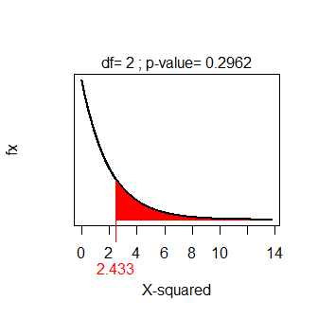

> gofCI(chi1,digits=3)

p.obs p.LCI p.UCI p.exp  
red 0.229 0.181 0.286 0.25  
pink 0.550 0.487 0.612 0.50  
white 0.221 0.173 0.277 0.25