Inference Concepts

Derek H. Ogle

## Background

Barrels designed to hold 200-gallons of gasoline were recently found in an abandoned warehouse. The contents of a random sample of 38 barrels were carefully measured to determine if the barrels had leaked a significant amount of gasoline. Assume that it is known that the actual content of the barrels has a standard deviation of 10 gallons. The results for the sample are found in [barrels.csv](https://github.com/droglenc/NCData/blob/master/Barrels.csv) on the class webpage. Use results computed from the sample to determine, at the 10% level, if there is evidence that the barrels had leaked.

## Getting the Data

> library(NCStats)  
> setwd("C:/aaaWork/Web/GitHub/NCMTH107/lecture/HOs")  
> brls <- read.csv("Barrels.csv")  
> str(brls)

'data.frame': 38 obs. of 2 variables:  
 $ barrel : int 1 2 3 4 5 6 7 8 9 10 ...  
 $ gasoline: num 183 197 192 200 190 ...

## Quick EDA

> Summarize(~gasoline,data=brls,digits=1)

n nvalid mean sd min Q1 median Q3 max percZero   
 38.0 38.0 197.7 10.6 178.8 189.5 199.3 204.4 223.4 0.0

> hist(~gasoline,data=brls,xlab="Gallons of Gasoline")

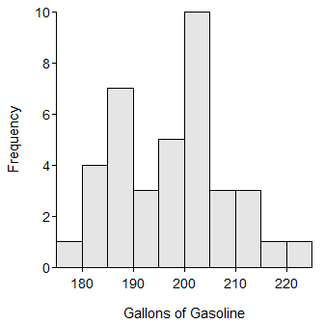

## 1-Sample Z-test

> ( gas.z <- z.test(brls$gasoline,sd=10,mu=200,alt="less",conf.level=0.90) )

One Sample z-test with brls$gasoline   
z = -1.4243, n = 38.000, Std. Dev. = 10.000, Std. Dev. of the sample mean =  
1.622, p-value = 0.07718  
alternative hypothesis: true mean is less than 200   
90 percent confidence interval:  
 -Inf 199.7684   
sample estimates:  
mean of brls$gasoline   
 197.6895

> plot(gas.z)

