t-Tests

Derek H. Ogle

## First Commands

> library(NCStats)  
> library(car) # for leveneTest

## Two-Sample t-Test

[Sholl *et al.* (2000)](http://www.sciencedirect.com/science/article/pii/S0272494499901469) performed an experiment to test the effect of sex (male, female) on spatial orientation ability. In one part of their study, the researchers took 30 males and 30 females to an unfamiliar wooded park and asked each individual to point to the south. The absolute pointing error (positive degrees off from due south, abserr) was recorded in [SexDirection.csv](https://raw.githubusercontent.com/droglenc/NCData/master/SexDirection.csv) . Test if men have a better sense of direction than women, at the 1% level?

> setwd("C:/aaaWork/Web/GitHub/NCMTH107/modules/1_Sample_t")  
> sdir <- read.csv("SexDirection.csv")  
> str(sdir)

'data.frame': 60 obs. of 2 variables:  
 $ abserr: int 13 13 38 59 58 8 130 68 23 5 ...  
 $ sex : Factor w/ 2 levels "female","male": 2 2 2 2 2 2 2 2 2 2 ...

> Summarize(abserr~sex,data=sdir,digits=1)

sex n nvalid mean sd min Q1 median Q3 max percZero  
1 female 30 30 55.8 48.3 3 15.8 35.0 88.2 176 0  
2 male 30 30 37.6 38.5 3 11.5 22.5 58.8 167 0

> hist(abserr~sex,data=sdir,xlab="Absolute Pointing Error")

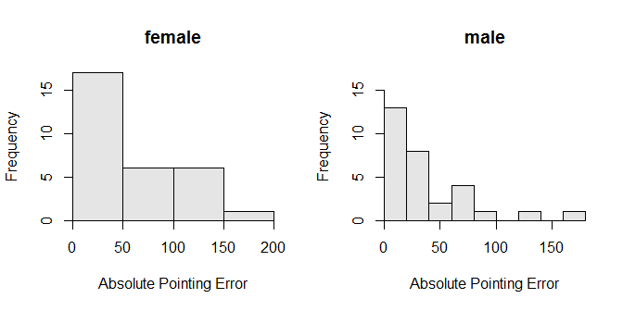

> leveneTest(abserr~sex,data=sdir)

Levene's Test for Homogeneity of Variance (center = median)  
 Df F value Pr(>F)  
group 1 2.1692 0.1462  
 58

> ( t2 <- t.test(abserr~sex,data=sdir,var.equal=TRUE,alt="greater",conf.level=0.99) )

Two Sample t-test with abserr by sex   
t = 1.6149, df = 58, p-value = 0.05588  
alternative hypothesis: true difference in means is greater than 0   
99 percent confidence interval:  
 -8.761457 Inf   
sample estimates:  
mean in group female mean in group male   
 55.8 37.6

> plot(t2)

