Bivariate EDA - Quantitative

R Handout

Derek H. Ogle

## Background

[Erickson et al. (2004)](http://onlinelibrary.wiley.com/doi/10.1017/S0952836903004400/abstract) compared the bite-force performance between [American Alligators (*Alligator mississippiensis*)](https://en.wikipedia.org/wiki/American_alligator) from the wild and those that had been in long-term captivity. In one aspect of their research they examined the relationship between the mass (kg) and snout-vent length (svl; cm) of the alligators. Their primary interest here was in determining if variability in the mass could be explained by knowing the snout-vent length of the individual. The data are recorded in [Alligators1.csv](https://github.com/droglenc/NCData/blob/master/Alligators1.csv). Use these data to describe the relationship between the mass and snout-vent length of the alligators.

## Getting The Data

> library(NCStats)  
> setwd("C:/aaaWork/Web/GitHub/NCMTH107/modules/BivEDA_Quantitative")  
> d <- read.csv("Alligators1.csv")  
> str(d)

'data.frame': 44 obs. of 3 variables:  
 $ type: Factor w/ 2 levels "captive","wild": 2 2 2 2 2 2 2 2 2 2 ...  
 $ svl : num 192 175 172 168 147 ...  
 $ mass: num 242 164 172 135 114 ...

> headtail(d)

type svl mass  
1 wild 191.6 242.2  
2 wild 175.3 163.6  
3 wild 172.4 172.2  
42 captive 156.7 175.9  
43 captive 174.3 226.1  
44 captive 189.1 296.1

## Bivariate EDA -- Quantitative

> plot(mass~svl,data=d,xlab="Snout-Vent Length (cm)",ylab="Body Mass (KG)",pch=19)

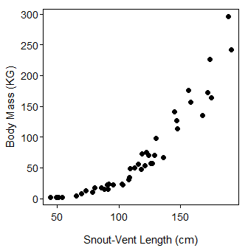

> corr(mass~svl,data=d)

[1] 0.9126669

> corr(mass~svl,data=d,use="pairwise.complete.obs")

[1] 0.9126669

> plot(mass~svl,data=d,xlab="Snout-Vent Length (cm)",ylab="Body Mass (KG)",pch=19,col=type)  
> legend("topleft",levels(d$type),pch=19,col=1:2,bty="n")

