Chi-Square Distribution

R Handout

Derek H. Ogle

## First Commands

library(NCStats)

## Chi-Square Distribution Calculations

An example of computing the p-value $χ^{2}$ =2.67 and df=3.

( distrib(2.67,distrib="chisq",df=3,lower.tail=FALSE) )

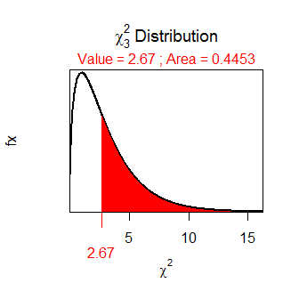

## [1] 0.4453496

An example of computing the p-value if $χ^{2}$ =16.82 and df=8.

( distrib(16.82,distrib="chisq",df=8,lower.tail=FALSE) )

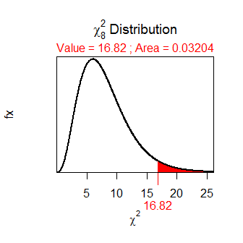

## [1] 0.03203895