Willy Wonka

Chapter 0 Homework

**10.1.** The number of points scored in a basketball game by a single player is a discrete quantitative variable.

**10.2.** The fact that a player does not score the same number of points in each basketball game is an example of natural variability.

**10.3.** The distribution of points scored per game by Steph Curry in the 2015-16 NBA season was approximately symmetric with a potential outlier of five or fewer points (Figure 1). The distribution is centered on a mean of 30.1 points with a standard deviation of 9.8 points (Table 1). I chose to use the mean and standard deviation because the distribution was not strongly skewed and the outlier was not extreme.

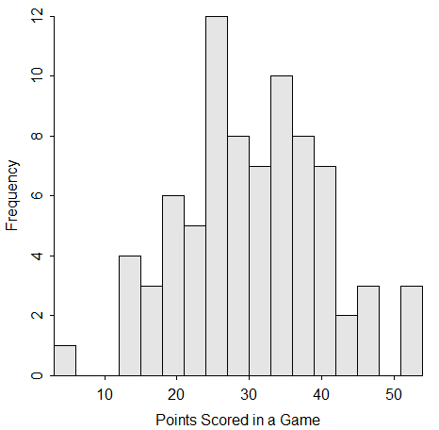

Figure 1. Histogram of points scored by Steph Curry in 79 games of the 2015-16 NBA season.

Table 1. Summary statistics of points scored by Steph Curry in 79 games of the 2015-16 NBA season.

n mean sd min Q1 median Q3 max

79.0 30.1 9.8 5.0 24.0 30.0 37.0 53.0

**R Appendix**

library(NCStats)

SC <- read.csv(“StephCurry16.csv”)

Summarize(~PTS,data=SC,digits=1)

hist(~PTS,data=SC,xlab="Points Scored in a Game",ylim=c(0,12),w=3)

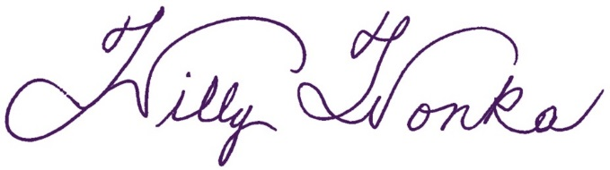I have neither given nor received unauthorized aid in completing this work, nor have I presented someone else's work as my own.