Inference Concepts

Derek H. Ogle

## Background

The [Survey of Study Habits and Attitudes (SSHA)](http://www.jstor.org/stable/1434291?seq=1#page_scan_tab_contents) was a psychological test that measures the motivation, attitudes, and study habits of college students. Scores range from 0 to 200 and follow (approximately) a normal distribution, with a mean of 110 and a standard deviation of 20. The survey was given to 40 "non-traditional" students to test the hypothesiis that they had stronger study habits and greater motivation for school work.

The results of the study are in [SSHA.csv](https://github.com/droglenc/NCData/raw/master/SSHA.csv). Use these data to test the hypothesis at the 5% level.

## Getting the Data

> library(NCStats)  
> setwd("C:/aaaWork/Web/GitHub/NCMTH107/resources/class/HOs")  
> d <- read.csv("SSHA.csv")  
> str(d)

'data.frame': 40 obs. of 1 variable:  
 $ score: int 113 131 108 72 124 129 125 100 141 117 ...

## Quick EDA

> Summarize(~score,data=d,digits=1)

n nvalid mean sd min Q1 median Q3 max percZero   
 40.0 40.0 121.1 24.8 72.0 106.8 125.0 138.0 180.0 0.0

> hist(~score,data=d,xlab="SSHA Score")

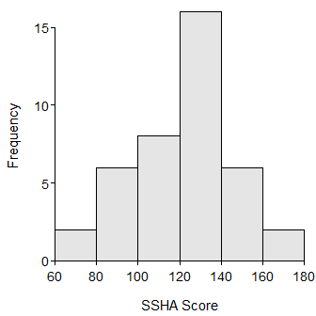

## 1-Sample Z-test

> ( z1 <- z.test(d$score,sd=20,mu=110,alt="greater",conf.level=0.95) )

One Sample z-test with d$score   
z = 3.5101, n = 40.000, Std. Dev. = 20.000, Std. Dev. of the sample mean =  
3.162, p-value = 0.0002239  
alternative hypothesis: true mean is greater than 110   
95 percent confidence interval:  
 115.8985 Inf   
sample estimates:  
mean of d$score   
 121.1

> plot(z1)

