Normal Distribution

Derek H. Ogle

## Wood-Burning Example

Suppose that the amount of wood that I burn per day is approximately normally distributed with a mean of 16 ft ${}^{3}$ and a standard deviation of 4 ft ${}^{3}$. Use this information to answer the questions below.

* What is an individual?
* What is the variable and what type of variable is it?
* On what proportion of days do I burn less than 22 ft ${}^{3}$ of wood?
* On what proportion of days do I burn more than 15 ft ${}^{3}$ of wood?
* On what proportion of days do I burn between 11 and 26 ft ${}^{3}$ of wood?
* What is the amount of wood burned per day such that I burn less than that amount on 10% of the days?
* What is the amount of wood burned per day such that I burn more than that amount on 20% of the days?
* What are the most common 50% of amounts of wood burned per day?

## Load NCStats Package

> library(NCStats)

### Forward, Less-Than

> ( distrib(22,mean=16,sd=4) )

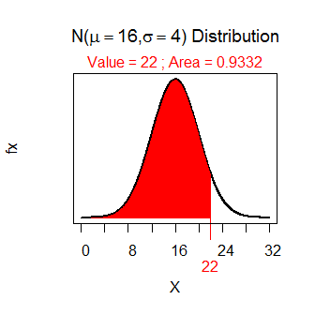

[1] 0.9331928

### Forward, Greater-Than

> ( distrib(15,mean=16,sd=4,lower.tail=FALSE) )

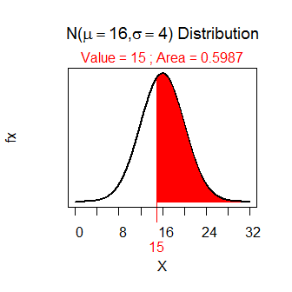

[1] 0.5987063

### Forward, Between

> ( ab <- distrib(26,mean=16,sd=4) )

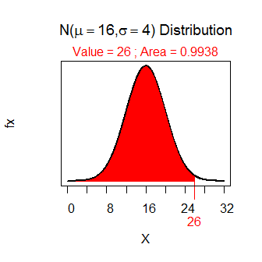

[1] 0.9937903

> ( a <- distrib(11,mean=16,sd=4) )

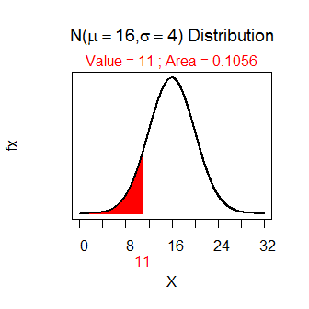

[1] 0.1056498

> ab-a

[1] 0.8881406

### Reverse, Less-Than}

> ( distrib(0.1,mean=16,sd=4,type="q") )

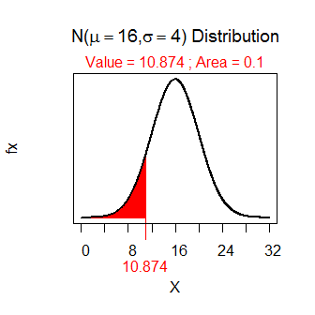

[1] 10.87379

### Reverse, Greater Than

> ( distrib(0.20,mean=16,sd=4,type="q",lower.tail=FALSE) )

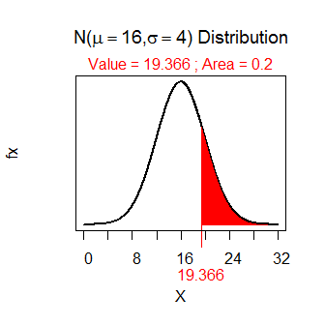

[1] 19.36648

### Reverse, Between

> ( distrib(0.25,mean=16,sd=4,type="q") )

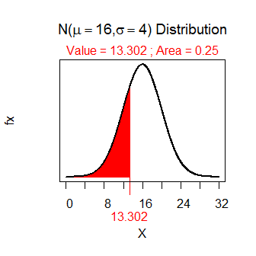

[1] 13.30204

> ( distrib(0.25,mean=16,sd=4,type="q",lower.tail=FALSE) )

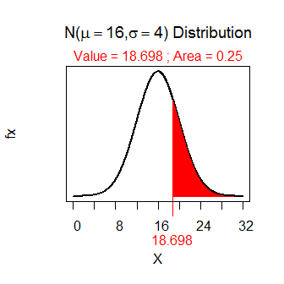

[1] 18.69796