**Multiple Choice [18 pts] -- choose the ONE BEST answer for each question by writing the corresponding letter in the blank to the left of the question.**

1. Two samples of bluebirds sang for an average of 45 and 53 minutes, respectively. This difference between statistics is an example of what type of variability?

______ A. Natural B. Extreme C. Process D. Variable E. Sampling

2. Three trees were infected with 17, 13, and 7 three-lined chestnut borers (i.e., insects), respectively. This difference among individuals is an example of what type of variability?

______ **A.** Natural **B.** Extreme **C.** Process **D.** Variable **E.** Sampling

--

3. What is the summary of all possible individuals of interest, whether actually examined or not, called?

______ **A.** Sample **B.** Statistic **C.** Gang **D.** Parameter **E.** Population

4. What is the group of individuals actually examined in a statistical study called?

______ **A.** Sample **B.** Statistic **C.** Gang **D.** Parameter **E.** Population

5. What is the symbol used to represent the population standard deviation?

______ **A.** x **B.** s **C.**  **D.**  **E.** Q3

--

6. What type of variable is “home continent” (Africa, Asia, Australia, Europe, N America, S America, Antarctica)?

______ **A.** Nominal **B.** Ordinal **C.** Response **D.** Continuous **E.** Discrete

7. What type of variable is how long (in years) someone has owned their TV?

______ **A.** Nominal **B.** Ordinal **C.** Response **D.** Continuous **E.** Discrete

--

8. Which graph would best be used to examine the distribution of the amount of money that townships in Wisconsin have spent on snow removal this year?

______ **A.** Bar Chart **B.** Dot Plot **C.** Histogram **D.** Scatterplot **E.** Stemplot

9. Which graph would best be used to examine the distribution of responses to “what is your favorite month of the year?”

______ **A.** Bar Chart **B.** Dot Plot **C.** Histogram **D.** Scatterplot **E.** Stemplot

10. The mean is ________ the median for a symmetric distribution.

______ **A.** less than **B.** equal to **C.** greater than **D.** five times **E.** a sibling of

11. Which measures should be used if the distribution is strongly left-skewed?

______ **A.** x & s **B.** x & IQR **C.** x & range **D.** Median & s **E.** Median & IQR

--

12. On any normal distribution, what proportion of the individuals are within +1 of ?

______ **A.** 0.680 **B.** 0.900 **C.** 0.950 **D.** 0.997 **E.** 1.000

13. On any normal distribution, what proportion of individuals are between Q1 and Q3?

______ **A.** 0.500 **B.** 0.680 **C.** 0.900 **D.** 0.950 **E.** 0.997

14. On a N(6,3) distribution, what proportion of the individuals are negative?

______ **A.** 0.025 **B.** 0.16 **C.** 0.50 **D.** 0.84 **E.** 0.975

**--**

15. Which of the following is not a possible value for the correlation?

______ **A.** -1 **B.** 0 **C.** 0.1 **D.** 0.34789 **E.** 1.2

16. Which of the following correlation coefficients represents the weakest relationship?

______ **A.** -1 **B.** 0 **C.** 0.1 **D.** 0.34789 **E.** 1.2

17. Which association occurs when most of the individuals are above average for one variable but below average for the other variable?

______ **A.** Negative **B.** Neutral **C.** Positive **D.** Strong **E.** Weak

18. What is the name of the variable that we are interested in predicting or explaining?

______ **A.** Continuous **B.** Discrete **C.** Explanatory **D.** Response **E.** Sampling

**Answer the following question in the space provided. Please be as specific as possible.**

19. **[6 pts]** The National Collegiate Athletic Association (NCAA) is interested in determining the mean team grade point average (gpa) for collegiate women’s athletic teams. To examine this questions they obtained the team gpa for the fall semester in 2012 from 72 women’s athletic teams from across the country. Use this information to identify the **I**ndividual, **V**ariable, **Po**pulation, **Pa**rameter, **Sa**mple, and **St**atistic.

**I** -- __________________________________________________________________________________________

**V** -- __________________________________________________________________________________________

**Po** -- __________________________________________________________________________________________

**Pa** -- __________________________________________________________________________________________

**Sa** -- __________________________________________________________________________________________

**St** -- __________________________________________________________________________________________

**Answer the following two questions in the space provided with your final answer clearly identified (e.g., circled). You must show all of your work to receive full credit (i.e., just providing the final answer will not receive full credit).**

20. **[4 pts]** Compute the standard deviation for the following data: 22, 29, 20, 11, 14, 18

21. Compute the median **[2 pts]** and IQR **[4 pts]** for the following data:

69, 28, 33, 35, 27, 28, 42, 44, 55, 44, 56, 59, 47, 60, 49, 52, 26, 66, 70

**Use distrib() in RStudio to produce the result(s) needed to answer the next question. Write your answers with complete sentences with the code used to produce the result below your sentence.**

22. **[8 pts]** Suppose that it is known that the distribution of number of carpenter ants in a nest is normally distributed with a mean of 1400 ants and a standard deviation of 300 ants. Use this information to answer the questions below *to one decimal place*.

1. What percentage of nests have more than 1900 ants?
2. What is the number of ants such that 15% of the nests have more ants?
3. What is the IQR for the number of ants in a nest?
4. What percentage of nests have between 700 and 1900 ants?

**library(NCStats)**

**distrib(x,mean=##,sd=##,lower.tail=XXXXX,type=”X”)**

where **x** is replaced with the value of the quantitative variable or the area

**mean=##** has ## replaced by the value of the mean

**sd=##** has ## replaced by the value of the standard deviation

**lower.tail=XXXXX** has XXXXX replaced with TRUE (default) for a “left-of” and FALSE for a “right-of” calculation

**type=”X”** has X replaced with p (default) for a forward and q for a reverse question

**Complete a thorough EDA that is appropriate to the type and number of variables in each of the following three questions. Your answer should be written with complete sentences.**

23. **[5 pts]** The ambient air temperature (oC) between 15-Nov and 31-Mar was measured in limestone caves in Maryland, Pennsylvania, and West Virginia inhabited by a certain species of bat. The histogram and descriptive statistics for the data in this sample are presented in Figure 1 and Table 1, respectively.

|  |  |
| --- | --- |
| **Figure 1.** Histogram of air temperature in caves. | **Table 1.** Descriptive statistics of air temperature in caves.  Min. 3.10  1st Qu. 4.70  Median 6.80  3rd Qu. 8.90  Max. 13.10  Mean 7.09  St. Dev. 2.11 |

24. **[2 pts]** The General Social Survey (GSS) received responses to the question “What is your religious preference?” from 16,905 people between 2000 and 2010. The percentage responses are shown in Table 2.

**Table 2.** Percentage of respondents by religious preference.

Catholic Jewish Protestant Other None

25.6% 1.9% 50.8% 6.5% 15.3%

25. **[5 pts]** Government researchers examined the relationship between the median price of a house and the percent of the population that was of a “lower status” (as defined by household income, percent unemployed, etc.) for a large sample of communities across the United States. Their results are shown in Figure 3.

r = -0.587

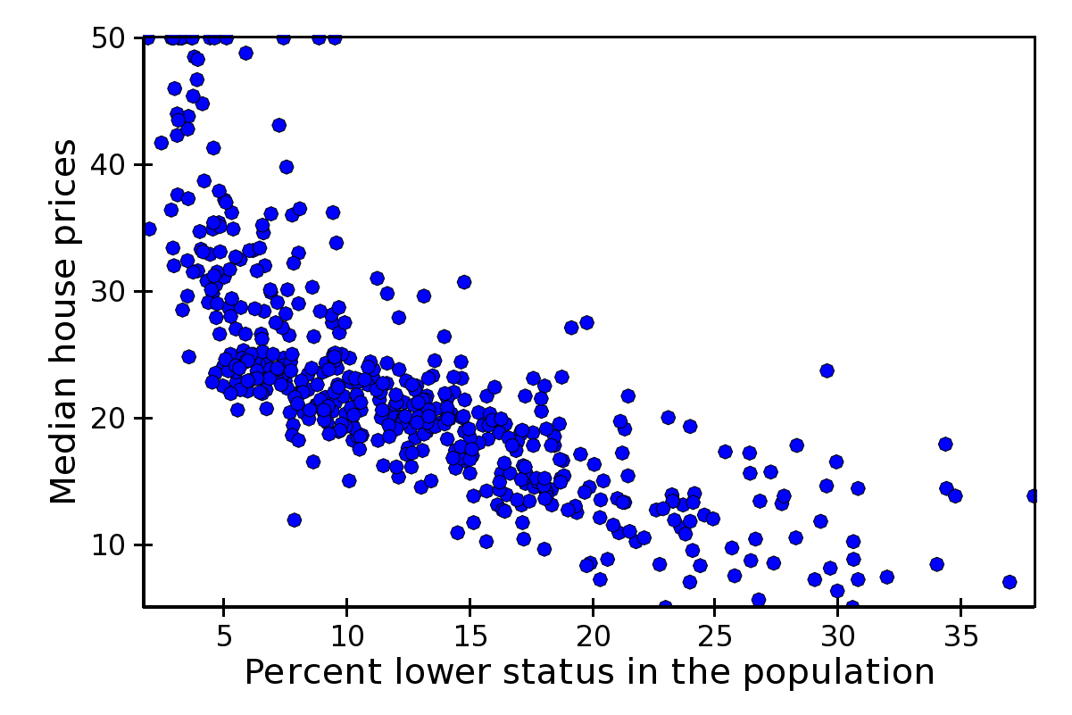

Figure 3. Scatterplot of median house prices versus the

percentage of the population classified as “lower status.”

**Short (Paragraph) Answers -- Answer TWO of the following questions with complete sentences. Make sure to clearly label which questions you chose to answer. Each question is worth 3 points.**

26. Thoroughly describe what the two major goals of statistics are **AND** why each is important.

27. Define natural and sampling variability. Provide a thoughtful example that depicts each type of variability.

28. **COMPLETELY** describe the underlying philosophical differences in how the mean and median measure center.

29. Describe two major principles or realities that lead to the importance of statistics in everyday life and scientific research.