***Answer each question below on separate sheets of paper. Make sure to clearly label each of your answers (e.g., #1 or #4a), show work (including R code) where appropriate, put your name on each extra sheet, and staple these questions to the top of your answer sheets when completed to hand in.***

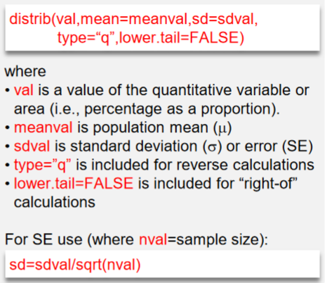

1. **[20 pts]** Renner (1970) examined the content of hydroxymethylfurfurol (HMF) in honey. HMF is an organic compound derived from cellulose without the use of fermentation and is a potential “carbon-neutral” source for fuels. This study found that the distribution of HMF in one kg portions of honey was strongly right-skewed with a mean of 9.5 g and a standard deviation of 13.5 g. Use this information to answer the questions below to three decimal places. *If you choose not to answer the question, carefully and specifically explain why.*
2. What is the probability that the mean HMF content in 30 portions of honey is more than 13 g?
3. What is the probability that the HMF content in a portion of honey is less than 5 g?
4. What is the probability that the mean HMF content in 40 portions of honey is between 10 and 12 g?
5. What is the probability that the mean HMF content in 20 portions of honey is less than 3 g?
6. What is the IQR for the mean HMF content in 50 portions of honey?
7. For the following questions, use HA: >250, =50, n=25, =0.10, and the population is symmetric.
   1. **[5 pts]** Compute the p-value ifx=290.
   2. **[2 pts]** Make a decision about HO from your computed p-value.
   3. **[5 pts]** Compute an appropriate confidence region ifx=290.
   4. **[2 pts]** Interpret your confidence region.
   5. **[5 pts*]** Compute  assuming that the actual  is 275.
8. **[5 pts]** Completely describe three major differences between a population distribution and a sampling distribution.
9. **[5 pts]** What is the definition of a p-value and how is it used to make a decision about H0?
10. An employee in the Human Resources department of a large firm wants to test whether the mean monthly expense claim by employees is greater than $500 (the amount currently allowed by company policy). Suppose that a random sample of 40 employees is taken and it is found that the mean expense claim for the most recent month was $560. Assume that the standard deviation is $150 and the employee’s boss wants to perform this test at the 1% level. Use this information to answer the questions below. *Show your work and R code where appropriate.*
    1. **[6 pts]** What are the null and alternative hypotheses? [*Make sure to define the parameter in the hypotheses.*]
    2. **[5 pts]** Compute the p-value.
    3. **[3 pts]** Make a decision; i.e., what can be concluded about the mean monthly expense claim and why? [*use a complete sentence*]
    4. **[5 pts]** Construct an appropriate confidence region.
    5. **[3 pts]** Interpret your confidence region. [*use a complete sentence*]
    6. **[4 pts]** Define a Type I and a Type II error for this study. [*use complete sentences*]
11. **[5 pts]** Students in the Mammology class want to capture enough field mice from the Maxwell Property such that they can estimate the mean weight of adult field mice to within 3 grams with 90% confidence. In a preliminary study they found that the standard deviation of the weights of adult field mice was 20 grams. Use this information to determine how many adult field mice should be sampled to meet the student’s constraints.
12. **[6 pts]** Suppose the following sets of sample means were taken from a population with a mean of 80.

Set #1. – 71.5, 73.4, 85.7, 89.4

Set #2. – 68.8, 69.3, 70.9, 71.0

Set #3. – 78, 79, 81, 82

Set #4. – 51, 64, 80, 95

Identify which set from above **best** represents each situation below.

* 1. Accurate and most precise.
  2. Inaccurate and most precise.
  3. Inaccurate and least precise.

1. **[5 pts]** Describe choices that you, as a researcher, can make to increase statistical power. Which is the best choice to make (statistically) **and why**?
2. **[5 pts]** Describe choices that you, as a researcher, can make to reduce the margin-of-error. Which is the best choice to make (statistically) **and why**?