Practical exam

Mason Deja

7/12/17

Inch lengths

1. Univariate EDA for the lengths of Largemouth Bass captured via angling

The total length of Largemouth Bass caught by angling is slightly left skewed with no outliers present (Figure 1). the center of the distribution is at 12.8 which is the median (Table 1). The dispersion goes from 12 (Q1) to 13.2(Q3).

Table 1

netType n mean sd min Q1 median Q3 max

1 angling 193 12.394 1.522 6.5 12 12.8 13.2 15.7

Figure 1

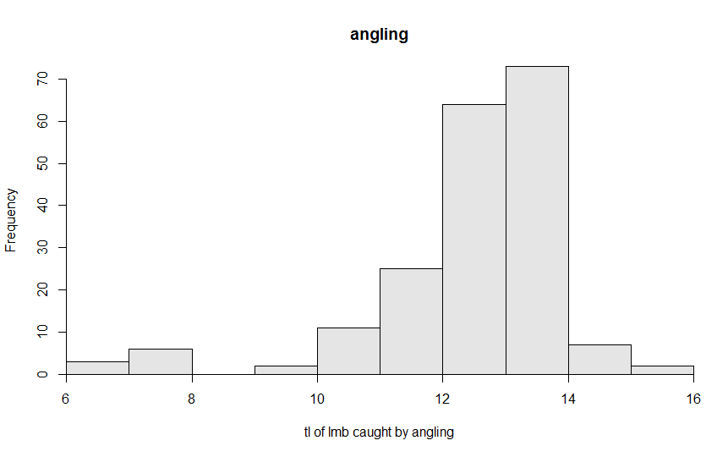

1. univariate EDA for the lengths of Bluntnose Minnows

The shape of the total length of Bluntnose Minnows is relatively symmetrical with no real outliers (figure 2). The middle is it at 2.100 which is the median (Table 2). The dispersion goes from 1.600(Q1) to 2.300(Q3). I used the IQR due to the split of the two groups.

Table 2

n mean sd min Q1 median Q3 max

5468.000 2.006 0.502 0.800 1.600 2.100 2.300 3.700

Figure 2

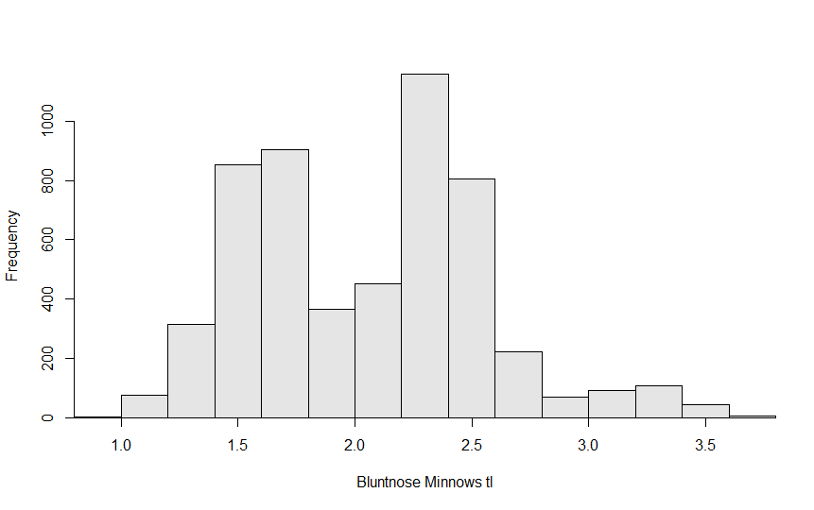

1. Univariate EDA for the frequency of fish (all fish, not separated by species) caught with each type of gear.

These tables show that Bluntnose Minnows were the most commonly fish seined, Bluegill was the most commonly fish caught in fyke nets and Largemouth Bass were the most commonly fish caught by angling(Frequency Table). Angling made up the lowest percentage of fish caught, seining was in the middle and fyke had the highest percentage caught (Perc Table).

Frequency table

netType

species angling fyke seine

Black Crappie 4 62 0

Bluegill 76 2674 117

Bluntnose Minnow 0 1730 3738

Central Mudminnow 0 1 2

Iowa Darter 0 65 152

Largemouth Bass 193 61 6

Pumpkinseed 1 4 1

Tadpole Madtom 0 0 4

Yellow Perch 0 70 0

Perc table

netType

species angling fyke seine Sum

Black Crappie 0.0 0.7 0.0 0.7

Bluegill 0.8 29.8 1.3 31.9

Bluntnose Minnow 0.0 19.3 41.7 61.0

Central Mudminnow 0.0 0.0 0.0 0.0

Iowa Darter 0.0 0.7 1.7 2.4

Largemouth Bass 2.2 0.7 0.1 3.0

Pumpkinseed 0.0 0.0 0.0 0.0

Tadpole Madtom 0.0 0.0 0.0 0.0

Yellow Perch 0.0 0.8 0.0 0.8

Sum 3.0 52.0 44.8 99.8

Inch biological

1. bivariate EDA for the weights and lengths of all Bluegill captured

The relationship between weights and lengths of Bluegills captured is nonlinear but has no outliers with a positive association (figure 3). This scatter plot has a strong correlation at 0.9385799.

Figure 3

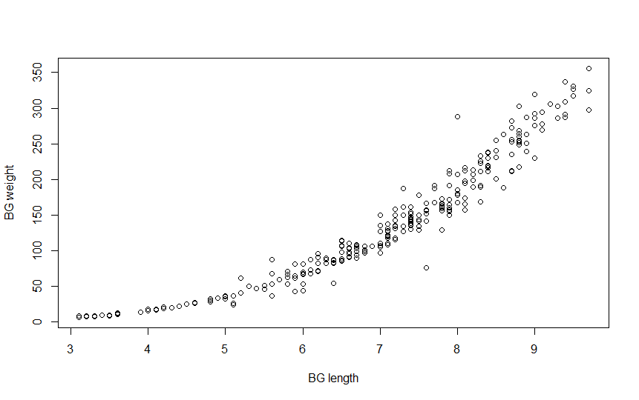

1. A) Percentage of lmb caught via angling=30.8% B) Percentage of Blue Gill caught in fyke nets= 37.1% C) Percentage of Iowa Darter caught in fyke nets=0.7 D) Percentage of Bluntnose minnows captured in seines=41.7.
2. A) The type of variable the number of lamprey caught in a trap is quantitative discrete. B) The type of variability that describes the fact that you are unlikely to catch the same amount of lamprey in the two different traps is sampling variability. C) The percentage of traps that will have more than 100 lamprey is 9.121%. D) The catch of lamprey that such that 30% of traps catch fewer lamprey is 72.134. E) 67.376 is the most common 80% of lamprey catches. F) The percentage of traps catch between 50 and 120 is 97.34195%.
3. A) The response variable is the time it takes to estimate the age a rock bass from its otolith. B) The factors being controlled are way otolith is counted (microscope or computer screen) and who is viewing the otoliths. C) The levels are two of how they are counted and three of who is counting them. D) In this experiment there are six treatments. E) There would 20 replicates in this experiment. F) I would look at 40 otoliths total which would mean I would look at 1-20 though a microscope and 20-40 on the computer.

R code

library(NCStats)

setwd("~/R stuff")

df<-read.csv("Inch17_lengths.csv")

str(df)

headtail(df)

lmb<-filterD(df,species=="Largemouth Bass",tl,netType=="angling")

str(lmb)

Summarize(tl~netType,data=lmb,digits=3)

hist(tl~netType,data=lmb,xlab="tl of lmb caught by angling")

#bluntnose minn

bnm<-filterD(df, species=="Bluntnose Minnow",tl)

str(bnm)

Summarize(~tl,data=bnm,digits=3)

hist(~tl,data=bnm,xlab="Bluntnose Minnows tl")

#allfish

allfish<-filterD(df)

(freq1<-xtabs(~species+netType,data=allfish))

percTable(freq1,digits=1)

barplot(freq1,xlab="fish species caught by each gear type",ylab="number of fish caught")

Summarize(tl~species,data=allfish,digits = 3)

#bg

library(NCStats)

setwd("~/R stuff")

df<-read.csv("Inch17_Biological.csv")

bg<-filterD(df,species=="Bluegill",w,tl)

corr(~w+tl,data=bg)

plot(w~tl,data=bg,ylab="BG weight",xlab="BG length")

#allfish2

(freq2<-xtabs(~species+netType,data=df))

percTable(freq2,digits=1)

#lamprey

library(NCStats)

distrib(100,mean=80,sd=15,lower.tail = FALSE)

distrib(.30,mean=80,sd=15,type = "q")

distrib(.80, mean=80,sd=15,type="q",lower.tail=FALSE)

A<-distrib(120,mean=80,sd=15)

B<-distrib(50,mean=80,sd=15)

(A-B)*100