***Answer each question below on separate sheets of paper. Make sure to clearly label each of your answers (e.g., #1 or #4a), put your name on each extra sheet used, and staple these questions to the top of your answer sheets when completed to hand in.***

1. **[4 pts]** A recent Quinnipiac University poll asked a sample of 899 voters “How concerned are you about climate change?” The percentage responses are shown in Table 1. Perform a proper EDA from these results.

**Table 1.** Percentage of respondents by answer to the climate change concern question.

Very Somewhat Not so Not Concerned

Concerned Concerned Concerned at all

45.2% 29.3% 14.4% 13.1%

1. **[22 pts]** A company produces packages of grape tomatoes that are advertised as weighing 16 ounces. If a package weighs less than 15.8 ounces or more than 16.5 ounces it is rejected for sale. Suppose that it is known that the distribution of package weights prior to possible rejection is normal with a mean of 16.1 ounces and a standard deviation of 0.3 ounces. Use this information to answer the questions below. *Please write the R code that you used along with your final numerical answer (to one decimal place).*
2. What percentage of packages are rejected for being too heavy?
3. What percentage of packages are acceptable for sale?
4. What should the weight limit be changed to so that only 5% of packages would be rejected for being too heavy?
5. What is the IQR for weight of packages?
6. What is the median weight of packages?

**library(NCStats)**

**distrib(val,mean=meanval,sd=sdval,lower.tail=FALSE,type=”q”)**

where

* **val** is a value of the quant. variable or area (i.e., percentage as a proportion)
* **meanval** is population mean ()
* **sdval** is standard deviation () or error (SE)
* **lower.tail=FALSE** is included for “right-of” calculations
* **type=”q”** is included for reverse calculations

1. **[16 pts]** Researchers observed groups of dolphins off the coast of Iceland in 1998. The researchers recorded the time of the day (Morning, Noon, Afternoon, and Evening) and the main activity of the group (travelling, feeding, or socializing). The number of dolphin groups observed by each time of day and activity is shown in Table 2. Use these results to answer the questions below the table *to one decimal place and show your work*.

Table 2. Frequency of dolphin groups by time of day and type of activity.

|  |  |  |  |
| --- | --- | --- | --- |
|  | **Type of Activity** | | |
| **Time of Day** | **Traveling** | **Feeding** | **Socializing** |
| **Morning** | 6 | 28 | 38 |
| **Noon** | 6 | 4 | 5 |
| **Afternoon** | 14 | 0 | 9 |
| **Evening** | 13 | 56 | 10 |

1. What percentage of the dolphin groups observed in the evening were feeding?
2. What percentage of the socializing dolphin groups were observed in the morning?
3. What percentage of all dolphin groups were feeding in the morning?
4. What percentage of all dolphin groups were observed in the evening?
5. **[10 pts]** Krochmal and Sparks (2007; J. Mammal.) examined the relationship between forearm length and age of 38 Northern Myotis Bats (*Myotis septentrionalis*) captured in Vermillion County, IN. Their results are shown in Figure 1. Use these results to construct a complete bivariate EDA.

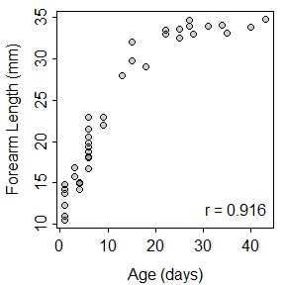

Figure 1. Scatterplot for Northern Myotis Bat forearm length on age.

1. **[10 pts]** Poysa (2003; Behav. Ecol. Sociobio.) examined the effect of predation risk on the number of eggs laid by Goldeneye ducks (*Bucephala clangula*). Specifically she identified groups of nests that were near each other and then measured relative predation risk (a metric that ranges from 0 to 100, with 100 representing the highest predation risk) and mean number of eggs laid for each group of nests. Use her results in Figure 2 to construct a complete bivariate EDA.

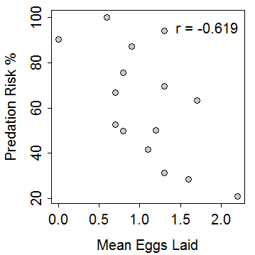

Figure 2. Scatterplot of predation risk on mean number of eggs laid for Goldeneye ducks.

1. **[4 pts]** What are the two major goals of regression?
2. **[4 pts]** Define RSS and explain how it is used to find the “best-fit line.”

**[Over for One More Page]**

1. **[30 pts]** Male Magnificent Frigatebirds (*Fregata magnificens*) display an enlarged red throat pouch to attract females. However, females may not always be able to see the size of the pouch. Madsen *et al.* (2004) hypothesized that females may judge the size of the pouch from the frequency of the drumming sound produced by the pouch. To determine if pouch size could be predicted from the drumming frequency, Madsen *et al.* recorded the pouch size and frequency of the drumming sound for 18 males (Figure 3). Use this information to answer the questions below. *Show your work as necessary*.

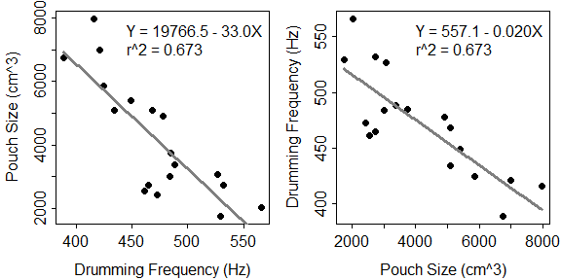

Figure 3. Fitted line plot for pouch size on drumming frequency (Left) and drumming frequency on pouch size (Right).

1. In terms of the variables of this problem, interpret the value of the slope? [*use a complete sentence*]
2. In terms of the variables of this problem, interpret the value of the intercept? [*use a complete sentence*]
3. How much would one expect the pouch size to change if drumming frequency increased by 100 Hz?
4. What is the predicted pouch size if the drumming frequency is 200 Hz?
5. What is the predicted pouch size if the drumming frequency is 500 Hz?
6. What is the residual if the pouch size is 4000 cm3 and the drumming frequency is 450 Hz?
7. What percentage of the variability in pouch size is explained by drumming frequency?
8. What is the correlation coefficient between pouch size and drumming frequency?
9. Do you have concerns about this regression? [*thoroughly explain your answer, whether you have any concerns or not.*]