Willy Wonka

Simple question labels, single spaced document, “serious” font, and complete sentences.

Proper titling.

Module 10 Homework

**Section: Definitions**

**1.** The number of points scored in a basketball game by a single player is a discrete quantitative variable.

**2.** The fact that a player does not score the same number of points in each basketball game is an example of natural variability.

Proper reference to a figure.

**Section: Exploratory Data Analysis**

**1.** The distribution of points scored per game by Steph Curry in the 2015-16 NBA season was approximately symmetric with a potential outlier of five or fewer points (Figure 1). The distribution is centered on a mean of 30.1 points with a standard deviation of 9.8 points (Table 1). I chose to use the mean and standard deviation because the distribution was not strongly skewed and the outlier was not extreme.

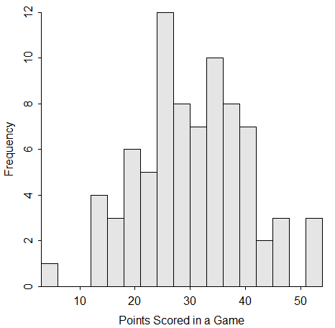

Proper reference to a table.

Fully descriptive figure label below the figure.

Fully descriptive table label above the table.

Figure 1. Histogram of points scored by Steph Curry in 79 games of the 2015-16 NBA season.

Table 1. Summary statistics of points scored by Steph Curry in 79 games of the 2015-16 NBA season.

n mean sd min Q1 median Q3 max

79.0 30.1 9.8 5.0 24.0 30.0 37.0 53.0

Used courier font for tabular R output so that labels line-up. Modified document margin so that tabular results did NOT wrap.

**R Appendix**

library(NCStats)

Included an appendix of good R commands.

SC <- read.csv(“StephCurry16.csv”)

Summarize(~PTS,data=SC,digits=1)

hist(~PTS,data=SC,xlab="Points Scored in a Game",ylim=c(0,12),w=3)

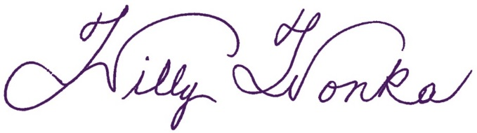I have neither given nor received unauthorized aid in completing this work, nor have I presented someone else's work as my own.

Included the "honesty pledge" with my signature.