Polich *et al.* (2013) examined the effects of tail-clipping on survivorship and growth of larval California Tiger Salamanders (*Ambystoma californiense*). In one part of their study, randomly selected larval salamanders were designated for one of four treatment groups which were defined by how much of the salamander’s tail was clipped: “Control”, “Small”, “Medium”, and “Large” were 0.0-, 2.5-, 5.0-, and 10.0-mm tail clips, respectively. The larvae were then released into experimental simulated vernal pools where they were fed *ad libitum* for two weeks. At the end of two weeks, the total length (snout to the end of the tail; mm) was measured and recorded. Their goal for this particular portion of the study was to compare *all pairs* of tail-clips to determine if the amount of tail-clip had a significant impact on the resultant total length. These data were entered into R and analyzed as provided at the end of the quiz handout. Answer the questions below **with the fullest amount of detail that you can provide – be specific and refer to results where appropriate** (you may want to label figures and tables on the output).

1. **[8 pts]** FULLY assess ALL assumptions appropriate to this analysis, **on the original scale only**.

*Answers to b-d should refer to either the original or transformed results. Questions b-d will refer to “total length” but this may be interpreted as “transformed total length” if you choose to use the transformed scale. Either way, you should be very precise with your language.*

1. **[3 pts]** What specific conclusion about salamander “total length” and tail-clip treatment can be made from the results in the ANOVA table?
2. **[3 pts]** What is the difference in **sample** mean “total length” between the “Control” and “Medium” tail-clip treatments? Be sure to explicitly state which treatment had a longer “total length.”
3. **[3 pts]** Interpret the first (when read from the top) confidence interval in the appropriate multiple comparison results that corresponds to a significant difference. Be sure to explicitly state which treatment had a longer total length. Back-transform to the original scale if appropriate.
4. **[6 pts]** On the schematic below, manually construct a means plot (i.e., a fitPlot() but without confidence intervals) from the provided results. Include letters by each mean that show which treatments were statistically different. Make sure to fully label the axes.



1. **[2 pts]** Briefly summarize the findings of this portion of the author’s study (i.e., what is the “take-home message” from these results).

**Results for Salamander Questions**

> library(NCStats)

> library(multcomp)

> d <- read.csv("salamanders.csv")

> d$Treatment <- factor(d$Treatment,levels=c("Control","Small","Medium","Large"))

> lm1 <- lm(TL~Treatment,data=d)

> transChooser(lm1)

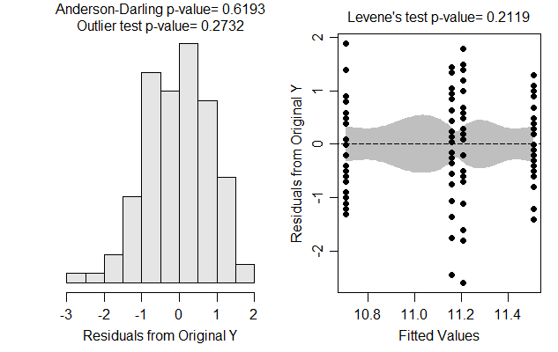

> anova(lm1)

Response: TL

Df Sum Sq Mean Sq F value Pr(>F)

Treatment 3 9.348 3.1161 3.953 0.01017

Residuals 109 85.924 0.7883

> summary(lm1)

Estimate Std. Error t value Pr(>|t|)

(Intercept) 11.5071 0.1678 68.581 < 2e-16

TreatmentSmall -0.3500 0.2373 -1.475 0.143100

TreatmentMedium -0.3000 0.2373 -1.264 0.208829

TreatmentLarge -0.8002 0.2352 -3.402 0.000937

Residual standard error: 0.8879 on 109 degrees of freedom

Multiple R-squared: 0.09812, Adjusted R-squared: 0.0733

F-statistic: 3.953 on 3 and 109 DF, p-value: 0.01017

> mc1a <- glht(lm1,mcp(Treatment="Dunnett"))

> summary(mc1a)

Estimate Std. Error t value Pr(>|t|)

Small - Control == 0 -0.3500 0.2373 -1.475 0.32318

Medium - Control == 0 -0.3000 0.2373 -1.264 0.44633

Large - Control == 0 -0.8002 0.2352 -3.402 0.00275

> confint(mc1a)

Estimate lwr upr

Small - Control == 0 -0.3500 -0.9150 0.2150

Medium - Control == 0 -0.3000 -0.8650 0.2650

Large - Control == 0 -0.8002 -1.3603 -0.2402

> mc1b <- glht(lm1,mcp(Treatment="Tukey"))

> summary(mc1b)

Estimate Std. Error t value Pr(>|t|)

Small - Control == 0 -0.3500 0.2373 -1.475 0.45606

Medium - Control == 0 -0.3000 0.2373 -1.264 0.58753

Large - Control == 0 -0.8003 0.2352 -3.402 0.00505

Medium - Small == 0 0.0500 0.2373 0.211 0.99667

Large - Small == 0 -0.4502 0.2352 -1.914 0.22826

Large - Medium == 0 -0.5002 0.2352 -2.127 0.15115

> confint(mc1b)

Estimate lwr upr

Small - Control == 0 -0.3500 -0.9687 0.2687

Medium - Control == 0 -0.3000 -0.9187 0.3187

Large - Control == 0 -0.8002 -1.4136 -0.1869

Medium - Small == 0 0.0500 -0.5687 0.6687

Large - Small == 0 -0.4502 -1.0636 0.1631

Large - Medium == 0 -0.5002 -1.1136 0.1131

> ##############################################################################

> d$logTL <- log(d$TL)

> lm2 <- lm(logTL~Treatment,data=d)

> transChooser(lm2)

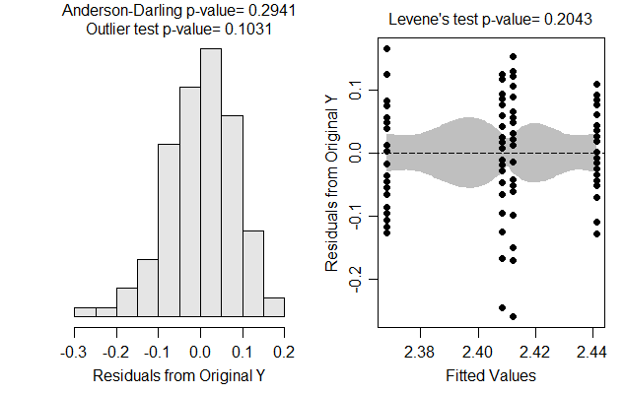

> anova(lm2)

Response: logTL

Df Sum Sq Mean Sq F value Pr(>F)

Treatment 3 0.0773 0.0257661 3.8867 0.01106

Residuals 109 0.7226 0.0066294

> summary(lm2)

Estimate Std. Error t value Pr(>|t|)

(Intercept) 2.44122 0.01539 158.653 < 2e-16

TreatmentSmall -0.03279 0.02176 -1.507 0.134694

TreatmentMedium -0.02916 0.02176 -1.340 0.182996

TreatmentLarge -0.07306 0.02157 -3.387 0.000985

Residual standard error: 0.08142 on 109 degrees of freedom

Multiple R-squared: 0.09663, Adjusted R-squared: 0.07177

F-statistic: 3.887 on 3 and 109 DF, p-value: 0.01106

> mc2a <- glht(lm2,mcp(Treatment="Dunnett"))

> summary(mc2a)

Estimate Std. Error t value Pr(>|t|)

Small - Control == 0 -0.03279 0.02176 -1.507 0.30645

Medium - Control == 0 -0.02916 0.02176 -1.340 0.39954

Large - Control == 0 -0.07306 0.02157 -3.387 0.00285

> confint(mc2a)

Estimate lwr upr

Small - Control == 0 -0.03279 -0.08461 0.01902

Medium - Control == 0 -0.02916 -0.08098 0.02266

Large - Control == 0 -0.07306 -0.12443 -0.02169

> mc2b <- glht(lm2,mcp(Treatment="Tukey"))

> summary(mc2b)

Estimate Std. Error t value Pr(>|t|)

Small - Control == 0 -0.032794 0.021761 -1.507 0.4368

Medium - Control == 0 -0.029162 0.021761 -1.340 0.5396

Large - Control == 0 -0.073056 0.021572 -3.387 0.0051

Medium - Small == 0 0.003632 0.021761 0.167 0.9983

Large - Small == 0 -0.040262 0.021572 -1.866 0.2487

Large - Medium == 0 -0.043894 0.021572 -2.035 0.1818

> confint(mc2b)

Estimate lwr upr

Small - Control == 0 -0.032794 -0.089568 0.023980

Medium - Control == 0 -0.029162 -0.085935 0.027612

Large - Control == 0 -0.073056 -0.129338 -0.016774

Medium - Small == 0 0.003632 -0.053141 0.060406

Large - Small == 0 -0.040262 -0.096544 0.016020

Large - Medium == 0 -0.043894 -0.100176 0.012388