Biometry Quiz #2 R Handout Results #1

Data on the catch-per-unit-effort (CPE; number of fish per net per hour) of yellow perch (*Perca flavescens*) captured with gill nets in a Midwestern lake were obtained during midday at five depths during two months with three randomly selected sites sampled at each depth during each month. The data are loaded, manipulated, and analyzed below.

**> library(NCStats)**

**> library(multcomp)**

**> setwd("C:/aaaWork/Class Materials/MTH207/Year_Specific/W13/Assessments")**

**> d75 <- read.table("box7_5.txt",header=TRUE)**

**> d75$Month <- factor(d75$Month,levels=c("Jun","Aug"))**

**> d75$Depth <- factor(d75$Depth)**

**> d75$comb <- d75$Month:d75$Depth**

**> str(d75)**

'data.frame': 30 obs. of 4 variables:

$ Month: Factor w/ 2 levels "Jun","Aug": 1 1 1 1 1 1 1 1 1 1 ...

$ Depth: Factor w/ 5 levels "2.5","5","10",..: 1 1 1 2 2 2 3 3 3 4 ...

$ CPE : int 2 4 7 6 10 12 8 12 33 10 ...

$ comb : Factor w/ 10 levels "Jun:2.5","Jun:5",..: 1 1 1 2 2 2 3 3 ...

**> lm1 <- lm(CPE~Month*Depth,data=d75)**

**> transChooser(lm1)**

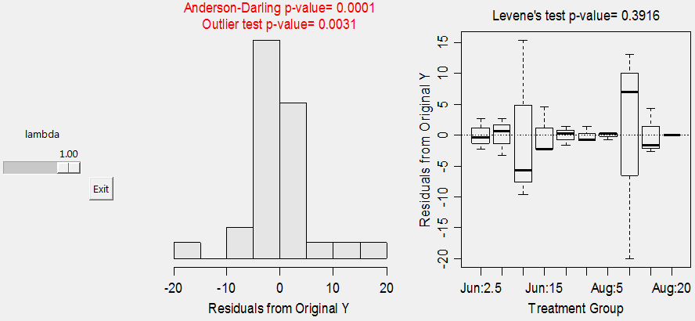

**> anova(lm1)**

Df Sum Sq Mean Sq F value Pr(>F)

Month 1 9.6 9.63 0.1785 0.6772

Depth 4 2249.8 562.45 10.4222 9.954e-05 ***

Month:Depth 4 400.2 100.05 1.8539 0.1582

Residuals 20 1079.3 53.97

Total 29 3739.0

**> mc1a <- glht(lm1,mcp(Month="Tukey"))**

**> confint(mc1a)**

Estimate lwr upr

Aug - Jun == 0 -3.6667 -16.1786 8.8453

**> mc1b <- glht(lm1,mcp(Depth="Tukey"))**

**> confint(mc1b)**

Estimate lwr upr

5 - 2.5 == 0 5.0000 -12.9484 22.9484

10 - 2.5 == 0 13.3333 -4.6151 31.2818

15 - 2.5 == 0 8.0000 -9.9484 25.9484

20 - 2.5 == 0 -2.6667 -20.6151 15.2818

10 - 5 == 0 8.3333 -9.6151 26.2818

15 - 5 == 0 3.0000 -14.9484 20.9484

20 - 5 == 0 -7.6667 -25.6151 10.2818

15 - 10 == 0 -5.3333 -23.2818 12.6151

20 - 10 == 0 -16.0000 -33.9484 1.9484

20 - 15 == 0 -10.6667 -28.6151 7.2818

**> lm2 <- lm(CPE~comb,data=d75)**

**> mc2 <- glht(lm1a,mcp(comb="Tukey"))**

**> glhtSig(mc2)**

[1] "Aug:10 - Aug:2.5" "Aug:10 - Aug:5" "Aug:15 - Aug:10"

[4] "Aug:20 - Aug:10" "Jun:2.5 - Aug:10" "Jun:5 - Aug:10" "Jun:20 - Aug:10"

**> fitPlot(lm1,which="Month",ylim=c(0,45),main="") # below left**

**> fitPlot(lm1,which="Depth",ylim=c(0,45),main="") # below center**

**> fitPlot(lm1,change.order=TRUE,ylim=c(-20,80),main="") # below right**

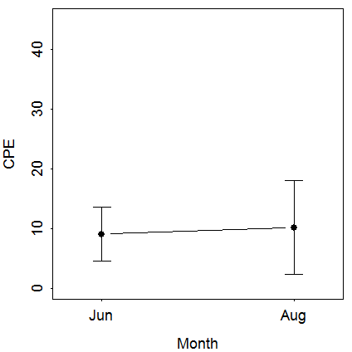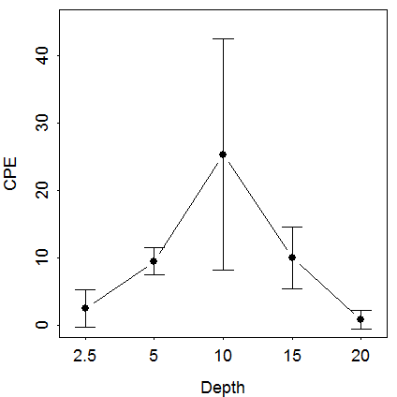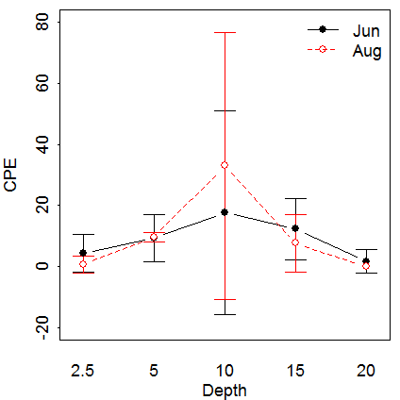

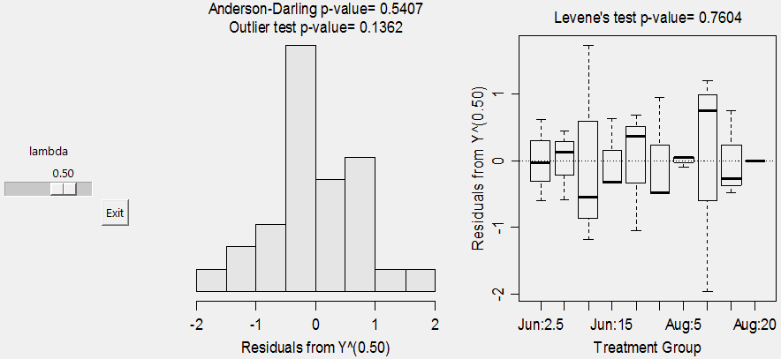

**> d75$tCPE <- d75$CPE^(0.5)**

**> lm3 <- lm(tCPE~Month*Depth,data=d75)**

**> anova(lm3)**

Df Sum Sq Mean Sq F value Pr(>F)

Month 1 0.890 0.8896 1.0828 0.31048

Depth 4 68.388 17.0970 20.8113 6.743e-07 ***

Month:Depth 4 8.891 2.2228 2.7056 0.05969 .

Residuals 20 16.430 0.8215

Total 29 94.599

**> mc3a <- glht(lm3,mcp(Month="Tukey"))**

**> confint(mc3a)**

Estimate lwr upr

Aug - Jun == 0 -1.548584 -3.092313 -0.004854

**> mc3b <- glht(lm3,mcp(Depth="Tukey"))**

**> confint(mc3b)**

Estimate lwr upr

5 - 2.5 == 0 1.0053 -1.2092 3.2198

10 - 2.5 == 0 1.9924 -0.2222 4.2069

15 - 2.5 == 0 1.4626 -0.7520 3.6771

20 - 2.5 == 0 -0.9712 -3.1858 1.2433

10 - 5 == 0 0.9871 -1.2275 3.2016

15 - 5 == 0 0.4573 -1.7573 2.6718

20 - 5 == 0 -1.9765 -4.1911 0.2380

15 - 10 == 0 -0.5298 -2.7444 1.6847

20 - 10 == 0 -2.9636 -5.1782 -0.7491

20 - 15 == 0 -2.4338 -4.6483 -0.2193

**> lm4 <- lm(CPE~comb,data=d75)**

**> mc4 <- glht(lm4,mcp(comb="Tukey"))**

**> glhtSig(mc4)**

[1] "Aug:10 - Jun:2.5" "Aug:10 - Jun:5" "Aug:10 - Jun:20"

[4] "Aug:10 - Aug:2.5" "Aug:10 - Aug:5" "Aug:15 - Aug:10" "Aug:20 - Aug:10"

**> fitPlot(lm3,which="Month",ylim=c(0,7),main="") # below left**

**> fitPlot(lm3,which="Depth",ylim=c(0,7),main="") # below center**

**> fitPlot(lm3,change.order=TRUE,ylim=c(-2,10),main="") # below right**

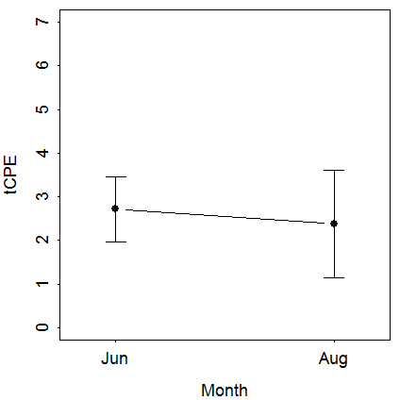 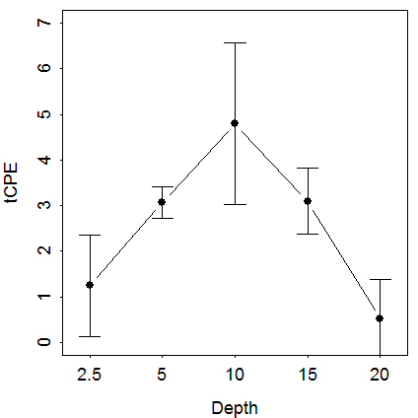 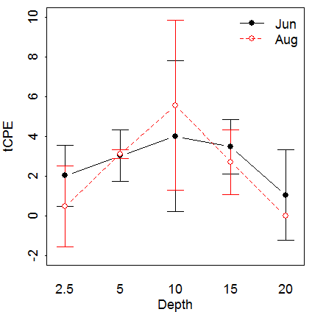

Biometry Quiz #2 R Handout Results #2

Wabnitz and Pauly (2008) examined the relationship between body weight (wt; kg) and straight carapace length (scl; cm) of populations of Kemp’s Ridley sea turtles (*Lepidochelys kempi*) from Florida and Chesapeake Bay. Specifically, Wabnitz and Pauly were hoping to develop a model where they could predict the weight of an individual turtle from the straight carapace length measurement. The data were entered, manipulated, and analyzed below.

**> kr <- read.table("KempsRidley.txt",header=TRUE)**

**> str(kr)**

'data.frame': 110 obs. of 3 variables:

$ scl: num 19.2 21.4 24.5 25.3 25.9 27.2 26.9 27.9 28.8 30.5 ...

$ wt : num 1.04 1.11 1.26 1.41 2.89 3.04 5.04 2.52 2.89 2.44 ...

$ loc: Factor w/ 2 levels "Chesapeake","Florida": 1 1 1 1 1 1 1 1 1 1 ...

**> lm5 <- lm(wt~scl,data=kr)**

**> transChooser(lm5)**

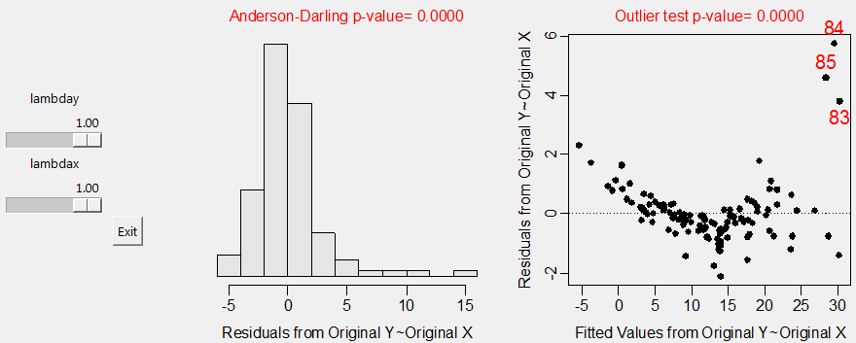

**> summary(lm5)**

Coefficients:

Estimate Std. Error t value Pr(>|t|)

(Intercept) -19.58204 1.18038 -16.59 <2e-16 ***

scl 0.74445 0.02682 27.76 <2e-16 ***

---

Residual standard error: 2.886 on 108 degrees of freedom

Multiple R-squared: 0.8771, Adjusted R-squared: 0.8759

F-statistic: 770.7 on 1 and 108 DF, p-value: < 2.2e-16

**> confint(lm5)**

2.5 % 97.5 %

(Intercept) -21.9217588 -17.2423176

scl 0.6912915 0.7976006

**> predict(lm5,data.frame(scl=40),interval="prediction")**

fit lwr upr

1 10.1958 4.447414 15.94419

**> predict(lm5,data.frame(scl=40),interval="confidence")**

fit lwr upr

1 10.1958 9.630369 10.76124

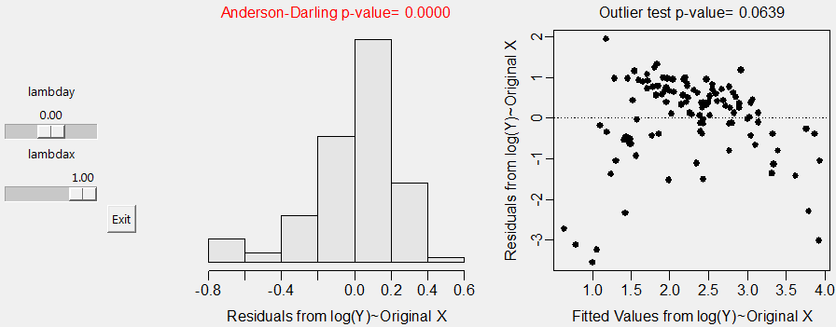

**> kr$logwt <- log(kr$wt)**

**> lm6 <- lm(logwt~scl,data=kr)**

**> summary(lm6)**

Coefficients:

Estimate Std. Error t value Pr(>|t|)

(Intercept) -0.684290 0.096026 -7.126 1.22e-10 ***

scl 0.069041 0.002182 31.648 < 2e-16 ***

---

Residual standard error: 0.2348 on 108 degrees of freedom

Multiple R-squared: 0.9027, Adjusted R-squared: 0.9018

F-statistic: 1002 on 1 and 108 DF, p-value: < 2.2e-16

**> confint(lm6)**

2.5 % 97.5 %

(Intercept) -0.87462914 -0.49394989

scl 0.06471697 0.07336537

**> predict(lm6,data.frame(scl=40),interval="prediction")**

fit lwr upr

1 2.077357 1.609718 2.544997

**> predict(lm6,data.frame(scl=40),interval="confidence")**

fit lwr upr

1 2.077357 2.031358 2.123356

**(OVER)**

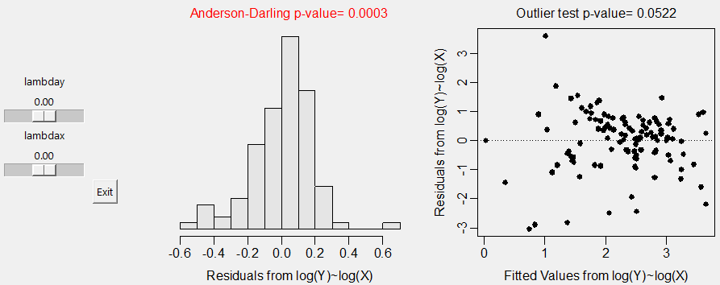

**> kr$logscl <- log(kr$scl)**

**> lm7 <- lm(logwt~logscl,data=kr)**

**> summary(lm7)**

Coefficients:

Estimate Std. Error t value Pr(>|t|)

(Intercept) -8.50562 0.25517 -33.33 <2e-16 ***

logscl 2.89192 0.06832 42.33 <2e-16 ***

---

Residual standard error: 0.1794 on 108 degrees of freedom

Multiple R-squared: 0.9431, Adjusted R-squared: 0.9426

F-statistic: 1792 on 1 and 108 DF, p-value: < 2.2e-16

**> confint(lm7)**

2.5 % 97.5 %

(Intercept) -9.011413 -7.999835

logscl 2.756495 3.027342

**> predict(lm7,data.frame(logscl=log(40)),interval="prediction")**

fit lwr upr

1 2.162315 1.805003 2.519626

**> predict(lm7,data.frame(logscl=log(40)),interval="confidence")**

fit lwr upr

1 2.162315 2.128024 2.196606