Fishing Regulation Proposal Form A – Special Regulation
Proposed Regulation
Increase minimum size limit for walleye to 18 inches, with daily bag limit of 3 per day.
Current Regulation
Statewide default – 15 inch minimum length limit; 5 daily bag
Author  Al Niebur |  | Date  9/10/13
Location Information
Affected water(s)
Shawano Lake, Washington Lake, Shawano Lake Outlet Channel, Wolf River Pond, Wolf River to Balsam Row Dam
County(ies)  Shawano | WBIC(s)  322800, 323700, 322600, 322500, 241300
Upstream/downstream boundaries, if applicable – Law Enforcement should be consulted
Downstream boundary would be confluence of Shawano Lake Outlet Channel.
Description of the Water and Fishery

Provide a brief description of the water(s)

Shawano Lake is a 6063 acre drainage lake with an outlet that drains to the Wolf River. Several small tributaries drain to the lake including a short inlet from Washington Lake. Shawano Lake contains moderate density gamefish populations including largemouth bass, walleye, northern pike, and muskellunge. Panfish populations are in high abundance comprised primarily of bluegill, black crappie, yellow perch, and pumpkinseed. Other forage species include spot tail shiners, lake chubsuckers, white sucker, and bluntnose minnows. Aquatic invasive species include zebra mussels, Eurasian watermilfoil (EWM), and Curly-leaf pondweed (CLP). The Shawano Area Waterway Association has attempted to manage the invasive plants with little to no success. The City of Shawano borders the west side of lake and the Village of Cecil on the east side and the lake is within an hour of the Fox Valley metropolitan area. Several boat launches are located around the entire lake and connected waterbodies. Shawano Lake receives extraordinarily high amounts of fishing pressure.

What is the stocking history over the past 20 years? What are the current stocking plans for the future? (automatic report available in Fisheries Database)

Shawano Lake is biennially stocked with large fingerling muskellunge at a rate of 0.5 muskellunge per acre. After comprehensive fish surveys confirmed walleye recruitment concerns in 2010 a large fingerling walleye stocking was initiated in 2011 with a recommended stocking rate of 10 walleyes per acre on a biennial frequency. Due to the large size of Shawano Lake and production limitations only a small plant of 10,000 fish was possible in the first year (2011). In 2013, Shawano Lake received 20,000 large fingerling walleye. In addition, Walleyes for Tomorrow began operation of a portable hatchery in 2012 with a goal of stocking 3 million walleye fry per year over the next 5-6 years pending evaluations. In 2012 and 2013, WFT stocked 1.8 million fry and 0.5 million fry, respectively.

Have there been any significant management actions (e.g. habitat work, chemical reclamation, etc.) or major anthropogenic disturbances (e.g. water quality changes, invasives, water level manipulations etc.) on the water in the past 20 years?

Aquatic invasive species have had a significant effect on Shawano Lake habitat, water quality and fish community. In the early 1990s, EWM and CLP became established in Shawano Lake and have now reached extreme nuisance levels. The latest comprehensive plant survey conducted in 2005, showed approximately 2640 acres of EWM and 1640 acres of CLP. More recently, zebra mussels have become established which has resulted in increased water clarity and subsequent increases in aquatic macrophytes – especially invasive species. Changes in water clarity and habitat are believed to be contributing factors to decreased walleye recruitment.

How often was the waterbody surveyed in the past 20 years and what type of surveys were conducted? (automatic report available in Fisheries Database)

Shawano Lake has been annually surveyed with fall electrofishing to evaluate walleye recruitment since 1991. Comprehensive surveys have been conducted in 1998, 2002, 2006, and 2010. In addition, Shawano Lake is currently classified as a high profile fishery and is surveyed on a 4 year rotation according to statewide lake assessment sampling protocols.

Management Goal
Summary statement that characterizes the desired fishery (for example, provide a naturally reproducing harvest-oriented walleye fishery; provide a high density bass fishery that maximizes predation on smaller fishes)

The management goal is to provide a walleye population of moderate density with a moderate proportion of quality size fish.

Justification
Current Problem
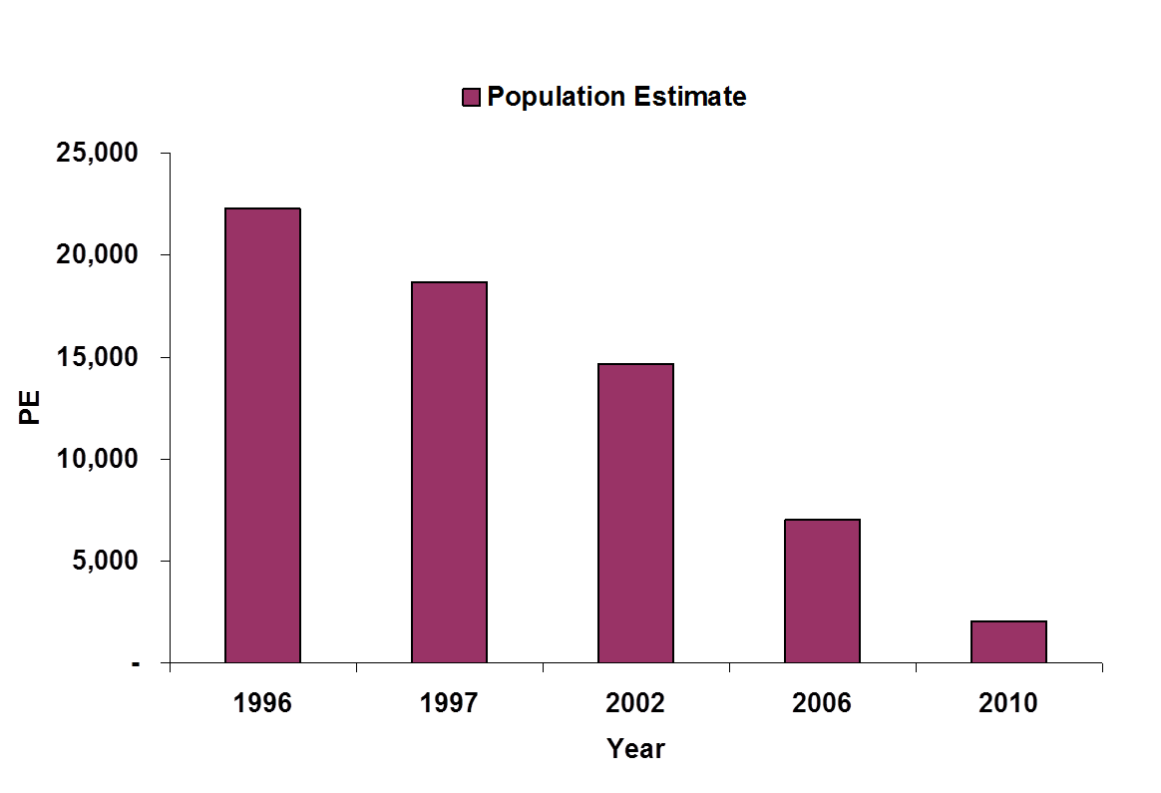
How is the management goal not being met with the current regulation? Provide available information to demonstrate the problem.
Figure 2: Trends in walleye population density from mark and recapture surveys in Shawano Lake..

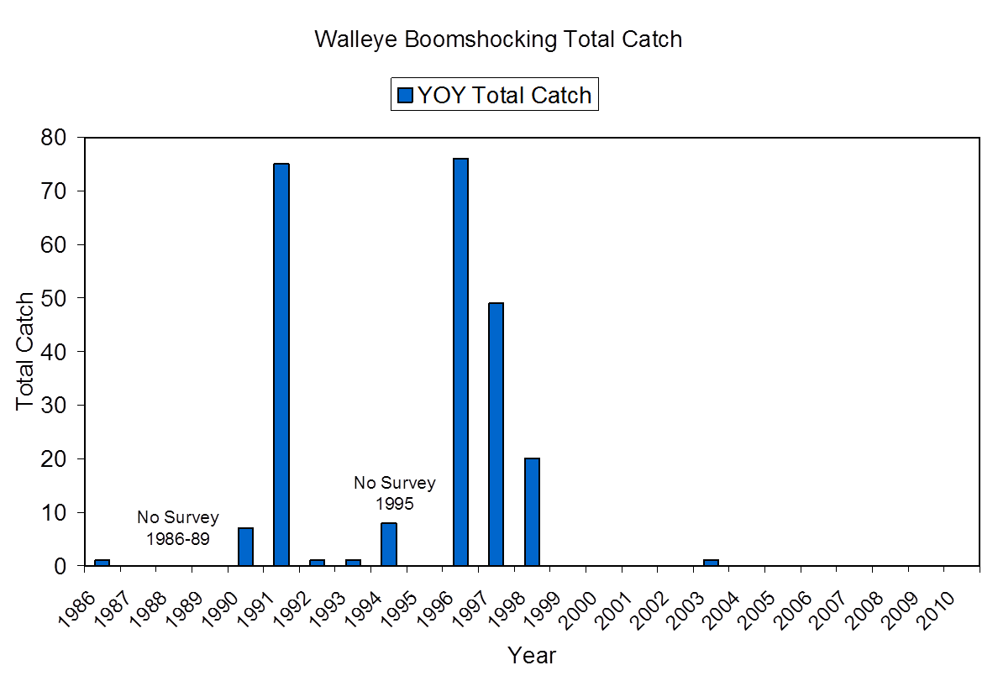
The Shawano Lake walleye population is characterized by poor recruitment and would likely benefit from the increased protection of an 18-inch minimum length limit. Annual fall electrofishing walleye recruitment surveys conducted on Shawano Lake indicate little to no recruitment since 1998 (Figure 1). In addition, mark and recapture surveys conducted over the past 20 years indicate a steady decline in abundance with the latest PE at 0.35/acre (Figure 2). Most of the adult walleye population in Shawano Lake now consists of larger and older aged fish. We suspect that dramatic changes in habitat and water clarity and subsequent shifts in fish community (i.e. increased centrarchid populations and higher predation on walleye young of year) to be contributing factors in decreased walleye recruitment.
Figure 1: Total catch of young of year walleye from fall electrofishing recruitment index stations on Shawano Lake.

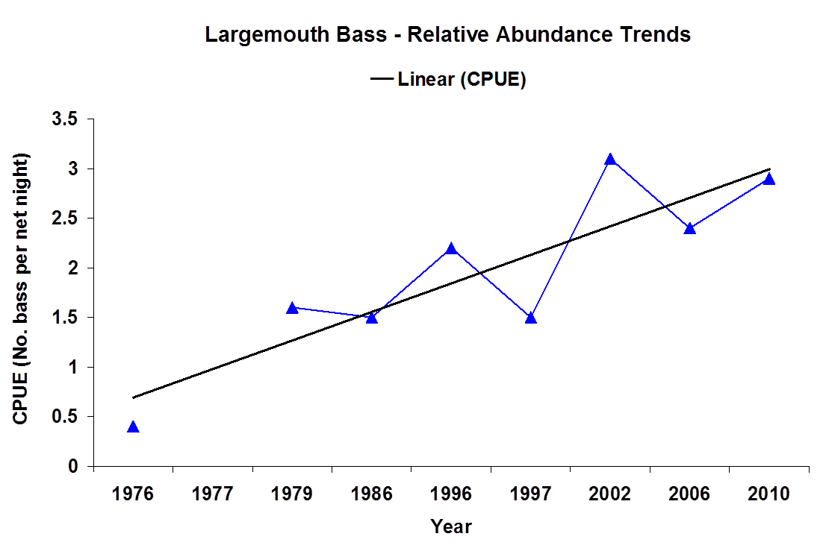
Some studies indicate that high bass populations are associated with decreased walleye abundance. Although we do not have adequate electrofishing trend data to assess largemouth bass abundance trends there is some evidence that bass populations have increased based on early spring fyke net catch over the past 20-30 years (Figure 3). The last spring electrofishing survey conducted in 2010 showed largemouth bass size structure indices for PSD12, RSD14 and RSD18 at 72%, 28%, and 10%, respectively. These size structure metrics, especially for legal and memorable size fish are well above the statewide median. Catch rates were at 20/mile – again slightly above the statewide median. Age estimation indicates fast growth with bass attaining legal size by 5 years. At this time we are not proposing changes to largemouth bass regulations since it appears that largemouth bass density, size structure, and growth are all at acceptable levels. In addition, largemouth bass are important predators for managing panfish populations (especially bluegill) and Shawano Lake has very high densities of panfish. Management of quality bluegill populations has been identified as an important goal by Shawano Lake anglers and maintaining adequate predator density will be important objective. However, if we notice further increases in bass abundance and declines in growth or size structure we may recommend removal of minimum length limit.

In an effort to increase adult walleye density and improve recruitment other management efforts are also being proposed that would complement this regulation. Stocking of large fingerling walleye has been initiated by WDNR and fry stocking by Walleyes for Tomorrow. Walleyes for Tomorrow is also working towards improving spawning areas for walleye by augmenting rock substrate along known walleye spawning areas.

Basis for Special Regulation
Is the proposed regulation in the toolbox? Use survey data or provide context for a similar water or group of waters (e.g. lake type, spatial proximity) to demonstrate how the proposed regulation will help meet the management goal. Demonstrate expected results of the regulation using tools such as modeling, comparisons to other waters, peer-reviewed literature, etc.

This proposal is part of the regulation toolbox for walleye management. This regulation has been routinely applied to many waters across the state to improve walleye recruitment and population density. This proposal is mainly intended for Shawano Lake and Washington Lake. The other waterbodies have been added since they are easily accessible from Shawano Lake and our local conservation warden identified the potential differing regulations as an issue for law enforcement.

Management Objectives of the Proposed Regulation
Objectives are used to evaluate the effectiveness of your action and determine if you have achieved your goal. Provide a management objective that is measurable and has a temporal component (e.g. increase walleye recruitment to 10/mile at least 3 out of 5 years and increase walleye PE from current 1.5/acre to 3 – 4/acre within 7 years; reduce largemouth bass relative abundance to less than 10/mile and increase RSD14 to 25).

Increase walleye recruitment to 10/mile at least 2 out of 5 years and increase adult walleye PE from current 0.3/acre to 2-3 acre within 10 years.

Evaluation
When and how will the above objectives be measured and evaluated? What is the sampling schedule for this water including frequency and planned protocols?

Shawano Lake is surveyed annually with a fall electrofishing survey to evaluate walleye recruitment. In addition, Shawano Lake is classified as a high profile lake and is surveyed on a 4 year rotation with all the assessment protocols (i.e. SNI, SNII, SNIII, SEI, SEII, FE). The last survey was conducted in 2010-11 and the next surveys are scheduled for 2014-15.

Will the proposed regulation affect Ceded Territory water? Yes __ No _X_

If the water is usually declared and speared for tribal harvest, what is the typical bag limit adjustment for sport harvest regulations?

Are there any anticipated impacts to tribal fisheries?

Are tournaments held on this water? Yes _X_ No __
If yes, please briefly describe frequency and type of tournaments.
Shawano lake annually hosts 8-12 bass tournaments, 1-2 musky tournaments, and 2-3 ice fishing derbies.
Other factors When developing this proposal, did you consider:
Fish contaminant/consumption advice? Yes _X_
How the regulations would affect males and females differently? Yes _X_
Predator – prey interactions? Yes _X_
Habitat availability? Yes _X_
Effects of hooking mortality? Yes _X_
Attraction of additional angling pressure, if applicable? Yes _X_
Alteration of nutrient cycling, if applicable? Yes __

Proposal Instigation
Was this regulation change initially a Conservation Congress advisory question, requested by a lake association or another public group, or is it based on biological survey and other data you collected? Please describe.

This proposal is based off biological survey data and also a recommendation of the Shawano Lake Fisheries Management Citizen Advisory Committee.

Public Participation
Was input solicited from stakeholders when developing the proposed regulation change? Include any contacts made with local Conservation Congress representatives, lake associations, angler groups, etc.

Input was solicited via stakeholder meetings, angler perception surveys, local fishing clubs (i.e. Walleyes for Tomorrow, Figure 8 Musky Club, and local bass clubs), and Shawano Lake Fisheries Management Citizen Advisory Committee (consortium of representatives from local fishing clubs, lake association, local Conservation Congress delegates, and other interested citizens).

Draft Question
This will be the question in the spring hearing questionnaire. Please use terms understandable to the general public using the following format.
This proposal would apply: (insert proposed regulation) a daily bag limit of 3 fish and increase minimum size limit to 18 inches for walleye in Shawano Lake, Shawano County.

The management goal is: to improve adult walleye abundance and recruitment. It is currently not being met because: walleye recruitment has declined dramatically and adult abundance is at very low levels.

This regulation proposal is one tool to help meet the management goal because: decreased harvest of adult walleyes is expected to improve abundance and potential for increased recruitment.

Do you favor applying (proposed reg) to Shawano Lake, Shawano county?

Example question:
This proposal would apply a daily bag limit of 3 fish and increase the minimum size limit to 18 inches for walleye in Shawano Lake, Shawano County. The current regulation is a 15-inch minimum length limit and daily bag limit of 5 fish. More restrictive regulations on walleyes were supported at local stakeholder meetings and from angler survey responses.

The management goal is to improve walleye adult abundance and recruitment. The objective is to increase adult walleye populations density from the current 0.3/acre to 2-3/acre and increase recruitment (young of year index) to 10/mile within 10 years. This regulation is one tool to help meet the management goal because decreased harvest of adult walleye is expected to improve abundance and potential for increased recruitment.

Do you favor increasing the current 15 inch minimum length limit for walleye with an 18 inch minimum length limit, and reducing the daily bag limit for walleye from 5 to 3 fish in Shawano Lake, Shawano county?

Regulation Proposal Checklist

Fish Team Supervisor

Reviewer Kendall K. Kamke | Date Nov. 27, 2013
Are adequate data presented to justify the regulation change? Yes X No

Is there adequate documentation that the proposed regulation will achieve the desired stated outcome?
Yes X No

Are the management objectives clear and complete? Yes X No

Reviewer Comments: (Is there additional information you want the author to provide before approving the proposal?)

Recommended Action: Approve X Reject

District Fish Supervisor
Reviewer | Date
Is the proposal necessary? -enforceable? -complete? Yes No

Does the proposal meet the district’s goal for providing varied fishing opportunities? Yes No

Is the proposed regulation easy for anglers to comply with and understand? Yes No

Reviewer Comments: (Is there additional information you want the author to provide before approving the proposal?)

Recommended Action: Approve Reject

Species Team
Reviewers | Date
Are adequate data presented to justify the regulation change? Yes No

Does the proposal fit with statewide species management goals? Yes No

Does the proposal meet regional and statewide goals for varied fishing opportunities? Yes No

Are the management objectives clear and complete? Yes No

Reviewer Comments: (Is there additional information you want the author to provide before approving the proposal?)

Recommended Action: Approve Reject

Law Enforcement Comments:
Please provide comments on enforceability of the reg proposal and other issues you think the Fisheries Management Board should consider.

