Age and Growth of the Pygmy Whitefish, *Prosopium coulterii*, in Lake Superior

Taylor R. Stewarta, Derek H. Oglea, Mark R. Vinsonb

aNorthland College, Ashland, WI 54806, USA

bU.S. Geological Survey, Great Lakes Science Center, Lake Superior Biological Station, Ashland, WI 54806, USA

E-mail address: [trstewart@usgs.gov](mailto:trstewart@usgs.gov)

Phone Number: (920) 268-5459

**Abstract**

In 1952, Pygmy Whitefish (*Prosopium coulterii*) were discovered in Lake Superior, which was at least 1770 km from all previous records of occurrence. A comprehensive life history study was published in 1953, but no further life-history studies of Lake Superior Pygmy Whitefish have occurred since. In 2013, we collected Pygmy Whitefish at 28 stations from throughout Lake Superior. The total length of all fish and the total length, weight, sex, and maturity were recorded, and scales and sagittal otoliths were collected, for a subsample of fish. Age assignments from scales and otolith thin-sections from fish collected in 2013 differed significantly (p<0.001), with otolith ages significantly greater after age-2. Maximum otolith age was 9 for females and 7 for males in 2013, compared to scale ages of 7 for females and 5 for males in 1953. Mean lengths of males and females in 2013 did differ at age-3, 5.5 and 8 (all p<0.001). Female Pygmy Whitefish live longer, grow to a longer maximum length, and are longer beginning at age-3 than males. Our results suggest that the growth dynamics of Pygmy Whitefish have not changed much in 60 years, and support the conclusion that Pygmy Whitefish live longer than previously thought, though longevity probably has not changed since 1953.

**Keywords**

Pygmy Whitefish, Prosopium coulterii, Lake Superior, Growth, Age

**Introduction**

The Pygmy Whitefish (*Prosopium coulterii*), is a small coregonine fish that may have the greatest discontinuous range of any freshwater fish in North America (Eschmeyer and Bailey 1955). First discovered in British Columbia in 1892 (Kendall 1917), Pygmy Whitefish are principally distributed in North America along the Pacific and Rocky Mountains from the Columbia River north to Alaska. West of the continental divide, populations of Pygmy Whitefish have been widely distributed in the Columbia River system in Montana, Idaho, and Washington State, Skeena and Frasier River systems, in British Columbia, in the Bristol Bay and Alaska Peninsula region, and in the upper Yukon River system (Teslin River) (Scott and Crossman 1973). Since then, isolated populations of Pygmy Whitefish have been found east of the continental divide in northern Canadian lakes (Lake Athabasca, Great Bear Lake, Waterton Lake, and Elliot Lake), along with lakes in the Liard and Peace river systems (Scott and Crossman 1973; Witt et al. 2011; Lindsey 1972). A single population has been discovered in Ekityki Lake on the Chukotski Peninsula in northeastern Russia (Chereshnev and Skopets 1992). Most recently, populations have been discovered in Bluefish Lake on the Yellowknife River and Winnange Lake in northwestern Ontario (Vecsei and Panayi 2014; Blanchfield et al. 2014). Pygmy Whitefish were first documented in Lake Superior in 1952 and is the most easterly area of this disjunt North American distribution (Eschmeyer and Bailey 1955; Dryer 1966). The ultimate distributional range of Pygmy Whitefish may not be known because they are difficult to sample due to their small size and preference for deep, cold waters. Eschmeyer and Bailey (1955) did conclude that the disjunct populations known at that time were the same species and likely represented relicts of a continuously distributed species from the late Pleistocene that survived in deep lakes after the retreat of the Wisconsin glaciation.

Little is known about the life history and population dynamics of Pygmy Whitefish. However, Eschmeyer and Bailey (1955) conducted a comprehensive life history study of Pygmy Whitefish following their discovery in Lake Superior. According to Eschmeyer and Bailey (1955), Pygmy Whitefish adults are variable in length, have a sub-terminal mouth, are toothless, and have a broadly rounded snout. Gillrakers are short to moderate in length. Color is a pale tan, immaculate below and dusted lightly with melanophores on the lateral and dorsal surfaces of the head and body. The back is marked by an irregular series of about 12 to 14 dark spots (Eschmeyer and Bailey 1955). They are characterized by slow growth and small size at maturity (McCart 1963; Page 2011). The sizes attained by Pygmy Whitefish in different geographic areas varied, most likely because of differences in growth rates related to different environments.

No further studies of Pygmy Whitefish in Lake Superior have occurred since the initial work by Eschmeyer and Bailey (1955). Thus, we have two objectives for this study. First, we will describe the age and growth metrics for Pygmy Whitefish collected throughout Lake Superior from 2013 and 1953. Second, we will compare ages assessed from scales and otoliths.

**Methods**

Pygmy Whitefish were collected at 28 stations throughout Lake Superior between May and July 2013 with either a #35 Yankee bottom trawl net or a roller trawl net (**Fig 1**). Both nets had an 11.9 m head rope, 15.5 m foot rope, and a 2.2 m wing height with stretch mesh sized of 89-mm at the mouth, 64-mm for the trammel, and 13-mm at the cod end. The trawl was towed across the lake bottom at approximately 3.5 km/h and mean distance towed was 1.77 (range: 0.64-3.25) km. Trawl tows were conducted cross contour, going from shallow to deep. Trawls had a mean beginning depth of 41.8 (range: 10.6-140.0) m and ending depth of 91.5 (range: 37.6-156.0) m. Water depth over the area trawled was recorded by a fathometer and station locations were determined by global positioning system coordinates. Average wingspread and door spread were measured using NetMind Trawl System™ sensors (Northstar Technical Inc., St. John's, Newfoundland), which were monitored live to ensure the net was fishing properly.

All captured Pygmy Whitefish were immediately measured for total length (TL; +1mm) before being placed on ice to preserve the integrity of the fish until the vessel was moored. Once the vessel was moored, two subsamples of fish were collected. Two subsamples were required because scales were not found on all fish due to damage done in the trawl. In the first subsample, to be used for comparing ages assessed from scales and otoliths, six fish of each sex per 10-mm length category were measured for TL, weighed (W; +0.1 g), sex was determined, and both scales and sagittal otoliths were removed. In the second subsample, to be used for all other analyses, six fish of each sex per 10-mm length category were measured for TL, weighed, had the sex and coarse state of maturity (immature, developing, or mature) determined from examination of the gonads, and sagittal otoliths were removed. Scales were removed from directly above the lateral line even with the posterior edge of the dorsal fin and were placed in a coin envelope to air dry. Otoliths were scraped clean and placed into vials to air dry.

Scales were removed from the envelopes, soaked in water, gently scraped clean, and then mounted between two slides. Annular increments were marked by two readers, who were blind to the length, weight, or sex of the fish at the time of reading, on the longest transect from the scale focus to the anterior edge of the scale (Beamish, 1987). The edge of the scale was considered to be an annulus as no new growth was observed and likely had not yet begun to form (McCart 1963). Thus, age was recorded as the number of observed.

Otoliths were mounted in clear epoxy and then were cross-sectioned along the dorsoventral plane through the nucleus with a Buehler IsoMet Low Speed™ saw (Brown et al. 2004). Sections were cut at a thickness of 24 microns. Sectioned otoliths were lightly polished using 2000 grit sandpaper to remove saw markings. Sectioned otoliths were placed in mineral oil and viewed under a Nikon SMZ745T stereo microscope (5x magnification) with a black background and finely concentrated fiber optic light.

All ages were assessed by two readers. If the initial age assessment from the two readers disagreed then the readers discussed their interpretations. If the readers could agree on an age, then that age was used in all further analyses with the exception of the age assessment bias and precision calculations. If the readers could not agree on an age then that fish was discarded from all further use. Between reader age determination bias and variability calculations were followed according to Kimura and Lyons (Kimura and Lyons 1991). Assessments were conducted off of digital images captured using a Nikon DS-Fi2 camera. Date of capture was determined in order to declare the edge as an annulus.

Age-bias was assessed with 63 paired otolith and scale ages. The age-bias calculated the mean, with a 95% confidence interval, between the two age structures. A 1:1 age agreement line was superimposed to show statistical differences in aging structures. Plots were fitted using R statistical environment v3.0.2 (R Development Core Team 2013).

Due to the fact that the fish in this study were subsampled, an otolith age-length key (ALK) was applied to the population. The key was used to assign ages to individuals that were not directly aged from an aging structure. Biotic comparisons between groups for the ALK were based on hierarchical fitting of two models in total: (i) a multinomial regression model with separate parameter estimates for each sex (male and female), (ii) a multinomial regression model with parameter estimates for the overall population, excluding sex as a factor. After fitting of the individual models, a chi-square test was calculated to test for differences among models, with no preference given (p>0.05). Because no significant difference was found between ALK models, we chose to apply the ALK model with parameter estimates for the whole population, excluding sex as a factor. Pygmy Whitefish with an unknown sex were randomly assigned where 50% of unknown fish are called Male and 50% are called Female. To eliminate sampling variability from the age-length key, a starting point was fixed at a random 8-digit seed.

Growth metrics were estimated with the Francis parameterizations of the Von Bertalanffy growth model (VBGM) (von Bertalanffy 1938; Francis 1988). Biotic comparisons among groups for the VBGM were fitted, with 95% confidence bands, separately for males and females. All growth summaries were completed based on ages that were assigned from otoliths. Age-2 fish were excluded from any growth analysis because of the evenly distributed, randomly assigned unknown sex fish given to both male and female groups. Statistical models were fitted to the length-at-age data for each sex using R statistical environment v3.0.2 (R Development Core Team 2013).

**Results**

Age bias comparisons between readers were calculated for both scale and otolith age determination. We conducted an age bias assessment on scale and otolith ages along with a growth comparison on mean lengths between males and females using the minimum, mean, and maximum common ages. A length frequency analysis showed the length-at-age and any outstanding age classes. Finally, a sex ratio was determined to show the proportion of sexes in the population.

Scale and otolith age comparisons between readers were determined on 77 scale and 90 otolith ages (**Fig 2**). The coefficient of variation (CV), average error percent (AEP), and absolute differences in ages were used to calculate precision between readers (**Table 1**).

Both structures had similar precision through age-2. Beyond that age, scale and otolith ages differed significantly (p<0.001), with otolith ages significantly greater after age-2 (**Fig 3**). Maximum otolith age was 9 for females and 8 for males in 2013, compared to scale ages of 7 for females and 5 for males in 1953. Mean lengths of males and females in 2013 did differ at age-3, 5.5 and 8 (p<0.001; **Fig 4**).

Length frequency analysis was important in determining the length-at-age of Pygmy Whitefish. The length frequency distribution is based off of all Pygmy Whitefish collected in Lake Superior by the Lake Superior Biological Station from 1998-2013. The total length of 2013 Pygmy Whitefish in Lake Superior ranged from 55 to 150 mm. The age-2 year class stood out alone and very distinct with all fish being less than 75 mm (**Fig 5**). Based off of this result, all Pygmy Whitefish with a length less than 75-mm were assigned to the age-2 year class. The following year classes showed a tremendous amount of overlap, most likely due to slow growth rates and sexual dimorphism. Age-1 Pygmy Whitefish are not represented in the catch data.

Analysis of the sex ratio proved that females are the prominent sex in Lake Superior Pygmy Whitefish with 61.86% (120 females to 74 males) of the catch being female. When the sex ratio was analyzed by age class, it demonstrated the consistent trend of males being scarce and or missing entirely from older age classes (**Table 2**).

**Discussion**

In many species of fish, sexual dimorphism in growth rates, size and longevity is evident, with females growing faster, attaining a larger size and having a longer lifespan than their male counterparts. This has been particularly proven in Pygmy Whitefish across North America (Eschmeyer and Bailey 1955; Heard and Hartman 1965; Mackay 2000; McCart 1963; Weisel and Dillon 1954; Zemlak and McPhail 2006). The difference between sexes is thought to be due to differences in the way males and females channel surplus energy into growth and reproduction. This appears to be prevalent in Lake Superior Pygmy Whitefish.

Otolith age determination proved to be difficult due to slow growth and seasonal bands causing significant noise and false annulus. Crowded annuli on older Pygmy Whitefish collected from Lake Superior were difficult to distinguish on scales, but more recognizable on otoliths. Similarly, annuli that were crowded near the edges of scales for slow-growing Pygmy Whitefish in Lake Superior were easier to recognize when otoliths were sectioned. Scale and otolith age comparisons proved that scales are a viable, non-lethal aging structure for the first 2 years of life; after which otolith ages are significantly greater. Because growth may be reduced as a result of sex differences and maturation, it is necessary to carry out age validation in the future over the entire range of ages. Error in aging may result in an accumulation of estimates in the aging structures at the age in which the aging technique fails. Such may have been the case in 1953, when scales were used as the only aging structure. Since Pygmy Whitefish show slow growth rates, finding areas of concentrated circuli proved to be challenging. Because of this, thin-sectioned otoliths should be used as the primary aging structure for this species. This present study is a first look at aging Pygmy Whitefish sagittal otoliths and age comparison between scales and otoliths. However, it is still possible to underage due to a slow growth rate, which can produce annuli that might be misinterpreted as checks or are not visible at all.

Lake Superior Pygmy Whitefish live longer than previously thought by Eschmeyer and Bailey (1955), but longevity probably has not significantly changed since 1953. Female Pygmy Whitefish live longer, grow to a longer maximum length, and are longer beginning at age-3 than males. The information gathered in this study helped close a 60 year gap in the biology and life history traits of Pygmy Whitefish in Lake Superior. Without age validation, it is difficult to place complete confidence in age assignments. Thus, we are hesitant to draw too many conclusions from this summary and further age structure analysis should be conducted.

**Acknowledgments**

We appreciate the field collection support from Lori Evrard, Charles Carrier, Keith Peterson, and Joe Walters onboard the R/V Kiyi (United States Geological Survey). Dalton Lebeda for conducting a second reading on scale ages (Northland College). Hanna Fiorio for assisting in otolith sample preparation (Northland College). A special thanks to Scott Sapper (Wisconsin Department of Natural Resources) and Glenn Miller (U.S. Fish and Wildlife Service) for providing guidance and clarification in developing protocol for otolith age determination.

**References**

Beamish RJ, MacFarlane GA (1987) Current Trends in Age Determination Methodology. In: Summerfelt RC, Hall GE (ed) Age and Growth of Fish. Iowa State University Press, Iowa, pp 15–42

Blanchfield PJ, Taylor EB, Watkinson DA (2014) Morphological and Genetic Analyses Identify a New Record of a Glacial Relict: Pygmy Whitefish (Prosopium coulterii) from Northwestern Ontario. Canadian Journal of Zoology 92:267–271

Brown P, Green C, Sivakumaran KP, Stoessel D, Giles A (2004) Validating Otolith Annuli for Annual Age Determination of Common Carp. Transactions of the American Fisheries Society 133:190–196

Chereshnev IA, Skopets MB (1992) A New Record of Pygmy Whitefish, *Prosopium coulteri*, from Amguem River Basin (Chukotski Peninsula). Journal of Ichthyology 32(4):46-55

Dryer WR (1966) Bathymetric Distribution of Fish in the Apostle Islands Region, Lake Superior. Transactions of the American Fisheries Society 95:248-259

Eschmeyer PH, Bailey RM (1955) The Pygmy Whitefish, *Coregonus coulteri*, in Lake Superior. Transaction of the American Fisheries Society 84:161-199

Francis RICC (1988) Are Growth Parameters Estimated from Tagging and Age-Length Data Comparable? Canadian Journal of Fisheries and Aquatic Sciences 45:936-942

Heard WR, Hartman WL (1965) Pygmy Whitefish, *Prosopium coulteri*, in the Naknek River system of Southwest Alaska. Fishery Bulletin, U.S. Fish and Wildlife Service 65:555-57

Kendall WC (1917) A Second Record for the Coulter’s Whitefish (*Coregonnus coulteri* Eigenmann). Copeia 45:54-56

Kimura DK, Lyons JJ (1991) Between Reader Bias and Variability in Age-Determination Process. Fishery Bulletin, National Oceanic and Atmospheric Administration 89:53-60

Lindsey CC, Franzin WG (1972) New Complexities in Zoogeography and Taxonomy of the Pygmy Whitefish (Prosopium coulteri). Fisheries Research Board of Canada 29(12): 1772–1775

Mackay WC (2000) Status of the Pygmy Whitefish (*Prosopium coulteri*) in Alberta. Alberta Environment, Fisheries and Wildlife Management Division, and Alberta Conservation Association, pp 16

McCart PJ (1963) Growth and morphometry of the Pygmy Whitefish (*Prosopium coulteri*) in British Columbia. Dissertation, University of British Columbia

Page LM, Burr BM (2011) Field Guide to Freshwater Fishes of North America North of Mexico. Houghton Mifflin Harcourt Publishing Company, New York

R Development Core Team (2014) R: a language and environment for statistical computing. R Foundation for Statistical Computing. http://R-project.org

Scott WB, Crossman EJ (1973) Freshwater Fishes of Canada. Gordon Soules Book Publishers Ltd, Vancouver

von Bertalanffy L (1938) A Quantitative Theory of Organic Growth. Human Biology 10(2):181-213

Weisel GF, Dillon JB (1954) Observations on the Pygmy Whitefish, *Prosopium coulteri*, from Bull Lake, Montana. Copeia 2:124-127

Witt JDS, Zemlak RJ, Taylor EB (2011) Phylogeography and the Origins of Range Disjunctions in a North Temperate Fish, the Pygmy Whitefish (*Prosopium coulterii*), Inferred from Mitochondrial and Nuclear DNA Sequence Analysis. Journal of Biogeography 38:1557–1569

Zemlak RJ, McPhail JD (2006) The Biology of Pygmy Whitefish, *Prosopium coulterii*, in a Closed Sub-Boreal Lake: Spatial Distribution and Diel Movements. Environment of Biological Fisheries 76:317-327

**Figures and Tables**

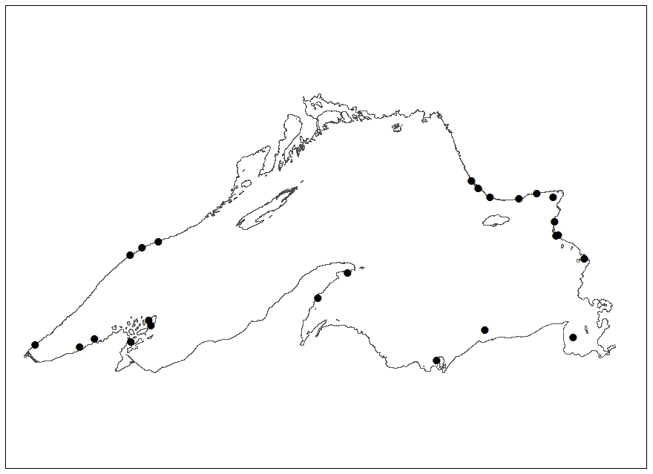

**Fig 1** Collection localities of Lake Superior Pygmy Whitefish in 2013.

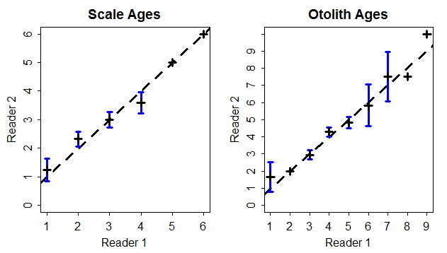

**Fig 2** Age-bias plot for scale and otolith ages between readers of Pygmy Whitefish. The diagonal line is the age-agreement line.

**Table 1** Precision summary statistics between readers for each aging structure.

|  |  |  |  |  |  |  |  |
| --- | --- | --- | --- | --- | --- | --- | --- |
| Structure | n | CV | APE | Percent of Absolute Difference in Ages | | | |
| 0 | 1 | 2 | 3 |
| Scale | 77 | 9.2 | 6.5 | 68.8 | 27.3 | 3.9 | N/A |
| Otolith | 90 | 8.7 | 6.2 | 58.9 | 35.6 | 3.3 | 2.2 |

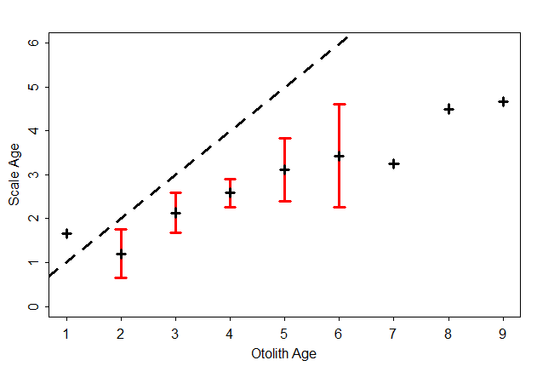

**Fig 3** Age-bias plot for otolith and scale ages of Pygmy Whitefish. The diagonal line is the age-agreement line.

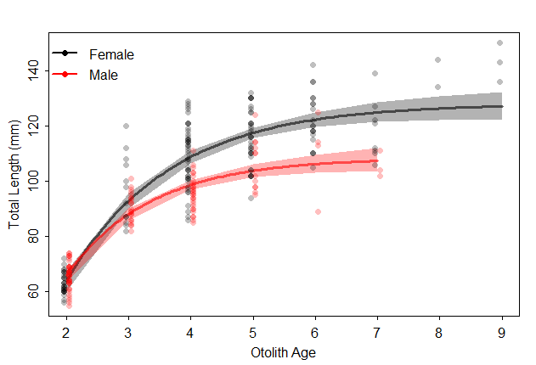

**Fig 4** Von Bertalanffy Growth Model fits (with 95% confidence bands) for male and female Pygmy Whitefish.

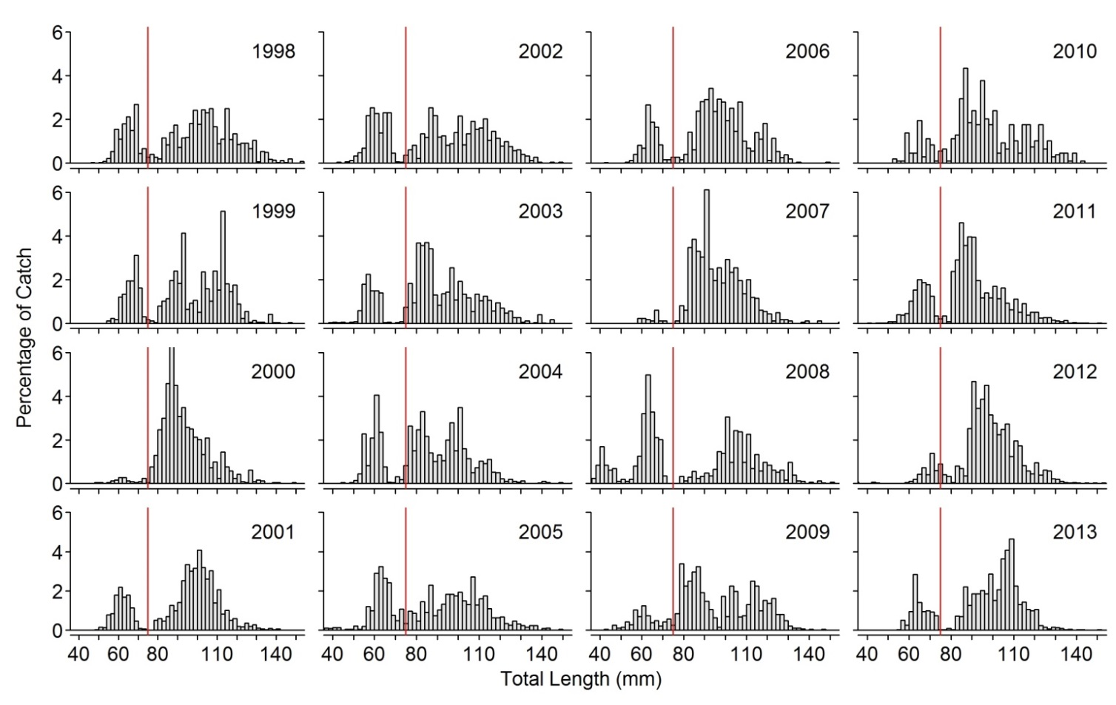

**Fig 5** Length frequency distribution of Lake Superior Pygmy Whitefish by year from 1998-2013 with an arbitrary line superimposed at 75-mm.

**Table 2** Proportional table displaying the sex ratio of 2013 Lake Superior Pygmy Whitefish by age class.

|  |  |  |  |  |  |  |  |  |
| --- | --- | --- | --- | --- | --- | --- | --- | --- |
| Age | 2 | 3 | 4 | 5 | 6 | 7 | 8 | 9 |
| Female | 0.016 | 0.136 | 0.384 | 0.248 | 0.128 | 0.040 | 0.016 | 0.032 |
| Male | 0.128 | 0.167 | 0.397 | 0.141 | 0.115 | 0.051 | 0.000 | 0.000 |