Data Entry & Exploration Exercise

- McInerny and Cross (2000) examined the effect of time of year, time of day, and density on CPE and the relationship between CPE and density for largemouth bass > 200 mm in 12 lakes in Minnesota. The day and night electrofishing CPE (+ 1 SE) and population density (with 95% CI) are shown for fall and spring samplings in the table below.

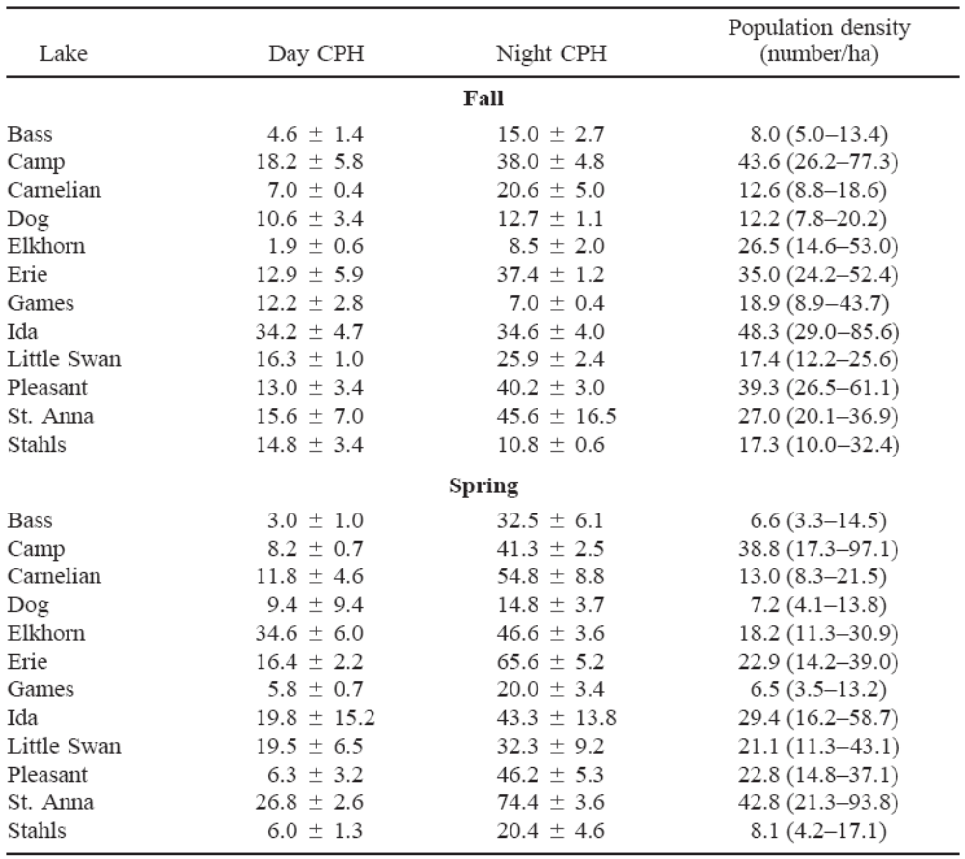

Enter the fall data (don’t include SE and CIs) into a table in Excel, load those data into R, and answer the following questions.

    - Construct a plot of night CPE versus day CPE. Comment.
    - Construct a plot of night CPE versus population density. Comment.
    - Identify and show the data (from you R data frame) that correspond to the four lakes that appear to diverge from the expected relationship between night CPE and population density. [Hint: use identify().]
    - Because they included other seasons, McInerny and Cross plotted the night CPE versus population density on a scale of 0 to 50 for density and 0 to 80 for night CPE. Modify your plot to use these scales. Does this affect your comments about this relationship?

