Catch Curve Exercise

- Total length measurements and age assignments for rock bass from Lake Ontario can be found in the RockbassLO1 data frame in the FSAdata package. More information on this data frame can be found by typing ?RockbassLO1. Load these data into an R object and estimate the instantaneous and total annual mortality rates, with associated 95% confidence interval. Show only enough results for your calculations to be verified. Interpret your findings.

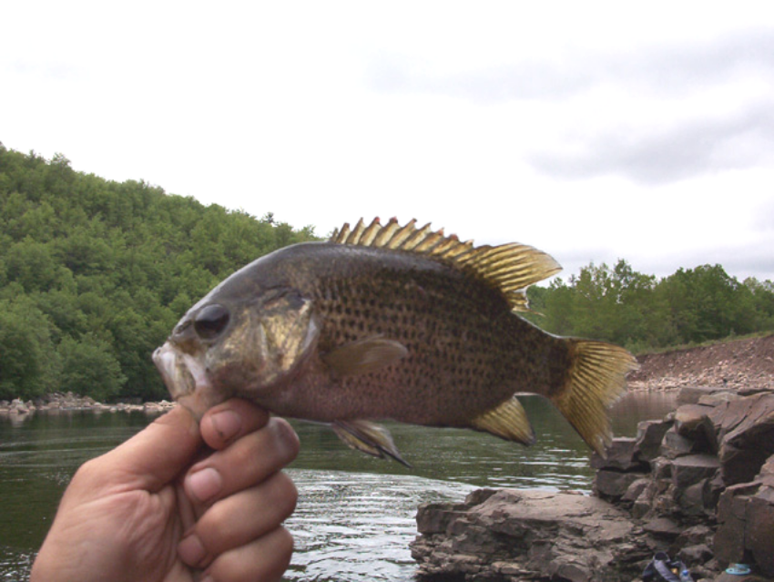

- The effect of violating the assumptions of catch curve models can be explored with cc.sim(). This function produces a graph of log(catch) versus age with three possible lines. A gray line represents what the ideal catch-curve model would look like given the default parameter values for the model (which can always be obtained by pressing the Reset button). A blue line represents the ideal catch-curve model given the current parameter choices but also assuming that no assumption has been violated. A red line represents the catch-curve model given the current parameter choices and including any choices for model assumption violations. Thus, a comparison of the blue line to the gray line allows the user to ascertain the effect of changing the underlying model parameters (e.g., N₀ (mean or CV), Z (mean or CV), or age of full recruitment) but not violating any assumptions. A comparison of the red line to the blue allows the user to ascertain the effect of violating an assumption (constant recruitment or constant instantaneous total mortality rate). It should be noted that the lines are plotted in this order -- gray, red, and blue -- such that some lines may not be seen if there is no difference between them (e.g., red hides gray and blue hides red and gray). The user can control the model parameters and parameters for modeling assumption violations through slider controls. The meaning of each slider control is described in the help function for cc.sim() obtained by typing ?cc.sim().

Use cc.sim() to explore answers to the following questions. It is suggested that you press the Reset and Re-Randomize buttons between each question to return to a base simulation and, thus, remove all altered parameter options.

- The default values of cc.sim()show an idealized catch curve model with no assumption violations. Describe what this model looks like.
- A catch curve model assumes a constant instantaneous total mortality rate for the descending portion of the catch curve. Simulate a 50% increase in mortality rate that is steady for all ages above age-5. Describe how the “shape” (i.e., “linear”, “bumpy”, “convex”, “concave”, “v-shaped”, or “offset”) of the descending limb portion of the catch curve model with this assumption violation (i.e., red line) differs from the idealized catch curve model with no assumption violations (i.e., blue line).
- (c) Repeat the previous question but assume that the increase in mortality rate is geometric (i.e., non-steady) for all ages above age-5.
- A cross-sectional catch curve model assumes a constant recruitment for all ages on the descending portion of the catch curve. Simulate a 50% increase in recruitment that is steady for all ages above age-5. Describe how the “shape” of the catch curve model with this assumption violation differs from the idealized catch curve model with no assumption violations.
- Repeat the previous question but assume that the increase in recruitment is geometric for all ages above age-5.
- Another way to simulate non-constant mortality rates and recruitment sizes is to introduce random variation into the model. Random variation can be introduced into the simulation model through the “Z CV” and “N0 CV” sliders. Describe the “shape” of the catch curve model when random variation is included.
- From the explorations above, offer plausible conclusions about potential assumption violations for each of the following descriptions of a catch-curve based on observed data.
  - The catch curve is “bumpy.”
  - The catch curve is “convex.”
  - The catch curve is “concave.”
  - The catch curve is “offset” (i.e., it looks linear over a range of young ages and then looks linear, but with a different intercept, over a range of older ages).
  - The catch curve is “v-shaped” (i.e., it is steeply linear over a range of young ages and then less steeply linear over a range of older ages).
  - The catch curve is “upside-down v-shaped” (i.e., it is relatively shallowly linear over a range of young ages and then more steeply linear over a range of older ages).
  - The catch curve is perfectly linear over the descending limb.
- Create a simulation using a 20% increase in mortality rate that is steady for all ages above age-5 and a 10% CV for mortality rate. Describe how easy it is to “see” the assumption violation in this situation. Comment on what lesson relative to assessing assumption violations from observed catch curves of real data is taught with this simulation.

