PSD Exercise

- The total length measurements for 91 Happles Lake rock bass can be found in the HLRockbass.xls data file on the class webpage. Read these data into an R object and compute the PSD value, with associated 95% confidence interval. Show only enough results for your calculations to be verified. Interpret your findings.

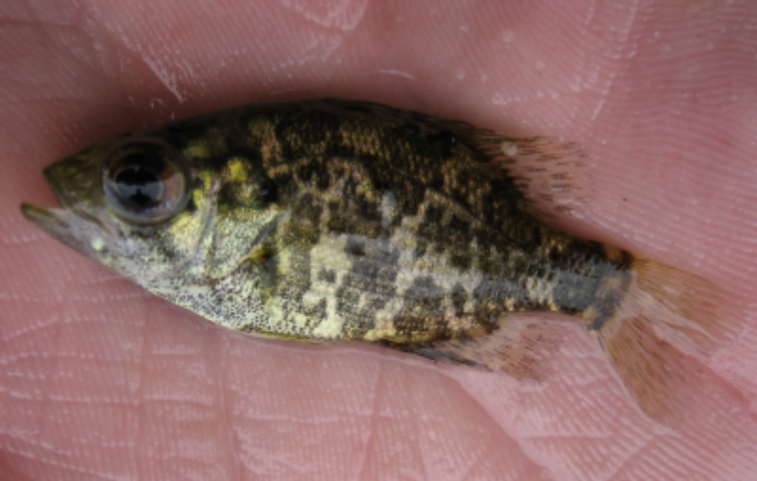

- The measured and expanded total length measurements for bluegill and largemouth bass captured in May, 2007 in Inch Lake can be found in the BluegillIL1 and LMBassIL1 data frames. Load these data and compute the PSD (with confidence interval) for both species, construct a tic-tac-toe graph for these species, and interpret your findings.

