RMarkdown Example

Derek H. Ogle

Tuesday, February 17, 2015

# Introduction

Brook trout are important. Isle Royale is a fun place to sample fish.

# Methods

We electrofished. Caught and aged fish. Used a catch curve analysis to estimate the instantaneous mortality rate.

# Results

A total of 494 brook trout were captured. The maximum catch of 126 fish occurred at age-2. The instantaneous mortality rate computed for ages 2 to 5 was 0.228 with a 95% confidence interval from 0.191 to 0.265.

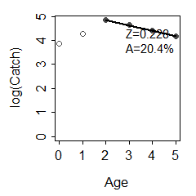

Log catch versus age for Tobin Harbor Brook Trout, with the ages used for estimating Z shown.

# Discussion

We did great work.