Experimental Evidence that Captured Rusty Crayfish (Orconectes rusticus) Exclude Uncaptured Rusty Crayfish from Entering Traps

Derek H. Ogle
Natural Sciences Division
Northland College
Ashland, Wisconsin 54806 USA
E-mail: dogle@northland.edu

Lori Kret
Natural Sciences Division
Northland College
Ashland, Wisconsin 54806 USA

ABSTRACT

Baited modified minnow traps are often used to collect rusty crayfish (Orconectes rusticus), an invasive species in many areas of North America. However, the use of baited traps as a collection gear for decapods has received considerable scrutiny. We designed a tank-experiment to determine if captured rusty crayfish exclude uncaptured rusty crayfish from baited traps. We found that significantly more crayfish were captured in traps where captured crayfish were immediately removed (experimental tanks) than in traps where crayfish were not immediately removed (control tanks). In addition, more small crayfish were captured in the experimental tanks. These results are consistent with a hypothesis that large and aggressive previously captured rusty crayfish exclude other, generally smaller, rusty crayfish from the trap.

INTRODUCTION

In the last 40 years, the rusty crayfish (Orconectes rusticus) has invaded several areas throughout the United States that are not contiguous to its native range (Lodge et al. 2000, Olden et al. 2006). The rusty crayfish has been shown to displace native crayfishes (Capelli 1982, Lodge et al. 1986), remove aquatic vegetation (Lodge and Lorman 1987, Lodge et al. 1994, Rosenthal et al. 2006), and reduce the abundance of aquatic snails (Lodge et al. 1994) and other macroinvertebrates (Charlebois and Lamberti 1996, McCarthy et al. 2006).
Traps, primarily a minnow trap in which the standard opening is made slightly larger, are the primary gear used to collect crayfish for monitoring purposes (e.g., Wilson et al. 2004, Olden et al. 2006). These traps are relatively inexpensive and easy to deploy (Somers and Stechey 1986) and thus can provide a large sample size. Modified minnow traps have been found to provide an adequate index of the density of male rusty crayfish (Capelli and Magnuson 1983, Olsen et al. 1991) but have not been shown to provide reliable estimates of absolute numbers or density.
Investigations of the behavior of the American lobster (Homarus americanus; Richards et al. 1983, Jury et al. 2001) and the rock lobster (Jasus edwardsii; Green 2002, Ihde et al. 2006) in and around lobster traps indicate that the aggressive behavior of these animals is used to actively exclude other lobsters from entering or staying in the lobster trap. This behavior leads to traps that appear to have low capture efficiencies which results in an underestimate of population size or density. For example, Jury et al. (2001) found that only 11% of lobsters that encountered a trap entered it; they hypothesized that “the agonistic interactions between conspecifics are the single most important factor influencing rate of entry and catch.” Concerns related to the catchability of lobsters in lobster traps have raised questions about the use of lobster catch-per-unit-effort in traps as a surrogate of absolute density (Miller 1990).
In addition to problems estimating density, trap catches of lobsters may lead to biased sex-ratios or size-frequencies depending on the exact nature of the aggressive behavior (Miller 1990). For example, Jury et al. (2001) noted that “when the lobster entering was larger, it usually chased the smaller lobster out of the kitchen. If the lobster attempting to enter the trap was smaller, the lobster in the kitchen defended the bait and prevented it from entering the trap.”
We hypothesized that captured rusty crayfish, because of its aggressive nature (Capelli and Munjal 1982, Klocker and Strayer 2004), will defend the baited traps in a manner similar to that observed for lobsters and will thus exclude uncaptured crayfish from the trap. We examined this hypothesis by experimentally testing whether more crayfish were captured in traps in which captured crayfish were immediately removed from the trap than in traps in which captured crayfish were not immediately removed from the trap.

METHODS AND MATERIALS

Experimental trials were conducted in two 1,893-liter (84-cm deep and 1.7-m bottom diameter and 2.0-m top diameter) plastic tanks. Each tank was divided into an upper and lower region with a 1.8-m diameter circular piece of 13-mm thick plywood (Fig. 1). The plywood divider had an opening approximately 14-cm by 27-cm in the middle. The upper region of the plywood divider was covered with approximately 15-mm of sand and between 35 and 37 shelters. Each shelter was constructed from 10-cm long 76-mm inner diameter white PVC pipe that was cut in half lengthwise. The bottom of the plywood divider was fitted with 13-mm square mesh wire screen that formed a basket beneath the divider. The tanks were placed side-by-side outside on the shore of a Bayfield County, Wisconsin lake and were filled to within approximately 15-cm of the top of the tank with water pumped directly from the lake. Each tank was covered with a 1.6-mm square mesh wire screen to exclude predatory birds or mammals.
Two crayfish traps were constructed from a minnow trap by widening the entrance holes to approximately 45-mm diameter. Each crayfish trap was further modified by using 13-mm square mesh wire screen to create a bait holding compartment in the top of the trap. One of the two crayfish traps was further modified by removing the bottom of the trap such that it had an opening of the same size as the opening in the plywood divider.
Each trial of the experiment consisted of randomly choosing one of the tanks to be the experimental tank where the captured crayfish were immediately removed from the trap. This tank was constructed by placing the crayfish trap with the opening in the bottom over the opening in the plywood divider. Crayfish that entered this trap would be removed from the trap by falling through the bottom of the trap and the plywood divider into the wire mesh basket below (Fig. 1). The other tank was then the control tank where the captured crayfish would not be immediately removed from the trap. This tank was constructed by placing a 1.6-mm wire mesh cover over the opening in the plywood divider and then placing the crayfish trap without an opening in the bottom on top of this cover.
Each trial began at approximately mid-day (1000 to 1400 h) by visually selecting 30 similarly-sized pairs of rusty crayfish from a larger group of crayfish. One crayfish from each pair was then stocked into each tank. With this allocation of individuals, the average length of crayfish in the experimental and control tanks per trial was not significantly different over the course of the study (p=0.4873). The stocking rate of 30 crayfish per tank equates to an approximate density of 12 crayfish m⁻² which is less than the maximum (18-21 m⁻²) but more than the typical (3-5 m⁻²) density reported by Charlebois and Lamberti (1996) for newly invaded lentic systems. Crayfish in the larger group were captured from a separate lake at night by hand by snorkelers so that the crayfish would not have had previous experience with traps. No crayfish was used in more than one trial.
Once stocked, the tanks were then left undisturbed overnight (18-24 hours). The next day (between 0830 and 1300 h) water was removed to a level below the under-the-
A

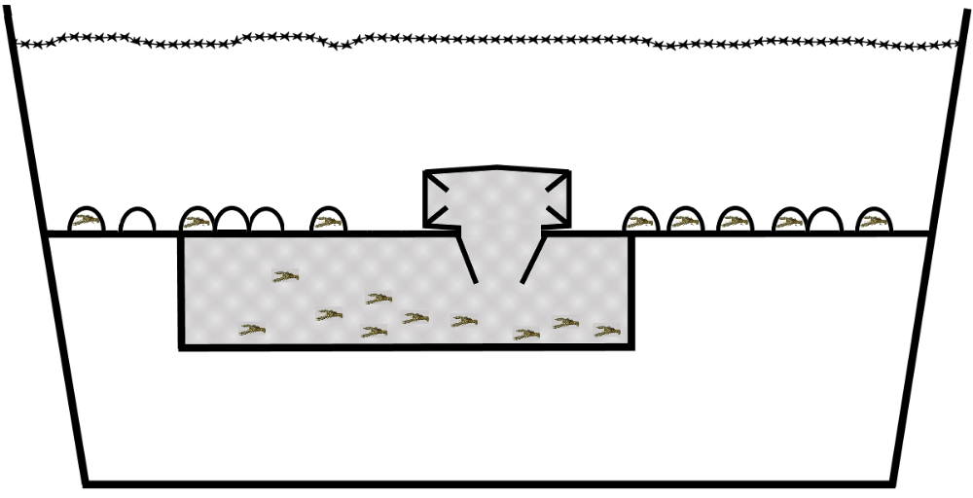

B

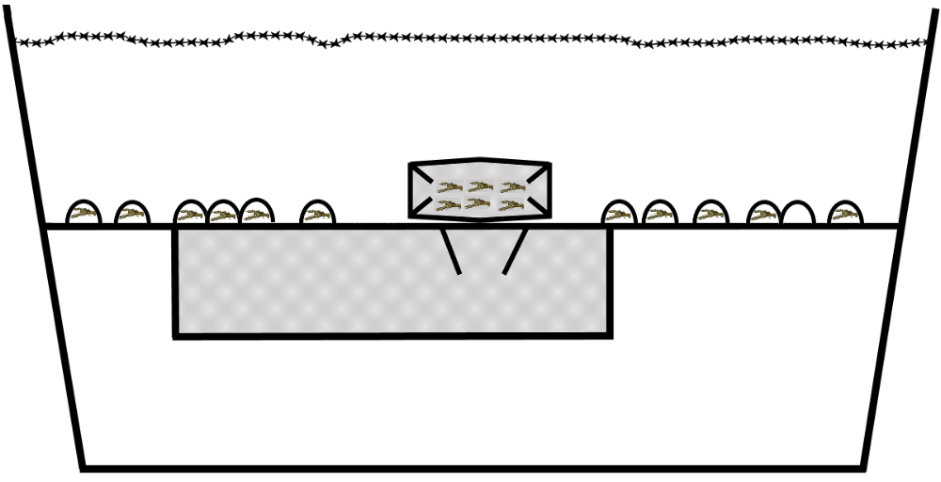

Figure 1. Schematic side view of the experimental tank (A) where the captured crayfish were immediately removed from the trap by falling through the opening in the plywood-divider and the control trap (B) where the captured crayfish remained in the trap.
plywood basket and the crayfish inside the trap in the control tank and inside the basket in the experimental tank were collected. The number of crayfish captured in each tank was recorded. The carapace length (nearest mm; tip of rostrum to tip of uropod), sex, and a subjective judgment of shell strength was recorded for all crayfish used in the trial.
The experiment was repeated for a total of 17 trials between 7 July and 11 August. The average water temperature in the tanks over this period was 25ºC with a range from 20ºC to 30.6ºC. The water temperature dropped an average of 1ºC from the beginning to the end of a trial (i.e., over-night), but there was no significant difference in temperature between the two tanks over the course of the study (p=0.49).
The hypothesis that more crayfish were captured more often in the experimental tank was tested with an exact binomial test (i.e., testing whether the proportion of trials that more crayfish were captured in the experimental tank was greater than 0.5). Matched-pairs t-tests were used to test the hypotheses that more crayfish were captured on average in the experimental tank and that the mean carapace length of captured crayfish differed between the experimental and control tanks. The effects of the treatment (experimental or control tank) and sex factors and the carapace length covariate on the probability of capture were examined with a logistic regression model. Factors in the full logistic regression model were simplified using Akaike’s information criterion and the principle of marginality (Fox 1997). Multiple comparisons for logistic regression model slopes and intercepts among all groups were constructed using the false discovery rate method of Benjamini and Hochberg (1995). All hypothesis tests were conducted with the R statistical language (version 2.5.1; R Development Core Team 2007) and used a significance level or false discovery rate of 0.05.

RESULTS AND DISCUSSION

More crayfish were captured in the experimental than in the control tanks in all but one trial (p=0.0003; Fig. 2). The lower 95% confidence limit for the proportion of trials in which more crayfish were captured in the experimental tank was 0.74. On average, 7.2 (lower 95% confidence limit was 5.0) more crayfish were captured in the experimental than in the control tanks (p<0.0005). The final logistic regression model, with significantly different intercepts between each pair of groups (largest q-value was 0.0012) except for between male and female crayfish in the experimental tanks (q-value=0.7330), shows that crayfish of all sizes and sexes had a higher probability of being captured in the experimental tanks (Fig. 3).
The observation that more crayfish were captured in traps where captured crayfish were immediately removed than in traps where captured crayfish were not immediately removed is consistent with two possible explanations. First, captured crayfish that remained in the trap may have escaped from the trap prior to the trap being “lifted.” There was no significant relationship (p=0.5577) between the number of captured fish in the control tanks and the time that the trap was “lifted.” Thus, if this explanation was true then it does not appear that captured crayfish left the trap gradually over time.
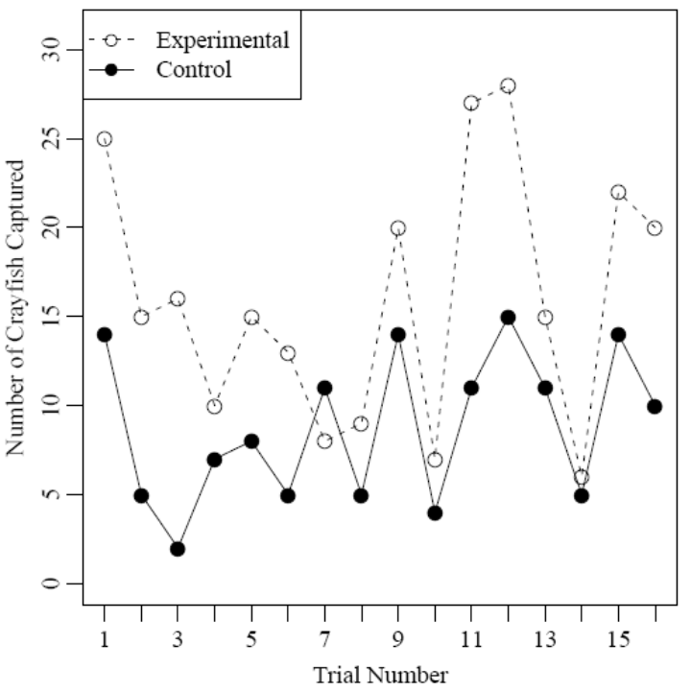
Figure 2. Number of crayfish caught (of 30 possible) in experimental and control tanks by trial number.

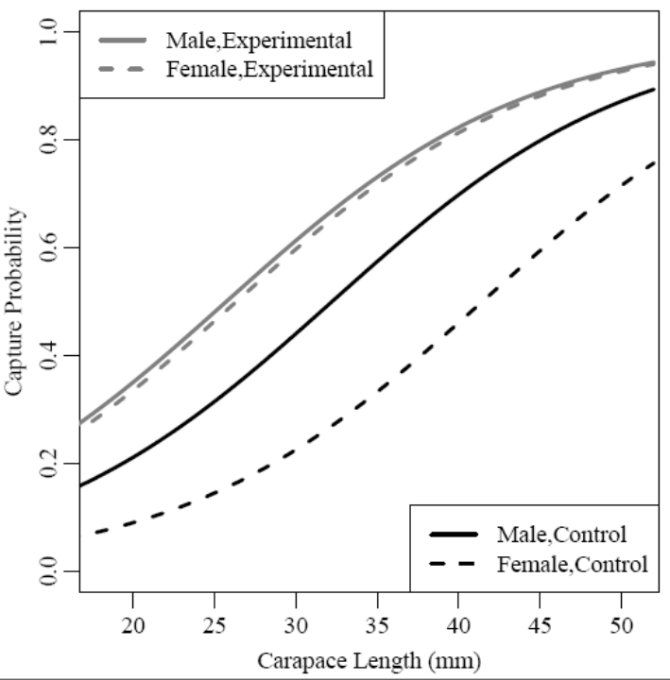
Figure 3. Predicted probabilities of capture for crayfish by carapace length, sex, and treatment (i.e., experimental or control tanks).
Furthermore, it is unlikely that crayfish would willingly leave a baited trap, and the bait in each trap was never exhausted at the end of any trial. Secondly, previously caught crayfish may have inhibited other crayfish from entering the trap.
There is evidence for a length bias in the crayfish that did not enter the trap with previously captured crayfish. The average length of captured crayfish per trial was significantly lower for crayfish captured in the experimental than in the control tanks (p=0.0371; 95% confidence interval = 0.07 to 2.08 mm lower in experimental tank; Fig. 4). As there was no difference in the average length of the crayfish stocked into the two tanks, this result suggests that more of the smaller crayfish were captured in the experimental tanks. In addition, the larger crayfish likely entered the trap first because they had a higher probability of capture. Thus, smaller crayfish may have been inhibited from entering the trap in the control but not the experimental tank by previously caught larger crayfish.

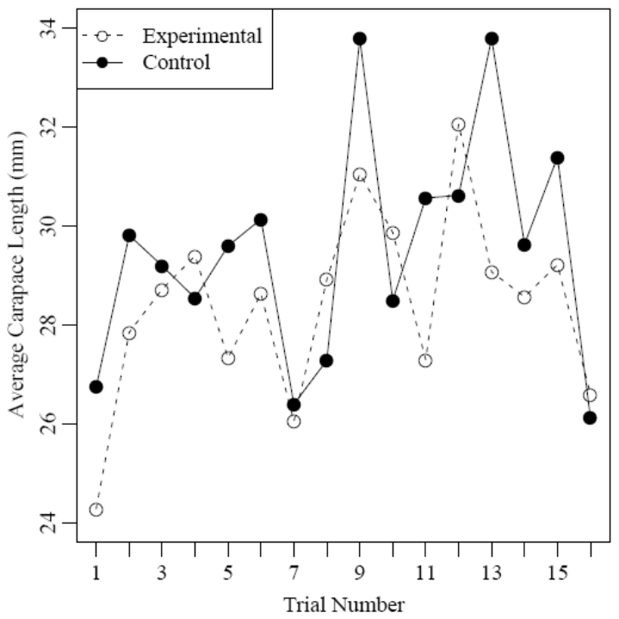
Figure 4. Average carapace length of captured crayfish caught in experimental and control tanks by trial number.

There is also evidence for a sex bias in the crayfish that did not enter the trap with previously captured crayfish. The final logistic regression model showed that males had a higher probability of being captured than females of the same size in the control tanks but not in the experimental tanks. Thus, uncaptured females may have avoided entering the trap in the control tanks because of previously captured males still in the trap.
This experiment strongly indicates that the immediate removal of captured rusty crayfish from a trap results in significantly more crayfish being captured. These results show that larger crayfish have a higher capture probability and are, thus, likely captured first. Given that larger crayfish have a competitive advantage in aggressive interactions with smaller crayfish (Bergman and Moore 2003) these results combine to suggest that the aggressive behavior of captured large crayfish serves to inhibit the capture of other smaller crayfish, similar to what was observed for lobsters (Jury et al. 2001, Green 2002). However, because we did not directly observe the behavior of rusty crayfish in this experiment nor did we observe this behavior in a fully natural setting, we suggest that visual observations via SCUBA or snorkeling (e.g., Bergman and Moore 2003) or with an underwater video camera (e.g., Jury et al. 2001, Green 2002) be used to fully test this hypothesis.

ACKNOWLEDGMENTS

This project was completed with funds from the R.D. and Linda Peters Foundation.

LITERATURE CITED

Benjamini, Y. and Y. Hochberg. 1995. Controlling the false discovery rate: a practical and powerful approach to multiple testing. Journal of the Royal Statistical Society B57:289-300.
Bergman, D.A. and P.A. Moore. 2003. Field observations of intraspecific agonistic behavior of two crayfish species, Orconectes rusticus and Orconectes virilis, in different habitats. The Biological Bulletin 205:26-35.
Capelli, G.M. 1982. Displacement of northern Wisconsin crayfish by Orconectes rusticus (Girard). Limnology and Oceanography 27:741-745.
Capelli, G.M. and J.J. Magnuson. 1983. Morphoedaphic and biogeographic analysis of crayfish distribution in northern Wisconsin. Journal of Crustacean Biology 3:548-564.
Capelli, G.M. and G.L. Munjal. 1982. Aggressive interactions and resource competition in relation to species displacement among crayfish of the genus Orconectes. Journal of Crustacean Biology 2:486-492.
Charlebois, P.M. and G.A. Lamberti. 1996. Invading crayfish in a Michigan stream: direct and indirect effects on periphyton and macroinvertebrates. Journal of the North Amercian Benthological Society 15:551-563.
Fox, J. 1997. Applied Regression Analysis, Linear Models, and Related Methods. Sage.
Green, N. 2002. Evaluating lobster catchability using remote video and the implications for density estimates obtained from trapping surveys for a southern rock lobster, Jasus edwardsii population. B.Sc. (Hons) Thesis, University of Tasmania, Hobart.
Ihde, T.F., S.D. Frusher, and J.M. Hoenig. 2006. Do large rock lobsters inhibit smaller ones from entering traps? A field experiment. Marine and Freshwater Research 57:665-674.
Jury, S.H., H. Howell, D.F. O’Gradt, and W.H. Watson III. 2001. Lobster trap video: in situ surveillance of the behaviour of Homarus americanus in and around traps. Marine and Freshwater Research 52:1125-1132.
Klocker, C.A. and D.L. Strayer. 2004. Interactions among an invasive crayfish (Orconectes rusticus), a native crayfish (Orconectes limosus), and native bivalves (sphaeriidae and unionidae). Northeastern Naturalist 11:167-178.
Lodge, D.M. T.K. Kratz, and G.M. Capelli. 1986. Long-term dynamics of three crayfish species in Trout Lake, Wisconsin. Canadian Journal of Fisheries and Aquatic Sciences 43:993-998.
Lodge, D.M., M.W. Kershner, J.E. Aloi, and A.P. Covich. 1994. Effects of an omnivorous crayfish (Orconectes rusticus) on a fresh-water littoral food-web. Ecology 75:1265-1281.
Lodge, D.M. and J.G. Lorman. 1987. Reductions in submersed macrophyte biomass and species richness by the crayfish Orconectes rusticus. Canadian Journal of Fisheries and Aquatic Sciences 44:591-597.
Lodge, D.M., C.A. Taylor, D.M. Holdich, and J. Skurdal. 2000. Nonindigenous crayfishes threaten North American biodiversity: lessons from Europe. Fisheries (Bethesda) 25:7-20.
McCarthy, J.M., C.L. Hein, J.D. Olden, and M.J. Vander Zanden. 2006. Coupling long-term studies with meta-analysis to investigate impacts of non-native crayfish on zoobenthic communities. Freshwater Biology 51:224-235.
Miller, R.J. 1990. Effectiveness of crab and lobster traps. Canadian Journal of Fisheries and Aquatic Sciences 47:1228-1251.
Olden, J.D., J.M. McCarthy, J.T. Maxted, W.W. Fetzer, and M.J. Vander Zanden. 2006. The rapid spread of rusty crayfish (Orconectes rusticus) with observations on native crayfish declines in Wisconsin (U.S.A.) over the past 130 years. Biological Invasions 8:1621-1628.
Olsen, T.M., D.M. Lodge, G.M. Capelli, and R.J. Houlihan. 1991. Mechanisms of impact of introduced crayfish (Orconectes rusticus) on littoral congeners, snails, and macrophytes. Canadian Journal of Fisheries and Aquatic Sciences 48:1853-1861.
R Development Core Team. 2007. R: A language and environment for statistical computing. R Foundation for Statistical Computing, Vienna, Austria. http://www.R-project.org.
Richards, R.A., J.S. Cobb, and M.J. Fogarth. 1983. Effects of behavioral interactions on the catchability of American lobster, Homarus americanus, and two species of Cancer crab. Fishery Bulletin, U.S. 81:51-60.
Rosenthal, S.K., S.S. Stevens, and D.M. Lodge. 2006. Whole-lake effects of invasive crayfish (Orconectes spp.) and the potential for restoration. Canadian Journal of Fisheries and Aquatic Sciences 63:1276-1285.
Somers, K.M. and D.P.M. Stechey. 1986. Variable trapability of crayfish associated with bait type, water temperature, and lunar phase. The American Midland Naturalist 116:36-44.
Wilson, K.A., J.J. Magnuson, D.M. Lodge, A.M. Hill, T.K. Kratz, W.L. Perry, and T.V. Willis. 2004. A long-term rusty crayfish (Orconectes rusticus) invasion: dispersal patterns and community change in a north temperate lake. Canadian Journal of Fisheries and Aquatic Sciences 61:2255-2266.

