**INTRODUCTION**

Stonecats are a widely distributed species, though it is considered endangered in VT.

Age and growth is important to understanding the dynamics of fish populations.

Little is known about age and growth of Stonecats.

Our primary objective is to describe the growth of Stonecats in two tributaries of Lake Champlain. Secondarily, we will compare the growth of Stonecats in these waters at the northeastern edge of their distribution to previously published results from other locations near the middle of the distribution of this species.

**METHODS**

*Study sites*.—Stonecats were collected from two Lake Champlain tributaries. The Great Chazy River which originates near Ellenburg, New York, and empties into northern Lake Champlain (44.93236N; 73.38537W) is approximately 86 km long and drains a watershed of 790 km2. The LaPlatte River is 24-km long, drains a 138 km2 watershed (Pelton et al. 1998), and enters Lake Champlain in Shelburne Bay (44.39959N; 73.23385W).

*Data Collection*.—Stonecats were collected from the lower 33 km of the Great Chazy River on 17-19 October 2012 as mortalities from a TFM lampricide treatment conducted on 16-18 October 2012. Additional specimens were collected from the Great Chazy River on 8-9 August 2011 and 15 November 2011, NY as part of a bioassay study (M. Calloway, U.S Fish and Wildlife Service, unpublished data). Stonecats were frozen as quickly as possible and returned to the lab where they were thawed and measured for standard (SL) and total lengths (TL) to the nearest mm before the dorsal spine was removed by cutting it just above the articulation point (Buckmeier et al. 2002; Manny et al. 2014; Fischer and Koch 2017).

Spines were placed in boiling water to remove excess skin and flesh and then allowed to dry before being set in epoxy. One or two 0.5-mm sections were cut from the spine using a BuehlerTM low-speed isomet saw (Buehler, Lake Bluff, Illinois). Thin sections were glued to slides for viewing under an Olympus SZX9TM dissecting microscope using fiber optic transmitted light. Three readers blind to fish size independently estimated age by identifying annuli in the patterns of translucent and opaque zones of the sectioned spine. The three readers attempted to reach a consensus age if there were discrepancies among their estimated ages. If a consensus could not be reached then the fish was removed from further analysis.

Stonecats were collected from the LaPlatte River from June to October 2012, May to October 2013, and June to October 2014 using backpack electrofishing and minnow traps. Backpack electrofishing generally used 200 volts, 20-30 Hz, and a 20-40% duty cycle and, because Stonecats are nocturnal, began no earlier than 0.5 h after sunset. Electrofishing effort depended on the length of stream section and ranged from 26 to 247 minutes, with a mean effort of 86 minutes (SD = 49.4). Minnow traps were 42 cm long and 23 cm diameter with 2.5 cm openings at each end and 0.6 cm square meshed sides. Minnow traps were set overnight (18-24 h soak time) in gangs of three or four attached to a single weight. Further sampling details are in Puchala et al. (2016).

Captured Stonecats not experiencing obvious distress were anesthetized in a 100 mg/L concentration of tricaine methanesulfonate (MS-222). Each individual was measured for TL to the nearest mm and all Stonecats approximately 90 mm TL and greater had a passive integrated transponder (PIT) tag (134-kHz, 8.4 x 1.4 mm; Biomark, Boise, Idaho) inserted into the peritoneal cavity through a 2-mm incision in the upper abdominal wall. The slit was then treated with iodine. Individuals were examined for the presence of a PIT tag after the first sampling event. Spines were not removed from these fish to minimize the traumatic impact of removal on other aspects of our overall study (Puchala et al. 2016).

*Data analysis.*— Growth of Stonecats collected from the Great Chazy River was summarized with the traditional von Bertalanffy growth function (VBGF; Beverton and Holt 1957):

$$L_{t}=L_{∞}\left(1-e^{-K\left(t-t_{0}\right)}\right)$$

where *Lt* is the observed TL at time (or age) *t*, *L*∞ is the asymptotic mean TL, *K* is the Brody growth coefficient, and *t0* is the theoretical time when the mean TL is zero (Ogle et al. 2017). We used fractional ages in this model to adjust for our fish being collected at various times throughout the growing season (Ogle et al. 2017). We assumed that annual growth on the spine commenced on June 1 (Carlson 1966) and was completed by November 1. Thus, the adjusted age was equal to the number of observed annuli for fish collected before June 1, was one more than the number of observed annuli for fish collected after November 1, and was the number of observed annuli plus the fraction of the growing season completed for fish captured between June 1 and November 1. We chose not to use a growth function with a seasonal component (e.g., Somers [1988]) for fish collected from the Great Chazy River because sampling dates were concentrated on only a few days in a year.

Growth of Stonecats collected from the LaPlatte River could not be summarized with the traditional VBGF because age for these fish could not be estimated. Rather we summarized growth of Stonecats from the LaPlatte River with the traditional VBGF modified by Francis (1988) for use with mark-recapture data and including a seasonal component:

$$ΔL=\left(\frac{{L_{2}g}_{1}-{L_{1}g}_{2}}{g_{1}-g_{2}}-L_{m}\right)\left(1-{\left[1+\frac{g_{1}-g_{2}}{L_{1}-L_{2}}\right]}^{ΔT+θ_{2}-θ_{1}}\right)$$

where

$$θ_{i}=\frac{u\sin\left(2π\left(t_{i}-w\right)\right)}{2π}$$

Here, *Lm* is the TL at time of marking, *L* is the change in TL between marking and recapture, *t1* and *t2* are the marking and recapture times (years), *t* is the change in time (years) between marking and recapture, *g1* and *g2* are parameters that represent the mean annual growth rate or increment at *L1* and *L2* (which are chosen by the analyst), *w* is a parameter that represents the time of year when the growth rate is maximum, and *u* is a parameter that describes the extent of the seasonal variation in growth (i.e., *u*=0 represents no seasonal variability in growth). For fish that were recaptured multiple times, we treated each interval between recaptures as independent capture-recapture (C-R) events (Ogle 2017). For example, if a fish was captured three times, we considered the interval from marking to the first recapture as one C-R observation and the interval from the first to second recapture as a separate C-R observation. Capture-recapture events based on observations within 7 d of each other were excluded from further analysis under the assumption that any growth that occurred in this short period was minimal and likely less than measurement error. We modeled a season component to growth with these data because fish were collected on many dates within each year, rather than on only a few dates as with the Great Chazy River data.

Both growth models were fit with the nls() function in R v3.5.1 (R Core Team 2018) using the “port” algorithm. The *g1*, *g2*, and *u* parameters were constrained to be positive and the *w* parameter was constrained to be between 0 and 1. All other parameters were unconstrained in model fitting. Three different starting values and two other algorithms (Gauss-Newton in the nls() function and Levenburg-Marquardt in the nlsLM() function from the minpack.lm package v1.2-1 [Elzhov et al. 2016]) were used to determine the robustness of parameter estimates to staring values and model fitting algorithms (Ogle et al. 2017). Bootstrap confidence intervals for model parameters were estimated from 999 bootstrapped samples using the nlsBoot() function from the nlsTools package v1.0-2 (Baty et al. 2015) as described in Ogle (2016).

Parameter estimates could not be compared between the two locations because different models were required for each location. Thus, we compared growth between locations by predicting annual growth increments for fish of various initial lengths. Predicted annual growth increments at two lengths (*L1* and *L2*) are the *g1* and *g2* parameter from the Francis model. Thus, we refit this model at several different values of *L1* and *L2* to represent growth increments throughout the range of lengths for Stonecats from the LaPlatte River. Annual growth increments were predicted for Stonecats from the Great Chazy River by first using the VBGF model fit to predict mean lengths at several ages and then finding the differences between these lengths. Bootstrap confidence intervals were constructed for both the predicted mean lengths and increments. We also compared the growth increments from the LaPlatte and Great Chazy rivers to mean lengths and corresponding increments reported for Stonecats in the literature (Carlson 1966, Paruch 1979, Gibson 1985). Some of the literature results were converted from SL to TL using results from a linear model fit to our measurements of SL and TL on fish collected from the Great Chazy River.

**RESULTS**

A total of 183 Stonecats from the Great Chazy River were aged from spines. Of these, six (3%) were removed from further analysis because the three readers could not agree on a consensus age. Age-classes ranged from 0 (young-of-the-year) to 5 with most fish age-0 (49%) and only five fish (3%) age-4 or older. Stonecats from the Great Chazy River ranged from 44 to 193 mm TL, with a mean TL of 114 (SD = 41.5) mm. The SL-TL relationship was TL=1.239+1.166SL (r2 = 0.996). Parameter estimates (with 95% confidence intervals) from fitting the traditional VBGF to the Great Chazy River Stonecats are 172 (160 - 193) for *L*∞, 0.79 (0.52 - 1.16) for *K*, and 0.13 (-0.15 – 0.34) for *t0* (Figure 1).

A total of 1311 Stonecats were tagged in the LaPlatte River. Of the 133 fish (10%) that were recaptured at least once, 111 fish (83%) were recaptured once, 20 fish (15%) were recaptured twice, and 2 fish (2%) were captured three times. Thus, 157 paired C-R events were observed, though 9 (6%) of these were within 7 days of each other and were removed from further analysis. Of the remaining C-R events, 61% of recaptures were in the same year as the original capture, 39% were in the following year, and 1% were two years later (Figure 2). Stonecats from the LaPlatte River ranged from 87 to 185 mm TL at the time of marking, with a mean of 131 (SD = 20.5) mm. One fish was 192 mm at the time of recapture. Parameter estimates (with 95% confidence intervals) from fitting the modified VBGF to the LaPlatte River Stonecats are 34.1 (32.6 – 35.8) for *g1* at *L1*=100, 18.0 (16.6 – 19.4) for *g2* at *L2*=150, 0.55 (0.52 – 0.58) for *w*, and 2.52 (2.27 – 2.87) for *u*.

Annual growth of Stonecats at lengths that corresponded to ages observed for Stonecates from the Great Chazy River was somewhat less in the LaPlatte River than the Great Chazy River for age-1 fish, similar for age-2 and age-3 fish, and somewhat greater for age-4 and age-5 fish (Figure 3). Growth of the Stonecats from the Great Chazy and LaPlatte rivers was greater than that for streams in Wisconsin (Paruch 1979), Ohio (Gilbert 1953), and the Vermillion River (South Dakota; Carlson 1966) for at least the first two years of life. However, growth for fish from the Lake Champlain tributaries was substantially less than that described for Stonecats from Lake Erie (Gilbert 1953).

**DISCUSSION**

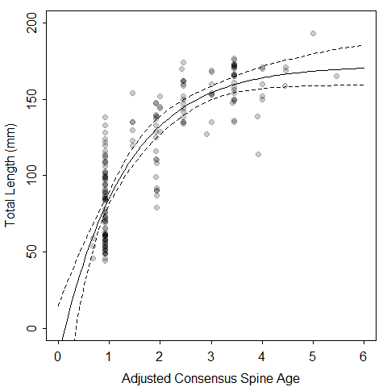

Figure 1. Fit (solid line), with 95% confidence bounds (dashed lines), of the traditional von Bertalanffy growth function to total lengths and ages estimated from spines of Stonecats collected from the Great Chazy River, New York in 2011 and 2012. Ages have been adjusted to represent the number of observed annuli on the spine plus the fraction of growth completed in the year the fish were collected. Observations are plotted with a semi-transparent color such that darker points represent more observations.

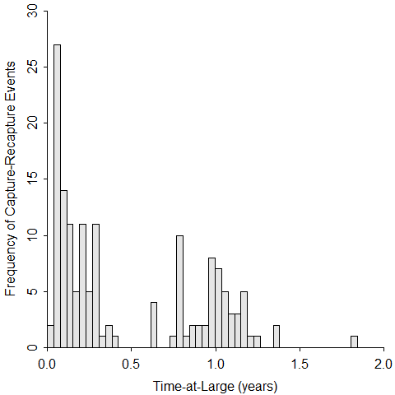

Figure 2. Histogram of times-at-large for Stonecats captured and recaptured from the LaPallette River, Vermont in 2012-2014. Each bar in the histogram is fourteen days wide. Note that 9 capture-recapture events where the time between capture and recapture was less than seven days are not included.

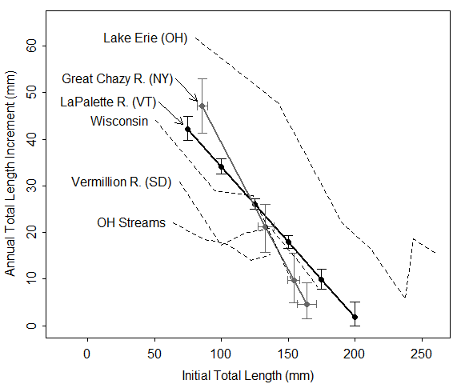

Figure 3. Annual total length increment versus initial total length for the two locations of this study (Great Chazy and LaPlatte rivers) and for four previous studies (Lake Erie [Gilbert 1953], Wisconsin streams [Paruch 1979], Vermillion River [Carlson 1966], and Ohio streams [Gilbert 1953]). The LaPlatte River results are shown with 95% bootstrap confidence intervals for the annual increment obtained from parameters in the von Bertalanffy growth function modified by Francis (1988). The Great Chazy Rier results show 95% bootstrap confidence intervals for both the annual increment and the initial total length as predicted from the fit of the traditional von Bertalanffy growth function.

**REFERENCES**

Baty, F., C. Ritz, S. Charles, M. Brutsche, J. P. Flandrois, and M. L. Delignette-Muller. 2015. A toolbox for nonlinear regression in R: the package nlstools. Journal of Statistical Software 66(5):1-21.

Becker, G. C. 1983. Fishes of Wisconsin. University of Wisconsin Press, Madison, WI. 1052 pp.

Beverton, R. J. H., and S. J. Holt. 1957. On the dynamics of exploited fish populations. United Kingdom Ministry of Agriculture; Fisheries.

Carlson, D. R. 1966. Age and growth of the stonecat, *Noturus flavus* Rafinesque, in the Vermillion River. Proceedings of the South Dakota Academy of Sciences 45:131-137.

Elzhov, T. V., K. M. Mullen, A.-N. Spiess, and B. Bolker. 2015. minpack.lm: R interface to the Levenberg-Marquardt nonlinear least-squares algorithm found in MINPACK, plus support for bounds. R package.

Fischer, J. R. and J. D. Koch. 2017. Fin rays and spines. Pages 173-187 *in* M. C. Quist and D. A. Isermann, editors. Age and Growth of Fishes: Principles and Techniques. American Fisheries Society, Bethesda, MD.

Francis, R. I. C. C. 1988. Maximum likelihood estimation of growth and growth variability from tagging data. New Zealand Journal of Marine and Freshwater Research 22:42-51.

Ogle, D. H. 2016. Introductory fisheries analysis with R. Chapman & Hall/CRC Press, Boca Raton, Florida.

Ogle, D. H., T. O. Brendan, and J. L. McCormick. 2017. Growth estimation: growth models and statistical inference. Pages 265-359 *in* M. C. Quist and D. A. Isermann, editors. Age and Growth of Fishes: Principles and Techniques. American Fisheries Society, Bethesda, MD.

Paruch, W. 1979. Age and growth of Ictaluridae in Wisconsin. M.Sc. Thesis, University of Wisconsin – Stevens Point. 97 pp.

R Development Core Team. 2017. R: a language and environment for statistical computing. R Foundation for Statistical Computing. Vienna, Austria. URL <http://R-project.org>.

Somers, I. F. 1988. On a seasonally oscillating growth function. Fishbyte 6:8-11.