PART I – FILE FINDER

1.
FileFinder run tests 1-3 using patterns %.log , licastb%.pdf, and %lab7%.b%

Test 1.1
java FindFile %.log
Files like '%.log'
./FindFileDatabase.log
./CS580/Lab7/paper_review_lab7_cs580Spring2013.log
./CS580/Lab3/paper_review_lab3_cs580Spring2013.log
./CS580/Lab2/annotated_bibliography_paper.log

Verification 1.1
find . -name \*.log
./FindFileDatabase.log
./CS580/Lab7/paper_review_lab7_cs580Spring2013.log
./CS580/Lab3/paper_review_lab3_cs580Spring2013.log
./CS580/Lab2/annotated_bibliography_paper.log

Test 1.2
java FindFile licastb%.pdf
Files like 'licastb%.pdf'
./CS580/Lightning Talk/6 - Research Topic (Multitouch and Regular Expressions)/licastb_CS580_LightningTalk.pdf
./CS580/Lightning Talk/7 - Immersion in the Dicipline/licastb_talk7.pdf
./CS580/Lightning Talk/2 - Research Topic (Evolutionary Computation)/licastb-powerpoint.pdf
./CS580/Lightning Talk/5 - Immersion in the Discipline/licastb_immersion_5.pdf

Verification 1.2
find . -name \licastb*.pdf
./CS580/Lightning Talk/6 - Research Topic (Multitouch and Regular Expressions)/licastb_CS580_LightningTalk.pdf
./CS580/Lightning Talk/7 - Immersion in the Dicipline/licastb_talk7.pdf
./CS580/Lightning Talk/2 - Research Topic (Evolutionary Computation)/licastb-powerpoint.pdf
./CS580/Lightning Talk/5 - Immersion in the Discipline/licastb_immersion_5.pdf

Test 1.3
java FindFile %lab7%.b%
Files like '%lab7%.b%'
./CS580/Lab7/paper_review_lab7_cs580Spring2013.bib
./CS580/Lab7/paper_review_lab7_cs580Spring2013.blg
./CS580/Lab7/paper_review_lab7_cs580Spring2013.bbl

Verification 1.3
java FindFile %lab7%.b%
Files like '%lab7%.b%'
./CS580/Lab7/paper_review_lab7_cs580Spring2013.bib
./CS580/Lab7/paper_review_lab7_cs580Spring2013.blg
./CS580/Lab7/paper_review_lab7_cs580Spring2013.bbl

2.
The .log file when the program is run and shows all of the commands that were run to create, or work with the database during the last program's session. In the case of the FileFinder init, a new connection was established, any previous Files tables were dropped and a new table was created so we can start from a clean slate. Then for every file in the directory the direct path and the file name were recorded in the database with an INSERT statement, and then the insert was committed. After every file was added to the database the connection was closed leaving a disconnect message and the program terminates.

Example from the file is below:
/*C3*/SET SCHEMA PUBLIC
DROP TABLE Files
CREATE TABLE Files(Path varchar(255),Name varchar(255))

INSERT INTO FILES VALUES('./FindFile.java','FindFile.java')
COMMIT
...
DISCONNECT

The .properties file that is generated looks like the following
#HSQL Database Engine 2.2.9
#Thu Mar 14 21:55:33 EDT 2013
version=2.2.9
modified=yes
and gives HSQLDB information regarding the type of database that the script file is for. When referring to the database type, it is actually referring to what version of HSQLDB was used to last create/modify the database and allows the program to determine whether the script is compatible with the running version.

The .script file contains all of the necessary SQL settings to create the database in its current form, including database settings, authentication, schema properties, access rules, and all of the data inserted into the database. The following example from the file has been significantly reduced length and complexity to show the described functions:

SET DATABASE UNIQUE NAME HSQLDB3D22A17819
SET DATABASE GC 0
SET DATABASE DEFAULT RESULT MEMORY ROWS 0
...
SET DATABASE TEXT TABLE DEFAULTS ''
...
SET FILES LOG TRUE
SET FILES LOG SIZE 50
CREATE USER "CMPSC380" PASSWORD DIGEST 'd41d8cd98f00b204e9800998ecf8427e'
ALTER USER "CMPSC380" SET LOCAL TRUE
CREATE SCHEMA PUBLIC AUTHORIZATION DBA
SET SCHEMA PUBLIC
CREATE MEMORY TABLE PUBLIC.FILES(PATH VARCHAR(255),NAME VARCHAR(255))
ALTER SEQUENCE SYSTEM_LOBS.LOB_ID RESTART WITH 1
SET DATABASE DEFAULT INITIAL SCHEMA PUBLIC
...
GRANT USAGE ON DOMAIN INFORMATION_SCHEMA.SQL_IDENTIFIER TO PUBLIC
GRANT DBA TO "CMPSC380"
SET SCHEMA SYSTEM_LOBS
INSERT INTO BLOCKS VALUES(0,2147483647,0)
SET SCHEMA PUBLIC
INSERT INTO FILES VALUES('./FindFileDatabase.properties','FindFileDatabase.properties')
INSERT INTO FILES VALUES('./FindFileDatabase.log','FindFileDatabase.log')
…

PART II – TWITTER CLIENT
3. Code attached
4. Code also attached
5.
Output from running the TwitterCreateProperties program:

java TwitterCreateProperties
[Thu Mar 14 22:52:43 EDT 2013]debug: true
[Thu Mar 14 22:52:43 EDT 2013]userAgent: twitter4j http://twitter4j.org/ /3.0.3
[Thu Mar 14 22:52:43 EDT 2013]user: null
[Thu Mar 14 22:52:43 EDT 2013]password: null
[Thu Mar 14 22:52:43 EDT 2013]useSSL: false
[Thu Mar 14 22:52:43 EDT 2013]prettyDebug: false
[Thu Mar 14 22:52:43 EDT 2013]gzipEnabled: true
[Thu Mar 14 22:52:43 EDT 2013]httpProxyHost: null
[Thu Mar 14 22:52:43 EDT 2013]httpProxyUser: null
[Thu Mar 14 22:52:43 EDT 2013]httpProxyPassword: null
[Thu Mar 14 22:52:43 EDT 2013]httpProxyPort: -1
[Thu Mar 14 22:52:43 EDT 2013]httpConnectionTimeout: 20000
[Thu Mar 14 22:52:43 EDT 2013]httpReadTimeout: 120000
[Thu Mar 14 22:52:43 EDT 2013]httpStreamingReadTimeout: 40000
[Thu Mar 14 22:52:43 EDT 2013]httpRetryCount: 0
[Thu Mar 14 22:52:43 EDT 2013]httpRetryIntervalSeconds: 5
[Thu Mar 14 22:52:43 EDT 2013]maxTotalConnections: 20
[Thu Mar 14 22:52:43 EDT 2013]defaultMaxPerRoute: 2
[Thu Mar 14 22:52:43 EDT 2013]oAuthConsumerKey: 87phzuHwuARcCwAjgVUYww
[Thu Mar 14 22:52:43 EDT 2013]oAuthConsumerSecret: ******************************************
[Thu Mar 14 22:52:43 EDT 2013]oAuthAccessToken: null
[Thu Mar 14 22:52:43 EDT 2013]oAuthAccessTokenSecret: null
[Thu Mar 14 22:52:43 EDT 2013]oAuthRequestTokenURL: http://api.twitter.com/oauth/request_token
[Thu Mar 14 22:52:43 EDT 2013]oAuthAuthorizationURL: http://api.twitter.com/oauth/authorize
[Thu Mar 14 22:52:43 EDT 2013]oAuthAccessTokenURL: http://api.twitter.com/oauth/access_token
[Thu Mar 14 22:52:43 EDT 2013]oAuthAuthenticationURL: http://api.twitter.com/oauth/authenticate
[Thu Mar 14 22:52:43 EDT 2013]restBaseURL: http://api.twitter.com/1.1/
[Thu Mar 14 22:52:43 EDT 2013]streamBaseURL: https://stream.twitter.com/1.1/
[Thu Mar 14 22:52:43 EDT 2013]userStreamBaseURL: https://userstream.twitter.com/1.1/
[Thu Mar 14 22:52:43 EDT 2013]siteStreamBaseURL: https://sitestream.twitter.com/1.1/
[Thu Mar 14 22:52:43 EDT 2013]dispatcherImpl: twitter4j.internal.async.DispatcherImpl
[Thu Mar 14 22:52:43 EDT 2013]loggerFactory: null
[Thu Mar 14 22:52:43 EDT 2013]asyncNumThreads: 1
[Thu Mar 14 22:52:43 EDT 2013]contributingTo: -1
[Thu Mar 14 22:52:43 EDT 2013]includeRTsEnabled: true
[Thu Mar 14 22:52:43 EDT 2013]includeEntitiesEnabled: true
[Thu Mar 14 22:52:43 EDT 2013]includeMyRetweetEnabled: true
[Thu Mar 14 22:52:43 EDT 2013]jsonStoreEnabled: false
[Thu Mar 14 22:52:43 EDT 2013]mbeanEnabled: false
[Thu Mar 14 22:52:43 EDT 2013]userStreamRepliesAllEnabled: false
[Thu Mar 14 22:52:43 EDT 2013]stallWarningsEnabled: true
[Thu Mar 14 22:52:43 EDT 2013]mediaProvider: TWITTER
[Thu Mar 14 22:52:43 EDT 2013]mediaProviderAPIKey: null
[Thu Mar 14 22:52:43 EDT 2013]mediaProviderParameters: null
[Thu Mar 14 22:52:43 EDT 2013]clientVersion: 3.0.3
[Thu Mar 14 22:52:43 EDT 2013]clientURL: http://twitter4j.org/en/twitter4j-3.0.3.xml
[Thu Mar 14 22:52:43 EDT 2013]DALVIK: twitter4j.dalvik
[Thu Mar 14 22:52:43 EDT 2013]GAE: twitter4j.gae
[Thu Mar 14 22:52:43 EDT 2013]DEFAULT_OAUTH_REQUEST_TOKEN_URL: http://api.twitter.com/oauth/request_token
[Thu Mar 14 22:52:43 EDT 2013]DEFAULT_OAUTH_AUTHORIZATION_URL: http://api.twitter.com/oauth/authorize
[Thu Mar 14 22:52:43 EDT 2013]DEFAULT_OAUTH_ACCESS_TOKEN_URL: http://api.twitter.com/oauth/access_token
[Thu Mar 14 22:52:43 EDT 2013]DEFAULT_OAUTH_AUTHENTICATION_URL: http://api.twitter.com/oauth/authenticate
[Thu Mar 14 22:52:43 EDT 2013]DEFAULT_REST_BASE_URL: http://api.twitter.com/1.1/
[Thu Mar 14 22:52:43 EDT 2013]DEFAULT_STREAM_BASE_URL: https://stream.twitter.com/1.1/
[Thu Mar 14 22:52:43 EDT 2013]DEFAULT_USER_STREAM_BASE_URL: https://userstream.twitter.com/1.1/
[Thu Mar 14 22:52:43 EDT 2013]DEFAULT_SITE_STREAM_BASE_URL: https://sitestream.twitter.com/1.1/
[Thu Mar 14 22:52:43 EDT 2013]IS_DALVIK: false
[Thu Mar 14 22:52:43 EDT 2013]IS_GAE: false
[Thu Mar 14 22:52:43 EDT 2013]serialVersionUID: -6610497517837844232
[Thu Mar 14 22:52:43 EDT 2013]dalvikDetected: false
[Thu Mar 14 22:52:43 EDT 2013]gaeDetected: false
[Thu Mar 14 22:52:43 EDT 2013]requestHeaders: {X-Twitter-Client-URL=http://twitter4j.org/en/twitter4j-3.0.3.xml, X-Twitter-Client=Twitter4J, Accept-Encoding=gzip, User-Agent=twitter4j http://twitter4j.org/ /3.0.3, X-Twitter-Client-Version=3.0.3}
[Thu Mar 14 22:52:43 EDT 2013]instances: [ConfigurationBase{debug=true, userAgent='twitter4j http://twitter4j.org/ /3.0.3', user='null', password='null', useSSL=false, prettyDebug=false, gzipEnabled=true, httpProxyHost='null', httpProxyUser='null', httpProxyPassword='null', httpProxyPort=-1, httpConnectionTimeout=20000, httpReadTimeout=120000, httpStreamingReadTimeout=40000, httpRetryCount=0, httpRetryIntervalSeconds=5, maxTotalConnections=20, defaultMaxPerRoute=2, oAuthConsumerKey='87phzuHwuARcCwAjgVUYww', oAuthConsumerSecret='D9AAkdfQcWR04CuU4IL4s3tVLxiijsez276ldayTng', oAuthAccessToken='null', oAuthAccessTokenSecret='null', oAuthRequestTokenURL='http://api.twitter.com/oauth/request_token', oAuthAuthorizationURL='http://api.twitter.com/oauth/authorize', oAuthAccessTokenURL='http://api.twitter.com/oauth/access_token', oAuthAuthenticationURL='http://api.twitter.com/oauth/authenticate', restBaseURL='http://api.twitter.com/1.1/', streamBaseURL='https://stream.twitter.com/1.1/', userStreamBaseURL='https://userstream.twitter.com/1.1/', siteStreamBaseURL='https://sitestream.twitter.com/1.1/', dispatcherImpl='twitter4j.internal.async.DispatcherImpl', loggerFactory='null', asyncNumThreads=1, contributingTo=-1, includeRTsEnabled=true, includeEntitiesEnabled=true, includeMyRetweetEnabled=true, jsonStoreEnabled=false, mbeanEnabled=false, userStreamRepliesAllEnabled=false, stallWarningsEnabled=true, mediaProvider='TWITTER', mediaProviderAPIKey='null', mediaProviderParameters=null, clientVersion='3.0.3', clientURL='http://twitter4j.org/en/twitter4j-3.0.3.xml', IS_DALVIK=false, IS_GAE=false, requestHeaders={X-Twitter-Client-URL=http://twitter4j.org/en/twitter4j-3.0.3.xml, X-Twitter-Client=Twitter4J, Accept-Encoding=gzip, User-Agent=twitter4j http://twitter4j.org/ /3.0.3, X-Twitter-Client-Version=3.0.3}}]
[Thu Mar 14 22:52:43 EDT 2013]Request:
[Thu Mar 14 22:52:43 EDT 2013]POST http://api.twitter.com/oauth/request_token
[Thu Mar 14 22:52:43 EDT 2013]OAuth base string: POST&http%3A%2F%2Fapi.twitter.com%2Foauth%2Frequest_token&oauth_consumer_key%3D87phzuHwuARcCwAjgVUYww%26oauth_nonce%3D3076343255%26oauth_signature_method%3DHMAC-SHA1%26oauth_timestamp%3D1363315963%26oauth_version%3D1.0
[Thu Mar 14 22:52:43 EDT 2013]OAuth signature: kLWCU+ZwL+VebUmpYPsiaupugxk=
[Thu Mar 14 22:52:43 EDT 2013]Authorization: *******************************************************************************************************************************************************************************************************************
[Thu Mar 14 22:52:43 EDT 2013]X-Twitter-Client-URL: http://twitter4j.org/en/twitter4j-3.0.3.xml
[Thu Mar 14 22:52:43 EDT 2013]X-Twitter-Client: Twitter4J
[Thu Mar 14 22:52:43 EDT 2013]Accept-Encoding: gzip
[Thu Mar 14 22:52:43 EDT 2013]User-Agent: twitter4j http://twitter4j.org/ /3.0.3
[Thu Mar 14 22:52:43 EDT 2013]X-Twitter-Client-Version: 3.0.3
[Thu Mar 14 22:52:43 EDT 2013]Post Params:
[Thu Mar 14 22:52:44 EDT 2013]Response:
[Thu Mar 14 22:52:44 EDT 2013]HTTP/1.1 200 OK
[Thu Mar 14 22:52:44 EDT 2013]X-Runtime: 0.02035
[Thu Mar 14 22:52:44 EDT 2013]ETag: "1d753ba2071f5cb2fd35721f969592a2"
[Thu Mar 14 22:52:44 EDT 2013]Content-Length: 150
[Thu Mar 14 22:52:44 EDT 2013]X-Transaction: baed160b5e2f3d1b
[Thu Mar 14 22:52:44 EDT 2013]X-MID: 2b014c6f6de78432936ccd0abb8692506fa0b2fd
[Thu Mar 14 22:52:44 EDT 2013]Expires: Tue, 31 Mar 1981 05:00:00 GMT
[Thu Mar 14 22:52:44 EDT 2013]Last-Modified: Fri, 15 Mar 2013 02:52:44 GMT
[Thu Mar 14 22:52:44 EDT 2013]Set-Cookie: guest_id=v1%3A136331596403966795; Domain=.twitter.com; Path=/; Expires=Sun, 15-Mar-2015 02:52:44 UTC
[Thu Mar 14 22:52:44 EDT 2013]Set-Cookie: _twitter_sess=BAh7CDoPY3JlYXRlZF9hdGwrCPe49ms9AToHaWQiJTZlMTZmMGFlZThlZGQ0%250AZTUwZjIyMjQ3YjhiZWFkNmM5IgpmbGFzaElDOidBY3Rpb25Db250cm9sbGVy%250AOjpGbGFzaDo6Rmxhc2hIYXNoewAGOgpAdXNlZHsA--3d494b257613b65ad1fdaa5bee0277c3cdf07261; domain=.twitter.com; path=/; HttpOnly
[Thu Mar 14 22:52:44 EDT 2013]Set-Cookie: k=10.40.15.122.1363315964139973; path=/; expires=Fri, 22-Mar-13 02:52:44 GMT; domain=.twitter.com
[Thu Mar 14 22:52:44 EDT 2013]Server: tfe
[Thu Mar 14 22:52:44 EDT 2013]Pragma: no-cache
[Thu Mar 14 22:52:44 EDT 2013]Cache-Control: no-cache, no-store, must-revalidate, pre-check=0, post-check=0
[Thu Mar 14 22:52:44 EDT 2013]X-Frame-Options: SAMEORIGIN
[Thu Mar 14 22:52:44 EDT 2013]Status: 200 OK
[Thu Mar 14 22:52:44 EDT 2013]Vary: Accept-Encoding
[Thu Mar 14 22:52:44 EDT 2013]Date: Fri, 15 Mar 2013 02:52:44 GMT
[Thu Mar 14 22:52:44 EDT 2013]Content-Encoding: gzip
[Thu Mar 14 22:52:44 EDT 2013]Content-Type: text/html; charset=utf-8
[Thu Mar 14 22:52:44 EDT 2013]oauth_token=lZiZPBYLqVwKWlMigM7T0c8cePhEl26NxU1CPIvuc&oauth_token_secret=2rERrCpAoOSEmCyxxl4JZgSQLCSqgZVBTHpwKovAw&oauth_callback_confirmed=true

Got request token.
Request token: lZiZPBYLqVwKWlMigM7T0c8cePhEl26NxU1CPIvuc
Request token secret: 2rERrCpAoOSEmCyxxl4JZgSQLCSqgZVBTHpwKovAw
Open the following URL and grant access to your account:
http://api.twitter.com/oauth/authorize?oauth_token=lZiZPBYLqVwKWlMigM7T0c8cePhEl26NxU1CPIvuc
Enter the PIN and hit enter after you granted access. [PIN]:3936432
[Thu Mar 14 22:55:00 EDT 2013]Request:
[Thu Mar 14 22:55:00 EDT 2013]POST http://api.twitter.com/oauth/access_token
[Thu Mar 14 22:55:00 EDT 2013]OAuth base string: POST&http%3A%2F%2Fapi.twitter.com%2Foauth%2Faccess_token&oauth_consumer_key%3D87phzuHwuARcCwAjgVUYww%26oauth_nonce%3D1054056879%26oauth_signature_method%3DHMAC-SHA1%26oauth_timestamp%3D1363316100%26oauth_token%3DlZiZPBYLqVwKWlMigM7T0c8cePhEl26NxU1CPIvuc%26oauth_verifier%3D3936432%26oauth_version%3D1.0
[Thu Mar 14 22:55:00 EDT 2013]OAuth signature: iWWhLWb+hEd3I7pjTcVBM5p8bTs=
[Thu Mar 14 22:55:00 EDT 2013]Authorization: *************************************************************************************************************************************************************************************************************************************************************************
[Thu Mar 14 22:55:00 EDT 2013]X-Twitter-Client-URL: http://twitter4j.org/en/twitter4j-3.0.3.xml
[Thu Mar 14 22:55:00 EDT 2013]X-Twitter-Client: Twitter4J
[Thu Mar 14 22:55:00 EDT 2013]Accept-Encoding: gzip
[Thu Mar 14 22:55:00 EDT 2013]User-Agent: twitter4j http://twitter4j.org/ /3.0.3
[Thu Mar 14 22:55:00 EDT 2013]X-Twitter-Client-Version: 3.0.3
[Thu Mar 14 22:55:00 EDT 2013]Post Params: oauth_verifier=3936432
[Thu Mar 14 22:55:01 EDT 2013]Response:
[Thu Mar 14 22:55:01 EDT 2013]HTTP/1.1 200 OK
[Thu Mar 14 22:55:01 EDT 2013]X-Runtime: 0.08551
[Thu Mar 14 22:55:01 EDT 2013]ETag: "27b465897a20bfe239e53082f35d507b"
[Thu Mar 14 22:55:01 EDT 2013]X-Transaction: e25a3d84bb9a6963
[Thu Mar 14 22:55:01 EDT 2013]Content-Length: 168
[Thu Mar 14 22:55:01 EDT 2013]Expires: Tue, 31 Mar 1981 05:00:00 GMT
[Thu Mar 14 22:55:01 EDT 2013]X-MID: 493455a1607fba0ceb26abed5b8649924074db87
[Thu Mar 14 22:55:01 EDT 2013]Last-Modified: Fri, 15 Mar 2013 02:55:00 GMT
[Thu Mar 14 22:55:01 EDT 2013]Set-Cookie: guest_id=v1%3A136331610080032389; Domain=.twitter.com; Path=/; Expires=Sun, 15-Mar-2015 02:55:01 UTC
[Thu Mar 14 22:55:01 EDT 2013]Set-Cookie: _twitter_sess=BAh7CCIKZmxhc2hJQzonQWN0aW9uQ29udHJvbGxlcjo6Rmxhc2g6OkZsYXNo%250ASGFzaHsABjoKQHVzZWR7ADoPY3JlYXRlZF9hdGwrCC7P%252BGs9AToHaWQiJWU2%250AMWY0ZjVkMjI3NGIwNWMzNjI1NjY3MGIzNDA2NWZm--b46e361f4c71aaa0a4179bc9da2c31a63101ec4c; domain=.twitter.com; path=/; HttpOnly
[Thu Mar 14 22:55:01 EDT 2013]Set-Cookie: k=10.40.46.110.1363316100896539; path=/; expires=Fri, 22-Mar-13 02:55:00 GMT; domain=.twitter.com
[Thu Mar 14 22:55:01 EDT 2013]Server: tfe
[Thu Mar 14 22:55:01 EDT 2013]Cache-Control: no-cache, no-store, must-revalidate, pre-check=0, post-check=0
[Thu Mar 14 22:55:01 EDT 2013]Pragma: no-cache
[Thu Mar 14 22:55:01 EDT 2013]X-Frame-Options: SAMEORIGIN
[Thu Mar 14 22:55:01 EDT 2013]Status: 200 OK
[Thu Mar 14 22:55:01 EDT 2013]Vary: Accept-Encoding
[Thu Mar 14 22:55:01 EDT 2013]Date: Fri, 15 Mar 2013 02:55:01 GMT
[Thu Mar 14 22:55:01 EDT 2013]Content-Encoding: gzip
[Thu Mar 14 22:55:01 EDT 2013]Content-Type: text/html; charset=utf-8
[Thu Mar 14 22:55:01 EDT 2013]oauth_token=209161770-wbIv5sYRkbN1WI6mBkF2ICrRhwXHgl9dbCjNMUbT&oauth_token_secret=9AAiWVHvU9jozK4LXPuJRDumKYZiZdpXapkfoZFqMY&user_id=209161770&screen_name=1bradensenough

Got access token.
Access token: 209161770-wbIv5sYRkbN1WI6mBkF2ICrRhwXHgl9dbCjNMUbT
Access token secret: 9AAiWVHvU9jozK4LXPuJRDumKYZiZdpXapkfoZFqMY
Writing the properties file

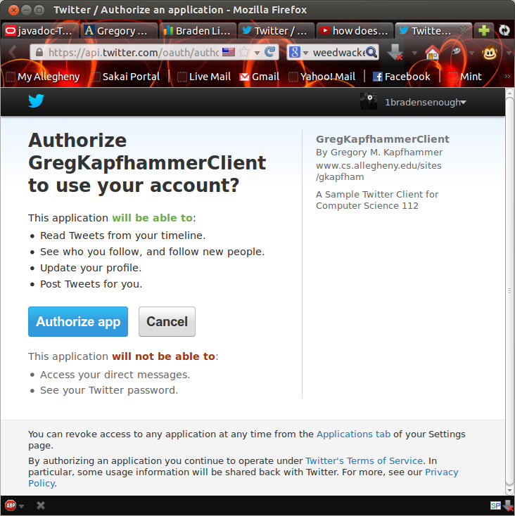

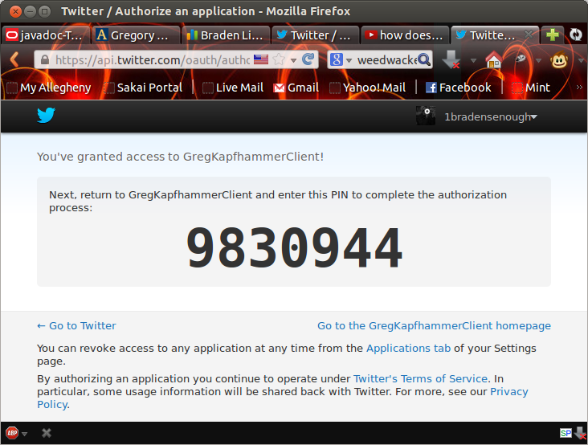

6. Documentation attached

7.
Program execution output showing all features:

java TwitterClient
Please type a number choice from the menu below:
1. View Home Timeline
2. Update status from "Tweets.txt" file
3. Update status from "Tweets.txt" file and view Home Timeline
4. Generate and tweet course notification for CS380s2013
5. Quit
1
Showing @1bradensenough's home timeline.

@1bradensenough - "No Bob, I will not let you name that sausage Evan..." #CS3804Life
@1bradensenough - "Tired to the point of hallucinating? Priceless." #CS3804Life
@wxdevin - RT @THON: Congratulations to Ryan Patrick on being selected as the THON 2014 Overall Chair!
@FSBigBob - Front Row WWE Raw Tix Tomorrow Morning...And You Get A Meet And Greet Before The Show..Listen/Win/Details Here> http://t.co/froeVTc8Jv
@1bradensenough - "Nothing tastes as good as blobfish feels." #CS3804Life
@1bradensenough - "I was a nerd growing up, and I'm a little antisocial and awkward." #CS3804Life
@1bradensenough - "Computer science is no more about computers than astronomy is about telescopes." #CS3804Life
@1bradensenough - "Thinking ahead will keep you ahead" #CS3804Life
@FSBigBob - Sidney Crosby Isn't Even Real http://t.co/pHP4zamvQy
@AndrewBoyer - Who's Laughing Meow http://t.co/7uZjzMdWIo
I have a feeling you may like this, meow. @KeegAlex
@AndrewBoyer - Momma Boyer doesn't mess around on pie day! http://t.co/ptLxUgPfdK
@wxdevin - Haha #1600Penn is so on key tonight! Hilarious!
@AndrewBoyer - Wish there was warmth to match the sun outside! #NeedSpring
@FSBigBob - Green-Stache Bash at Shenanigans In The North Hills .. Come Drink http://t.co/3ouSW9qNkS
@Tutorialzine - New Tutorial: Let’s Build a Lightweight Blog System (Part 1) http://t.co/osRXvFT5C0
@FSBigBob - RT @Clace28: @FSBigBob all I can picture is this http://t.co/MIUa1HGmLR
@FSBigBob - Groat is just making turtle sex noises at this point of the broadcast
@FSBigBob - Well this sucks RT @ProFootballTalk: Saints have signed CB Keenan Lewis (formerly of Steelers) to a five-year deal
@PittTweet - Study by Pitt psychiatry prof Dorothy Sit finds that postpartum depression affects 1 in 7 women: http://t.co/LmgVgktvjn
@PittTweet - RT @RhiansHope: .@thepittnews caption contest. #pittspringbreak http://t.co/NoY7C3TYdT

Please type a number choice from the menu below:
1. View Home Timeline
2. Update status from "Tweets.txt" file
3. Update status from "Tweets.txt" file and view Home Timeline
4. Generate and tweet course notification for CS380s2013
5. Quit
2
Successfully updated the status to ["Why am I still up?" #CS3804Life].

Please type a number choice from the menu below:
1. View Home Timeline
2. Update status from "Tweets.txt" file
3. Update status from "Tweets.txt" file and view Home Timeline
4. Generate and tweet course notification for CS380s2013
5. Quit
3
Successfully updated the status to ["Phase two of lab: Sleep until conscious tomorrow" #CS3804Life].

Showing @1bradensenough's home timeline.

@1bradensenough - "Why am I still up?" #CS3804Life
@1bradensenough - "No Bob, I will not let you name that sausage Evan..." #CS3804Life
@1bradensenough - "Tired to the point of hallucinating? Priceless." #CS3804Life
@wxdevin - RT @THON: Congratulations to Ryan Patrick on being selected as the THON 2014 Overall Chair!
@FSBigBob - Front Row WWE Raw Tix Tomorrow Morning...And You Get A Meet And Greet Before The Show..Listen/Win/Details Here> http://t.co/froeVTc8Jv
@1bradensenough - "Nothing tastes as good as blobfish feels." #CS3804Life
@1bradensenough - "I was a nerd growing up, and I'm a little antisocial and awkward." #CS3804Life
@1bradensenough - "Computer science is no more about computers than astronomy is about telescopes." #CS3804Life
@1bradensenough - "Thinking ahead will keep you ahead" #CS3804Life
@FSBigBob - Sidney Crosby Isn't Even Real http://t.co/pHP4zamvQy
@AndrewBoyer - Who's Laughing Meow http://t.co/7uZjzMdWIo
I have a feeling you may like this, meow. @KeegAlex
@AndrewBoyer - Momma Boyer doesn't mess around on pie day! http://t.co/ptLxUgPfdK
@wxdevin - Haha #1600Penn is so on key tonight! Hilarious!
@AndrewBoyer - Wish there was warmth to match the sun outside! #NeedSpring
@FSBigBob - Green-Stache Bash at Shenanigans In The North Hills .. Come Drink http://t.co/3ouSW9qNkS
@Tutorialzine - New Tutorial: Let’s Build a Lightweight Blog System (Part 1) http://t.co/osRXvFT5C0
@FSBigBob - RT @Clace28: @FSBigBob all I can picture is this http://t.co/MIUa1HGmLR
@FSBigBob - Groat is just making turtle sex noises at this point of the broadcast
@FSBigBob - Well this sucks RT @ProFootballTalk: Saints have signed CB Keenan Lewis (formerly of Steelers) to a five-year deal
@PittTweet - Study by Pitt psychiatry prof Dorothy Sit finds that postpartum depression affects 1 in 7 women: http://t.co/LmgVgktvjn

Please type a number choice from the menu below:
1. View Home Timeline
2. Update status from "Tweets.txt" file
3. Update status from "Tweets.txt" file and view Home Timeline
4. Generate and tweet course notification for CS380s2013
5. Quit
4

I would like to send my class a[n]:
1. assignment reminder
2. cancellation notification
3. personalized message
1
Tweet will look like "Assignment Reminder: 'assignmentname' will be due on 'duedate'.
Type the assignment name: Lab 5
Type the assignment due date: Friday (That's today...)
Successfully updated the status to [Assignment reminder: Lab 5 will be due on Friday (That's today...). #CS3804Life].

Please type a number choice from the menu below:
1. View Home Timeline
2. Update status from "Tweets.txt" file
3. Update status from "Tweets.txt" file and view Home Timeline
4. Generate and tweet course notification for CS380s2013
5. Quit
4

I would like to send my class a[n]:
1. assignment reminder
2. cancellation notification
3. personalized message
2
Successfully updated the status to [Course Notification: The next CS380 class session has been cancelled. Enjoy your day! #CS3804Life].

Please type a number choice from the menu below:
1. View Home Timeline
2. Update status from "Tweets.txt" file
3. Update status from "Tweets.txt" file and view Home Timeline
4. Generate and tweet course notification for CS380s2013
5. Quit
4

I would like to send my class a[n]:
1. assignment reminder
2. cancellation notification
3. personalized message
3
Type the personalized message you would like to send:
Just kidding, we have a lab to turn in, why would it be cancelled?!
Successfully updated the status to [Just kidding, we have a lab to turn in, why would it be cancelled?! #CS3804Life].

Please type a number choice from the menu below:
1. View Home Timeline
2. Update status from "Tweets.txt" file
3. Update status from "Tweets.txt" file and view Home Timeline
4. Generate and tweet course notification for CS380s2013
5. Quit
5

Now exiting :'(

8.
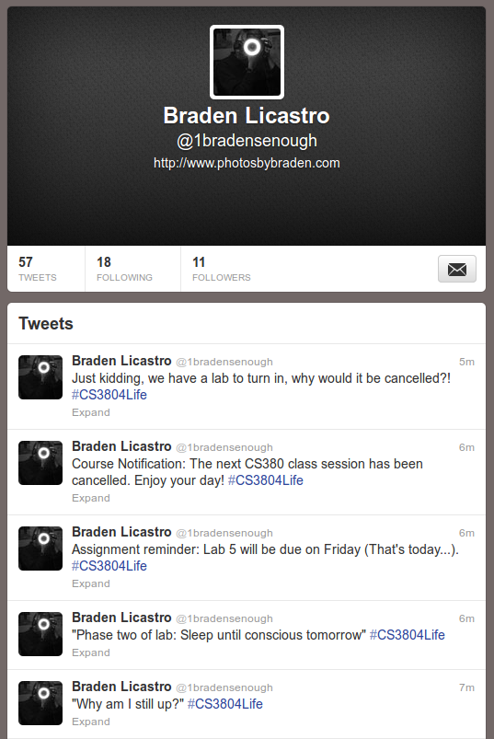

9.
Enter text here

